Democracy in Scotland and the United Kingdom

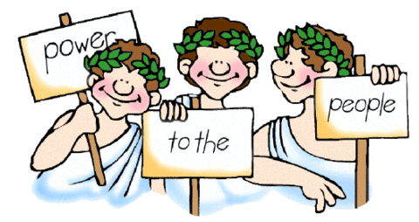

Higher Modern Studies

**Topic 4: Voting Behaviour**

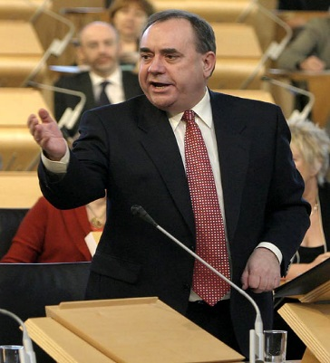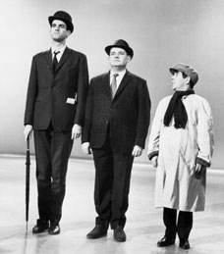

**Topic 4: Voting Behaviour**

This topic covers a range of factors which affect voting behaviour in the United Kingdom.

You will learn about:

* Outcomes of elections and
* Factors affecting voting behaviour.

**Introduction to Voting Behaviour**

**‘Voting behaviour’ is the phrase used to explain the complex mix of factors or influences that decide the way people vote in elections**. There are a range of factors that affect the way people vote in elections in the UK.

**Voting - Not a random choice**

When most people go to vote, they do **not** turn up at the polling station and decide there and then who will get their vote. Voting is not a random choice. Rather, in the days and weeks before the election, voters are influenced by a range of factors that will affect the way in which they vote. This section examines these factors.

For example, a voter may hear about and begin to agree with, the policy of independence for Scotland. If this were the case, they may be more likely to vote for the Scottish National Party (SNP), as the SNP’s main policy is independence for Scotland.

In this Study Theme you will learn that there are a variety of factors which influence voters. Later, you will also learn that some factors are more important than others in deciding which candidates or parties voters choose.

**What factors affect the way people vote?**

There are many factors or influences that affect the way people vote in elections. These can be divided into two groups: **long-term factors** and **short-term factors**.

**Long-term factors** are those factors which are built up over a lifetime perhaps even before a person is first politically aware. This is known as the process of ‘political socialisation’. For example, if the majority of people in an area are known to vote Conservative, including a person’s family, then that particular voter, it is argued, is more likely to vote Conservative too.

**Short-term factors** are those factors to which voters react. For example, the decision taken by Tony Blair to support the American-led invasion of Iraq in 2003, angered many Labour voters and there is evidence from the results of 2005 UK General Election that some voters switched away from Labour because of this decision.

**Electoral Stability?**

Political scientists have found that the UK’s electorate is fairly stable i.e. the majority of voters who do vote, tend to vote the same way in any election. People who vote the same way year on year are known as **committed voters**.

Recently, however, evidence suggests the numbers of **uncommitted voters** or ‘**floating voters’** is rising with at least 10% of voters describing themselves as uncommitted to any one party. This trend is sometimes known as increased electoral volatility.

Finally, elections in recent years have been characterised by lower turnouts. Evidence shows that the number of **apathetic voters** i.e. those choosing not to vote, is growing. In the 2005 UK election, only 61.2% although this was up from 59% in 2001. In 2010, however, turnout improved to 65.1%

**Tasks**

1. What is meant by the term ‘voting behaviour’?

2. Explain, with examples, the difference between short-term factors affecting voting behaviour and long-term factors affecting voting behaviour.

3. Explain what is meant by the following terms: ‘committed’, ‘floating’ and ‘apathetic’ voters.

**The Media’s Influence on Voting Behaviour – Newspapers**

[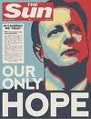](http://www.google.co.uk/imgres?imgurl=http://blogs.timeslive.co.za/minor/files/2010/05/cameron-only-hope-poster1.jpg&imgrefurl=http://blogs.timeslive.co.za/minor/tag/jacob-zuma/&usg=__9JfhQh5QWNhkvsg8xKARK0Nv_7Q=&h=500&w=384&sz=50&hl=en&start=1&zoom=1&itbs=1&tbnid=6sZdy0m9bSCSkM:&tbnh=130&tbnw=100&prev=/images?q%3Dgeneral%2Belection%2B2010%2Bnewspaper%2Bfront%2Bpage%26hl%3Den%26gbv%3D2%26tbs%3Disch:1)The influence of the media on voting behaviour has often been the subject of fierce debate. Some political analysts argue that the media has little influence on voting behaviour and its influence on voting behaviour is overstated. On the other hand, politicians and political parties appear to believe that the media can and does influence the final result of elections and is a major influence on voters.

**The Influence of Newspapers**

Newspapers are an important source of information. **Just under half of households in the UK claim to have access to a newspaper, usually the same title every day.**

For the majority of voters, this means the choice of news story they read about (or don’t read about) and the slant or ‘spin’ put on stories by the newspaper owner or editor, is more or less the same day in and day out. This, some political analysts argue, allows a newspaper to greatly influence its readership.

**Note**: Newspaper sales overall are falling as less and less people are reading newspapers today.

[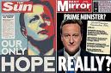](http://www.google.co.uk/imgres?imgurl=http://www.thepunch.com.au/images/uploads/sun_mirror_election.jpg&imgrefurl=http://www.thepunch.com.au/tags/newspapers/&usg=__UfFI7RHQEWDxrtIiZ-rkC6MY3mM=&h=310&w=470&sz=38&hl=en&start=7&zoom=1&itbs=1&tbnid=F9jTURqzaVC2aM:&tbnh=85&tbnw=129&prev=/images?q%3Dtony%2Bblair%2Band%2Bsun%2Bnewspaper%26hl%3Den%26gbv%3D2%26tbs%3Disch:1) [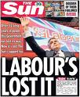](http://www.google.co.uk/imgres?imgurl=http://news.sky.com/sky-news/content/StaticFile/jpg/2009/Sep/Week4/15395832.jpg&imgrefurl=http://news.sky.com/skynews/Home/UK-News/Front-Covers-From-The-Sun-Newspaper-Showing-Their-Support-For-The-Main-Political-Parties/Media-Gallery/200909415395809&usg=__NUVT4_04NmLPoUQp_Ne763w5-4w=&h=400&w=328&sz=80&hl=en&start=4&zoom=1&itbs=1&tbnid=3-dlzBxlXhX5WM:&tbnh=124&tbnw=102&prev=/images?q%3Dtony%2Bblair%2Band%2Bsun%2Bnewspaper%26hl%3Den%26gbv%3D2%26tbs%3Disch:1) 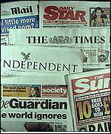

**Freedom of the Press**

Newspaper owners or editors are free to report the news as they decide. Freedom of the press is an important political right. As a result, newspapers are free to support / criticise whichever political party or politicians they choose. This support is reflected in their **choice of stories** (successes / scandals), in their **choice of pictures** (flattering or demeaning), in their **use of political cartoon** or in their **editorials** (supportive or critical).

**Extent of Newspaper Bias**

Most newspapers are biased in one way or another. For example, popular newspapers are very clear about which politicians or party they support compared to quality newspapers where the bias is less obvious. Come election time, popular newspapers will openly urge their readers to vote for one party or another. At the 2010 General Election, studies showed the Daily Mail was strongly pro-Conservative and the Daily Mirror strongly pro-Labour.

Cautionary note: Analysis of the 2005 General Election shows that no one newspaper backs the same political party all the time. The Sun, for example, criticised Labour more than the Conservatives in the weeks leading up to the election but still urged its readers to vote Labour. By 2010, however, the Sun had switched its support from Labour to the Conservatives and it urged its readers to do the same.

Below are three examples of different newspapers reaction to Labour’s 2005 General Election victory. Look carefully at the selection of pictures and text and decide for yourself whether these newspapers were pleased with the result.

**Daily Express The Sun Daily Mirror**

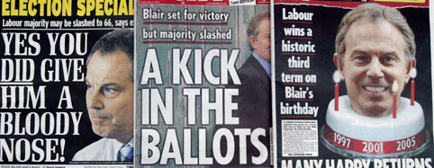

**Newspaper Circulation and Support in the run-up to the 2010 General Election**

The table below shows a selection of different national newspapers, their average circulation and the political party supported in the run-up to the 2010 General Election.

|  |  |  |
| --- | --- | --- |
| **Daily Newspapers** |  |  |
| **Favoured** | **Circulation** | **Party** |
| The Sun | 3.0m | Pro-Conservative |
| Daily Mirror/Daily Record | 1.65m | Strongly Pro-Labour |
| Daily Mail | 2.12m | Pro-Conservative |
| The Times | 0.5m | Pro-Conservative |
| Guardian | 0.25m | Liberal Democrats |
| Daily Telegraph | 0.7m | Pro-Conservative |
|  |  |  |
| **Sunday Newspapers** |  |  |
| News of the World | 2.89m | Pro-Conservative |
| Sunday Mirror | 1.14m | Pro-Labour |

**Newspapers and Political Parties**

In recent years, political parties have become more determined to retain the support of newspaper owners and their editors. For example, between 1997 and 2005, Tony Blair met several times with Rupert Murdoch, who is owner of the Sun and News of the World, in order to convince Murdoch that his newspaper should continue to support Labour. **Politicians clearly believe newspaper support is crucial in helping to win elections.**

**Note**: The relationship between politicians and newspapers is often strained. However, politicians need newspapers to get their message across and newspapers need access to politicians to keep their readers informed.

[**“The Sun Wot Won It!”**](http://www.bbc.co.uk/learningzone/clips/the-influence-of-the-media/4050.html)

**Newspaper owners and editors believe they can influence the outcome of elections.** At the elections of 1997, 2001 and 2005, The Sun newspaper backed Labour to win and in doing so The Sun claimed, to have ‘won it’ for Labour. The Sun said something similar in 2010 when it switched to the Conservatives and they too won. So does newspaper support decide the election?

**Many political analysts argue The Sun’s support for Labour up to the 2005 election made little or no difference to the results in 1997-’05 elections**. Each time electoral opinion polls correctly forecast Labour was going to win and arguably, The Sun backed Labour rather than be seen to back the losing Conservatives. The Sun, being the paper it is, appears to prefer to ‘back a winner’ rather than disappoint its readers by ‘supporting a loser’.

However, there are other political analysts who argue that in a close electoral contest, as in 1992 General Election, The Sun’s support for the Conservatives did help ‘win it’. **So newspaper support cannot be discounted as a factor affecting voting behaviour completely.**

**Extent of Newspaper Influence**

Although political parties believe newspaper support to be importantin gaining electoral support, not all political analysts agree. Why?

• **Evidence suggests voters tend to buy a newspaper which agrees with their political point of view.** If an article disagrees with their opinion they ignore or reject it. Evidence also suggests that even the most biased of newspapers e.g. the pro-Labour Daily Mirror, criticises the party they claim to support when they feel the criticism is justified.

• **Many people buy newspapers for reasons other than politics.** A great deal of what a newspaper publishes is not of interest to its readers. Readers often claim they do not know the political view of their paper.

• **The electorate are more sophisticated than they are often credited**. They are aware of bias of their newspaper but are not so easily influenced as editors may believe.

• **Other factors are more important than newspapers in influencing voters**.

**Tasks**

1. “All UK households regularly access newspapers.” (Beth Scott) Explain why the statement made by Beth Scott is **exaggerated**.

2. In what ways can the information in newspapers influence voters? Make **three** points.

3. “Papers like the Sun support Labour all the time.” (Rachel Barr) What information is there to **oppose** the view of Rachel Barr?

4. Look carefully at the section entitled, “Evidence of Newspaper Bias’. For each newspaper front page, explain whether you think the editor is happy with Labour’s election victory.

5. “The Sun was the UK’s best-selling daily newspaper in 2010. There was no support amongst newspapers for the Labour.” (Kane Campbell) To what extent is Kane Campbell **selective in his use of facts**?

6. What evidence is there that newspapers and politicians believe newspapers influence the way people vote? Make **two** points.

7. Give **two** reasons why some political analysts would disagree that newspapers are an important factor in influencing voters.

**Voting Behaviour – Television**

In surveys, most people claim to get their political news from television. Hourly news bulletins, 24 hour news channels, interactive news services via the ‘red button’, etc., mean political discussion is broadcast into most households on a daily basis. For this reason, television is seen as an important influence on voting behaviour.

As well TV news bulletins, viewers may also access politicians and political debate through programmes such as Panorama, Question Time or the Tonight programme.

**The Law and Television**

Unlike newspapers, television is required by law to be politically neutral. This is a recognition that TV is a more powerful medium for influencing people than newspapers and as such, requires greater control.

When political issues are covered on TV, bulletins must put across the facts. When opinions are given or analysis made, this should be balanced. Politicians or people representing different political parties should each be given an opportunity to have their say.

Achieving an absolute political balance on TV is very difficult. Often parties who oppose the government complain that the governing party gets too much coverage or their views are marginalised. It is argued that the PM, in particular, gets more coverage than they sometimes deserve. Occasionally, arguments break out between the parties over TV coverage. For example, the SNP were deeply unhappy that the SNP were not able to take part in the three leaders’ debates in the run up to the 2010 election.

**Political Parties and the Television Media**

As with newspapers, politicians need access to television to get their message across. Equally, the TV editors need to have reasonable relations with politicians in order to get stories. Although both politicians and TV need each other, there is often an uneasy relationship between the two.

To cope with the media, especially TV, political parties employ ‘spin doctors’ whose job it is to ‘work the media’. A famous example is Alastair Campbell, Tony Blair’s spin doctor (on whom the foul-mouthed character Malcolm Tucker in the television comedy ‘The Thick of It’ was alleged to have been based). Spin doctors aim to control the news agenda to ensure their party / politicians achieve positive publicity. Often these same individuals will seek to deliver good ‘[sound bites](http://www.telegraph.co.uk/news/election-2010/7638412/General-Election-2010-David-Camerons-sound-bite-attack-on-Labour-citadel.html)’ or short catchy phrases (Conservatives 2010 – ‘Time for Change’) which will stick with voters and attract support. In recent years, all the main parties have increased spending on media offices / media training for their candidates to improve their TV image.

[**Party Political Broadcasts (PPBs)**](http://www.youtube.com/watch?v=cCJX3o8qjhU)

[PPBs](http://www.youtube.com/watch?v=p0kzXFHKagk) are the one exception where television can be biased.

Throughout the year but more importantly in the weeks leading up to an election, political parties are given the opportunity to put their opinions across to voters.

The more support a party attracts in elections, the greater the number of [PPBs](http://www.youtube.com/watch?v=wEYMIaq0GgM&feature=related) it will be allowed to show.

Parties often spend thousands of pounds making slick PPBs which reflects the importance parties give to the TV media.

[**So Does TV Coverage of Politics Influence Voters?**](http://www.bbc.co.uk/learningzone/clips/does-the-media-influence-how-people-vote/4642.html)

Well… yes and no. For some voters the answer is no. Those who are strongly committed to one party will simply ignore programmes or [PPBs](http://www.youtube.com/watch?v=aTN7xxE0yiU) that they don’t agree with. Millions of other people switch channels or go and make a cup of tea! However, evidence suggests less committed voters (which are increasing), may be influenced by what they see or hear. Brown’s poor media image was thought to have cost Labour votes in the 2010 election.

**The Media’s Influence on Voting Behaviour – The Impact of the 2010 General Election Debates**

In recent years newspaper sales have declined. Despite 24-hour TV news coverage, the numbers regularly watching TV news bulletins is noticeably less than popular soap programmes. For example, around 6m people watch the 10pm news (BBC and ITV combined) whereas Coronation Street attracts well over 8m viewers an episode. However, the series of [three 2010 elections debates](http://www.youtube.com/watch?v=rk5HvJmy_yg) were watched by very large numbers of viewers with audiences of between 6-9m.

**Note**: Despite general agreement that the Liberal Democrat leader, Nick Clegg’s performances were, overall, the best of the three party leaders, this did **not** result in real election success for the Liberal Democrats. Perhaps a few floating voters changed their vote but most stuck with the party they said they were always going to support.

**Influence of Other Media**

**Radio**

For many people the radio is an important source of political information. Although there are many radio channels, ‘serious’ radio channels such as BBC Radio 4 and Radio Scotland are listened to by many tens of thousands of people.

**The Internet**

The growing influence of the internet/technology on voters cannot be ignored. Political parties are aware that a small but increasing number of people are moving away from traditional media sources and by way of an alternative, will access the internet. All the major parties have developed their websites and they experimented with new technology e.g. by contacting voters through text messages. Recently, many politicians have taken to [Facebook](http://www.facebook.com/pages/?browse&ps=151), [blogs](http://www.guardian.co.uk/politics/2010/jan/03/labour-tory-internet-campaigns) and [tweets](http://tweetminster.co.uk/mps) as ways of reaching out to voters to get their message across.

**Tasks**

1. In what **three** ways can people access political news?

2. In what way is television coverage of politics different from newspaper political coverage?

3. Why is an absolute political balance on TV difficult to achieve? Make **three** points.

4. Using examples, explain what is meant by ‘spin doctors’ and ‘sound bites’.

5. What evidence is there that political parties think good TV coverage is important to political success? Make **two** points.

6. “TV political coverage affects voting behaviour.” (Charlie Tully) Do you **agree** with Charlies view? Explain your answer.

7. Assess the impact on voting behaviour of the three election debates.

8. Which parts of the media are becoming more important and why?

**Practice** **End of** **Unit Assessment Task:**

The media is one of the factors which is thought to influence voting behaviour.

* Explain, in detail, at least two key ways the media is thought to influence voting behaviour.
* Analyse the extent to which the media influences voting behaviour.

The marking instructions for this type of assessment task can be seen on the next page.

**Marking Instructions:**

**Explain, in detail, at least two key ways the media is thought to influence voting behaviour.**

For this part of the task you must explain at least two aspects of a complex political issue.

Your explanation must be supported by points of description.

Each explanation must make at least two developed points which make the political issue clear. Developed points can include, for example:

* additional detail
* examples
* evidence
* reasons
* drawing out implications

**Analyse the extent to which the media influences voting behaviour.**

For this part of the task your analysis must derive from a body of accurate information.

You must move beyond description and explanation of relevant detail.

You must identify at least two relevant aspects/features and clearly show at least one of the following:

* links between aspects
* similarities and contradictions
* consistency and inconsistencies
* different views/ interpretations
* possible consequences/ implications
* a logical order
* relative importance

**Enquiry Skills**

The following task is from the SQA Specimen Paper. Study Sources A and B below and opposite then attempt the question that follows. The marking instructions are on the three pages following the question. Use these to help you.





Attempt the following question, using **only** the information in Sources A and B opposite and above.

To what extent is it accurate to state that the televised debates had a significant impact on voting intentions? **(8)**

**Marking Insturctions**

*Candidates can be credited in a number of ways* ***up to a maximum of 8 marks.***

**Evidence that supports the view (…** *the televised debates had a significant impact on voting intentions)*

* The televised debates allowed voters to visually connect with candidates. (1 mark)
* Ipsos MORI poll revealed 60% of voters felt the debates would help them decide who to vote for. *Link to Source 2 — before first live debate 14% of voters indicated they would not vote for the main parties; following the leader’s initial performances this had decreased to 8% with the main parties receiving a boost in percentages of voters who would vote for them.* (2 marks)
* Coverage of the leaders during the debates could alter how the media reports on each of the leaders and their parties. (1 mark)
* Success of TV debates increased Nick Clegg’s popularity as a potential leader. *Link to Source 2 — 21% of voters claimed they would vote Liberal Democrat which rose to 32% following his performance during the first debate.* (2 marks)
* Following the debates, an independent polling organisation found over a million voters (4% of voters) altered the way they would vote. *Link to Source 2 — before the first debate Conservatives had a 5-point lead which disappeared following the leader’s first performance.* (2 marks)
* TV debates motivated people to vote who may not have voted previously, with 17% rise in young voters indicating they would turn out to vote in some areas. (1 mark)

**Evidence that does not support the view (…***the televised debates had a significant impact on voting intentions)*

* *Only 12% said the survey changed their minds about who to vote for. Link to Source 2 — very little change in percentages for Labour and Conservatives of voters who claimed they would vote for them in a General Election.* (2 marks)
* *Source 1 — Initial viewing figures of 61% declined across the three debates.* (1 mark)
* *Source 2 — Labour and Conservative vote remained largely unchanged.* (1 mark)

Candidates may also be credited up to **2 marks** on any comment/evaluation of the origin and reliability of the sources.

* Source A – “Various” sources — extent of adaptation not known. Source therefore not wholly reliable.
* Comment on reliability of statistics from Ipsos MORI (both sources)
* Reliability of statistics from British Election Study 2010 — well-respected organisation.
* Independent company survey — no reference to size of sample for survey, limited information on connection of company to TV debates; however, independent therefore may be less likely to be biased.
* Source B — full reference, including date; widely respected polling organisation — more reliable.

For full marks, candidates **must** make an overall judgement as to the extent of the accuracy of the given statement.

Overall, the evidence **does not** support view as:

* *Source 1 — Liberal Democrats came third with only 23% of the vote (up only 1% from 2005) despite appearing to do best in the debates.*
* *Source 2 — actual election results very close to statistics in first pie chart taken before televised debates.*

**Social Class and Voting Behaviour**

**What is Social Class?**

A person’s social class is a measure of their status in society. Social class is usually measured in terms of occupation, income, professional qualifications, housing type, etc. According to the **Market Research** definition of social class*, Social Class A would be higher managerial e.g. accountant, lawyer, etc., whereas Social Class E would be the poorest groups in society including long-term unemployed or those in low wage employment.

**Market Research Social Class Scale**

A Higher managerial Non-manual Lawyer

B Lower managerial Non-manual Teacher

C1 Skilled supervisor Non-manual Senior technician

C2 Skilled manual Manual Plumber

D Unskilled manual Manual Labourer

E Disadvantaged e.g. unemployed Poor

**Social Class and Voting Behaviour**

[It has long been recognised that one of the **most**](http://www.bbc.co.uk/learningzone/clips/does-social-class-influence-how-people-vote/3829.html) important factors affecting voting behaviour has been the influence of social class.

Up to the 1980s, it was argued that the majority of voters in the UK tended to vote according to their social class. This meant that the majority of people in Social Class A (formerly the middle classes) more often voted for the Conservatives, as they were the party who traditionally favoured low taxation or policies that tended to benefit the better off. On the other hand, the majority of people in Social Class E (formerly the working class) more often voted Labour, as traditional Labour policies tended to support the poorest in society e.g. support for the Welfare State.

**Reduction in class-based voting**

Studies of voting behaviour show that there has been a reduction in the number of people voting according to their class. **Although there is still an important link between social class and voting behaviour, the link is not as strong as it once was.** For example, according to the [Ipsos/MORI](http://www.ipsos-mori.com/researchpublications/researcharchive/poll.aspx?oItemId=2613&view=wide) polling organisation, at the 2010 UK General Election of those who turned out to vote, the Conservatives attracted 39% of all AB voters compared to just 29% for Labour. On the other hand, Labour gained 40% of all DE voters whereas only 31% of D/E voters opted for the Conservatives.

Studies of voting behaviour in recent elections show that most people do not vote according to their social class. This movement away from social class as the biggest influence on voting behaviour is known as **dealignment**.

**Dealignment**

Some people have never voted according to their class because:

* In classes AB (‘middle class radicals’) some better off people have always voted Labour despite the fact they may be better off financially voting Conservative. This may be because they are well paid so they wish to support a party that tends to help the poorest more or gives support to working people e.g. introduction/extension of Min. Wage.
* In classes DE (‘working class Conservatives’) some poorer people may vote Conservative (although they might not personally benefit) because they aspire to a ‘higher class’. They may also feel the Conservatives provide more opportunities for people to ‘rise and go’ or that the Conservatives have better policies on managing the economy, education or law and order.

Class has also become less important in recent elections because:

* **Changes within society** – Nowadays people are less likely to see themselves in Social Classes D or E. As disposable incomes have increased, people regard themselves as ‘further up the social ladder’. On the other hand, many more people today work in the public sector and as a consequence are more likely to vote Labour as Labour traditionally provides greater support to the public sector.
* **Tactical voting** – As many votes are ‘wasted’ under the FPTP electoral system, more voters are choosing to vote tactically. They know their favoured candidate is not going to win so they vote to keep the candidate/party they least like out. In 2010, some Labour politicians urged Liberal Democrat voters to vote tactically to keep out the Conservatives.
* **Third party choice** – For many years the Liberal Democrats and the SNP in Scotland have been credible voting alternatives. In the last thirty years both these parties have attracted considerable support in elections, have won parliamentary and Scottish parliamentary seats (The SNP were elected to power in Scotland in 2007 and again in 2011 with an overall majority) or have been the dominant party in local councils elections. In 2010, the Liberal Democrats polled 24% of the vote in the UK as a whole, won 57 seats and made an arrangement to share power with the Conservatives in a coalition government. The SNP won 6 seats and attracted 20% of the vote in Scotland. The Green Party won their first UK Parliamentary seat in 2010 in the constituency of Brighton Pavilion.

**Note:** Other factors, such as the media, have also reduced the importance of social class as a factor affecting voting behaviour in recent years.

**Tasks**

1. Explain what is meant by a person’s ‘social class’.
2. Using examples, describe the Market Research definition of social class.
3. Describe traditional social class voting behaviour.
4. Give reasons for traditional social class voting behaviour.
5. Using examples from the 2010 General Election, what evidence is there that social class remains an influence on voting behaviour.
6. What are ‘middle class radicals’ and ‘working class Conservatives’?
7. Explain **three** reasons to explain recent class dealignment.

**Practice** **End of** **Unit Assessment Task:**

Class is one of the factors which is thought to influence voting behaviour.

* Explain, in detail, at least two key ways class is thought to influence voting behaviour.
* Analyse the extent to which class influences voting behaviour.

The marking instructions for this type of assessment task can be seen on the next page.

**Marking Instructions:**

**Explain, in detail, at least two key ways class is thought to influence voting behaviour.**

For this part of the task you must explain at least two aspects of a complex political issue.

Your explanation must be supported by points of description.

Each explanation must make at least two developed points which make the political issue clear. Developed points can include, for example:

* additional detail
* examples
* evidence
* reasons
* drawing out implications

**Analyse the extent to which class influences voting behaviour.**

For this part of the task your analysis must derive from a body of accurate information.

You must move beyond description and explanation of relevant detail.

You must identify at least two relevant aspects/features and clearly show at least one of the following:

* links between aspects
* similarities and contradictions
* consistency and inconsistencies
* different views/ interpretations
* possible consequences/ implications
* a logical order
* relative importance

**Short-term Factors Affecting Voting Behaviour**

The numbers of uncommitted voters or ‘floating voters’ is increasing amongst the electorate. As a consequence, a greater proportion of voters are more likely to be influenced by what is known as **short-term** factors on voting behaviour. Short-term factors include: single issue voting, the image of the party leader and the extent of party unity.

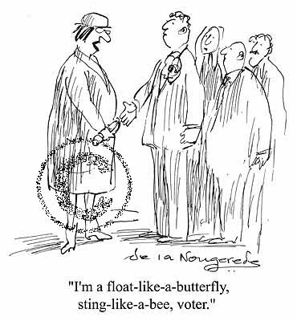

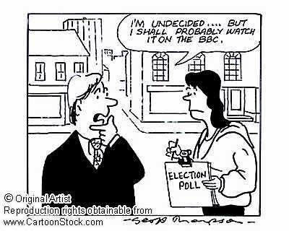

**Single Issue Voting**

In recent years, it has become clear that some voters decide between the parties on [**single issues**](http://www.bbc.co.uk/learningzone/clips/do-issues-influence-how-people-vote/3833.html) e.g. health or education. In the 2005 election, one key single issue was the war in Iraq. In 2010 the economy became the main issue with a number of voters choosing the Conservatives as they were, arguably, seen to have the best policies to handle the on-going economic crisis.

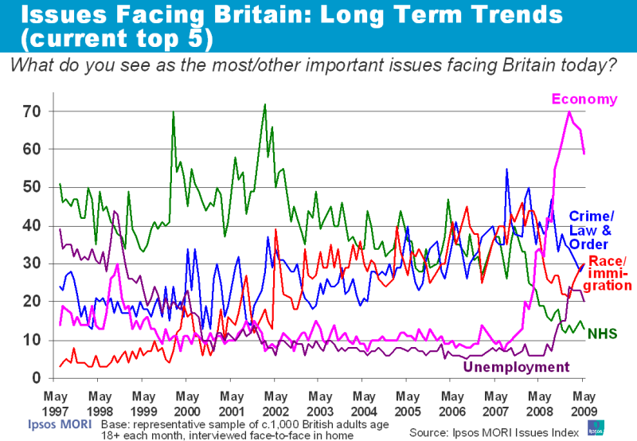

[Since the onset of the current economic crisis, the economy has become the most important single issue of concern to voters.](http://www.ipsos-mori.com/researchpublications/researcharchive/poll.aspx?oItemID=56&view=wide)

[**Image of Party Leader**](http://www.bbc.co.uk/learningzone/clips/does-personality-and-leadership-style-influence-how-people-vote/3819.html)

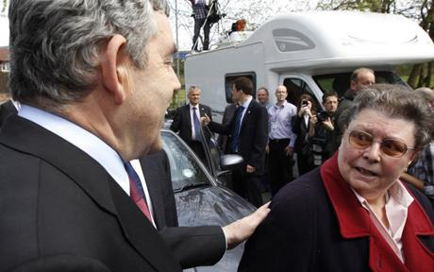[Gordon Brown’s image](http://www.ipsos-mori.com/researchpublications/researcharchive/poll.aspx?oItemID=88&view=wide) at the 2010 election was generally seen as very poor. He was often described as dour. His unguarded comments describing one lady voter as ‘bigoted’ are thought to have cost Labour votes.

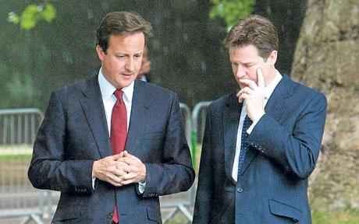

By way of contrast, both David Cameron and Nick Clegg enjoyed high poll ratings which, arguably, helped the Conservatives and Liberal Democrats in 2010.



In Scotland, Alex Salmond is seen as an able, competent and combative politician whose leadership skills have helped secure votes for the SNP in recent elections.

**Extent of Political Party Unity**

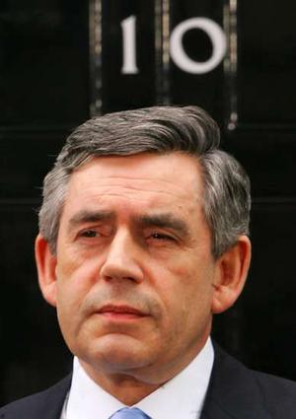The extent to which a political party is unified in the run-up to an election is seen by some political commentators as a crucial short-term factor in affecting voting behaviour. A disunited party arguing with itself is less likely to attract uncommitted voters. For example, it is argued that there were a number of Labour MPs who were unhappy with Gordon Brown’s leadership and there was talk of a leadership challenge.

Another example of disagreement (prior to the SNPs victory in 2011 and the referendum campaign) was between those members of the SNP who wanted an independent Scotland as soon as possible (fundamentalists) and those who would have liked to secure and retain power in the Scottish Parliament with a long-term aim of independence (gradualists).

**Tasks**

1. Explain why short-term factors are becoming more important as influences on voting behaviour.
2. Look at the information on single issue voting. For **two** of the issues mentioned, economy and health, describe the trend in public opinion on these issues.
3. What is meant by ‘single issue voting’. Give **two** examples of single issue voting affecting voting behaviour at recent elections.
4. Explain the way in which the **image of the party leader** and **extent of party unity** affect voting behaviour. Give examples to improve your answer.

**Practice** **End of** **Unit Assessment Task:**

Short term factors are thought to influence voting behaviour to an extent.

* Explain, in detail, at least two key ways short term factors are thought to influence voting behaviour.
* Analyse the extent to which short term factors influence voting behaviour.

The marking instructions for this type of assessment task can be seen on the next page.

**Marking Instructions:**

**Explain, in detail, at least two key ways short term factors are thought to influence voting behaviour.**

For this part of the task you must explain at least two aspects of a complex political issue.

Your explanation must be supported by points of description.

Each explanation must make at least two developed points which make the political issue clear. Developed points can include, for example:

* additional detail
* examples
* evidence
* reasons
* drawing out implications

**Analyse the extent to which short term factors influence voting behaviour.**

For this part of the task your analysis must derive from a body of accurate information.

You must move beyond description and explanation of relevant detail.

You must identify at least two relevant aspects/features and clearly show at least one of the following:

* links between aspects
* similarities and contradictions
* consistency and inconsistencies
* different views/ interpretations
* possible consequences/ implications
* a logical order
* relative importance

**Long-Term Factors Affecting Voting Behaviour**

In this section you will learn that as well as the media and class, there are a number of other long-term factors that affect voting behaviour in the UK. These factors include age, gender, place and race.

**Long-term Factors Affecting Voting Behaviour:** [**Age**](http://www.bbc.co.uk/learningzone/clips/does-age-influence-how-people-vote/6068.html)

For many years age has been an important factor affecting the way people vote. Why?

* The Conservative’s traditional policies of lower taxation and less radical change may appeal to elderly people, many of whom are wealthy. However, it may be that as people become older they move up the ‘social ladder’ so it a change of class rather than age that is affecting older voters.
* Labour / Liberal Democrats have greater focus on education which appeals to younger voters.

|  |  |  |  |
| --- | --- | --- | --- |
| Age Group | Conservative | Labour | Lib. Dem |
| 18-24 | 30 | 31 | 30 |
| 25-34 | 35 | 30 | 29 |
| 55-64 | 38 | 28 | 23 |
| Age 65+ | 44 | 31 | 16 |

**Source Ipsos/Mori 2010**

**Long-term Factors Affecting Voting Behaviour: Gender**

Before 1997, gender was seen as a factor affecting voting behaviour with more men consistently voting Labour than women. In the two General Elections of 1997 and 2001, there was little difference between male and female voting. However, in 2005, it is argued that women’s support for Labour, especially amongst ‘school-gate mums’, helped Labour win, again making gender a factor in voting. But why Labour? Labour targeted families with children for most support e.g. Child Trust Fund. Lower paid women workers also benefited more from policies such as the Minimum Wage. In 2010, Labour continued to have marginally more support from women voters.

|  |  |  |  |
| --- | --- | --- | --- |
|  | Conservative | Labour | LibDem |
| Men | 38 | 28 | 22 |
| Women | 36 | 31 | 26 |

**Source Ipsos/Mori 2010**

**Long-term Factors Affecting Voting Behaviour:** [**Place**](http://news.bbc.co.uk/1/shared/election2010/results)

Place or geographic location plays a part in affecting voting choice:

* Generally, the further south and east someone lives (outside inner London) the more likely they are to vote Conservative; the further north and west, **not** Conservative.
* People in urban areas are more likely to vote Labour; rural areas Conservative or Liberal Democrat.
* Again, people in the South and East tend to wealthier than those elsewhere so location may also be linked to social class.

**Tenure** (Whether people own or rent their home)

Generally, a person is more likely to vote Labour if they rent their home and Conservative if they have a mortgage or have bought their home outright. However, as people who are wealthier can afford to buy this may again link to class.

|  |  |  |  |
| --- | --- | --- | --- |
|  | Cons | Lab | Lib Dems |
| Owned | 45 | 24 | 21 |
| Rented | 24 | 47 | 19 |

**Source Ipsos/Mori 2010**

**Long-term Factors Affecting Voting Behaviour:** [**Race**](http://www.bbc.co.uk/learningzone/clips/does-ethnic-origin-and-or-religion-influence-how-people-vote/3805.html)

Race or more correctly, **ethnicity**, is also a factor affecting voting behaviour. In 2010, 8% of voters were from ethnic minority groups with the majority (80%) of those again supporting Labour. Why? Labour has traditionally been both more sympathetic to immigration and to poorer groups of which minorities are more likely to be in.

However, in 2005, unlike 1997 and 2001 where close to 90% of people from ethnic minority groups opted for Labour, a greater number of Asian voters switched away from Labour as protest vote over the invasion of Iraq.

**Long-term Factors Affecting Voting Behaviour**

How can I remember all the long-term factors affecting voting behaviour? Try the following:

**M Media** Influence of newspaper, TV, etc.

**A Age** Younger or older

**G Gender** Male or female

**I** **Issues** Single issues e.g. Iraq War

**C. Class** Status in society

**P Place** Where you live in UK

**R Race** Better described asEthnicity

**Summary: How important are long-term factors in affecting voting behaviour?**

Most political analysts would agree that the media has increased in importance as a factor affecting voting behaviour. In the same way, most agree that the influence of social class has declined. However, it is almost impossible to evaluate the importance of any one long-term factor affecting voting behaviour.

For example, a male voter may be getting older, live in the south of England and have bought his house. However, he may also be a member of a trade union and work in a manual job. At first he may appear to be more likely to vote Conservative but equally, he may be a Labour supporter as trade unionists and manual workers are more likely to vote Labour. The point is that all the factors that affect the way people vote do not happen in isolation. The factors that affect the way people vote are interconnected and, at best, only give a pointer to the way different people are likely to vote. Finally, there are many short-term factors that affect voting behaviour and these cannot be overlooked.

**Tasks**

1. What links are there been age and voting behaviour. Make **two** points.

2. “Gender was a factor in deciding voting behaviour in the four elections between 1997 and 2010.” - Paddy Deery

To what extent does the information **support** the view of Paddy?

3. “Geographic location and housing tenure have no impact on voting behaviour.” - Gerald Nyakura

What information is there to **oppose** Gerald’s view. Make **two** points.

4. Explain why people from ethnic minority groups have traditionally supported Labour. Make **two** points.

5. For what reason did many Asian voters switch their vote away from Labour in 2005.

**Practice** **End of** **Unit Assessment Task:**

Long term factors are thought to influence voting behaviour to an extent.

* Explain, in detail, at least two key ways long term factors are thought to influence voting behaviour.
* Analyse the extent to which long term factors influence voting behaviour.

The marking instructions for this type of assessment task can be seen on the next page.

**Marking Instructions:**

**Explain, in detail, at least two key ways long term factors are thought to influence voting behaviour.**

For this part of the task you must explain at least two aspects of a complex political issue.

Your explanation must be supported by points of description.

Each explanation must make at least two developed points which make the political issue clear. Developed points can include, for example:

* additional detail
* examples
* evidence
* reasons
* drawing out implications

**Analyse the extent to which long term factors influence voting behaviour.**

For this part of the task your analysis must derive from a body of accurate information.

You must move beyond description and explanation of relevant detail.

You must identify at least two relevant aspects/features and clearly show at least one of the following:

* links between aspects
* similarities and contradictions
* consistency and inconsistencies
* different views/ interpretations
* possible consequences/ implications
* a logical order
* relative importance