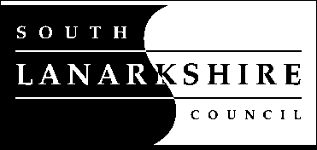 | Our ref: | MD
 | Your ref:
 | If calling ask for: | Marianne Duncan
 | Phone: | 01555 892251
 | Date: | 13.9.21
PARTICAPATORY BUDGETING

Dear Parents/Carers,

Participatory Budgeting (PB) is a way for adults and children to have a direct say in how to spend part of the public budget. The Scottish Government recommends that all councils allocate at least 1% of their budgets via PB by the financial year 2020/21, which equates to 5% of school Pupil Equity Fund finances allocated to each school in South Lanarkshire this year.
This year, I will be running a small steering group of parents and pupils who are interested in coming together to come up with ideas on how to spend this money. The ideas should be in line with our school priorities – you can find our School Recovery Plan 2021-22 on our website. We will present these ideas to our school community, giving parents/carers the opportunity to have your say through an online vote.
If you are interested in being involved in this opportunity, please contact the school by this Friday (17th of September) and speak to Mrs Duncan. There will also be an online meeting for this group on Wednesday the 22nd of September at 7pm via Google Meet.

Yours sincerely,

Marianne Duncan

Marianne Duncan
Depute Head

