Google Classroom Pupil/ Parent help sheet
How to upload files to the Google Classroom Stream
from your computer.
Log onto Google Classroom and go onto the Stream. Click on the section headed
Share something with your class.
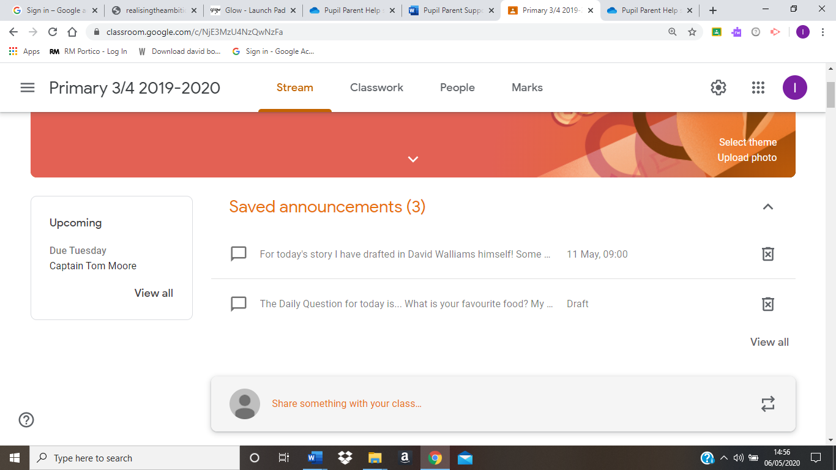
Click on Add.
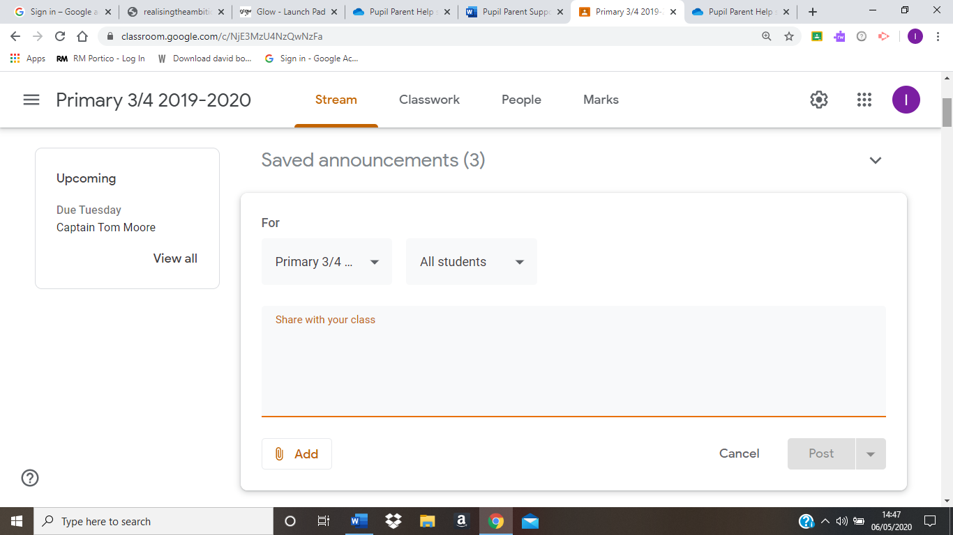

Click on File.
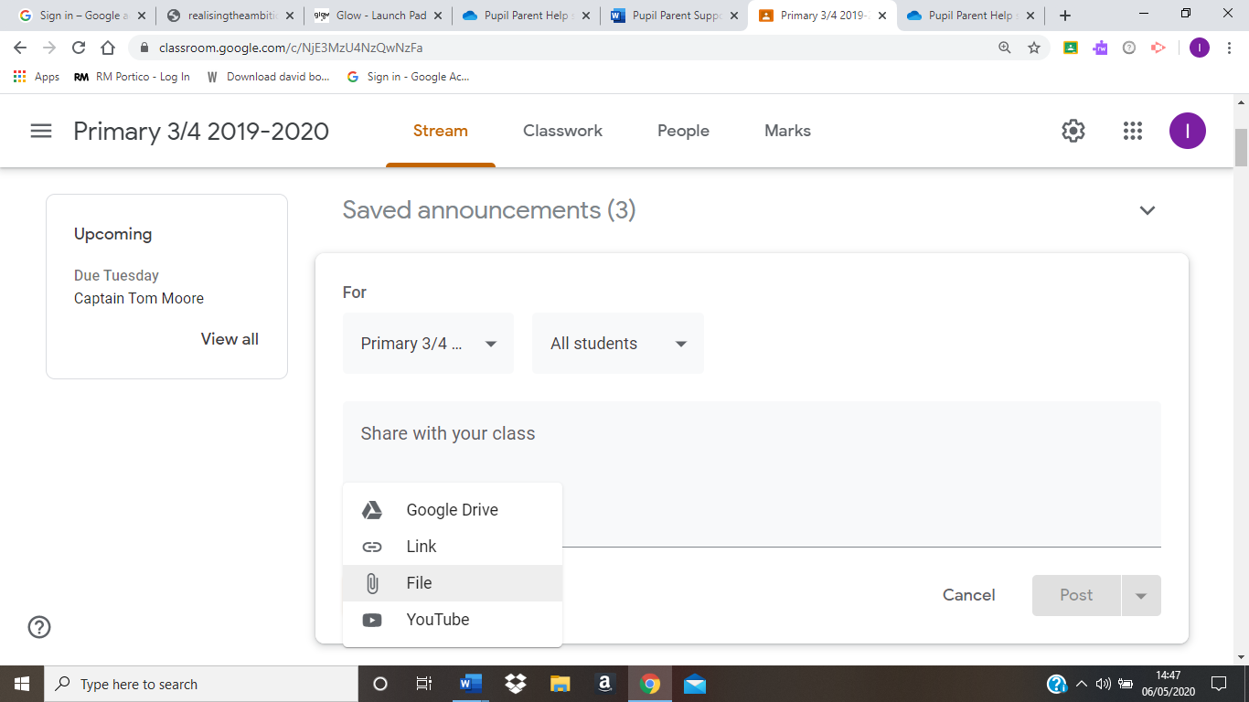

Click on Select files from your device
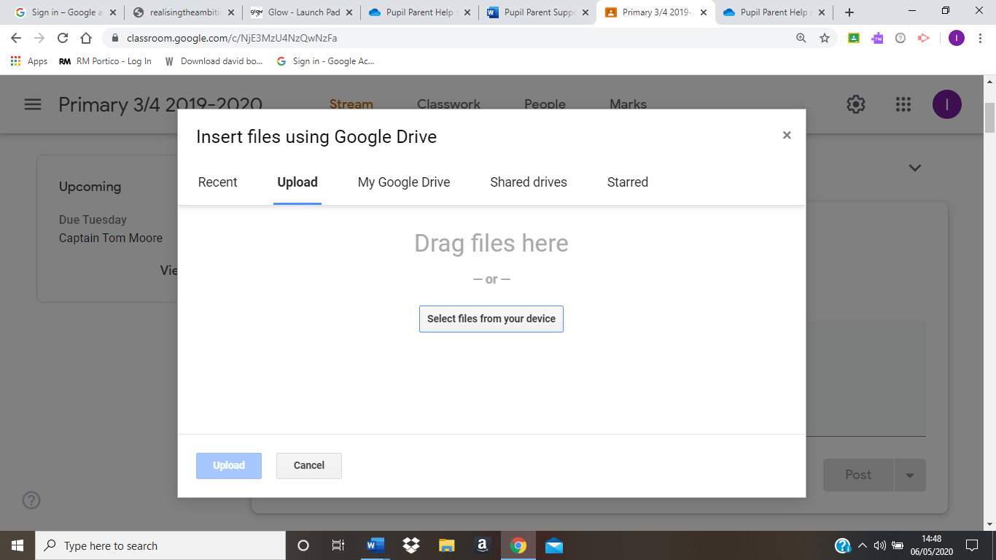

Select the folder where you have the file saved eg: Pictures
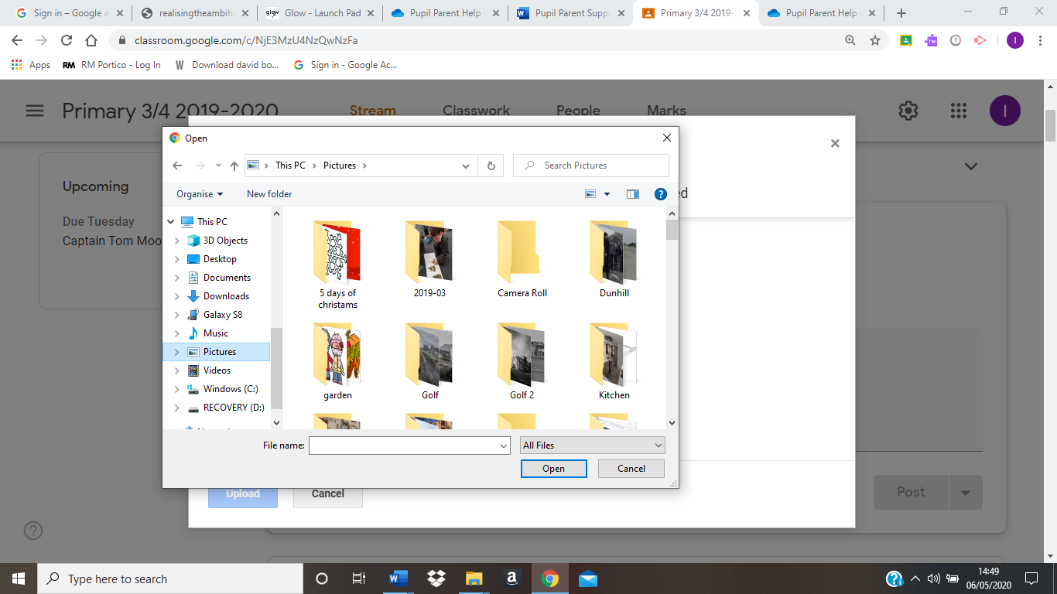

Select the file you want to upload to the Google Classroom
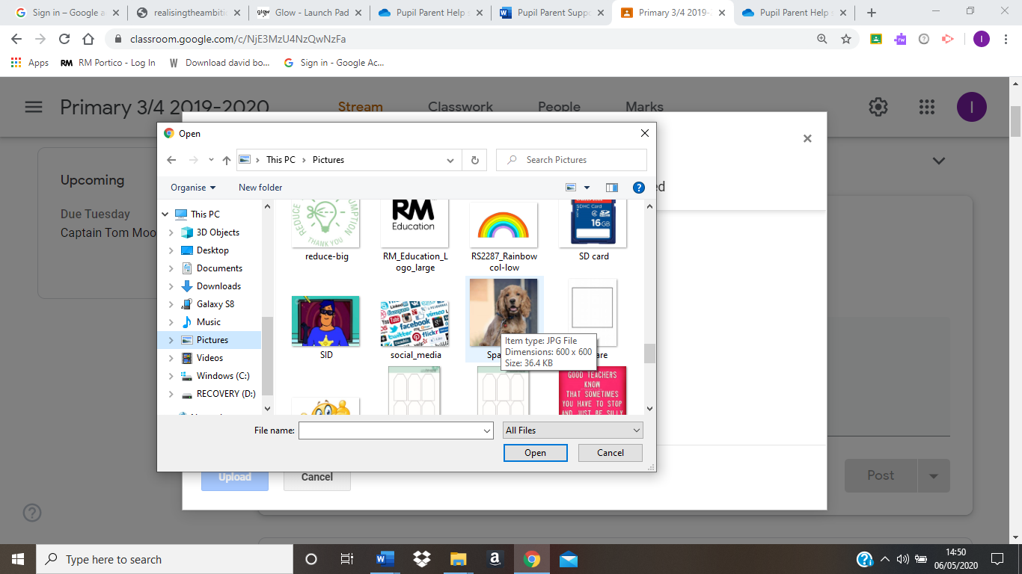

Your file name will apppear here once it has uploaded.
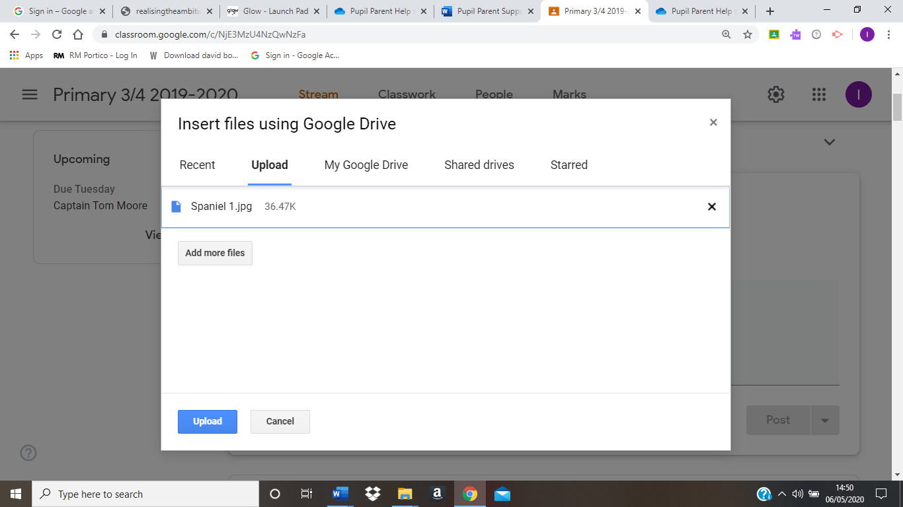
Click Upload and the file will be added to your post in the Stream.

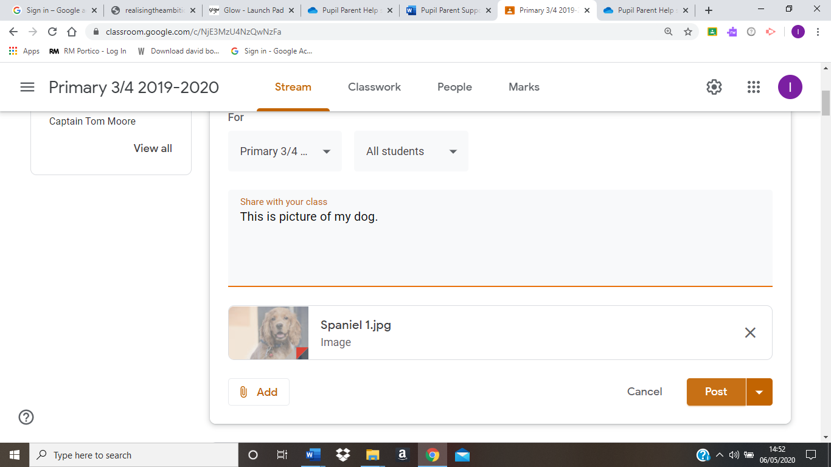
Finally, click Post.

