Google Classroom Pupil/Parent help sheet
How to upload photos to the Google Classroom

Log onto Glow and access the Google Classroom.
Connect you phone/camera to your device.
Go to the Classroom section and click on the Class Drive Folder
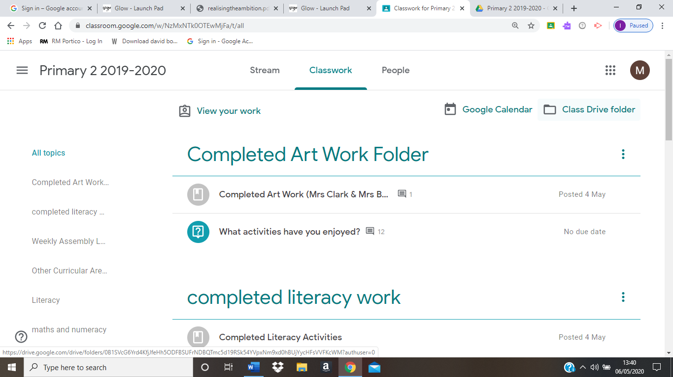

Select New
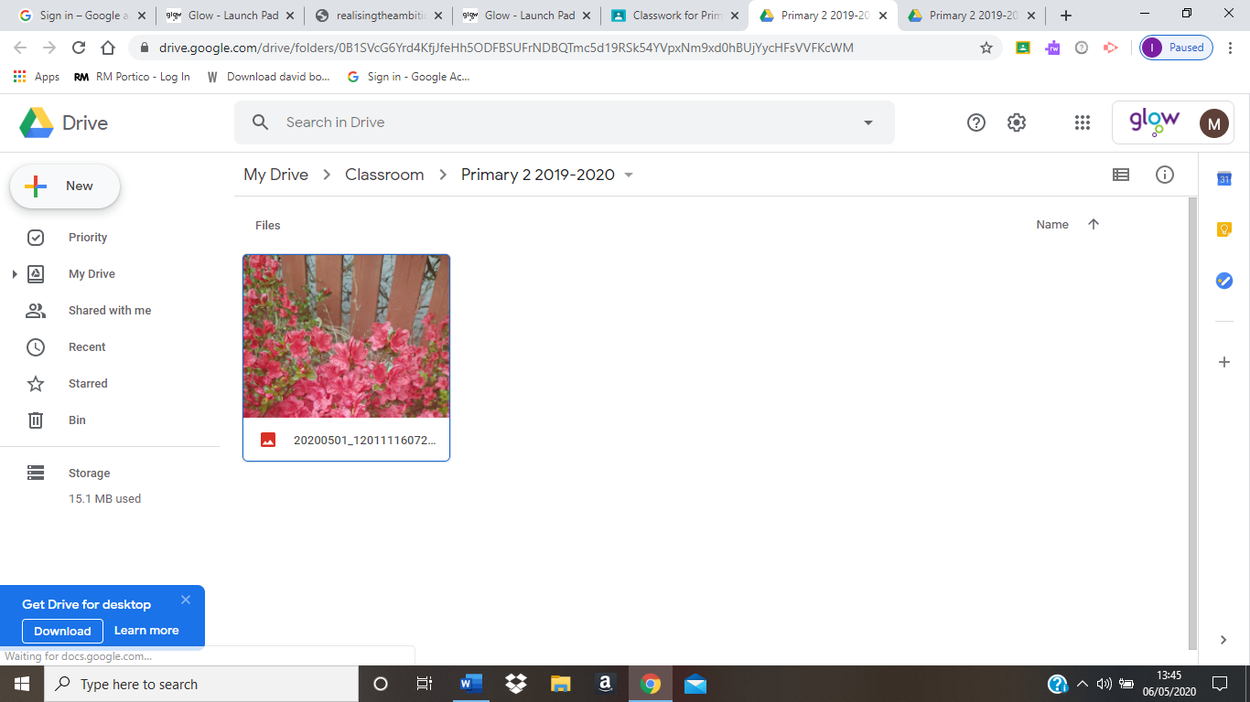

Then select File Upload
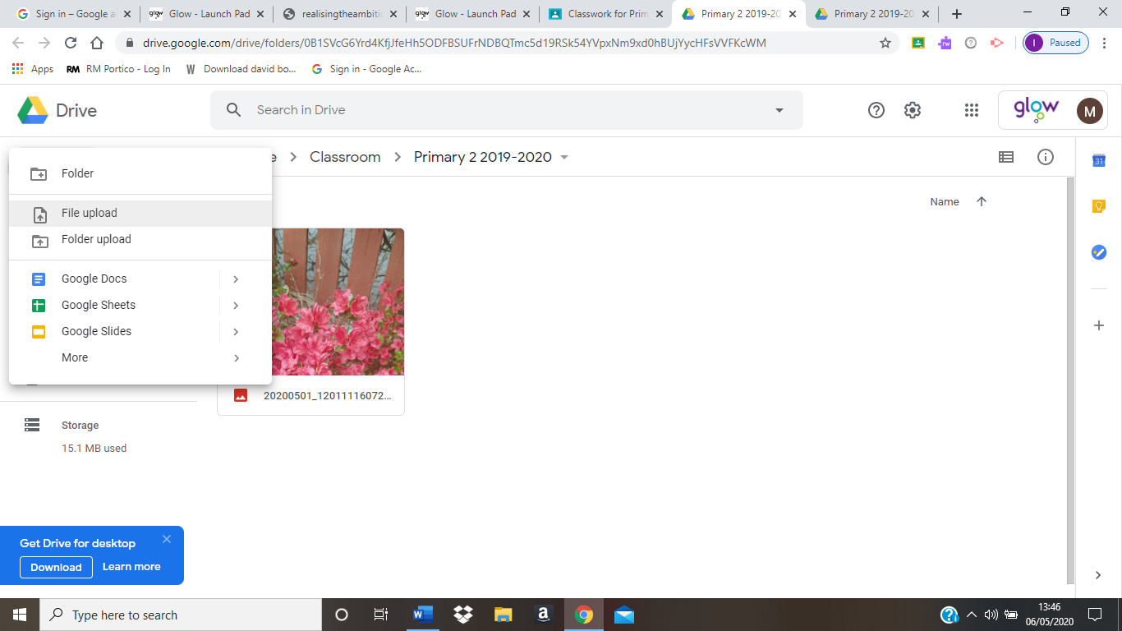

Search for your phone device here eg Galaxy S8 then click Phone then DCMI then Camera and select the photo you wish to upload
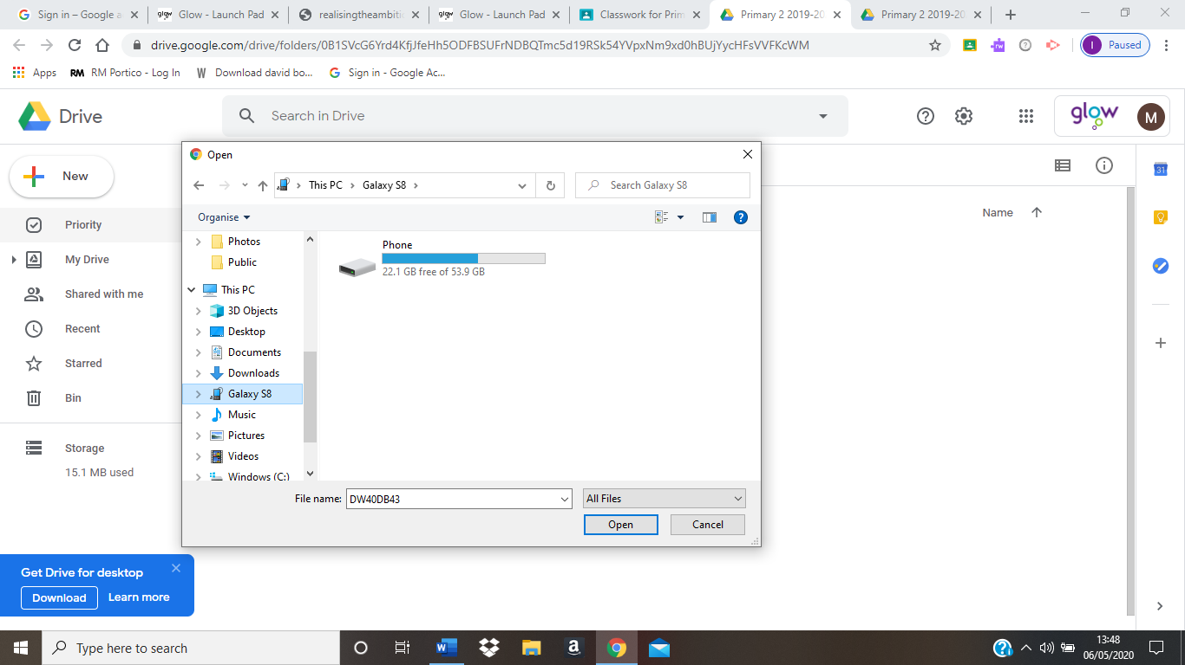

A message will appear telling you your file is uploading, after which it will appear in the Class Drive Folder.
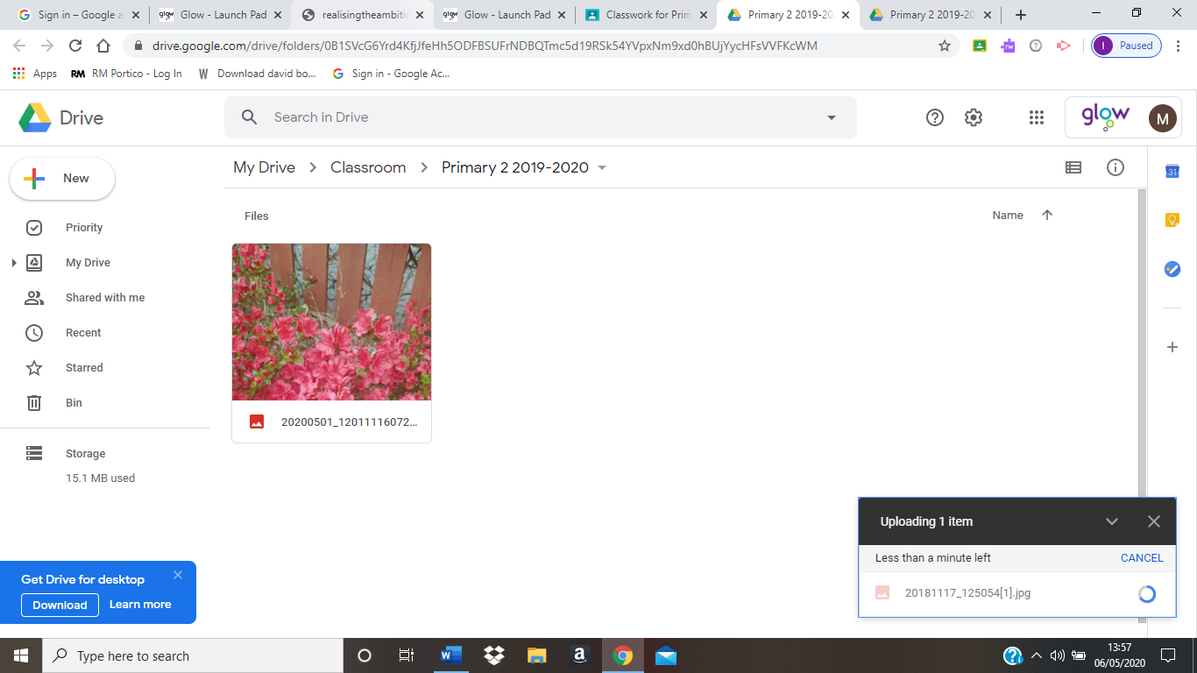
You can delete files from the Class Drive Folder by right clicking on the file and selecting Remove.
