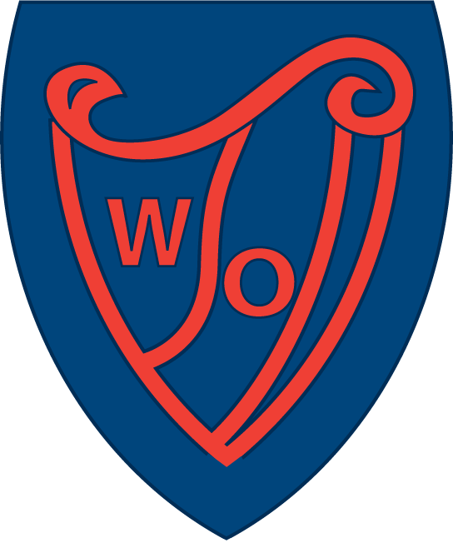
Curriculum for Excellence Class: Room 10, Primary 5

What are we learning this term? Term 4
Language & Literacy | Social Studies | Health & Wellbeing | Religious & Moral
This term we will focus on-  - Higher order reading strategies including determining importance, comparing, and synthesising.  - Active Spelling Strategies.  - Comprehension skills through our class novel, ‘The Boy in the Dress’.  - In writing, we will use Talk for Writing approaches and develop skills in discursive writing and poetry.  - In Languages, we will be practicing BSL focusing on how to sign body parts and clothes. We will also revise and consolidate fingerspelling.  - In Listening and Talking, we will create and present solo talks relating to our Social Studies topic, ‘European Excursions’. | This term we will focus on European Excursions. We will:  - Discover famous landmarks across Europe and learn why they are important.  - Build our atlas and map-reading skills, including locating different countries and cities.  - Learn about a variety of cultures and traditions, and how people live in different places.  - Compare countries to explore what makes each one unique.  - Find out about weather and climate across Europe, and how this affects daily life. | - In PE, we will develop skills in Athletics and Fitness.  - In Health and Wellbeing, we will look at the theme of being included, and our reflection of P5 and moving into P6.  - We will explore and discuss the ways in which physical activity and sport can lead to positive destinations beyond school.  - We will explore themes of growing up and relationships.  - In addition, we will also be further developing our understanding of children’s rights as a Rights Respecting School. | - Our focus this term will be on developing our understanding of caring and happiness through stories.  - We will explore ‘The Secret to Happiness and Success’ within the Sikh religion.  - We will also explore ‘The Words Reflect Ones Inner Self’ within the Islamic religion.
Numeracy & Mathematics | Technologies |     Science | Expressive Arts
This term, we will further develop our mental agility skills through Number Talks.  We will also be developing skills in-  - Shape.  - Angles and Symmetry.  - Expressions and Equations.  - Data Analysis.  - Measure. | We will be using our ICT skills to enhance our learning across the curriculum.  We will also:  - Develop our research skills through our Social Studies topic.  - In Craft and Design, we will create and build a famous European landmark.  - Develop skills in using Google Classroom.  - Develop skills in using Microsoft Office.  - Develop our iPad skills by using apps to research, present information, and create digital work. | In science, we will be focusing on Changing Materials, investigating evaporation and filtration.  - We will explore how substances can change to make new substances and describe how they are different.  - We will learn about the properties of different materials and describe how they can be utilised for different uses.  - We will take part in practical activities to separate simple mixtures and learn what helps substances dissolve more easily or quickly, linking this to everyday life. | - In Art, we will develop skills in 3D clay modelling.  - In Drama, we will use Talk for Writing as a stimulus for performance.  - In Music, we will be developing our music skills through Charanga.  - We will also explore European music and dance through our Social Studies topic.

Language & Literacy | Social Studies | Health & Wellbeing | Religious & Moral
- Read for pleasure!  - Read your class reading book every night. Talk to a parent or carer about what you are reading.  - Write a book review, giving your opinion on your book.  - Practise your spelling words using active spelling strategies & word games.  - Practise presenting your solo talk to a family member. | - Research and create a PowerPoint on a famous European landmark.  - Discuss with your friends and family places they may have visited in Europe, or places they may want to visit and why.  - Create a poster of places you have visited or would like to visit in Europe. | - Discuss your year in P5 with someone at home and reflect.  - Create a set of rules for the MUGA.  - Go outside and play!  - Make up a new game and explain the rules to friends. | - Visit the library and find out some interesting facts on Islam and Sikhism.  - Share your learning with your family.  - Make a poster on how you demonstrate you are caring and share with your class.
Numeracy & Mathematics | Technologies | Science | Expressive Arts
- Go on an angle hunt in your garden.  - Measure and weigh out ingredients for a recipe.  - Practise all multiplication tables and quickfire number facts recall every night.  - Design your own Maths board game.  - Practise your maths skills on Topmarks or Sumdog. | - Create a PowerPoint on a European country.  - With the help of an adult, research and cook a European dish.  - Use the microphone function on Google Docs to write a story.  - Discuss internet safety and social media with people at home. What are their views?  - Visit ‘Scratch’ and practise your coding skills.  - Use Google Classroom. | - Visit the Science Centre.  - With an adult, find things at home which dissolve.  - With an adult, try this bath bomb experiment-  https://edu.rsc.org/primary-science/making-bath-bombs/4011691.article | - Research historical and present European artists who have had an impact on the world today.  - Visit a gallery or museum.  - Choose a European artist and try to create a picture in the same style.
Home Learning Opportunities

Here are some activities for you to try at home!

