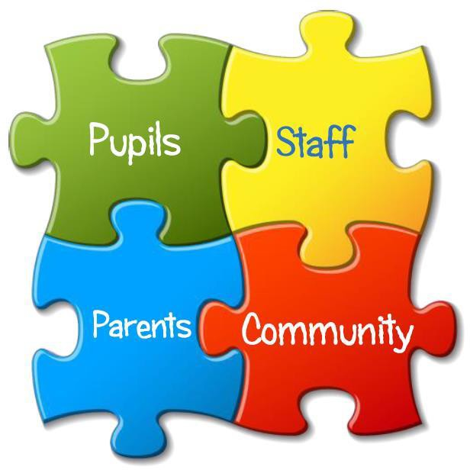






Wester Overton Parent Council meeting minutes
13th January 2026
Present: June Moir, Laura Ann Bailkoski, Emma Beaumont, Alison Chand, Stephanie Chillingworth, Sarah Hamilton-Reilly, Lisa Hendry (chair), Mary Ann Hutchison, Karen Kelly.
Apologies: Sarah Murray, Rebekkah O’Flaherty, Jonathan Orr, Amy Piper, Kirsty Redfern, Gillian Storrie.
Date of next meeting: Thursday 19th February 2026.
Welcome and apologies
Minutes from previous meeting and matters arising
June’s news
June gave the following news from the school:
Enrolments
At present we have 48 enrolments, which would create a 13-class structure of 1,2, 2/1, 2, 3, 3,4, 4/5, 5, 5/6, 6/7 & 7. This is likely to change as we move through the next 2 terms.
PVGs
Head teachers have been advised by the AHDS that they should only have PVG’d parents helping at discos and events, even walking children to a venue, so we would ask that anyone helping completes a PVG asap as these can take such a long time to be processed.
Staffing
Mrs Hannah is due to return soon, but I will update you as soon as this is confirmed. We have been informed we will have a peripatetic support assistant, but no date has been confirmed. Miss Halford has now left and Mr McCracken will be in P2 for the rest of the session.
Attachment
We have now received the 3rd ‘Jigsaw Piece’ in our attachment accreditation. We were allocated over £5000 for sensory equipment which has now been ordered and has started to arrive.
Pupil Voice Groups
We have invited different people from organisations and across the community to speak to our pupil voice groups to give our children a better understanding of how the community works together, This month we had Carla Sommerville from school meals and Sandy and Laura from Fairtrade. The visits have been well received by pupils, who have been very articulate in expressing their views within the sessions.
Playground
We’ve had a few issues regarding the playground due to the weather. The field has been flooded due to the amount of rain over the winter months, and our MUGA remained closed for a week due to ice. We are aware of the issues and hope to open the field back up soon.
Mobile phone policy
Parent Council to add views and give feedback [parents attending indicated that they were happy with proposed content].
Parent Councils
Connect will be changing. Information has been sent out to PCs to update to the new platform.
200 Club update
- Draw took place for December. Winners as follows:
£40: No. 102, Melissa McGillvray
£20: No. 136, Kat Rae
£20: No. 84, Rebekkah O’Flaherty.
- Draw also took place for January. Winners as follows:
£40: No. 126, Peter O’Brien
£20: No. 102, Melissa McGillvray
£20: No. 15, Mary (Moira) Meiklejohn.

AOB

- Query raised about children’s target books – June explained that they come from skills frameworks, which children discuss a lot at school. Parent Council indicated preference for target books over snapshot jotters.

Next meeting date: Thursday 19th February 2026.

