



**Cost of the School Day Policy**

**June 2024**

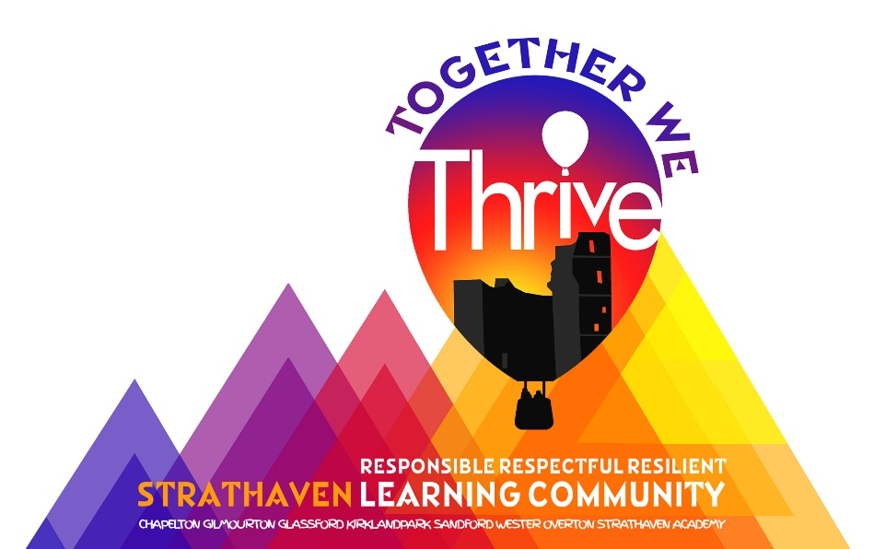

At Wester Overton Primary School we recognise the need to reduce the Cost of the School Day for all our pupils and particularly for our pupils who are already experiencing poverty. We examine the School Day through the following headings; Uniform, Travel, Learning, Friendship, School Trips, Eating, Fun, Clubs and Home learning.

**Uniform**

We ask that uniform is worn by all children to ensure equity and remove stigma. Our current uniform is grey skirt or trousers or blue tartan pinafore, blue polo shirt or blue shirt and tie and blue sweatshirt, cardigan or jumper. Families can purchase uniforms from Ayrshire Schoolwear (<https://ayrshireschoolwear.com/>) Scotcrest Uniforms (<https://scotcrestschools.co.uk/> ) or My Uniform (https://myuniform.com). We **do not** insist on badged sweatshirts/polo shirts, and supermarket plain alternatives are perfectly acceptable in school colours. We also run a recycled uniform service, where uniforms can be returned to the school when outgrown. There are then laundered and distributed free of charge. We also hold a supply of coats and jackets which are also distributed free of charge. Information on clothing grants can be found here:

https://www.southlanarkshire.gov.uk/FreeSchoolMeals

**Travel**

The majority of our children travel to school on foot. Transport is provided for those who live more than 1 mile away by the Local Authority. We are a Cycle Friendly school and encourage cycling to school by providing Bikeability training for all P5 and 6 pupils. We have cycle storage on-site, and run a bike recycling service, where outgrown bikes can be donated to be allocated to another family for free. Pupils who do not have a bike will be provided with one free of charge.

**Learning**

Children at Wester Overton Primary School do not need to pay for any core learning materials. All materials, including basic stationery, are provided and young people do not need to bring their own equipment. We currently have a procedure for young people to borrow equipment if they need it for home learning and provide any materials required (e.g paper/ books/craft equipment). Children who do not have PE kit are provided with this from our kit store. Travel for all swimming /sports activities is paid for from the school fund.

**Friendships**

We ensure that any pupil experiencing poverty-related bullying has a way of reporting this in confidence. We teach young people about poverty related issues as part of our anti-bullying programme and regular Health and Wellbeing Curriculum. In addition, we are a Rights Committed School and incorporate poverty related issues into our assembly programme. We intend to gather the views of our young people and families on the Cost of the School Day and involve them in decision making around this.

**School Trips**

We are mindful that school trips can be an unwelcome cost for many families. Our trips are planned by linking appropriate field trips to class learning and make our pupils’ learning experience more real and enjoyable. All day trips are free of charge, with activities and travel paid for, and we do not allow any children to take spending money.

**Eating at school**

In 2023-2024 we had 9 % of pupils who were in receipt of Free School Meals. We are aware that there may be a stigma associated with a free lunch and we try to reduce this by using the cashless Parent Pay system and widely publicising information regarding free school meals. We estimate that approximately 90% of pupils who are eligible for Free School Meals take up their entitlement. Families are regularly encouraged to apply for Free School Meals. Information can be found here:

https://www.southlanarkshire.gov.uk/FreeSchoolMeals

**Fun Events**

Wester Overton Primary School recognise that events planned for enjoyment can actually put added pressure on to families. We currently look carefully at attendance and participation in these events in order to see if there are any poverty-related patterns that require action.

As with school trips, our Fun Events e.g. the pantomime trip to the theatre, are planned well in advance and are free to reduce pressure on families. We currently fund raise only once a year through online Christmas fundraising, where families can chose which items they would like to buy/ contribute to without the financial public pressure of attending a Christmas Fair. We understand that not all families are able to contribute. We limit fundraising to two charities each year; our Macmillan Coffee morning and the local foodbanks.

Dress down days are always free and limited to one per term to minimise poverty related bullying and stigma. We are mindful that families living in poverty may find it a struggle to send children to school in casual or party clothes.

We are aware that many families in our community are struggling financially. We invite families to contribute to hampers and donate Christmas gifts anonymously. These are then distributed to families in our school community.

**School Clubs**

At Wester Overton Primary School we do not charge children to take part in any of our clubs. Some clubs may require specific equipment and we help families who may not be able to afford these by providing all equipment. Transport to events is free and paid for by the school fund.

**Home Learning**

We try to reduce the cost of learning at home as much as possible by lending equipment, providing craft materials and providing computer access during break times. We do not set formal homework at Wester Overton, and instead families are provided with a home learning grid with learning opportunities to be covered over the term ahead. Families who do not have access to a suitable digital device for home learning can be leant one by the school. Homework is not linked to our Relationships Policy.

We are very clear that the Cost of the School Day is an area that requires constant vigilance and will not be ‘fixed’ by any one action.

The [Money Matters Advice Service](https://www.southlanarkshire.gov.uk/site/scripts/directory_search.php?directoryID=32&keywords=money+matters+advice+service+-&search=Search) is a free and confidential service that helps South Lanarkshire residents claim benefits and deal with debt https://www.southlanarkshire.gov.uk/info/200150/managing_your_money/1850/money_matters_advice_service