**Head Teacher Welcome**

I would like to extend a very warm welcome back to all our children, families and staff. I have enjoyed welcoming our new P1s and new starts to our school and I am pleased to say all our children are settling in well to new classes and routines. I am very excited to start this new session with a quarterly newsletter which I hope will keep you informed about what is happening in our school and to celebrate our achievements. *Kirsty McKellar HT*

**Drop Offs and Pick Ups**

Before 9am please drop off your child at the children’s entrance which is at the top of the ramp at the front of the building. If your child has arrived after 9am please enter through the main entrance to the school which is shared with High Mill Primary School. Please pick up your child at 3pm at the children’s entrance. If you are picking up your child during the school day, please let the office know you have arrived and we will bring your child to the children’s entrance in order to keep the same routine for your child/ children.

If someone different is coming to collect your child, please call the school office to set up a safe password to collect your child.

If your child comes to school in a bus/taxi please let the company know if your child is absent or going to an appointment.

**Victoria Park School**

**Summer 2024 Newsletter**

Victoria Park School

Market Road

Carluke

ML8 4BE

01555 750591

office@victoriapark.s-lanark.sch.uk



@vps

https://blogs.glowscotland.org.uk/sl/victoriaparkprimaryschool

Contact us

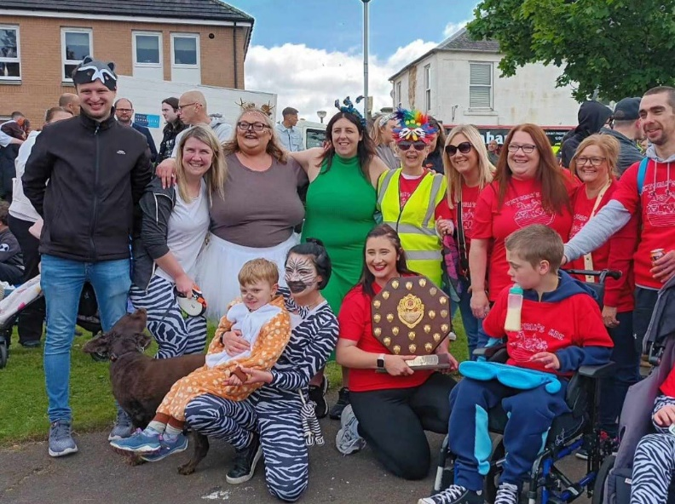

**Carluke & District Gala Day June 2024**

I am excited to report that Victoria Park School won **1st** place with “Victoria’s Ark”. A huge thank you to our Friends of Victoria Park Parent Council and staff who worked tirelessly in the background to ensure our ark was ready to set sail on the day. The weather at the start of the parade was certainly fitting for our theme! Thank you also to all the children, families and staff who walked in the parade and supported us on the day. Our Gala maid Chantelle made everyone very proud.

**Attendance**

It is our aim for children to attend school as much as possible however we are aware there will be occasions your child is unable to attend. Please let the school office know before 9am if your child is unwell. If your child has slept in, please bring your child into school if you can. This keeps your child in the routine of waking up and coming to school. If you are coming in late let us know as soon as possible and we can ensure we have lunch ordered for you child.

If you are unable to get through by telephone, please leave a message. If your child has any appointments, please let the office know in advance.

**Medication and Items for Personal Care**

Please complete an Administration of Medication form if your child requires medication at school. Medicine should be labelled with your child’s name and dob from the pharmacy on the box and on the items inside if possible.

Please do not add medicine to children’s drinks unless an Administration of Medication form is completed.

It is useful to always have at least a week’s worth of pads and wipes sent in at the start of the week. Children are changed twice per day.

**Clothing**

As you will be aware our Scottish weather can be so changeable and so I would ask that children are dressed for going outside depending on the forecasted weather. We do try to get outside in all weathers. For younger children especially it is always useful to have a change of clothes in their bags in case they get wet or dirty.

We would welcome children brining in rain suits and wellies for going outside in the rainier weather.

Many children don’t like to wear shoes indoors and so I would ask that children wear shoes that can be put on quickly in the event of an emergency.

**Staffing 2024-2025**

**A full list of staffing is available on the school website**

**Head Teacher** – Kirsty McKellar

**Acting Depute Head Teacher** – Leeanne Inglis

**Principal Teachers** – Elspeth Blair/Alison Hawthorn

**Team Leaders** – Pauline Newns / Donna Melvin/ Laura Drysdale

**Room 1 –** Margaret Duffy **Room 5** – Carene Taylor/Elspeth Blair

**Room 2 –** Jen Kelso **Room 6** – Louise Hayley-Murray

**Room 3 –** Michelle Harris **Room 7** – Michaele McIntosh

**Room 4 –** Annie Baird **Room 8** – Leeanne Inglis/Alison Hawthorn

\**Children call staff by their first names.*

**Celebrating Achievements**

Very soon we will be introducing certificates for children’s achievements made at home. If you have any achievements that you would like to share please e-mail the school office and if you have any photographs please attach these too! Achievements can be anything from brushing teeth to joining a club! I am hoping there will be lots of summer holiday pictures so please send in what you can and we will award your child with a certificate to celebrate them being the best they can be!

**Important Dates**

**Meet the Team**

Tuesday 3rd September

**P1/New Starts Settling In Reviews**

Wednesday 11th and Thursday 12th September

**September Weekend**

Friday 27th and Monday 30th September

**October Break**

Monday 14th – Friday 18th October

Children return Monday 21sr October