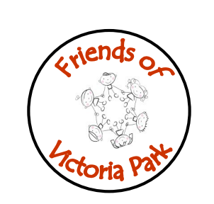
Victoria Park
Friends of
Victoria Park
Friends of
Victoria Park
Friends of
Victoria Park
Friends of

Tuesday 30th May 2023
Attending | Apologies
Lorna Baillie  Donna Bittles  Victoria McLeod  Lauren Thomson  Anna Wright  Laura Brown  Murray Anderson  Kirsty McKellar DHT  Callum Taylor Active Schools | Sally Sneddon
Agenda Item | Notes and Actions
Talk from Callum Taylor Active Schools | Callum spoke the group about his service and what they are currently offering the school.  Logan Kidd (Active Schools Inclusion Development Officer) is able to offer our school every Monday to help develop playground play.  Logan Kidd is supporting the school in running a sports day next week.  Logan Kidd has secured around £2000 of sports equipment for the playground. The equipment was chosen in conjunction with the PT and DHT.  Callum gathered information from parents about what they already attend and what are the barriers to attending classes.  Callum noted that he is hoping to run ASN classes at Carluke Leisure Centre over the summer. These would be “Stay and Play” sessions.
Gala Day | Gala Day is on Saturday 10th July.  T-Shirts and Banners have been created. Mickey ears have arrived.  Lorna to look into acquiring bubble guns for children to use.  Laura attended the Gala Meeting and fed back on this.  Kirsty to create a leaflet with further information about the Gala for parents.
Budget | Lorna reimbursed parents for items purchased at Christmas, Halloween and Gala Day.

Next Meeting 6th June 2023

