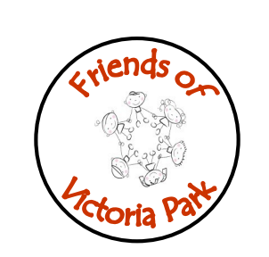
Victoria Park
Friends of
Victoria Park
Friends of
Victoria Park
Friends of
Victoria Park
Friends of

Thursday 4th May 2023
Attending | Apologies
Sally Sneddon  Victoria McLeod  Lauren Thomson  Anna Wright  Laura Brown  Murray Anderson  Liz Coomber HT  Kirsty McKellar DHT  Chris Curtis SLT | None
Agenda Item | Notes and Actions
Talk from Speech and Language Therapy | Chris Curtis spoke about the speech and language service and their input into the school.  Christ Curtis gave out his details which will also be shared on facebook so parents can contact him and his colleague Jen.
Gala Day | Gala Day is on Saturday 10th July.  T-shirts and Mickey ears have been ordered.  Laura/Kirsty to find out when next Gala meeting is.  Discussed what decorations will be used.

Next Meeting 30th May 2023

