Victoria Park School
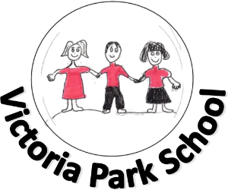

Emotion Works
Parent Guide

What is Emotion Works?

At Victoria Park school we have a whole school approach to learning about emotional awareness and regulation called Emotion Works. This ensures we are using a common language and approach across the school to teaching emotional literacy. Emotion Works is an educational programme which puts learning at the heart of emotional health and wellbeing.
Emotion Works is ‘home grown’ in Scotland so is very well aligned to the Scottish Curriculum and related policies such as “Getting it Right for Every Child” (GIRFEC) and the national inclusion agenda. There is a strong overlap with other agendas and initiatives locally such as South Lanarkshire Council’s “Attachment Strategy”. The mental health and wellbeing of our children has never been so important which is why we are ensuring all children learn about emotional awareness. The resources and ideas within Emotion Works are able to be adapted accordingly to meet the needs of children with severe and profound learning needs.
How Can it Help You at Home?
As children’s first teachers we value the enormous impact parents have in a child’s education. You may wish to use the cogs to support your child in understanding their emotions. If your child is showing distressed behaviours and struggles to regulate their emotions Emotion Works can give you a great structure to work through with your child what happened and how they were feeling as well as make strategies to support them in the future.
Emotion Works is taught through different “cogs” that represent a different part of emotional literacy. Below is a guide to the cogs and how school and home can use them to teach children about emotional awareness and regulation.
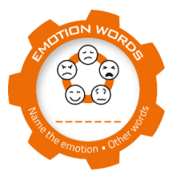
The orange cog represents the names of emotions. Choose an emotion to focus on.

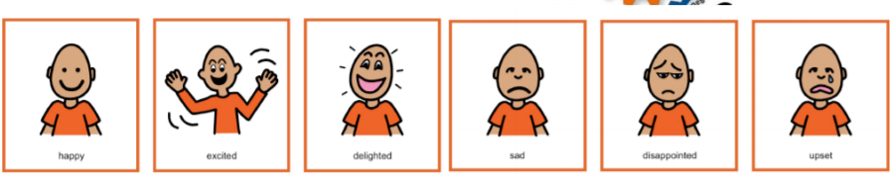

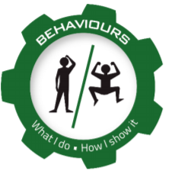
The green cog represents how your child might show through their behaviour how they feel. How does your child express the emotions they are feeling?

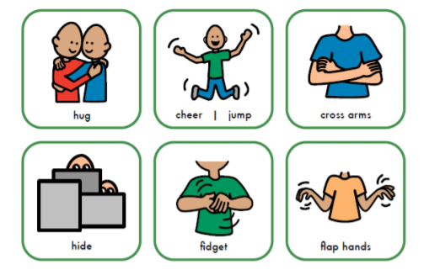

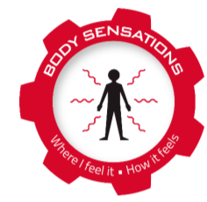
The red cog represents the physical symptoms of how your child feels that you can’t see on the outside. Where and how does your child feel this emotion?

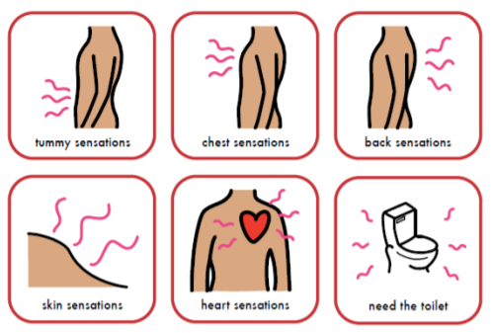

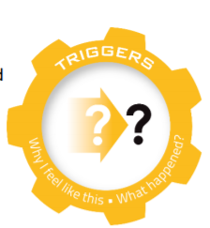
The yellow cog represents what makes your child feel an emotion. This can be positive and negative.

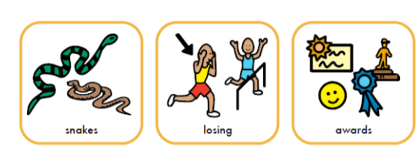

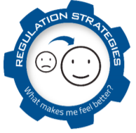
The blue cog is about what can make your child calm or make them feel better. It is great for your child to be able to self-regulate their emotions and have their own strategies for this.
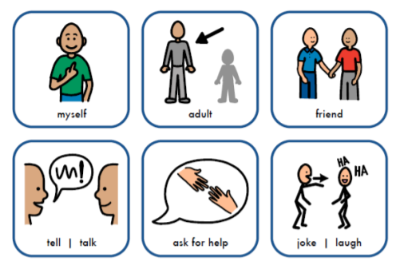

If you would like to learn more about how Emotion Works can help your child please do not hesitate to contact:

Alison Hawthorn (Principal Teacher)
&
Kirsty McKellar (Depute Head Teacher)

