1. **Commitment**

Udston Primary School will refer to this Outdoor Play and Learning (OPAL) Policy in all decisions which affect children’s play. We are committed to providing the strategic and operational leadership needed to provide and maintain quality play provision for all our children.

1. **Rationale**

At Udston Primary School, we believe that all children need opportunities to play which allow them to explore, manipulate, experience and affect their environment. We acknowledge the UN Convention on the Rights of the Child, especially Article 31, and supports a child’s right to play. We believe play provision should be welcoming and accessible to every child, irrespective of gender, sexual orientation, economic or social circumstances, ethnic or cultural background or origin, or individual abilities.

We have a Shared Vision of what our school should be like for our children, parents/carers and staff. Our School Motto is LEARN TOGTHER ~ LAUGH TOGETHER ~ACHIEVE TOGTHER. We all share the same values of TRUST, TEAMWORK, RESPECT, EFFORT and KINDNESS. Our Shared Vision is supported by 12 Aims which underpin everything we do and influence the decisions we make:

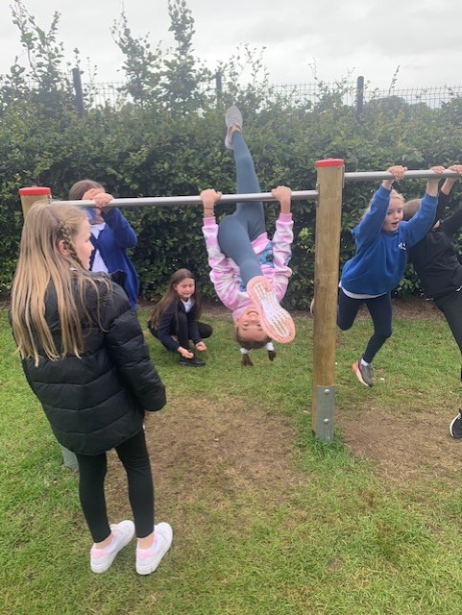

* Friendly & Inclusive Ethos
* Nurturing Positive Relationships
* Safe & Happy Children
* Health & Wellbeing
* Excellence in Learning & Teaching
* Creativity & Innovation
* Support & Challenge
* Equity
* Maximising Attendance & High Attainment
* High Standards of Behaviour
* Celebrating Success & Achievement
* Engaged Families

The OPAL Programme rationale is that:

“… *better, more active and creative playtimes can mean happier and healthier children, and having happier, healthier, more active children usually results in a more positive attitude to learning in school, with more effective classroom lessons, less staff time spent resolving unnecessary behavioural problems, fewer playtime accidents, happier staff and a healthier attitude to life.”*

The OPAL rationale links purposefully and meaningfully with all 12 of our Shared Aims, as well as our School Values, and will complement what we are trying to achieve for our children, parents/carers and staff.

1. **Definition and value of play**

The definition of play is widely discussed in educational research. As a school, we define play as an activity which is:

* + - 1. **Intrinsically motivated**
      2. **Entails active engagement**
      3. **Results in joyful experience**

(Pasi Sahlberg, 2020)

Play is extremely powerful. There are multiple benefits of play which come through in educational research, some of which include the development of the following skills:

* **Creativity**
* **Collaboration**
* **Communication**
* **Problem-solving**
* **Curiosity**
* **Risk-taking**
* **Wellbeing**
* **Executive Functioning (working memory, flexible thinking, self-control)**

(Pasi Sahlberg, 2020)

We also believe that play:

* is critical to children’s health and wellbeing, and essential for their physical, emotional, social, spiritual and intellectual development.
* enables children to explore the physical and social environment, different concepts and different ideas.
* enhances children’s self-esteem and their understanding of others through freely chosen social interactions, within peer groups, with individuals, and within groups of different ages, abilities, interests, genders, ethnicities and cultures.
* requires ongoing communication and negotiation skills, enabling children to develop a balance between their right to act freely and their responsibilities to others.
* enables children to experience a wide range of emotions and develop their ability to cope with these, including sadness and happiness, rejection and acceptance, frustration and achievement, boredom and fascination, fear and confidence.
* encourages self-confidence and the ability to make choices, problem solve and to be creative.
* maintains children’s openness to learning, develops their capabilities and allows them to push the boundaries of what they can achieve.

Scotland’s National Outdoor Play & Learning position statement states that outdoor play and learning is ‘life-enhancing’, improves learning and is vital for children to thrive in health, wellbeing and development. There have been a number of Scottish Government policies and guidance over recent years which set out national expectations and continue to highlight outdoor play and learning experiences for children as being key to the provision of high-quality learning. These include:

* Scotland’s National Improvement Framework (2022)
* A Report by HM Inspectors: ‘Successful approaches to learning outdoors’ (2022)
* Scotland’s National Performance Framework (2018)
* The Play Strategy for Scotland: Our Vision (2013)
* The Children and Young People (Scotland) Act (2014)
* Getting it Right for Every Child (2008)
* Curriculum for Excellence 3-18 (2008)

A 2022 report by HM Inspectors states that schools should be *“providing regular, frequent, enjoyable and challenging opportunities for all children and young people to learn outdoors”.* Our commitment to embedding the OPAL Programme ensures our children will have access to high-quality outdoor play and learning experiences every day.

1. **Aims**

In relation to play, we aim to:

* provide **support and challenge** by ensuring our play settings provide a varied, challenging and stimulating environment.
* have **safe and happy children** who are allowed to take risks and use a common-sense approach to the management of these risks and their benefits.
* create a **friendly and inclusive ethos** by providing opportunities for children to develop their relationships with each other.
* **nurture positive relationships** which enable children to develop respect for their surroundings and each other.
* put children’s **Health and Wellbeing** at the core through the development of their physical, emotional, social, spiritual and intellectual development.
* develop **creativity and innovation** by providing a range of environments that will encourage children to explore and play imaginatively.
* Provide **excellence in learning and teaching** which raises **attainment** through a range of environments which will support children’s learning across the curriculum and learning about the world around them.
* ensure **equity** by providing equal access to high-quality play opportunities for everyone. This includes the provision of suitable outdoor clothing and footwear.
* have **high standards of behaviour** through high levels of engagement in play experiences which promote independence and teamwork within children.
* **maximise attendance** by building emotional and physical resilience.
* encourage children torecognise and **celebrate their success & achievements** during play experiences, with a focus on the development of intrinsic motivation rather than external rewards and recognition.
* **engage families** in outdoor play and learning by sharing photographs of children’s learning experiences and inviting families to attend ‘Stay & Play’ sessions after school.

1. **Rights**

Our school recognises the UN Convention on the Rights of the Child, which includes *the right to play, recreation and leisure* (Article 31) and the *right of children to be listened to on matters important to them* (Article 12). We acknowledge that we have a duty to take these rights seriously and listen to children’s views on their play. We are committed to Getting it Right for Every Child and use the Wellbeing Indicators during outdoor play and learning experiences through our child friendly SHANARRI Family approach:

* 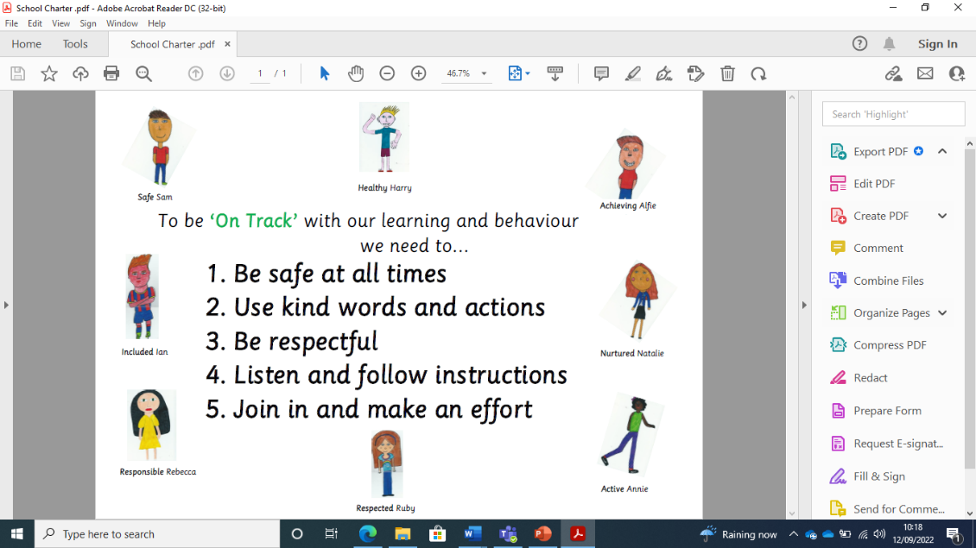Safe Sam
* Healthy Harry
* Achieving Alfie
* Nurtured Natalie
* Active Annie
* Respected Ruby
* Responsible Rebecca
* Included Ian

1. **Benefit and Risk**

*‘Play is great for children’s wellbeing and development. When planning and providing play opportunities, the goal is not to eliminate risk, but to weigh up the risks and benefits. No child will learn about risk if they are wrapped in cotton wool.’*

Managing Risk in Play Provision: An Implementation Guide (2012)

Udston Primary School will use the Health and Safety Executive guidance document *‘Children’s Play and Leisure – Promoting a Balanced Approach’* (September 2012) as the core value statement informing its approach to managing risk in play. In doing so, we will adopt a risk-benefit approach as detailed in *‘Managing Risk in Play Provision’: An Implementation Guide.*

Risk-taking is an essential feature of play provision, and of all environments in which children legitimately spend time at play. Play provision aims to offer children the chance to encounter acceptable risks as part of a stimulating, challenging and managed play environment. In the words of the play sector publication ‘Best Play’, play provision should aim to *‘manage the balance between the need to offer risk and the need to keep children and young people safe from harm’*.

Risk-Benefit Assessment is an easy-to-use method to support play providers to balance the benefits of an activity with any inherent risk, taking into account the risks, whilst recognising the benefits to children and young people of challenging play experiences. This approach is supported by the Health and Safety Executive (HSE) and the UK Government. Learning how to carry out a Risk-Benefit Assessment is not only important for our children whilst playing in school, it is also an invaluable life-skill which we hope our children will use when out in the wider community, particularly as they get older.

In addition to standard risk-benefit assessments, we will practice dynamic risk management with children, encouraging them to identify and manage risks in an environment where adults are present to support them.

**A copy of the full H&SE Managing Risk Statement can be found in Appendix 1 of this Play Policy.**

1. **Supervision**

The law requires that children in school have supervision, however, for primary school playtimes there are no stated ratios. We recognise OPAL’s three models of supervision: Direct, Remote and Ranging. Except for new children in the early weeks of Primary 1, or children with Additional Support Needs, we do not believe direct supervision is possible or beneficial. Supervision will take remote and ranging models, so that children can quickly find an adult, and adults can patrol large sites to gain an awareness of the kinds of play and levels of risk likely to be emerging.

During playtimes and lunchtimes, our playground will be supervised by the Play Team consisting of Support Staff and members of the Senior Leadership Team. All adults in the Play Team spread out between the different zones of the playground, ensuring they are visible to children and have a good view of the play happening within their zone. The zones of our playground requiring adult supervision include:

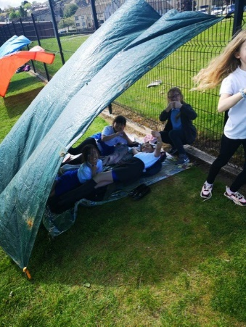

**Dining Hall Side**

Jean Fisher

Diane Cummings-Saunds

Ailsa McMillan

Irene Mullen

Fiona Goulding (lunchtime)

**MUGA Side**

Rebecca Turnbull

Margaret Burns

Nicki Jamieson

Noreen Sneddon

Fiona Goulding (playtime)

Janitor

**Tumble Bars/Extension**

Maria Warrener

Elaine Orr

1. **The Adult’s Role in Play**

The school will help children maximise the benefits they can gain from play by the provision of trained staff who are informed by and work in accordance with the Playwork Principles. Staff will use and refer to these principles when appropriate interventions are needed, and ultimately will strive for facilitating an environment that nurtures children’s self-directed play.

The playworker's core function is to create an environment that will stimulate children's play and maximise their opportunities for a wide range of play experiences. A skilled and experienced playworker is capable of enriching the child’s play experience, both in terms of the design and resources of the physical environment, and in terms of the attitudes and culture fostered within the play setting. Playworkers are a channel of access to new materials and tools, and they can act as a stimulus to children to explore and learn. They are also available to participate in the play if invited. For example, adults might assist children during Den Building activities, or help problem-solve in the Construction Zone.

**A copy of the Playwork Principles can be found in Appendix 2 of this Play Policy.**

1. **Equality and diversity**

Through providing a rich play offer meting every child’s needs we will ensure all children, regardless of age, gender, race, disability or other special needs, can develop and thrive, build strong relationships and enjoy school

1. **Environment**

We believe that a rich play setting should ensure that all children have access to stimulating environments that are free from unacceptable or unnecessary risks and thereby offer children the opportunity to explore for themselves through their freely chosen play. We hope our commitment to Outdoor Play and Learning will help children develop a lifelong love and enjoyment of the outdoors.We will strive to continually improve the quality and diversity of our school’s grounds to enhance play. We will use the document ‘Best Play’ to guide us on what a quality play environment should contain.

<https://www.playscotland.org/resources/best-play-what-play-provision-should-do-for-children/>

1. **Safeguarding**

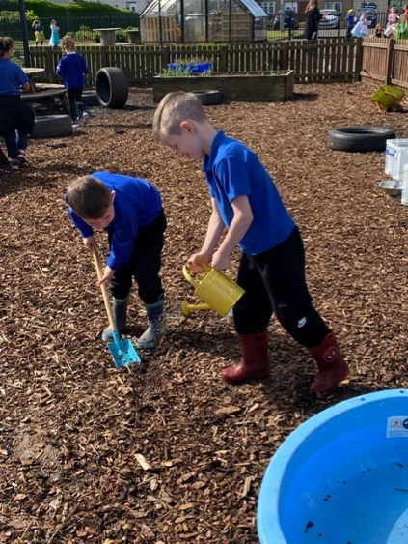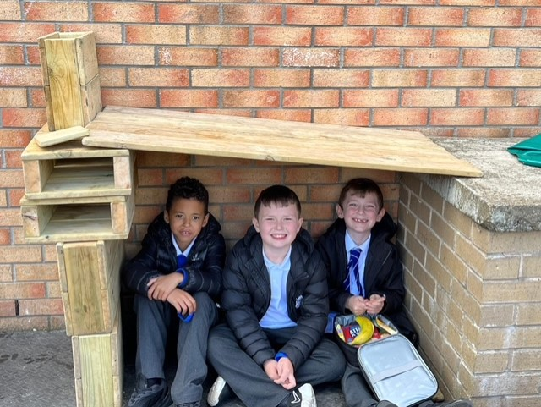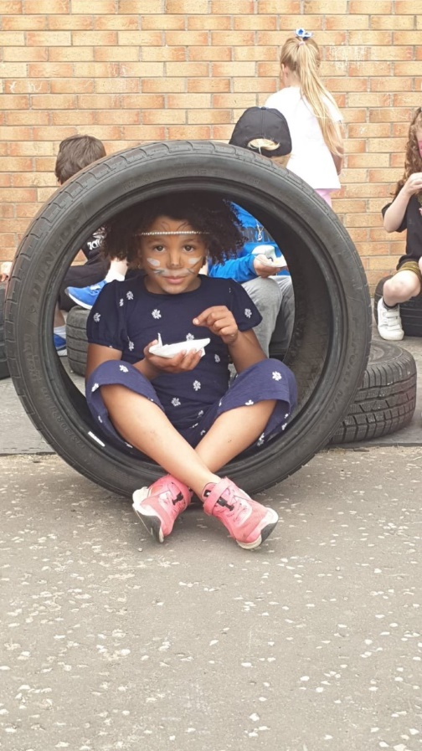Through rich play experiences, children will develop their mental, social and emotional wellbeing, and learn to advocate for their own rights. This will support safeguarding.