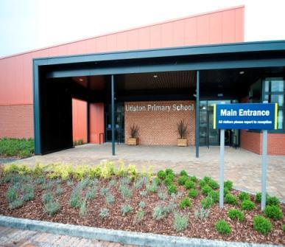

Mrs Parker

Udston Primary

Thornhill Road Hamilton

ML3 9PS

Home learning Guide for parents

**Contents Page**

1. Introduction by Head Teacher
2. Homework Rationale
3. Home Learning Policy for each stage
4. Useful Websites
5. Contact us
6. **Introduction by Head Teacher**

Dear parent/carers,

At Udston Primary School we value the importance of strong partnership working between home and school to support pupils and improve outcomes for our children. One key aspect of this is working in partnership to support home learning provided by the school and your child’s class teacher. This allows parents to be fully informed and have the necessary information to consolidate and extend their child’s learning at home.

We recognise that all families are unique and many parents and carers have varying views about the importance of homework and balancing this with busy family lives. We wish to provide a structured but flexible approach to homework that enhances the work done in the classroom. As a school we strongly value reading and the impact that this can have on other areas of the curriculum – and we would promote this at all stages of your child’s educational journey.

Home learning provides an opportunity to practise and apply skills in different contexts and provides information for parents about their child’s progress in learning. Each child’s progress is reviewed through class-based learning activities rather than the teacher marking home learning activities.

We have also included a list of suitable websites that can support and enhance pupil learning at home.

I hope that you enjoy supporting your child’s learning at home, please do not hesitate to contact us for further support or guidance.

Michelle Parker

Head Teacher

**2. Rationale**

**Purpose of Homework**

Whilst we believe strongly that the purpose of homework at Udston Primary School is to **support and reinforce current learning in class, it is important that this is manageable, achievable and supports the learning in class**. Parents and carers can make a huge difference to their child’s attainment by providing opportunities at home to practise and consolidate skills learnt in numeracy and literacy. This Partnership approach to homework also gives children regular opportunities to discuss learning at home, alongside keeping parents and carers informed about current learning in school.

Homework can play a positive role in raising a child’s level of attainment and independence. We also acknowledge the importance of role play and free time in a child’s growth and development. While homework is important, it should not prevent children from taking part in the wide range of out-of-school clubs and organisations that play an important part in the lives of many children.

**What should homework look like?**

Homework should never be onerous and will only be assigned to children once an appropriate amount of learning has taken place in class first. In line with The Scottish Government, we believe that quality homework (short, achievable tasks) is more important than quantity. Homework should:

* help and encourage independent learning.
* promote a partnership between home and school in supporting each child’s learning.
* consolidate and reinforce learning done in school and to allow children to practise skills taught in lessons.
* help children develop good work habits for the future.
* provide a contact for pupil/parent interaction.
* help parents gain an insight into their child’s schoolwork.

**Background to Homework Rationale**

The Senior Leadership Team have now canvassed the views of parents/carers and staff on 2 occasions. This took the format of surveys before Covid-19 and more recently at last session’s October parent/carer meetings. On both occasions it was evident that parents and staff have strong opinions on both sides, so we want to listen to all views and move forward with a balanced approach. The homework rationale should provide clarity and structure to homework provided for each stage throughout the school. It was clear that homework was still important to all, but this should be streamlined to fit the context of our families.

These are the results from the most recent survey:

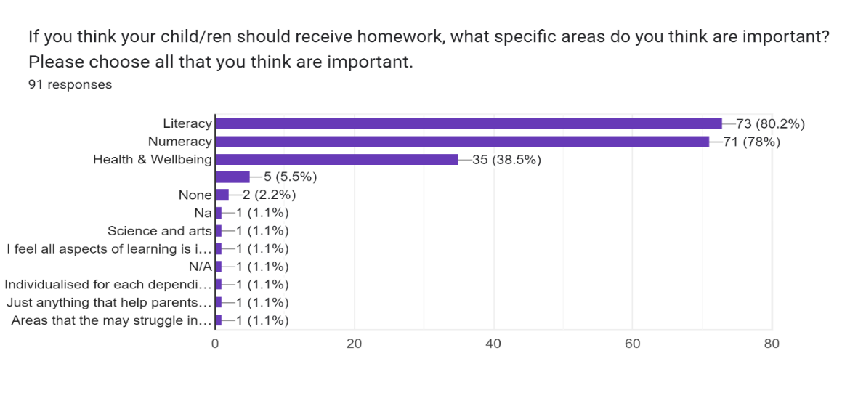

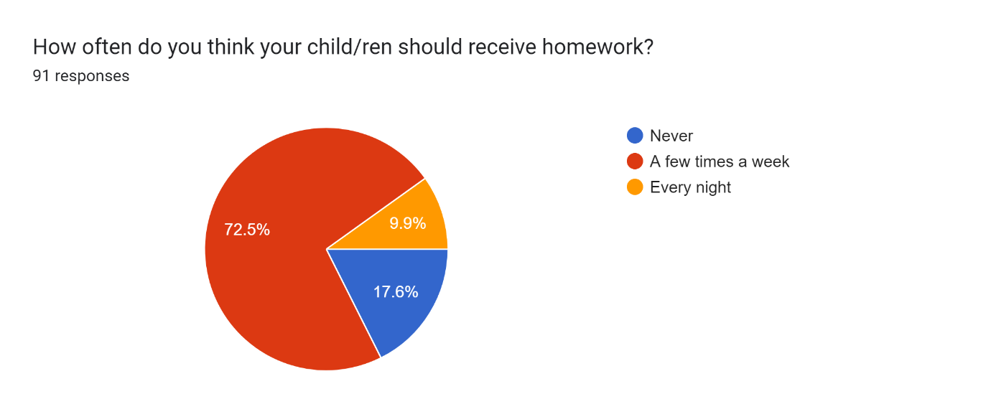

**3. Homework at each stage**

At Udston Primary School, regular, weekly homework will look different depending on the age and stage of the pupils. The following table shows the homework structure for this session (any changes will be posted on Google Classroom):

|  |  |  |  |
| --- | --- | --- | --- |
|  | **Literacy** | **Numeracy** | **Timescale** |
| **P1** | * Sound grid & Common words * Talk for Writing story * Education City Games | * 0-9 number rhymes | * Posted on a Monday, due the following Monday |
| **P2** | * Phoneme/common word grid (parents notified each week) * Spelling menu * Reading book (once/twice a week choose from the reading menu) | * Concept shared with parents – maths menu * Top marks * Education City | * Posted on a Monday, due on Friday |
| **P3** | * Reading – Book Banded Readers * Reading for Pleasure 15/20min * Spelling – spelling & sentences, spelling booklet activities | * Top marks etc. * Consolidation & practice of number bonds/ Times tables | * Posted on a Monday, due on Friday 3pm * Posted on a Friday 3pm and due next Friday 3pm (Room 8) |
| **P4** | * Reading – Book Banded Readers * Reading for Pleasure 15/20min * Spelling – sentences | * Top marks etc. * Consolidation & practice of number bonds/ Times tables | * Posted on a Monday, due on Friday 3pm * Posted on a Friday 3pm and due next Friday 3pm (Room 8) |
| **P5** | * Reading: 15-30mins per night own book or library (reading for pleasure) * Class Reading book when applicable * Spelling and sentences | * Education City * SHM worksheets related to class work * Times tables | * Posted on a Friday 3pm and due next Friday 3pm (Room 8) * Posted on a Saturday, due on Friday 9am (Room 10) |
| **P6** | * Reading: 15-30mins per night own book or library (reading for pleasure) * Class Reading book when applicable * Spelling and sentences | * Education City * SHM worksheets related to class work * Times tables * Number Talks Strategies | * Posted on a Friday at 3pm and due back in the following Friday at 9am (Room 9) |
| **P7** | * Reading: 15-30mins per night of their own book or from library (reading for pleasure) * Class Reading book when applicable * Spelling and sentences | * Education City * Worksheets related to class work * Times tables | * Posted on a Monday, due on Friday 3pm (Rooms 11 & 12) |

In some classes, a sharing the learning session will take place in class to celebrate and share pictures etc.

**What is the role of the teacher?**

The role of the teacher is to assign appropriate, achievable homework tasks for your child. The class teacher will go over all tasks assigned and check for understanding before homework is issued. A homework jotter will be issued where required.

Children are assessed in class through teacher observation and application of learning. Home learning activities are not formally marked and returned to parents in the majority of classes. Time is used instead to plan meaningful, high quality learning experiences during the school day.

**What is the role of the parent?**

All work is uploaded to **Google Classroom**. As a parent or carer, you should ensure that you have the appropriate log in to access Google Classroom. Please contact Mrs Drennan if you have any technical issues ([gw07drennansusan01@glow.sch.uk](mailto:gw07drennansusan01@glow.sch.uk))

You should ensure that your child has a quiet, comfortable space to complete their homework tasks. If your child has access to the Internet, you should also support them with accessing Google Classroom online.

**What is the role of the pupil?**

To complete homework tasks within the allocated time.

To ensure that written work is well presented.

To ensure that homework is submitted as and when requested.

**What is the role of the school?**

As a school, we are fully committed to supporting all our pupils with their homework tasks. All activities are designed to reinforce and enhance classroom learning. It is our job to ensure that all homework is manageable and relevant for your child’s needs. Learning at home should not be onerous, time- consuming or challenging. We seek as a school to encourage pupils to work independently as much as possible to promote confidence and competency.

**4. Useful Websites**

www.educationcity.com

www.topmarks.co.uk

[www.mathsframe.co.uk](http://www.mathsframe.co.uk)

[www.math-aids.com](http://www.math-aids.com)

[www.mathplayground.com/math-games.html](https://www.mathplayground.com/math-games.html)

[www.bbc.co.uk/bitesize/primary-games](http://www.bbc.co.uk/bitesize/primary-games)

[www.abcya.com/](http://www.abcya.com/)

[www.french-games.net](http://www.french-games.net)

www.[maths-games.org/](https://maths-games.org/)

[www.toytheater.com/category/math-games/](http://www.toytheater.com/category/math-games/)

[www.ictgames.com/mobilePage](http://www.ictgames.com/mobilePage)

**5. Contact us**

If you have any questions or queries regarding your child’s homework, please do not hesitate to contact to relevant member of the Senior Leadership Team:

Mrs Turnbull (Rooms 1-4) [gw11turnbullrebecca@glow.sch.uk](mailto:gw11turnbullrebecca@glow.sch.uk)

Mrs Drennan (Rooms 5-8) [gw07drennansusan01@glow.sch.uk](mailto:gw07drennansusan01@glow.sch.uk)

Mrs Parker (Rooms 9-12) [gw14udstonpsht@glow.sch.uk](mailto:gw14udstonpsht@glow.sch.uk)

Created November 2023

Updated November 2024