**Townhill PS News**

**October 2022**

School Motto: Together we Promote Success for all as EVERY child matters and every moment counts.

It is hard to believe we are already starting to talk about and prepare for Christmas! But as you know, it will be here before you know it!

We are so excited to be able to offer a ‘normal’ Christmas calendar this session with parties, our infant Nativity and our senior Christmas Carol concert! We will also be having our Christmas service for P4-7 at Hillhouse Parish Church with Rev. Christopher Rankine. Lots to look forward to!

As a Silver level Reading school, we have launched a new Twitter account to share all of the wonderful goings on at Townhill!

Please give us a follow **@readingatTPS** This account is central to

our ‘Going for Gold’ application and will help us showcase just how committed we are to further developing our reading culture!

We hope our children enjoy a happy and safe Halloween if they are out Trick or Treating!

Thank you for your continued support and partnership.

Mrs Ally McGovern

Head Teacher

Our school vision:

Together at Townhill we nurture, encourage and inspire the development of skills for lifelong learning and success. We embrace equality and diversity to promote a happy and healthy life.



Our school blog:

<https://blogs.glowscotland.org.uk/sl/townhillps/>

Please follow us on Twitter:

**@townhillps**

We now have 760 followers!



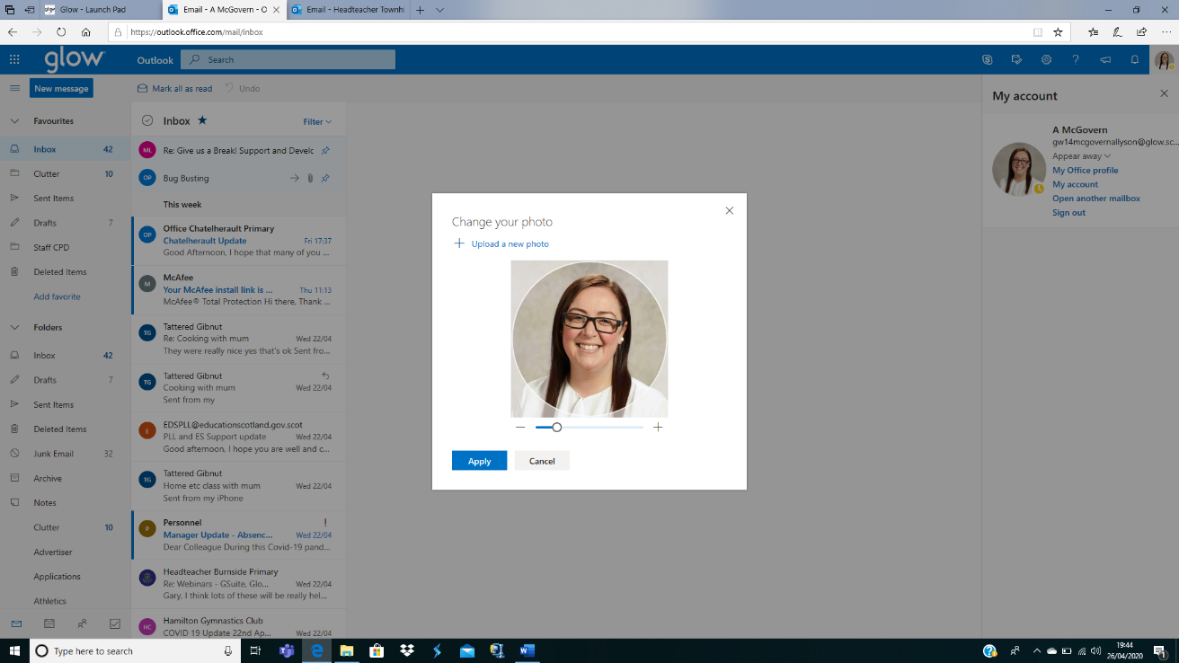

If you have any questions or concerns please do not hesitate to contact the school or by emailing one of the addresses below:

[office@townhill-pri.s-lanark.sch.uk](mailto:office@townhill-pri.s-lanark.sch.uk) Office email

[headteacher@townhill-pri.s-lanark.sch.uk](mailto:headteacher@townhill-pri.s-lanark.sch.uk) Mrs McGovern’s email

[gw20townhilldht@glow.sch.uk](mailto:gw20townhilldht@glow.sch.uk) Mrs Love’s email

[gw07neillyjennifer@glow.sch.uk](mailto:gw07neillyjennifer@glow.sch.uk) Miss Neilly’s email



**Breakfast Club Leaders**

We were delighted to appoint the following children to the position of Breakfast Club Leader!

Emily Read, Elise Low, Evie Carlyle, Aurora Martin

These superstars are such an essential help to

Mrs Comer and support with registers, food collection,

clearing up and organisation! Well done girls!

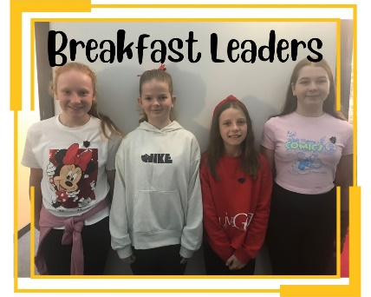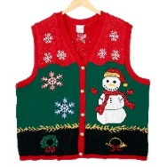

**Parents’ Evening**

We are delighted to be able to host our first face-to-face Parents’ Evening since 2019!

Parents’ Evening will take place on Thursday 17th November where parents/carers will be invited to make an appointment to speak with their child’s teacher. We will be using School Cloud platform to organise appointments as this allows parents to select times to suit their needs. A further letter detailing this alongside a parent guide on how to access school cloud will be issued next week. Appointments will go live on Tuesday 1st November at 9am and close on Friday 11th November at 4pm.

Parent’s Evening will be held in our school gym hall. We ask that children do not attend these appointments. We understand this may not be possible for all and ask that if present children are reminded not to run around etc. as space will tight and to wait quietly at the seating area whilst your appointment is going on.

The travelling Book Fair will also be at Parents’ Evening and all classes will have visited the stalls prior to Parents’ Evening. This will be situated at our entrance and manned by Mrs Morrison and Mrs Comer.

The TPTT will have a stall at Parent’s Evening where you can ask any questions about the fabulous work they do to support our school and to find out how you can get involved! Go and visit them!

We will also have senior pupils attending to encourage as many parents as possible to complete our parent questionnaires! These will be available via QR code and hopefully some of our mobile devices!

We look forward to seeing you all there!

**Christmas**

We are once again looking for donations of Christmas attire to add to our ‘Rake and Take’ rails. Any gently used Christmas jumpers, t-shirts and party wear should be handed in via the school office to allow us time to distribute items and advertise collection.

**The Townhill Parent and Teacher Team- The TPT- TEAM=Together Everyone Achieves More!**

Helen Agnew, Chair of the TPT Team can be contacted on:

**Townhill.ptt.chair@gmail.com**

Our next meeting will be **Wednesday 30th November at 7pm** online.

If you are interested in joining us then please drop Helen an email.

Our annual Christmas Hamper fundraiser will go ahead this year and the theme for all hampers will be colour! This means that every class will be given a colour and their donation should be that colour! This is very exciting and gives lots of scope when selecting your donation! We are always very excited to see what people come up with! The Hamper donation day ‘Fling it in Friday’ will be on Friday 25th November. We will send out a letter in the coming weeks detailing the colour for each class! We will then sell raffle tickets for the Hampers and these will be drawn at our infant Nativity! Hamper raffles will also be on sale at each of our Carol concerts and infant nativity. It is always very exciting!



**Parking**

Unfortunately, parking continues to be a serious issue outside our school. At our recent TPTT meeting we have discussed buying ‘Parking characters’ which we will position outside our school on Luss Brae as a reminder to make sensible choices when collecting your child from school.

A reminder that the school carpark is for staff and visiting specialists only, please make alternative arrangements when dropping off and collecting your child**. We have noticed that a few cars have been parking at the end of the carpark and also in the emergency vehicle corridor- this is not permitted. Please park outwith the grounds and in a sensible space.**

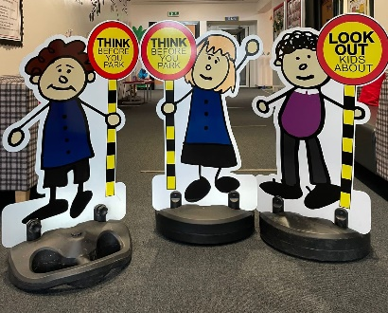



**ALLERGY INFORMATION**

**There has been an increase recently of nut-based snacks being brought in to school. Can we please remind all parents/carers that these are not allowed an an alternative should be given instead.**

**There are members of our school community who have severe allergies to some food items, therefore the following are not allowed in school:**

**• peanuts or products which may contain peanuts**

**• tree nuts – such as walnuts, brazil nuts, almonds and hazelnuts etc.**

* **Please note that this includes most chocolate spreads, Nutella products and Kinder Bueno. I would urge all parents/carers to bear this in mind when providing your child with snack and/or packed lunches. Thank you for your support with this. This applies to all pupils, staff and visitors.**

**A reminder we are no longer able to take in and distribute birthday cakes/treats.**





**MOBILE PHONES**

Pupils are discouraged from bringing any mobile devices, including phones, to school however, if they require them for after school, **they must be switched off and in school bags at all times.**

**Scooters/bikes in school**

Many of our children cycle or scoot to school and we can now encourage this. **Anyone bringing a bike or scooter to school should make sure they wear a suitable helmet and reflective clothing and must get off their bike/scooter in the playground and push it to the bike shelter**. **The school cannot accept responsibility for any loss or damage to bikes/scooters while on school property**



**Attendance at school**

If your child is well and able then they should attend school every day. Regular school attendance is essential for all of our children to make good progress, achieve their academic potential and consequently have better chances in life. Our whole school attendance target is 95%. It is the responsibility of parents/carers and the school to achieve this. There are 190 school days across the school year, leaving 175 days to book holidays and attend non urgent appointments.

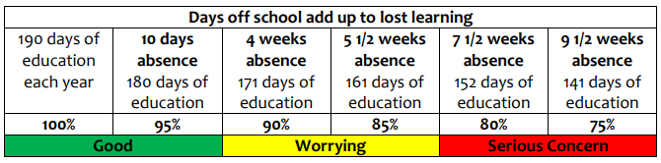

We appreciate that children are unwell from time to time and that there can be exceptional circumstances for absences, but we ask that you think carefully about keeping your child out of school. There is a strong connection between attendance and achievement at school. Absence is proven to have a significant negative impact upon a child’s educational attainment. This year Miss Neilly and I will be working closely to ensure attendance is high at Townhill PS.



**Upcoming Diary Dates**

**Please note new/changed diary dates in yellow.**

**Inset Days**

**3. Monday 14th November 2022**

**4. Wednesday 15th February 2023**

**5. Tuesday 2nd May 2023**

**Holidays**

**Christmas Close on Fri, 23rd December – re-open on Mon, 9th January ’23**

**February Break Mon, 13th and Tue, 14th February ‘23**

**Spring Break Close on Fri, 31st March – Reopen on Mon, 17th April ’23**

**May Holiday Mon, 1st May ‘23**

**Local Holiday Fri, 26th and Mon, 29th May ‘23**

**Summer School closes at 1pm on Tues, 27th June 2023**

**Parents’ Evenings**

**Thursday 17th November 2022**

**Thursday 23rd March 2023**

**Diary Dates**

**Flu Immunisations (P1-7) Monday 7th November 2022**

**‘Fling it in Friday’ Hamper donations- more details to follow Friday 25th November**

**Carol Concert (P4-7) Tuesday 13th December at 7pm, Wednesday 14th December at 9:30am**

**Christmas Lunch Thursday 15th December**

**Infant Nativity (P1-3) Monday 19th December at 9:30am**

**Christmas Service Friday 23rd December at 9:30am at Hillhouse Parish Church (P4-7)**



In the event of a pupil having to quarantine, either as a result of someone in their household

developing symptoms of COVID-19, or as a result of returning from a country on the

quarantine list, we have prepared a two home learning programme of work that we will



