**Townhill PS News**

**September 2022**

School Motto: Together we Promote Success for all as EVERY child matters and every moment counts.

A whole 5 weeks back at school!

Our children have settled well back into school life and there is such a ‘learning’ buzz around the school. Please continue to look out on Twitter for pictures of the amazing learning opportunities going on throughout the week!

A massive thank you to parents for your support with our Townhill uniform policy, our children look fantastic and it really helps create a sense of belonging when we are the same. A reminder we have lots of brand new and gently used uniform available for all at our ‘Rake and Take’ stall, please come and take what you need. Please remember that our changing rooms are now open therefore children DO NOT need to wear sports clothes on PE days.

Another massive thank you to everyone who has signed up to be a parent helper within Townhill! We are hoping the POVG process will be quick and we can have you in to help as soon as possible! #positivepartnerships

Thank you for your continued support and partnership.

Mrs Ally McGovern

Head Teacher

Our school vision:

Together at Townhill we nurture, encourage and inspire the development of skills for lifelong learning and success. We embrace equality and diversity to promote a happy and healthy life.

Our school blog:

<https://blogs.glowscotland.org.uk/sl/townhillps/>

Please follow us on Twitter:

**@townhillps**

We now have 739 followers!

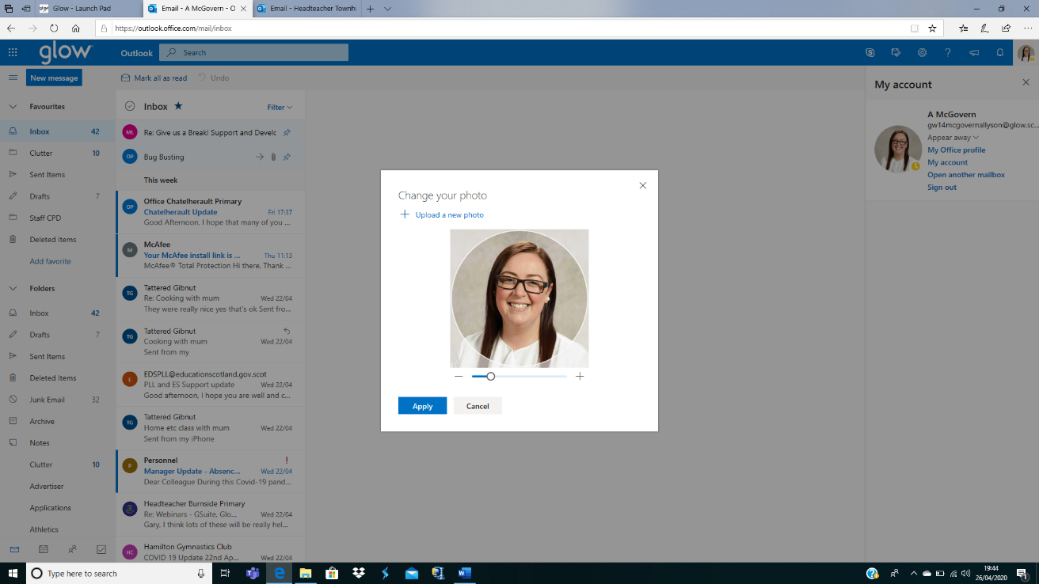

If you have any questions or concerns please do not hesitate to contact the school or by emailing one of the addresses below:

[office@townhill-pri.s-lanark.sch.uk](mailto:office@townhill-pri.s-lanark.sch.uk) Office email

[headteacher@townhill-pri.s-lanark.sch.uk](mailto:headteacher@townhill-pri.s-lanark.sch.uk) Mrs McGovern’s email

[gw20townhilldht@glow.sch.uk](mailto:gw20townhilldht@glow.sch.uk) Mrs Love’s email

[gw07neillyjennifer@glow.sch.uk](mailto:gw07neillyjennifer@glow.sch.uk) Miss Neilly’s email





**Staffing update**

As announced on our August newsletter Mrs Amy Stewart secured a new permanent post withn SLC and finished up on Wednesday 7th September! We have no doubt that Mrs Stewart will shine in her new role and we know she will keep in touch. We have been very lucky to secure Mrs Rachel Arnott (formerly Barlas) to cover Mrs Stewart’s post for the year. Mrs Arnott worked at Townhill last session and knows our school and our pupils very well, we are so happy to have her!

We have also secured a new member of support staff in place of Miss Maclean who has gone off for teacher training. Miss Hannah McConnell is awaiting final recruitment checks and then will be starting at Townhill. Miss McConnell worked at Townhill last session on placement and again has excellent knowledge of our school.

Mrs Kennedy has given birth to another beautiful girl called Freya who is the apple of her big sister Eilidh’s eye! We are so happy to hear such lovely news and cannot wait for baby cuddles when Freya visits!

**Home-school Communication**

As a school we actively encourage open lines of communication. This helps us all to build and maintain strong relationships for the benefit of the pupils. If a parent/carer needs to speak to a member of the school staff, their first point of contact is their child’s class teacher. Parents/carers can contact their child’s class teacher in a number of ways, including:

* Writing a message in their child’s homework diary/jotter or equivalent which the child will deliver;
* Speaking to the class teacher briefly at the end of the day once the other children have left (please note this method might not always be appropriate as not all staff will be in the playground and some requests/conversations require more time and privacy, also only P1 and P2 parents/carers are permitted playground access);
* By contacting the school office by telephone and leaving a message for their child’s class teacher to contact them.
* By emailing any of the email addresses below.

[office@townhill-pri.s-lanark.sch.uk](mailto:office@townhill-pri.s-lanark.sch.uk) Office email

[headteacher@townhill-pri.s-lanark.sch.uk](mailto:headteacher@townhill-pri.s-lanark.sch.uk) Mrs McGovern’s email (Pastoral resp. for R10-14)

[gw20townhilldht@glow.sch.uk](mailto:gw20townhilldht@glow.sch.uk) Mrs Love’s email (Pastoral resp. for R1-4)

[gw07neillyjennifer@glow.sch.uk](mailto:gw07neillyjennifer@glow.sch.uk) Miss Neilly’s email (Pastoral resp. for R6-9)

**Parents should avoid emailing class teachers directly unless an arrangement has been agreed and cleared by the Senior leadership Team.**

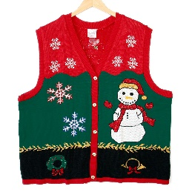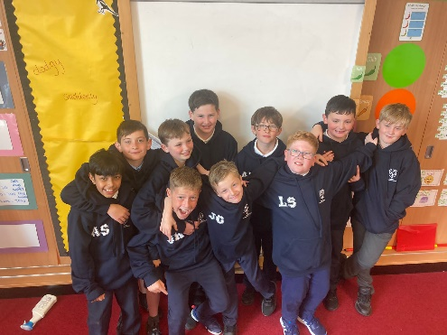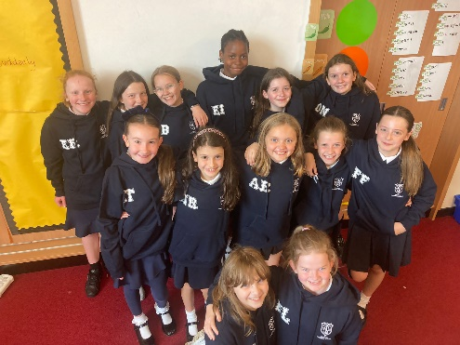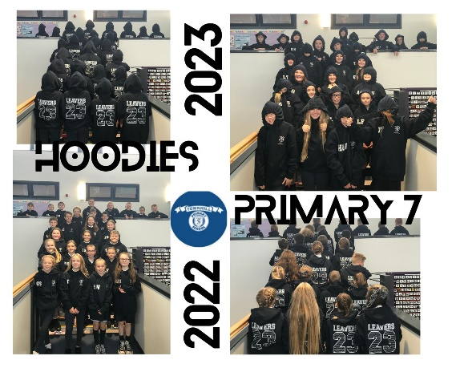

**Halloween/Christmas**

As we are nearing two special times of the year we are once again looking for donations of Halloween costumes and Christmas attire to add to our ‘Rake and Take’ rails. Any gently used costumes, Christmas jumpers, t-shirts and party wear should be handed in via the school office to allow us time to distribute items and advertise collection.

**Hoodies**

Our Primary 7 pupils were thrilled to receive their wonderful Townhill hoodies last week! This has created such a sense of belonging four our senior children and they look so smart wearing them. A MASSIVE thank you to our wonderful TPTT for continuing to cover the full cost of these. #P7leavers #HOODIES

**Wear Red for Dyslexia**

On Friday 7th October we will celebrating ‘Go Red for Dyslexia’ to help spread awareness of dyslexia across the Townhill community. We have some fun activities planned for this day and will have an assembly focused on the superpower that is dyslexia! Children are encouraged to wear something red on this day, have red hair, red socks etc and can dress down. Let’s get involved! #succeedwithdyslexia

**Meet the Teacher**

Our recent ‘Meet the Teacher’ event was such a lovely way to welcome parents back through our doors! The whole place had a very positive buzz in every single classroom ad we were able to show off our wonderful school. A huge thank you to those visitors that completed our feedback sheet. We had lots of very positive comments- thank you! We are mindful of the very long queue and will look at alternatives for any future events.

**Snapshot**

Our first Snapshot of the session is Literacy. On Friday 7th October the children will bring home their Literacy work/jotters and their feedback sheet. Please take some time to read through their jotters with them and use the feedback sheet guide to discuss their work. There is also a space for a pupil and parent comment too! Please ensure that all contents are returned to school on Monday 10th October as the children will need their jotters/activity booklets.

**Captains and Vice Captains**

We are vey proud to announce our new Captains and Vice Captains for our houses!

Livingston

Captains- Caiden Hunter and Hannah Allan

Vice Captains - Owen Harkins and Maggie Smart

Lauder

Captains- Holly Sutton and Freya Fairbairn

Vice Captains-Cooper Orr and Charlie Watson

Burns

Captains- Alfie Anderson and Liam Edwards

Vice Captains-Harlee Wilkie and Lexie Dick

Baird

Captains-Calum Law and Callum Lowe

Vice Captains-Emma Borland and Amy Burns

What stars! We were blown away with the confidence of all

of the children that put themselves forward, well done!

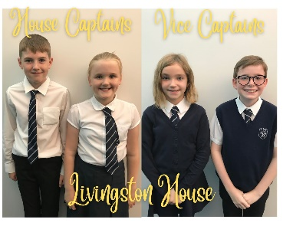

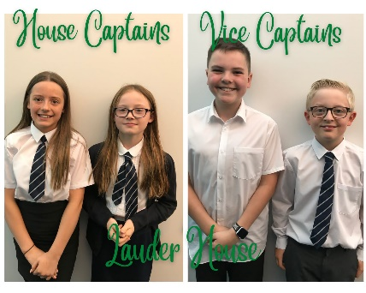

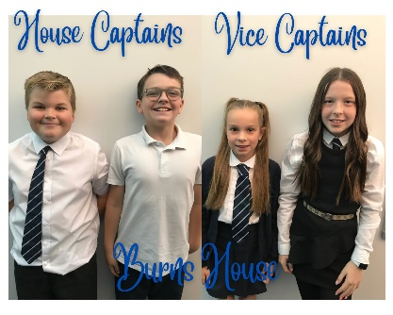

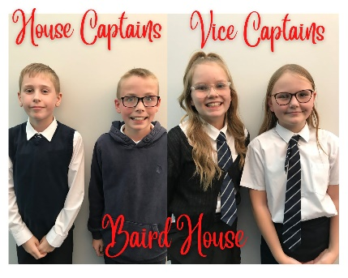

**Smart Watches**

This session more children are coming to school with smart watches. Unfortunately, these have not always been put in to ‘School Mode’ and have disturbed lessons. Please ensure that all smart watches are on school mode or equivalent for the duration of the day and encourage your chid not access messages etc during playtimes and lunchtimes.

**Fake nails**

We have noticed that some senior pupils have taken to wearing false nails to school. We must actively discourage this as it is a hazard in the gym hall when using PE equipment. We view this the same way as we do jewellery and children will not be permitted to take part in lessons where they could potentially hurt themselves. Please support us with this.

**ALLERGY INFORMATION**

**There has been an increase recently of nut-based snacks being brought in to school. Can we please remind all parents/carers that these are not allowed an an alternative should be given instead.**

**There are members of our school community who have severe allergies to some food items, therefore the following are not allowed in school:**

**• peanuts or products which may contain peanuts**

**• tree nuts – such as walnuts, brazil nuts, almonds and hazelnuts etc.**

* **Please note that this includes most chocolate spreads, Nutella products and Kinder Bueno. I would urge all parents/carers to bear this in mind when providing your child with snack and/or packed lunches. Thank you for your support with this. This applies to all pupils, staff and visitors.**

**A reminder we are no longer able to take in and distribute birthday cakes/treats.**



**Attendance at school**

If your child is well and able then they should attend school every day. Regular school attendance is essential for all of our children to make good progress, achieve their academic potential and consequently have better chances in life. Our whole school attendance target is 95%. It is the responsibility of parents/carers and the school to achieve this. There are 190 school days across the school year, leaving 175 days to book holidays and attend non urgent appointments.

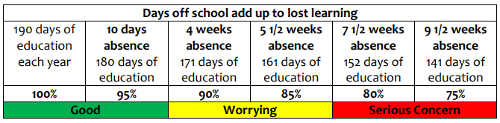

We appreciate that children are unwell from time to time and that there can be exceptional circumstances for absences, but we ask that you think carefully about keeping your child out of school. There is a strong connection between attendance and achievement at school. Absence is proven to have a significant negative impact upon a child’s educational attainment. This year Miss Neilly and I will be working closely to ensure attendance is high at Townhill PS.



**MOBILE PHONES**

Pupils are discouraged from bringing any mobile devices, including phones, to school however, if they require them for after school, **they must be switched off and in school bags at all times.**

**Scooters/bikes in school**

Many of our children cycle or scoot to school and we can now encourage this. **Anyone bringing a bike or scooter to school should make sure they wear a suitable helmet and reflective clothing and must get off their bike/scooter in the playground and push it to the bike shelter**. **The school cannot accept responsibility for any loss or damage to bikes/scooters while on school property**





**The Townhill Parent and Teacher Team- The TPT- TEAM=Together Everyone Achieves More!**

Helen Agnew, Chair of the TPT Team has a new email and can be contacted on:

**Townhill.ptt.chair@gmail.com**

Our Townhill Parent and Team had a very successful year in 2020-2021. Not only did they support the ongoing work of the school but helped raised an incredible amount of money to be used on playground improvements. Work has already started with the repairs on the senior Trim Trail and exciting plans are taking place for the removal of the sandpit and some playground games to be painted! It is a very exciting time for us all.

Our first meeting will be **Tuesday 25th October at 7pm** where we will also hold our Annual General Meeting. We would love to see as many faces as possible and given that this will be our first in person meeting since 2019 we would love to see as many faces as possible! There will also be tea and coffee!

If you are interested in coming along to the meeting then please drop Helen an email.



In the event of a pupil having to quarantine, either as a result of someone in their household

developing symptoms of COVID-19, or as a result of returning from a country on the

quarantine list, we have prepared a two home learning programme of work that we will



**Parking**

Unfortunately, parking continues to be a serious issue outside our school. I have been in discussion with Police Scotland who will begin ‘drop ins’ and visit our school during drop off and pick up times to help us manage the ongoing issues we are having.

A gentle reminder that the school carpark is for staff and visiting specialists only, please make alternative arrangements when dropping off and collecting your child**.**



**Sportathon**

Last week we enjoyed our Sportathon, organised by Miss Neilly and P7. They created a very long and very tiring assault course for the children and what a great day was had by all! Our Sportathon was to help us raise money to buy in new reading books for the children and I am very pleased to say we have managed to raise **£2692!** Wow! A massive thank you to each and every family for the part they have played in this, and we canoe wait to get ordering some exciting new texts for or children!



**Upcoming Diary Dates**

**Please note new/changed diary dates in yellow.**

**Inset Days**

**3. Monday 14th November 2022**

**4. Wednesday 15th February 2023**

**5. Tuesday 2nd May 2023**

**Holidays**

**October Week Mon, 17th – Fri, 21st October ‘22**

**School Photographs Thursday 27th October all day**

**Halloween Disco Thursday 27th October**

**Harvest Assembly Friday 28th October**

**Christmas Close on Fri, 23rd December – re-open on Mon, 9th January ’23**

**February Break Mon, 13th and Tue, 14th February ‘23**

**Spring Break Close on Fri, 31st March – Reopen on Mon, 17th April ’23**

**May Holiday Mon, 1st May ‘23**

**Local Holiday Fri, 26th and Mon, 29th May ‘23**

**Summer School closes at 1pm on Tues, 27th June 2023**

**Parents’ Evenings**

**Thursday 17th November 2022**

**Thursday 23rd March 2023**

**Diary Dates**

**Flu Immunisations (P1-7) Monday 7th November 2022**



