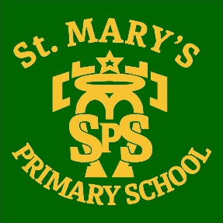
Updated guidance from
Monday 28th Feb’

Following updated guidance from the Scottish Government, the changes and what they mean for St. Mary’s are outlined below:
- Assemblies can resume meaning all classes can come together in the hall while maintaining space between classes and ensuring appropriate ventilation.

- Transition visits will now be permitted allowing smooth transition for P7-S1 pupils and for Nursery to P1 pupils.

- Parents will be welcome to attend outdoor Sports Day.

- Visits to school by parents and other visitors must still be pre-arranged, face coverings are required and they are encouraged to ensure they have a negative LFT before attending.

- All learning areas will be fitted with a CO2 monitoring device to ensure appropriate ventilation is in place.

- Staff will continue the twice weekly LFT testing scheme.

- Staff will maintain a 2m distance between adults and where possible between staff and pupils. No distancing is required between pupils.

- Face coverings for adults are not required in classroom however staff will continue to do so where they cannot maintain distance between other adults and or pupils.

