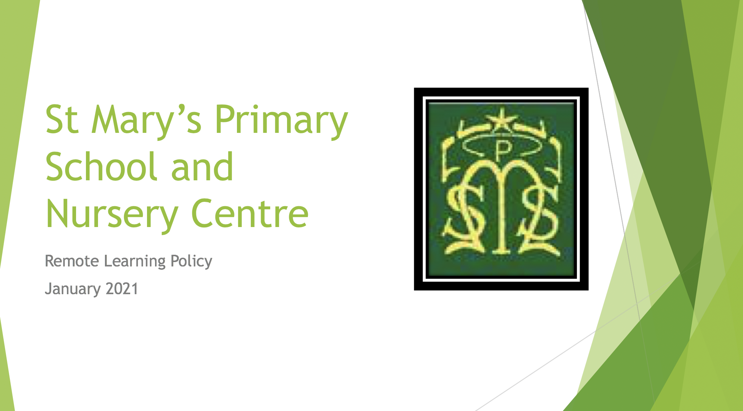

Rationale
This position statement was written with cognisance given to the following guidance, Remote Learning CERG, Education Scotland (January 2021) and SLC Remote Learning: Advice & Guidance for Establishments (January 2021).
For the purpose of this position statement Education Scotland’s definition of remote learning has been adopted:
‘…learning that is directed by practitioners and undertaken by children and young people who are not physically with the practitioner while instruction is taking place. It involves a combination of ‘live’ interactions between teacher and learners and also learning which takes place away from the direct presence of the class teacher.’
As has SLC’s definition of continuity of learning which states that, ‘aspirationally, continuity of learning during lockdown should be as close to the daily face-to-face experience as context allows’.
This statement clarifies how the ongoing education of pupils at St. Mary’s Primary School will be delivered using Google Classroom and telephone conversations when necessary. Pre-recorded lessons will be available to support learning and timetabled live interaction will be available via Google Meet.
The aims of St. Mary’s Primary School’s remote learning offer:
- To provide high quality teaching, learning and assessment experiences for all learners
- To provide high quality consolidation of learning
- To provide a safe online environment for all learners to ask questions and interact with their teacher and peers
- To promote independent learning and develop skills for life
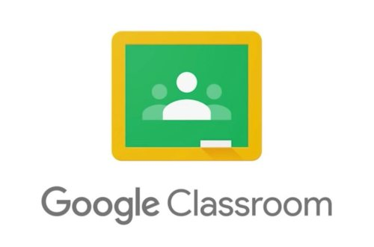
- To engage and enhance parental involvement in supporting their child’s education

An important point to note is that remote learning will not replicate face-to-face in school teaching – in style, approach or hours of delivery.

Our offer
As communicated in each class’ Readiness to Learn information sheet each child will:
- have access to work from 3pm on a Friday – this is to help working parents organise their child’s learning should they wish to
- have their work offer organised in to Weekly folders so that all work is easily located
- be taught five Literacy and five Numeracy lessons in the week. These will be delivered in a variety of ways including pre-recorded videos, sourced video links or PowerPoints, and include a mixture of follow up activities.
- have access to online reading resources
- be taught five other lessons from other curricular areas, including Health and Wellbeing
- be directed to further activities and websites
- have access to live Stream chat with their teacher throughout the day
- be offered Live interaction through Google Meet at timetabled slots in the week

Our expectations
Pupils
- Pupils will try to structure to their school day by logging-in to Google Classroom around 9.00am.
- Pupils should try to complete all set work and hand in work as instructed by their teacher.
- Should use the Google Classroom ‘Stream’ to communicate with their teachers and ask questions if they require help at particular time slots throughout the day.
- In line with their expected timetable, pupils should try to connect to Google Meet at their relevant time slots.
- Pupils will not record and / or share any Google Classroom content, i.e. resources, pre-recorded lessons or live sessions. Any pupil found to be capturing personal information will face further actions in keeping with SLC IT Agreement.

Parent / Carers will
- try to ensure a structure to the ‘school day’
- encourage and support their child’s work, checking that set work is completed and sent in to the teacher
- not record and / or share any Google Classroom / Google Meet content.
- not be visible during live lessons
- inform the school office when pupils or family members are ill, should so that teachers can be informed and absences can be recorded
- If there are any concerns, in the first instance, parents should contact the pupil’s teacher.
Teachers will
- be available daily for check-in sessions and to answer pupil questions using the Stream chat or Google Meet (timetabled)
- ensure that differentiated, high quality work will be uploaded for a Friday afternoon
- upload pre-recordings, websites, YouTube clips and other resources to support and progress learning
- provide feedback on work that is submitted
- maintain a register of engagement
- track the return rate of work for Literacy, Numeracy and Other areas
- provide support, encouragement and pastoral care

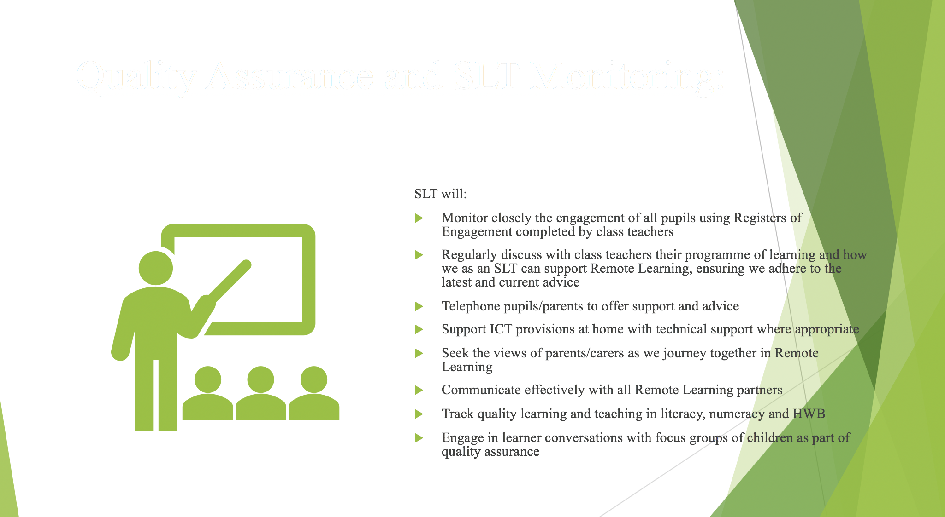

‘Live’ online sessions
Teachers will interact in a ‘live’ manner through Google Meet. Teachers have read SLC Video Conferencing with Learners (September 2020) and will be adhering to this. This function allows for resources to be shared, and pupils to ask questions in ‘real-time’. Pupils will be provided with details of sessions and will be expected to participate in them if requested and able to. Should a parent wish to speak to a staff member, they should request by email and not via Google Meet during a session. Teachers will record a live session so that the video or audio could be reviewed in any issues were to arise.
Teachers and pupils should follow the same guidelines as conversations in school (e.g. appropriate standards and behaviour by both staff and pupils). Teachers will not ask pupils to change to another communication platform. Teachers will never ask pupils to share their passwords.

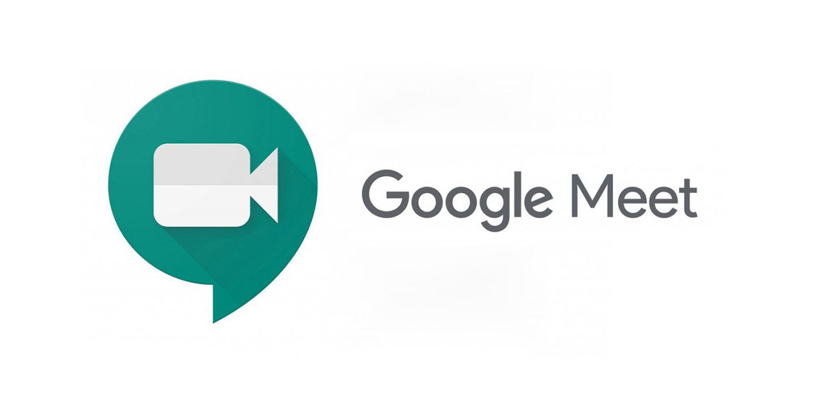

Resources
Supplies of paper, pencils, rubbers, rulers and jotters are available from the school office if required to complete remote learning tasks.
If a pupil does not have access to a device for online learning then a request can be made to Mrs O’Hara who will action this as appropriate with regard given to the devices available.

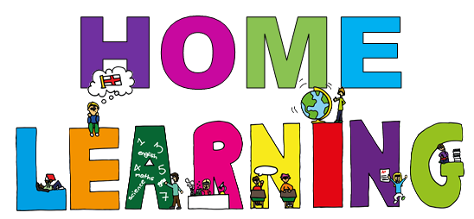

Advice and Guidance
Guides and handouts are all available on our school app and copies can be requested from the school office.
In addition, please see the link below for support videos
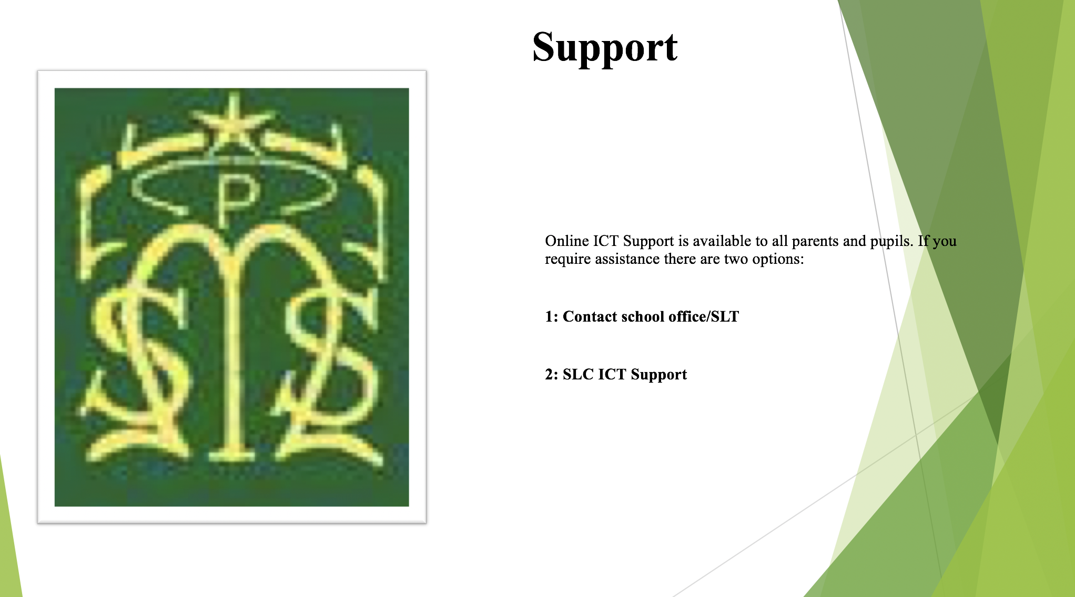
https://sites.google.com/sl.glow.scot/slcremotelearning/home

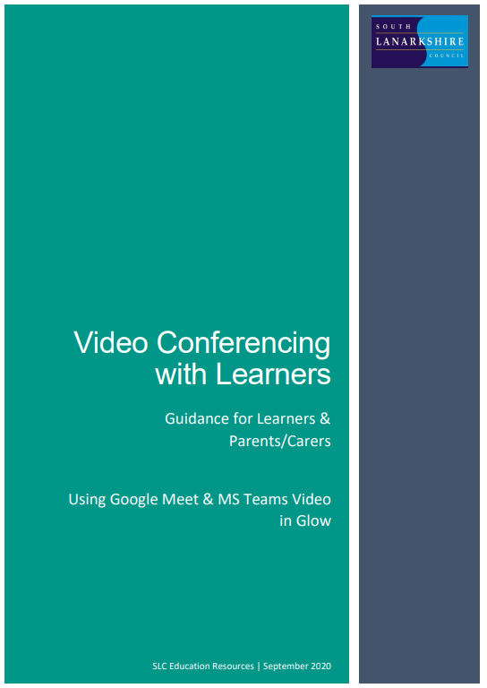
APPENDIX I
Contents
Important Note for Parents/Carers 7
Learners – setting up Google Meet at Home 8
Before the online meeting starts 8
Connecting to the online meeting 9
During the online meeting 11
After the online meeting 11
Connecting to Google Meet on a tablet or mobile device 13
Parents/carers – helping your child with Google meetings 14
Before the online meeting starts 14
Connecting to the online meeting 14
During the online meeting 15
After the online meeting 16

Important Note for Parents/Carers

Video conferencing can be an effective way to keep in touch, provide support, reinforce and deliver new learning but this is a new way of interacting for most learners, teachers and parents/carers.
Please familiarise yourself and your child with the following advice and guidance to ensure that everyone feels safe and secure whilst using video conferencing for learning; and note that online meetings may be recorded to ensure everyone is protected when using video calls. Learners will be informed of this (if recording is taking place) at the beginning of online session and recordings that include images or audio of learners will not be shared with other learners or on other online platforms such as Google Classroom or Microsoft Teams.
There are 2 video conferencing platforms, available for use by SLC staff, from within the national digital platform Glow. Until recently this has only been enabled for staff-to-staff communication. Following the implementation of recent technical changes to Google Meet and Microsoft Teams, Education Scotland has now opened access to these tools to allow staff-to-learner communication. It should be noted that these are the only platforms currently sanctioned for use within SLC as they meet the technical requirements necessary to ensure the safeguarding of all participants.

Learners – setting up Google Meet at Home

Your teacher will be using an online videoconferencing platform called Google Meet, to deliver some of your lessons or to connect with you when unable to meet with you face-to-face.
Follow the instructions and advice below to ensure you make the most of these online sessions.

Before the online meeting starts
- Find a suitable place to sit – this should be somewhere:
  - that is not your bedroom, unless this is completely unavoidable
  - with your back towards a wall to reduce how much of your surroundings are in the camera frame and try not to have personal items on display such as family photographs
(at the time of writing this guidance, blurred backgrounds were not an option in Meet)
  - quiet with no distractions eg turn off the TV, radio etc or use headphones (see below)
  - with good light but do not sit with your back to a window as it makes it difficult for others to see you
  - with a table or hard surface to place your device on to maintain a stable image/connection
- Prepare as you would for a real lesson in school – which means:
  - dress appropriately, as you would if others outside your home would see you
  - be on time for the session starting and be ready to take part – your teacher will share the dates/times of online sessions; you should discuss this schedule with your parent/carer
  - have a pen/pencil and paper/jotter beside you to take notes or have a digital alternative such as a Word or Google doc open in advance of the session starting
also
  - let other people in your house know that you are joining an online lesson so they do not accidently interrupt you once the session gets underway

Connecting to the online meeting
Most of your online sessions will take place through your Google Classroom(s) in Glow and your teacher will have shared the schedule showing dates/times in advance.
The link to your online meeting space is on the banner in your Google Classroom(s).
You will not be able to join the meeting until your teacher has started it.
- Log into your Glow account and go to Google Classroom
(if you are using a tablet or mobile device, see page 7 for help connecting with the Meet app)
- Click on the meeting link on the Classroom banner (remember you won’t be able to join the meeting until your teacher has started it – see point 8 below)
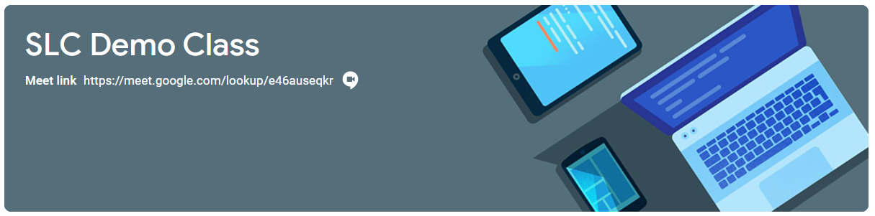
- You may see a message about using your camera and microphone – click Allow (even if you know you don’t want either to be on during the meeting – this can be done later)
You will now see a preview window showing your webcam view – click on the microphone icon to MUTE your mic – the icon will turn red (do the same to turn off camera, if you wish)
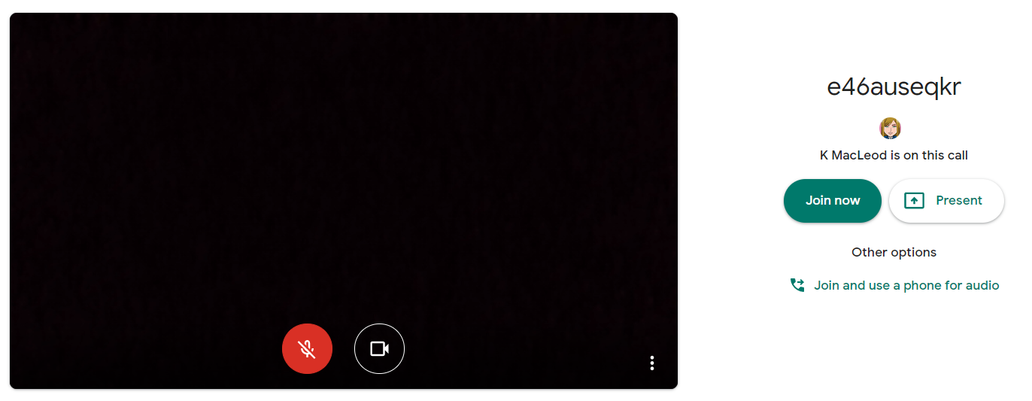
Ms Smith is on this call
- Click Join now to enter the Google Meet – do not click Present
- Once connected, listen carefully to your teacher and instructions being given
If you are experiencing any technical problems eg unable to hear or see your teacher – use the chat facility to report this and wait for the teacher (or support person) to take action. Do not interrupt by turning on your mic (unless this is permitted by your teacher/class code)
- Before starting the lesson, your teacher will remind everyone that it will be recorded - you will see the red REC button on the top left of your screen when the recording begins
- If your internet connection fails and you ‘drop out’ of the meeting, you should be able to reconnect by following the steps above, as long your teacher is still in the meeting
- If you see this message when you click on the Meet link in Classroom…
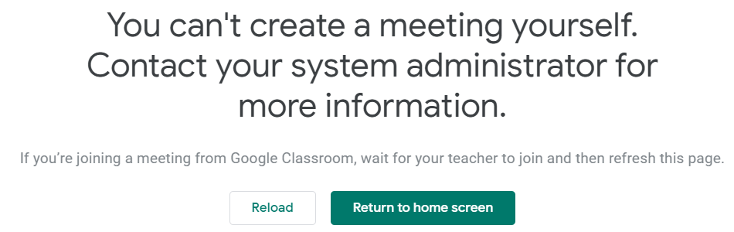
it means your teacher has not started the meeting yet – go back to Classroom and try again nearer the time of the meeting

During the online meeting
- Behave as would be expected in face-to-face lessons.
Your teacher is able to remove you from the meeting if you do not conduct yourself appropriately and this is likely to result in follow-up action by Mrs O’Hara who may also discuss this with your parents/carers
- Use the chat facility to communicate with your teacher and/or participate in discussions – this can be found on the top right of your screen
The chat area is also where your teacher may post links and resources and where you may need to register your attendance and/or access an exit ticket/pass
- Only unmute your microphone if your teacher gives you permission – remember to mute it again once finished speaking
You will find the mic/camera controls by clicking anywhere on your screen, a white banner appears at the bottom, click on the red microphone icon to unmute, click on the white microphone icon to mute
- Only share your screen (Present now) if your teacher gives you permission – remember to stop sharing once you have finished
- You may find it easier to follow what’s being said during lessons by turning on captions, which show text of the conversation; no one else can see you are using closed captions and only you can put them on or off

- At the end of the meeting, disconnect by clicking on the red ‘hang up’ icon (found between the microphone and camera icons)

After the online meeting
- Follow up on any actions given to you by your teacher – these may be posted on your
Google Classroom
- If there was anything during the meeting that caused you concern, it is important that you contact your teacher and/or discuss with your parent/carer who can contact your school.

Connecting to Google Meet on a tablet or mobile device

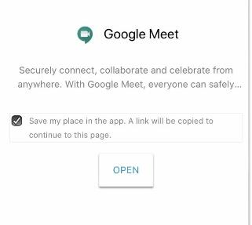
- Click on the meeting link on the Classroom banner or, if you don’t see the link,
look for the video icon and click on it
- Your device will prompt you to download the
Google Meet App – click OPEN
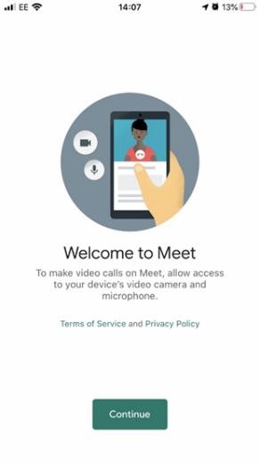
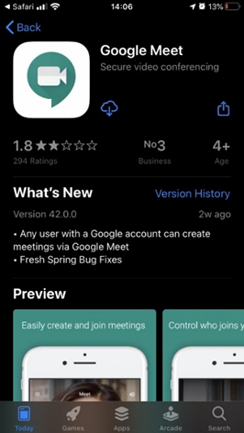
- You need to download the app from your app store and once you click to download you’ll see a Welcome to Meet message – click Continue and allow access to your camera and microphone when prompted
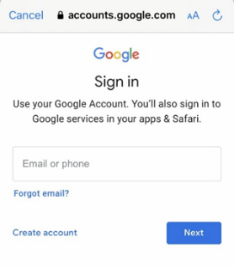
- Click to Sign In and Choose an Account – you need to use your Glow account and it should have the @sl.glow.scot ending not @glow.sch.uk
If you don’t see your Glow account, then click to Add another account and enter your Glow account details – REMEMBER username@sl.glow.scot not glow.sch.uk
- You are now in Google Meet – but if your teacher hasn’t started the meeting you won’t be able to join yet. Controls for camera, microphone and hang up are on the screen and more controls can be accessed once the meeting starts, including closed captions, as well as tabs for chat and attendees. Turning your phone landscape can improve the Meet experience as presenters and presentations are displayed in a larger format.

Parents/carers – helping your child with Google meetings

Before the online meeting starts
- Information and a schedule of meetings will be made available to learners in advance of any online sessions; learners are asked to ensure these are shared with parents/carers to help you plan for online lessons/meetings
- Help your child by finding a quiet and well-lit place, preferably not a bedroom, to take part in online lessons; the background area should be clear and away from an area where other members of the household may be visible on camera
- Remind your child of the need to behave appropriately and to follow teacher instructions and the class code of conduct; for younger children it would be desirable if you stayed close by to monitor their activity
Inappropriate behaviour may result in a child being removed from a lesson and a follow-up discussion with senior school staff
- All online meetings will be recorded to ensure everyone feels safe and secure while using videoconferencing – your child will be reminded of this before recordings begin; only teachers are permitted to record meetings

Connecting to the online meeting
- Your child has been provided with instructions for joining a Google Meet videoconference but may require some help getting the sound and/or camera to work – you can help your child explore the different settings for this prior to an online session starting
- Go to https://meet.google.com – learners are not able to start or create meetings but from his window they can click on the settings cog on the top right of the screen
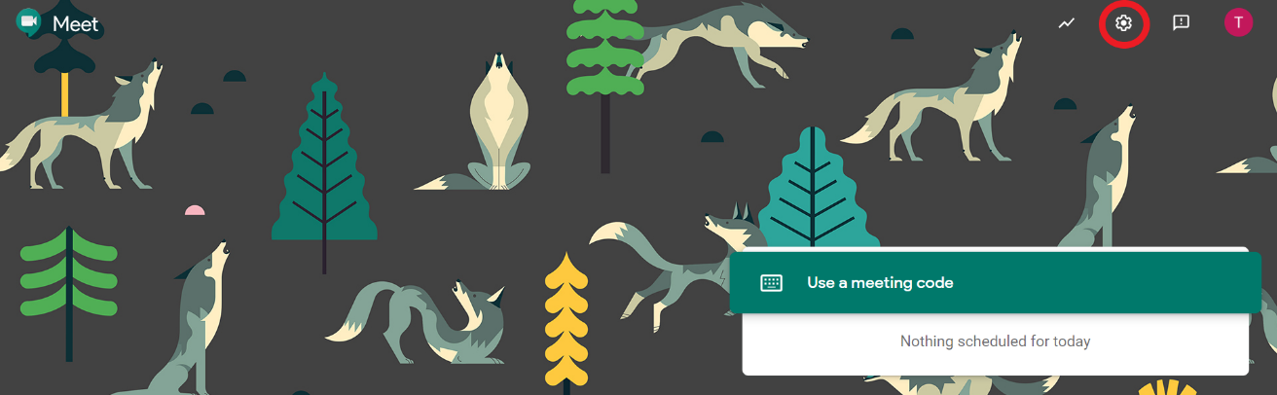
Audio settings – from this window your child can select to use their headphones instead of the default speakers; Video settings – your child can select a different webcam if required
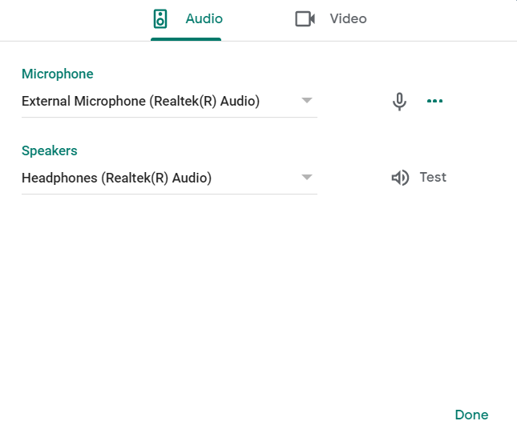
Your child may also require help downloading the Meet app onto a tablet or mobile device – instructions for this can be found in the Learner instructions.

During the online meeting
- It is important that parents/carers do not attempt to participate in online meetings with learners, this is to protect your own privacy and that of others. If you need to speak to your child’s teacher, please use the usual means of communication to do this.
If you child is experiencing difficulty during a meeting they should use the chat facility to communicate this to their teacher, parent/carers must not interrupt meetings by speaking or appearing on camera.

After the online meeting
- It would be helpful if you could follow up with your child after online meetings (depending on their age and stage) to ensure they are clear about next steps provided by their teacher.
- If you have any concerns about the use of Google Meet or the content of online lessons, please contact the school using the normal channels of communication.

