28/8/20

Dear Parent/Carer

Face Coverings Update - Primary Schools

As you may be aware the Scottish Government announced changes to the wearing of face coverings in schools and on school transport. These changes will be implemented from 31 August 2020.

This means that from Monday all pupils aged 5 and over will be expected to wear a face covering on school transport, just as they already do on public transport.

Unlike secondary schools, there is no requirement for primary pupils to wear face coverings during the school day, unless they choose to do so.

We appreciate that children may feel more comfortable in using their own face coverings however please be assured that a supply of re-usable face coverings will be available within school if required.

Please see links below to resources to help you discuss these changes with your child.

https://youtu.be/3fya_vJEc4o

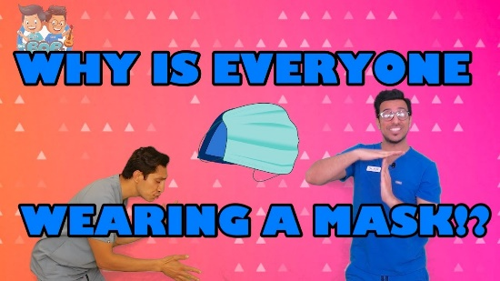 | Coronavirus Safety Measures For Kids | Mask Episode by Drs Bop 'n Pop | Education for Kids!  Having trouble explaining what Coronavirus is to your kids?! Here we talk about what Coronavirus or COVID-19 for children! Check out this educational episode...  youtu.be
(for P1 and P2)

https://youtu.be/iE6L-4tO-rs
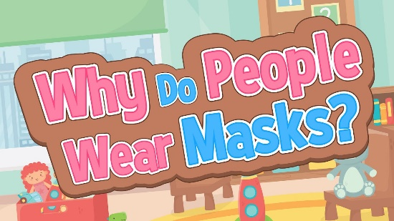 | Why Do People Wear Masks | Little Ones Version | Jack Hartmann  Why do people wear masks? It's ok to ask. In Jack Hartmann's Why Do People Wear Masks video Jack explains the importance of wearing masks and who wears a mas...  youtu.be
(for P1 & P2)

http://www.childcareresources.org/wp-content/uploads/2020/04/COVID-19-Masks-Book-Young-Kids.pdf
SCARY! MASKS AREN'T - Child Care Resources
Child Care Resources is a 501(c)(3) nonprofit. Our mission is to help kids grow into successful adults by enriching the learning environment of
www.childcareresources.org
Online story

https://kidshealth.org/en/parents/coronavirus-masks.html

Information - scroll to bottom for short video for older pupils

https://www.cdc.gov/coronavirus/2019-ncov/prevent-getting-sick/how-to-wear-cloth-face-coverings.html
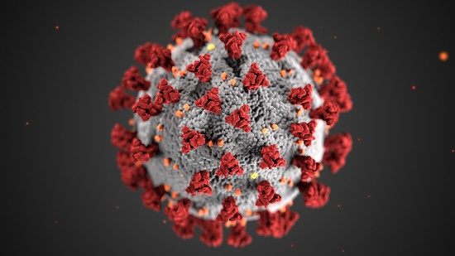 | How to Safely Wear and Take Off a Cloth Face Covering | CDC  Coronavirus disease 2019 (COVID-19) is a virus (more specifically, a coronavirus) identified as the cause of an outbreak of respiratory illness first detected in Wuhan, China.  www.cdc.gov

The safety and wellbeing of children, young people and staff is paramount and your cooperation in this matter is greatly appreciated.

Yours sincerely,

Eileen Feeley

Head Teacher

