**Strategic Improvement Priorities over 3 year cycle Timescale:**

|  |  |  |  |
| --- | --- | --- | --- |
| Strategic Priority | Year 1  2023/2024 | Year 2  2024/2025 | Year 3  2025/2026 |
| **School Focuses** | | | |
| 1. | Develop Technologies, specifically develop Digital Literacy and introduce Computing Science to be developed across the school and nursery. Introduce Technological Developments in society and business | Raise attainment in Literacy, focusing on reading and writing in all classes, aided through the use of digital literacy approaches. We will begin to look at developing Computing Science, taking into account technological developments in society and business and focusing on key skills. | Introduce Craft design, engineering and graphics.  Introduce food and textile technology,  All aspects of digital literacy and computing science embedded across our curriculum |
| 2. | Reading Schools – Silver Award | Increase engagement in Reading – striving to achieve our Reading Schools Gold Award through building on our whole school approaches, including family and community learning to attain our Gold Award. | developing Play Pedagogy and Approaches across all stages of the school and embedding in our early years classes |
| 3. | Developing in Faith - Diversity and Inclusivity | Learning Community – build and further develop staff, parent and learners’ understanding of UNCRC, Anti-Racism and diversity and respect for all. | Developing in Faith Focus – further embed anti-racism approaches and inclusive environment. |
| 4. | Attachment Informed Practice | Ensure the wellbeing needs of learners are identified using techniques and strategies from the Attachment Network, building on and reevaluating our Relationship Policy | Continue to build on attachment approaches and further our Play develop our approaches across all stages of the school and embedding in our early years classes |
| **Nursery Focuses** | | | |
|  |  | Use SLC trackers and progression pathways to effectively deliver excellent, high quality learning and teaching within our nursery |  |
| 2. |  | Increase engagement in Reading – striving to achieve our Reading Schools Gold Award through building on our whole school approaches, including family and community learning to attain our Gold Award. |  |

**Context of school**

St Elizabeth’s is in the Eddlewood area of Hamilton and has a diverse catchment area with children attending from Eddlewood as well as Silvertonhill. We are a Catholic Primary School with a large Nursery Class feeding into Holy Cross High School and linking in with 9 other feeder primary schools.

Our SIMD/FME data currently indicates 58% of our children fall into this category. We have a large range of children with English as an Additional Language, having a total of 19 different languages within our school. Our work is based upon our 6 values of Enjoyment, Faith, Kindness, Love, Perseverance and Respect and these are embedded within the daily life of our school and nursery. Together with our school vision of ‘striving to support and develop a love of lifelong learning for everyone and our school motto of Learn Together, Laugh Together, Be the Best You Can, we believe we create a focused, loving learning environment for our children and their families.

We are situated within the Holy Cross Learning Community and have strong links with the feeder primaries as well as with Holy Cross itself. We work well with both Hollandbush and Chatelherault Nursery as well as with the Early Years Team and have good links with early years staff in many establishments. We regularly work together for the benefit of our learners in a range of ways and have built and developed strong partnerships with a range of staff and agencies. We have a strong partnership with our neighbouring school Our Lady and St Anne’s and plan events for our children to enjoy, particularly linked with our Parish.

We have a very supportive parent body in both our school and nursery and regularly involve them in the work we do. Furthermore, our school Community Partnership Group meet monthly and work tirelessly to support our school by providing extra curricular opportunities for our families.

Our Curriculum is based upon the 4 Contexts of Learning – the Ethos and Life of our Nursery/School; Curricular Areas; Interdisciplinary Learning; Opportunities for Personal Achievement. Promoting Positive Relationships is pivotal to our success and we aim to build relationships within a kind, respectful ethos, based on the integral Gospel value of love. This aligns with our school and nursery values. We encourage our children to participate in a range of opportunities to develop responsibility and leadership at all stages, being involved in a range of roles to help promote respect of themselves and others.

Our pupils hugely benefit from a range of extra curricular activities throughout the school year, offered and led by our Active Schools Co-ordinator as well as by school staff and some senior pupils. Each year, our Primary 7 pupils are offered the opportunity to experience a week long residential trip, building on their team building skills as well as their resilience, wellbeing and sense of achievement. Our pupils take part in our weekly celebration assemblies and are encouraged to share information about any successes that occur out with school. This is shared further within our school and nursery community on our social media apps. Our children are also given the opportunity to participate in local events involving them in numeracy, athletics, literacy and modern language events.

The following information details our key focuses for session 2024/2025.

**Performance Data - Achievement of Curriculum for Excellence Levels (2022/23)**

**The following data informs our school improvement plan and self-evaluation as part of our standards and quality reporting.**

File path: [Data Portal](https://glowscotland.sharepoint.com/sites/SouthLanarkshire/Staff/headteachers/HTtest/slcdataportal/Shared%20Documents/Forms/AllItems.aspx) > Primary > Attainment Tools > SSR 1.0a.xls

**Performance Data - Excellence**

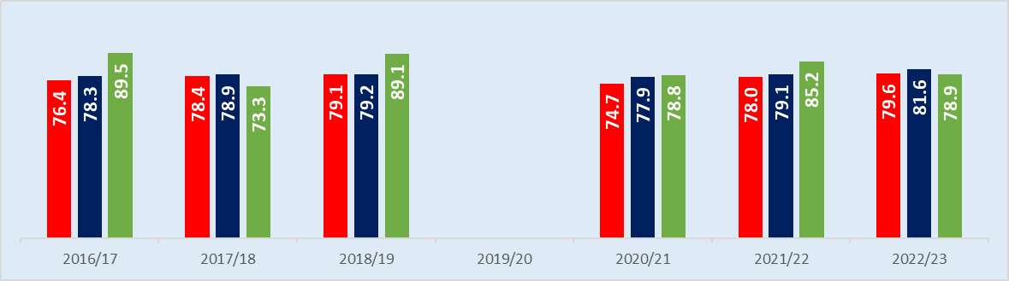

**Numeracy**

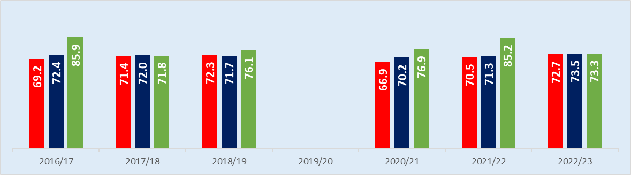

**Literacy**

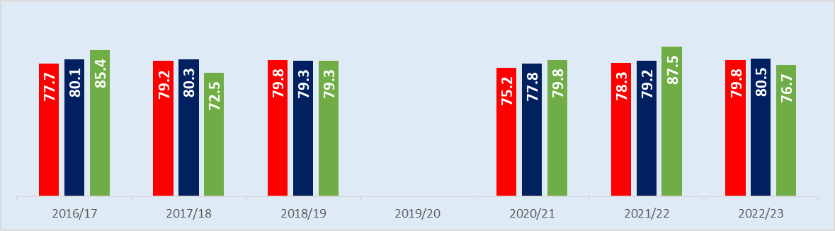

**Reading**

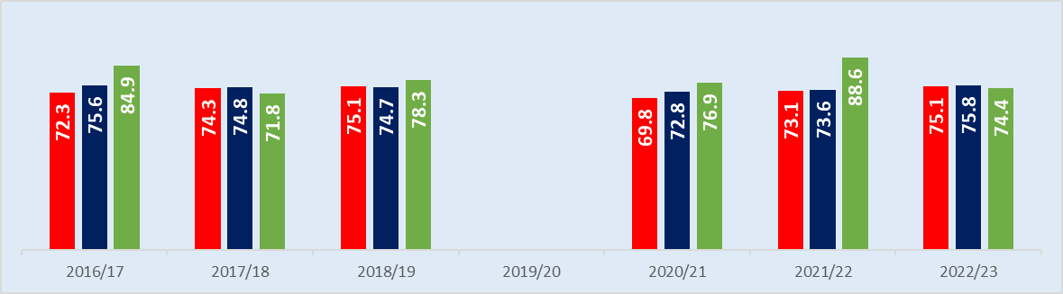

**Writing**

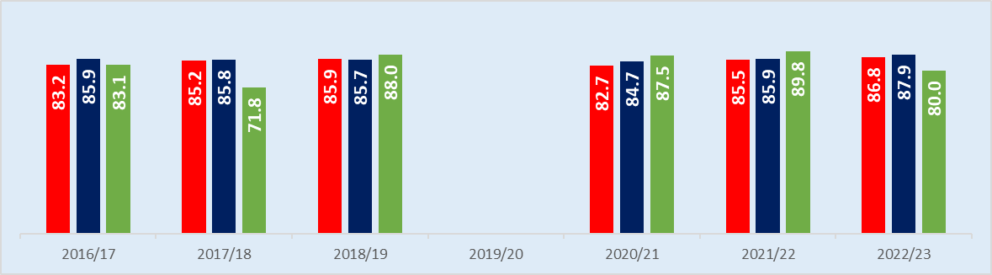

**Listening & Talking**

**Performance Data –**







**Equity (Local)**

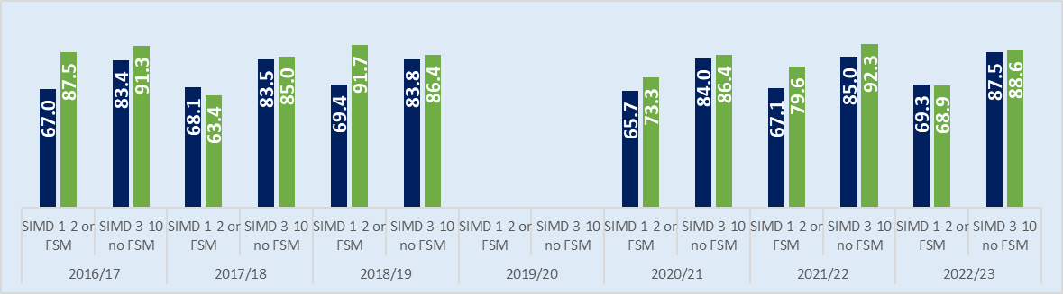

**Numeracy**

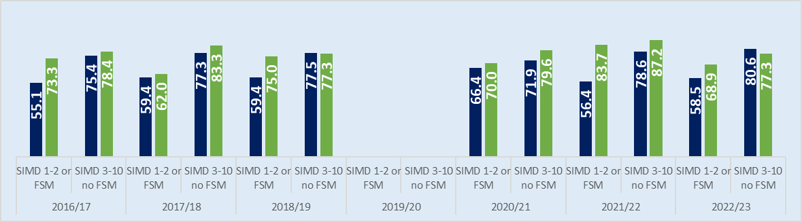

**Literacy**

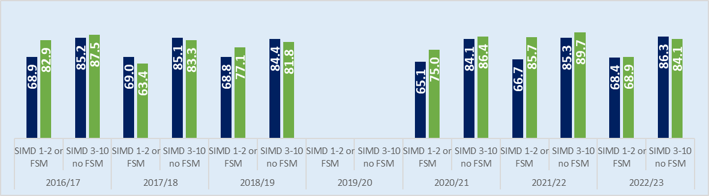

**Reading**

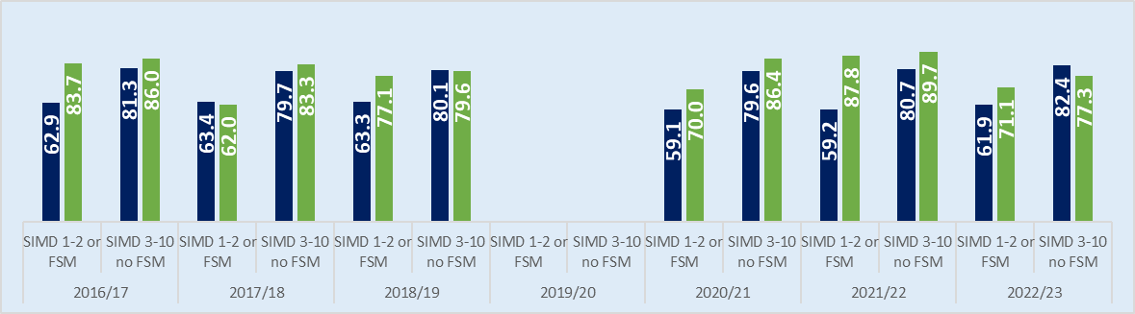

**Writing**

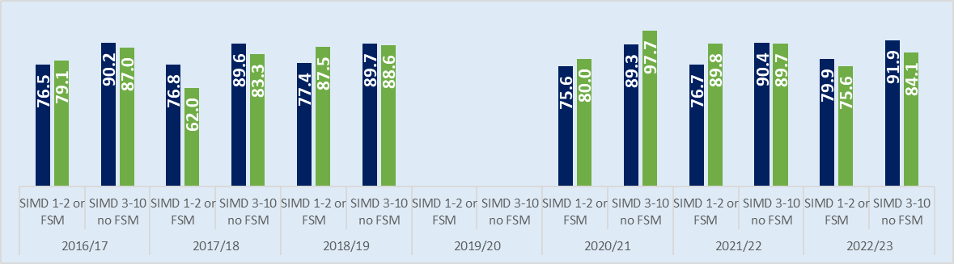

**Listening & Talking**

Improvement Planning and Standards and Quality Reporting for 2024/2025

**School Strategic Priority 1 – Increase Digital Literacy to help raise attainment**

|  |  |  |  |  |  |
| --- | --- | --- | --- | --- | --- |
| **NIF Priority (select from drop down menus)**  Improvement in attainment, particularly in literacy and numeracy.  **NIF Driver**  Curriculum and assessment  Teacher and practitioner professionalism | **SLC Priority (select from drop down menus)**  **Provide a rich and stimulating curriculum that helps raise standards in literacy and numeracy**  **Support children and young people to develop their skills for learning, life and work** | **SLC Stretch Aims**  **ACEL Primary – Literacy – P1, P4 & P7 combined**  **ACEL Primary – Numeracy – P1, P4 & P7 combined** | | **HGIOS?4 QIs (select from drop down menus)**  1.2 Leadership of learning  2.3 Learning, teaching and assessment  3.2 Raising attainment and achievement | |
| **Rationale for strategic priority** | **Outcome (Intended impact)** | **Operational activity** | | **Measures** | **School Lead** |
| Raise attainment in Literacy across the school through continued implementation of digital literacy approaches.  We will begin to look at developing Computing Science, taking into account technological developments in society and business and focusing on key skills for learning, life and work. | 1.By June 2025, almost all identified children in P2, P3 and P5 will have made progress in attainment in literacy. | * Continue to use IDL Literacy, 5 minute box, NELI to support identified children in literacy. * All teaching staff to be refreshed on the use of Read/Write facility on chromebooks and this will be incorporated into daily learning. | | * Assessment results and progress through IDL * Standardised assessments * Pupil Evaluations | *HT/APT*  *All staff* |
| 2.By June 2025, almost all identified pupils will have made progress in attainment in numeracy | * All classes to follow progression pathway for Digital Technologies * Continue to use IDL Numeracy, Number Box to support identified children in numeracy * All teaching staff to be refreshed on the use Number Talks and support materials for numeracy * Support staff to share skills with each other | | * Assessment results and progress through IDL * Standardised assessments * Class work * Pupil Evaluations | *HT/APT*  *All staff* |
| 2.By June 2025, almost all pupils will have developed their digital skills and confidence | * All classes to continue to follow the SLC progression pathway for Digital Technologies * Pupil Focus Group and Digital Leaders identified to buddy up with identified children and be able to support | | * Class work and assessment * Digital Leader evaluations * Teacher Evaluations | *HT/APT*  *All staff* |
| By Dec 24, all staff will have continued to increase their confidence with digital technologies  By June 2025, we will have built staff confidence in Computing Science | * Staff development days – time allocated for key focuses * Working party to continue to help develop * Staff sharing of skills through peer learning in classes | | * Pupil Feedback * Teacher Observations * Learning Community Professional Dialogue | *HT/APT*  *All staff* |
| **Progress and Impact** | | | **Next Step(s) and rationale to inform SIP for 2025/2026 or establishment maintenance agenda** | | |
|  | | |  | | |

Improvement Planning and Standards and Quality Reporting for 2024/2025

**School - Strategic Priority 2 Reading Schools – Gold Award**

|  |  |  |  |  |  |
| --- | --- | --- | --- | --- | --- |
| **NIF Priority (select from drop down menus)**  Improvement in attainment, particularly in literacy and numeracy.  **NIF Driver**  Parent/carer involvement and engagement  School and ELC leadership | **SLC Priority (select from drop down menus)**  **Provide a rich and stimulating curriculum that helps raise standards in literacy and numeracy**  **Ensure inclusion, equity and equality are at the heart of what we do** | **SLC Stretch Aims**  **ACEL Primary – Literacy – P1, P4 & P7 combined**  **Attendance** | **HGIOS?4 QIs (select from drop down menus)**  2.3 Learning, teaching and assessment  2.5 Family learning  3.1 Ensuring wellbeing, equality and inclusion | | |
| **Rationale for strategic priority** | **Outcome (Intended impact)** | **Operational activity** | **Measures** | | **School Lead** |
| Our literacy data continues to indicate a need to improve on children’s reading skills particularly at our P2, P5 and P6 stages.  Reading for Pleasure is a school wide priority. | * By October 2024, opportunities for all children and families to have access to appropriate reading materials which will help reduce barriers to reading for enjoyment | * Encourage families to join local library-Kathleen from Fairhill Library in school * Start Family Book Club * Lending Library for adults to be created in School reception area | * Pupil and parent questionnaires * Teacher evaluations * Monitor of family engagement | | *HT,*  *Reading Schools Lead,* |
| * By September 2024, all children to begin to understand theme of inclusion and diversity more fully through transition book work. * Through transition book, all children demonstrate an understanding of the importance of recognizing the different needs of children and being respectful of them which will positively impact on all families and children | * Engage families in each class’s I.D.L.   Book Project at the start of term  P.1 King of the Classroom  P.2-3 All are Welcome  P.4-7 If the World were a 100 People | * Pupil evaluations * Monitor links to UNCRC | | *HT*  *All staff* |
| * By June 2025, parental engagement and involvement will have continued through stay and learn events in school. Help share learning, targeting identified families and children to help raise the engagement and attainment of identified children | * Children to self evaluate their progress in reading and what they want to focus on this session. * Continue to build on use of padlets to share info with home and families | * Self Evaluation toolkit with children * Audit use of padlet amongst families | | *All staff* |
| * Staff knowledge, personal reading skills and engagement will impact positively on the teaching and learning of and enthusiasm for reading. | * Create Staff Book Club. * Join Local Authority Book Club | * Staff Development Day evaluations * Pupil questionnaires | | *HT*  *All staff* |
| * By October 2024, good practice will be shared and reviewed/evaluated, identifying gaps and amend as needed * By June 2025, all children’s will experience engagement with other pupils out with our school * By March 2025, P6 and P7 pupils to experience a range of business links throughout the year. * Community understanding of the work of our school to be increased due to events and pupils being engaged with businesses. | * Establish links with a Core/Silver Level Reading School to operate as an Ambassador school * Work with Fairhill Library on joint Reading Project * Work with Our Lady and Saint Anne’s Church and local Hairdresser’s to encourage customers to “Read while you Wait” * Work with partner schools to build reading culture * World of Work activities to be promoted throughout the year. | * Focus Group feedback involving pupils and staff * World of Work links * Pupil evaluations * Staff observations * Staff evaluations | | *HT*  *Reading Schools Lead* |
|  | * By June 2025, all pupils will have an increased awareness of Equality and Inclusion within our school community, building respect and understanding of others. | * All children have access to contemporary and diverse reading materials which are relevant to the needs/ languages and cultural identities of the children | * Learners audit and order books to update contemporary and diverse reading materials which are relevant to the needs/ languages and cultural identities of the children | | *HT*  *Reading Schools Lead* |
|  | * By June 2025, positive impact on health and wellbeing needs as well as literacy needs due to focused time allocated to reading for enjoyment with a wide variety of books on offer to help meet the needs of identified children, using digital technologies as appropriate. | * Staff prioritise DEAR Time throughout the year, demonstrating a secure knowledge of readers’ interests and supporting them with appropriate book recommendations. | * Sharing Assembly * Pupil reading survey completed in Oct 24 and then in May 25 | | *HT*  *Reading Schools Lead* |
| **Progress and Impact** | | | | **Next Step(s) and rationale to inform SIP for 2025/2026 or establishment maintenance agenda** | |
|  | | | |  | |

Improvement Planning and Standards and Quality Reporting for 2024/2025

**School Strategic Priority 3 Developing in Faith**

|  |  |  |  |  |  |
| --- | --- | --- | --- | --- | --- |
| **NIF Priority (select from drop down menus)**  Placing the human rights and needs of every child and young person at the centre of education  **NIF Driver**  Teacher and practitioner professionalism  Choose an item. | **SLC Priority (select from drop down menus)**  **Improve Health and Wellbeing to enable children and families to flourish**  **Ensure inclusion, equity and equality are at the heart of what we do** | **SLC Stretch Aims**  **Attendance**  **Attendance** | **HGIOS?4 QIs (select from drop down menus)**  1.2 Leadership of learning  3.1 Ensuring wellbeing, equality and inclusion  Choose an item. | | |
| **Rationale for strategic priority** | **Outcome (Intended impact)** | **Operational activity** | **Measures** | | **School Lead** |
| To further promote an inclusive ethos which aims to honour the life, dignity and voice of each person, made in the image of God  Attachment Informed Practice is an SLC priority and monitoring and evaluation processes have highlighted a need to enhance our Attachment Informed Approaches across the school.  As we review our Relationships Policy and due to the increase in the number of learners with ASN within our school, we recognise that, as a staff, we need to consider the class/school environment to best meet these needs. | **Attachment Informed Practice -** (PSR Focus)  By the end of August 2024, staff will have considered their classroom and playrooms set up in order to ensure it is best meeting children’s needs. | **Attachment Informed Practice**   * The Circle Framework – section 1: Environment. | * Staff will complete an audit of their classroom and adapt it using suggestions/ information in The Circle Framework. | | HT, all staff in school and nursery |
| By June 2024, almost all Primary 5, 6 and P7 pupils will have developed a greater awareness of adversity and trauma and how to support themselves and others.  Accreditation of Attachment Pledge 1 ‘Act to Make a Difference’ | * All Primary 6 pupils will participate in mental health and wellbeing lessons using ‘The Compassionate and Connected Classroom’. * All Staff to complete Readiness for Change Pledge 1: Act to Make a Difference survey and   begin working on the points within the subsequent action plan | * HGIOURS – Pupil Voice Groups/Wee Blethers * The Circle: Inclusive Classroom audits | | P6 teacher  HT, all staff |
| By March 25 Attachment Pledge 2 ‘Recognise Behaviour as Communication’. | * All Staff to complete Pledge 2: ‘Recognise Behaviour as Communication’ survey and begin working on the points within the subsequent action plan. | * Staff, parent and pupil evaluations | | HT, all staff in school and nursery |
| By June 25 Attachment Pledge 3: ‘Respond with compassion’ will have been created to highlight requirements for accreditation. | * Submit evidence to Attachment Accreditation panel. | * Jigsaw pledges received | | HT  All staff in school and nursery |
| Anti-Racism  Theme 4 of the Race Equality Framework for Scotland 2016-2030 states that Everyone has the opportunity to learn in an inclusive environment without disadvantage in relation to racial inequality or racism.  Article 29 of the UNCRC | Anti-Racism  By November 2024, all teachers will confidently know where to access Anti Racism education materials, CLPL and support.  All pupils will have experience of a text which has a theme of race equality. | Anti-Racism   * Promote the use of the Curriculum Hub – Anti Racist Education, and SLC Framework for developing an Anti-Racist and decolonised curriculum. * Transition book used at the start of term in each class has links to race equality and diversity. | Anti-Racism   * Staff confidence survey on Anti-Racism Education (June24/ May25) | | HT, all staff |
| By June 2025, almost all Primary 7 pupils will further develop their knowledge and understanding of Anti-Racism, unconscious bias and representation matters. | * Teachers will begin to engage with Education Scotland document Promoting & Developing race equality and anti-racist education: an overview | * Staff evaluation discussions about current practice and next steps. * Survey results * Minutes of discussions * Teacher Evaluations * Moderation of Practice | | HT, all staff |
| By June 2025, almost all Primary 6 and 7npupils will participate more confidently in discussions around inclusion within our school and wider society. | * All Primary 6 and 7 pupils will complete a block of lessons about Anti-Racism. | * Class work * Sharing Assembly * Pupil Focus Group * Teacher Evaluations | | P6 and P7 teachers |
| By June 2025, almost all Primary 5 pupils will participate more confidently in discussions around inclusion within our school and wider society. | * All Primary 5 pupils will study the novel ‘Planet Omar’ by Zanib Mian to raise awareness of diversity and inclusion. | * Class work * Sharing Assembly * Pupil Focus Group * Teacher Evaluations | | P5 teacher |
| By June 2025, teacher awareness of resources and issues will be discussed and shared. | * Teachers to discuss their approach to their novel with colleagues within the Learning Community. | * Learning Community work with peers * Teacher Evaluations | | All staff |
| By June 2025, parental awareness of race equality and inclusion will have increased amongst almost all parents | * Parents/Carers on the Parent Council will participate in a discussions about anti-racism education and will be shown the materials we have been using. | * All Parents/Carers surveyed at Parents’ Evening in Nov and March on anti-racist education | | HT |
| By June 2025, almost all Primary 7 pupils will further develop their knowledge and understanding of Anti-Racism, unconscious bias and representation matters. | * All Primary 7 pupils will complete a block of lessons about Anti-Racism. * This will be shared at a whole school Assembly | * Class work * Sharing Assembly * Pupil Focus Group * Teacher Evaluations | | HT  P7 teacher |
|  | By June 2025, almost all Primary 7 pupils will have the opportunity to share their learning experiences and knowledge out with the school community. | * Organisation of a sharing event with Holy Cross Learning Community schools. * Pupils to create a workshop activity for other schools based on their knowledge and experiences. | * Pupil Feedback * Teacher Observations * Learning Community Professional Dialogue | | HT  All staff |
| **UNCRC**  We have identified a need to focus our attention on the UNCRC and to incorporate these rights into the work of our school.identified that while the children were aware of the UNCRC, this should now become a focus for the school to further embed and become more consistent across the school.  The UNCRC (incorporation) (Scotland) Act (2024) incorporates the need to make rights real for every child. | **UNCRC**  By June 2025, all pupils will be aware that they are entitled to all 54 children’s rights regardless.  All stakeholders will be made aware of some children’s rights and will give examples of how children’s rights are met within school.  By June 2025, most pupils will report that they:  are empowered and have their views taken seriously; are encouraged to play an active role in their own learning; and are becoming active citizens regarding any local and global issues. | **UNCRC**  Staff will teach their class about their rights within the UNCRC and the four categories of rights these all fall into.  Pupils and staff will select the rights most pertinent to their age/stage and create a class rights-based charter.  The language of rights will be used at assemblies and around the school by all staff.  Pupil groups will be supported to express their views appropriately and will be involved in decisions which affect their lives in school.  The UNCRC and SDGs will feature in our sustainability topic planning. | * Pupil evaluations * Staff evaluations * Parental evaluations * Observations of engagement around the school. * Pupil Group feedback | | HT  All staff |
| **Progress and Impact** | | | | **Next Step(s) and rationale to inform SIP for 2025/2026 or establishment maintenance agenda** | |
|  | | | |  | |

Improvement Planning and Standards and Quality Reporting for 2024/2025

**School Strategic Priority 4 – Play Pedagogy**

|  |  |  |  |  |  |
| --- | --- | --- | --- | --- | --- |
| **NIF Priority (select from drop down menus)**  Improvement in attainment, particularly in literacy and numeracy.  **NIF Driver**  Curriculum and assessment  Teacher and practitioner professionalism | **SLC Priority (select from drop down menus)**  **Provide a rich and stimulating curriculum that helps raise standards in literacy and numeracy**  **Support children and young people to develop their skills for learning, life and work** | **SLC Stretch Aims**  **ACEL Primary – Literacy – P1, P4 & P7 combined**  **ACEL Primary – Numeracy – P1, P4 & P7 combined** | | **HGIOS?4 QIs (select from drop down menus)**  1.2 Leadership of learning  2.3 Learning, teaching and assessment  3.2 Raising attainment and achievement | |
| **Rationale for strategic priority** | **Outcome (Intended impact)** | **Operational activity** | | **Measures** | **School Lead** |
| Continue to build on our approaches to play in the early years and introduce enquiry based learning into P4-P7 classes | 1.Introduce Fun 31 for a Friday afternoon, linking in to the UNCRC 31ST right – the right to play and socialize. | * Children will have opportunities to experience a range of play in a range of areas across the school. * Consult children on the types of play they would like and incorporate outdoor play for all stages * We will link in with nursery children to help build the capacity for interaction with older buddy children | | * Staff Observations * Pupil Evaluations | *HT*  *All staff* |
|  | 2.By Dec 2024, we will have continued to monitored play within P1 and P2, working through the SLC Play pedagogy and developing our own policy and procedures. | * Early Years staff meeting to discuss observations, planned learning experiences and pupil voice and how this impacts of learning in early years. | | * Pupil Evaluations * Staff Evaluations | *HT*  *All staff* |
| **Progress and Impact** | | | **Next Step(s) and rationale to inform SIP for 2025/2026 or establishment maintenance agenda** | | |
|  | | |  | | |

PEF Improvement Planning and Standards and Quality Reporting for 2024/25

|  |  |  |  |  |  |  |
| --- | --- | --- | --- | --- | --- | --- |
| **SLC Stretch Aims**  **ACEL Primary – Literacy – P1, P4 & P7 combined**  **ACEL Primary – Numeracy – P1, P4 & P7 combined**  **Attendance** | | | | | | |
| **Rationale for PEF / PB Spend** | **Allocation of PEF / PB spend** | **Outcome (Intended impact)** | **Operational activity** | **Measures** | **Mid year review**  **RAG** | **End of year review**  **RAG** |
| 0.3 Teacher from  Apr to Aug 2024 | £5,065.33 | Pupils receiving focused support across the school. | Teacher in class | * Assessment data  * Pupils conversations |  |  |
| 0.7 teacher from  Apr to Aug 2024 | £12,633.33 | Pupils receiving focused support across the school. | Teacher in class | * Assessment data  * Pupils conversations |  |  |
| Counselling  support | £2,250 | Identified pupils and families have received a year long input from a Barnardo’s Counsellor, resulting in their emotional and social wellbeing increasing | *Weekly support provided by counsellor  *Play sessions provided in school to develop social skills | *Feedback from parents and families  *Observations of children  *Feedback from Counsellor |  |  |
| Swimming | £625.00 | Increase our P5 children’s self confidence and emotional wellbeing, as well as ensure they had the important life skill of being able to swim. | *Block of swimming for 5 weeks, to be continued into P6 session 24/25 | *Info from swimming instructor  *Pupil engagement  *Teacher observations |  |  |
| Chromebooks | £6,000 | Our focus on digital skills has resulted in us increasing the hardware we have available. Also, due to the Refresh program, our devices were reducing considerably and as this would have had a negative impact on learning and teaching, as a staff we decided to purchase additional devices. | *Chromebooks are available for use with in each class on a daily basis to help support learning | *Monitoring the impact of technology on attainment and support |  |  |
| Through our digital literacy focus, we have agreed it would be helpful to introduce the use of Clickview across our school | £610.50 | Increase skills in watching, talking and listening. | *Talking and listening being promoted through play in the early years and through enquiry based learning further up the school. | * Pupil questionnaire  * Staff evaluations |  |  |
| We have still to allocate the remainder of our budget but are considering new resources to help support reading from P1 to P3, new library resources identified through our Gold Award Action Plan, new Expressive Arts resources and further resources to develop Attachment and Anti Racism understanding |  |  |  |  |  |  |
|  |  |  |  |  |  |  |
|  | TOTAL SPEND (incl carry forward) £ |  |  |  |  |  |
| ***Progress and Impact*** | | | **Next Step(s) and rationale to inform PEF spend session 2025/2026.** | | | |
|  | | |  | | | |

Improvement Planning and Standards and Quality Reporting for 2024/2025

**Nursery Strategic Priority 1 – Increase Early Literacy and Numeracy Skills**

|  |  |  |  |  |  |
| --- | --- | --- | --- | --- | --- |
| **NIF Priority (select from drop down menus)**  Improvement in attainment, particularly in literacy and numeracy.  **NIF Driver**  Curriculum and assessment  Teacher and practitioner professionalism | **SLC Priority (select from drop down menus)**  **Provide a rich and stimulating curriculum that helps raise standards in literacy and numeracy**  **Support children and young people to develop their skills for learning, life and work** | **SLC Stretch Aims**  **ACEL Primary – Literacy – P1, P4 & P7 combined**  **ACEL Primary – Numeracy – P1, P4 & P7 combined** | | **HGIOELC QIs (select from drop down menus)**  3.2 Securing children’s progress  2.3 Learning teaching and assessment  1.4 Leadership and management of practitioners | |
| **Rationale for strategic priority** | **Outcome (Intended impact)** | **Operational activity** | | **Measures** | **School Lead** |
| Raise attainment in early literacy and numeracy skills across the nursery and continue with the implementation of digital literacy approaches as appropriate. | 1.By June 2025, all children in our 2-3 room will have been exposed to 10 nursery rhymes/songs; all ante-preschool children will have been exposed to 10 nursery rhymes/songs, bringing the total they will have experienced to 20; all pre-school children another 10, bringing their total to 30. | * Staff to include nursery rhymes/songs into their planning and follow agreed programme within the nursery | | * Children’s confidence in reciting rhymes * Observations and monitoring of children’s early talking and listening skills | *HT/EYD*  *All staff* |
|  | 2. By June 2025, almost all children will be on track with literacy and numeracy progress relevant to their stage of development and be ready for the next stage in their learning | * Personal plans to reflect ongoing key literacy and numeracy targets for all children * Parental engagement events to be held to showcase learning experiences that can be followed through at home. | | * Planning Folders * Trackers * Professional discussions * Parent/child evaluations | *HT/EYD*  *All staff* |
|  | 3.By Dec 2024, staff will feel more confident in the use of SLC trackers and SLC Planning. | * Staff to incorporate SLC planning tools into their planning of experiences within the nursery. * Staff to become more familiar with Early Years Trackers across the nursery and to use these robustly moving forward. * Identified children will receive appropriate support, particularly pre-schoolers | | * Tracker documents * Planning documents | *HT/EYD*  *All staff* |
|  |  |  | |  |  |
| **Progress and Impact** | | | **Next Step(s) and rationale to inform SIP for 2025/2026 or establishment maintenance agenda** | | |
|  | | |  | | |

Improvement Planning and Standards and Quality Reporting for 2024/2025

**Nursery Strategic Priority 2 – Reading Schools – Gold Award**

|  |  |  |  |  |  |
| --- | --- | --- | --- | --- | --- |
| **NIF Priority (select from drop down menus)**  Choose an item.  **NIF Driver**  Choose an item.  Choose an item. | **SLC Priority (select from drop down menus)**  **Provide a rich and stimulating curriculum that helps raise standards in literacy and numeracy**  **Ensure inclusion, equity and equality are at the heart of what we do** | **SLC Stretch Aims**  **ACEL Primary – Literacy – P1, P4 & P7 combined**  **Attendance** | **HGIOS?4 QIs (select from drop down menus)**  2.3 Learning, teaching and assessment  2.5 Family learning  3.1 Ensuring wellbeing, equality and inclusion  **HGIOELC QIs (select from drop down menus)**  3.3 Developing creativity and skills for life and learning  2.5 Family learning  2.7 Partnership | | |
| **Rationale for strategic priority** | **Outcome (Intended impact)** | **Operational activity** | **Measures** | | **School Lead** |
| Our literacy data continues to indicate a need to improve on children’s literacy skills at the early stages  Reading for Pleasure is a school and nursery priority. | * Continue to raise our nursery profile within the community, which will allow our learners the opportunities to celebrate success more widely. | * Throughout the year, we will continue to invite members of the Community to take part in Reading Celebrations in the nursery * We will continue to Celebrate learner achievements and include community spaces this session * Work with school buddies on joint Reading Project – this to include 2-3 room, ante pre and pre-school children | * Community questionnaires to gather feedback * Parent focus group | | *HT, EYD, ALL STAFF*  *Reading Schools Lead,*  *All staff* |
|  | * Continue to build on parental engagement and involvement to help share learning | * Continue to build on use of padlets to share info with home, families and other nurseries | * Audit use of padlet amongst families | | *All staff* |
| * Continue to provide opportunities for all children and families to have access to appropriate reading materials which will help reduce barriers to reading for enjoyment | * Encourage families to join local library-Kathleen from Fairhill Library in nursery to meet with parents * Continue Book Bug * Parental lending library to continue in nursery reception area | * Child and parent questionnaires * Teacher evaluations * Monitor of family engagement | | *HT, EYD*  *Reading Schools Lead,* |
| * Continue to build staff knowledge and personal reading skills and engagement which will impact on the teaching and learning of and enthusiasm for reading. | * Create Staff Book Club, link in with Primary colleagues. * Early Years Workers to join Local Authority Book Club | * Staff Development Day evaluations * Children questionnaires | | *HT, EYD*  *All staff* |
| * Share good practice and review /evaluate what we are doing to identify gaps and amend as needed * Children’s engagement with other children out with our nursery to increase | * Establish links with a Core/Silver Level Reading School, or nursery to operate as an Ambassador Nursery * Work with Fairhill Library and the school children on joint Reading Project | * Focus Group feedback involving children and staff | | *HT, EYD*  *Reading Schools Lead* |
| * Increase awareness of Equality and inclusion within our school community, building respect and understanding of others. | * All children have access to contemporary and diverse reading materials which are relevant to the needs/ languages and cultural identities of the children | * Learners audit and order books with the help of buddies, to update contemporary and diverse reading materials which are relevant to the needs/ languages and cultural identities of the children in our nursery and community. | | *HT/EYD*  *Reading Schools Lead* |
| **Progress and Impact** | | | | **Next Step(s) and rationale to inform SIP for 2025/2026 or establishment maintenance agenda** | |
|  | | | |  | |

**Maintenance Agenda**

|  |  |  |
| --- | --- | --- |
| **Key actions** | **Relevant stakeholder involvement** | **Timeline for completion** |
| *Continue to build on expressive arts curriculum focusing on the Music and Drama experiences we provide for our children as we recognise this as a key area for further development and the importance this plays in children’s Health and Wellbeing* | *All children* | *Continuous for Session 2024/25* |
| *Continue to provide experiences for our children, in nursery and school, in the local woods. We have 2 members of staff trained in Forest Schools and we will continue to use their expertise in this area for the benefit of all our children. Parents have identified this as an area they would be keen to join us in.* | All children, staff and parents of particular stages in our school | *Continuous for Session 2024/25* |
|  |  |  |
|  |  |  |
|  |  |  |
|  |  |  |
|  |  |  |