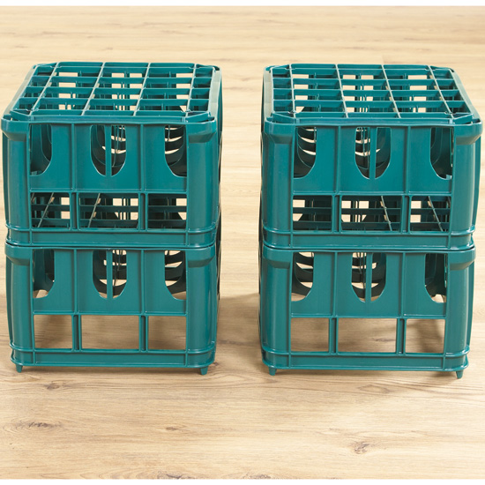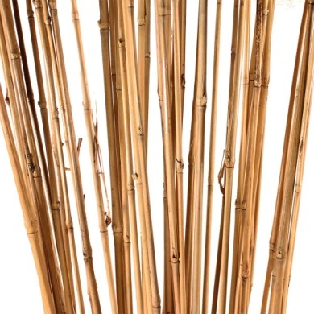[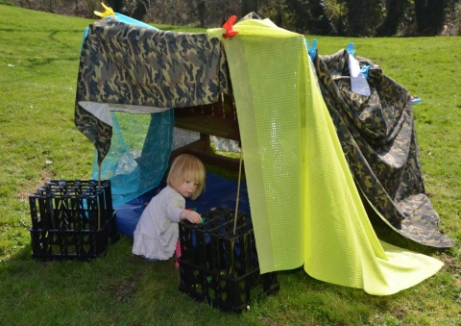](http://www.google.co.uk/url?sa=i&rct=j&q=&esrc=s&frm=1&source=images&cd=&cad=rja&uact=8&ved=0ahUKEwisl8Pa-oPLAhXKWRoKHecrCA0QjRwIBw&url=http://www.earlyyears.co.uk/inspiration/outdoor-play-5-den-building-ideas/&psig=AFQjCNHLnLOmJCAy4TI-Ba0P0h39S1kxcw&ust=1455975790231971)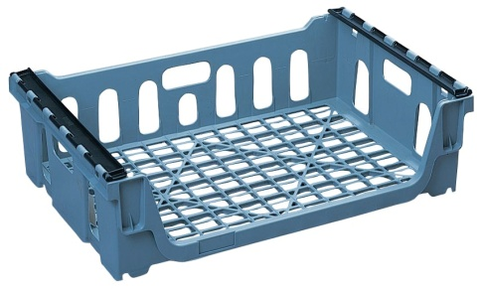

**Bottle / milk crates**

**Sticks for**

**den-building**

# Bread crates

# Fabric / sheets / tarpaulins for den-building

**Thank you.**

**St.Elizabeth’s ☺**

As part of our school Improvement Plan this year,

we are developing Outdoor Learning

and free play in our playground.

We hope to see more adventurous play and play which involves natural and recycled materials.

We are looking for some items to help us kick start this new approach and wondered if you could help us source them, preferably for free!

If you have any contacts or think you yourself could help, please contact us (285080).