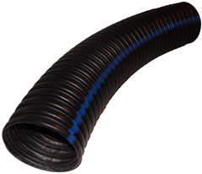

# Carpet samples /

# cardboard tubes

[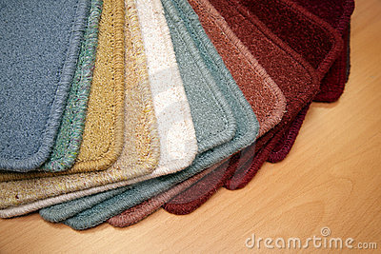](http://it.dreamstime.com/immagini-stock-libere-da-diritti-campioni-di-moquette-image4397279)

# Lengths of plastic pipe in all colours, shapes and sizes

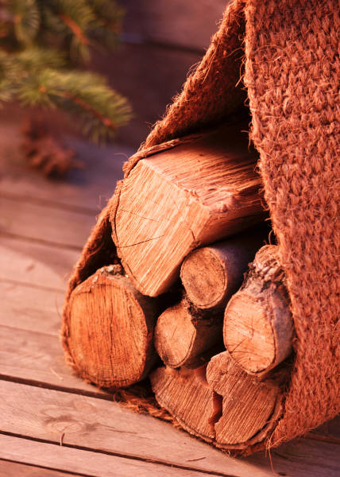

**Thank you.**

**St.Elizabeth’s ☺**

**Old decking / log cut offs**

As part of our school Improvement Plan this year,

we are developing Outdoor Learning

and free play in our playground.

We hope to see more adventurous play and play which involves natural and recycled materials.

We are looking for some items to help us kick start this new approach and wondered if you could help us source them, preferably for free!

If you have any contacts or think you yourself could help, please contact us (285080).