St Elizabeth’s Primary and Nursery School

[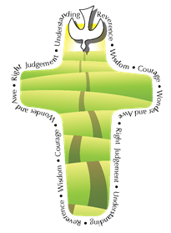](https://www.google.co.uk/url?sa=i&rct=j&q=&esrc=s&frm=1&source=images&cd=&ved=0ahUKEwiZu5WNwdbKAhWHbRQKHQpHCaEQjRwIBw&url=https%3A%2F%2Fblogs.glowscotland.org.uk%2Fnl%2Fstaugustines%2F2015%2F10%2F28%2Fpope-francis-faith-award%2F&psig=AFQjCNHKbqvvhJ851my0zZHSkoDO1agFZQ&ust=1454414131922722)

[](https://www.google.co.uk/url?sa=i&rct=j&q=&esrc=s&frm=1&source=images&cd=&ved=0ahUKEwiZu5WNwdbKAhWHbRQKHQpHCaEQjRwIBw&url=https%3A%2F%2Fblogs.glowscotland.org.uk%2Fnl%2Fstaugustines%2F2015%2F10%2F28%2Fpope-francis-faith-award%2F&psig=AFQjCNHKbqvvhJ851my0zZHSkoDO1agFZQ&ust=1454414131922722)

**Pope Francis Faith Award**

Lucy Mackay

Cole Taylor

Daniel Pollock

Josh McPartlin

Holly Dougan

Ian Benson

Hannah Kearney

Carly Kenny

Caragh Fraser

Kian Hainie

Leah Donald

Leah Burns

Beth McMenemen

How beautiful it would be if each of you, every evening, could say: “Today at school, at home, at work, guided by God, I showed a sign of love towards one of my friends, my parents, an older person!”

*(Pope Francis, addressing young people, April 2013)*