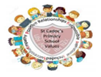
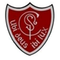
Welcome
Where there is God there is light
March 2026
St Cadoc’s Primary
Newsletter



Dear Parents/Carers,

The Lenten season marks a special time of reflection and preparation. Our pupils are embracing this by leading Stations of the Cross at 8.45am on Wednesday and Friday mornings. Please remember this is open to everyone in our school community and we would love you to join us.

During this season we also practise almsgiving; a tangible way to show our love and compassion for those in need. Throughout the Lenten season, pupils can donate any spare coins via our ‘Wee Boxes’ for SCIAF, our chosen Lenten Charity. Every small contribution helps our pupils see the impact of their generosity in the wider world.

Our Mini Vinnies are also hard at work preparing a community foodbank which you can read about in this newsletter and Room 4 (P4.5) led a beautiful assembly to share the importance of the Liturgical season.

Finally, I would like to congratulate those pupils who made the Sacrament of Reconciliation on the 5th of March. This sacramental milestone was a beautiful step in the children’s spiritual journey. Can I ask that you keep them in your prayers at this special time.

Kathleen Faloon
Headteacher


Extra-curricular activity
Monday lunchtime: Sidekicks P1
Tuesday lunchtime: P5/6 multi-sports club
Wednesday 3pm-4pm: P1/2 multi-sports club
Wednesday 4pm-5pm: P3/4 & P5-7 Community Club (at Cairns)

Easy Fundraising
Support our school effortlessly by signing up for Easy Fundraising and raising funds every time you shop online!
https://www.easyfundraising.org.uk/causes/stcadocsprim

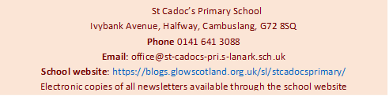
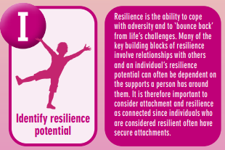
Parent Helpers
We are always looking for parent helpers. If you think you can help in any way, please let us know. All parent helpers need to be PVG registered. This can be done by handing in three forms of ID to the school office (photo ID, DOB and proof of address).
Attachment
Attachment refers to the deep and enduring emotional bond established between a child and their primary caregivers, providing a foundation for emotional security and healthy relationships throughout life. St Cadoc’s prides itself on adopting attachment-informed practice. Each month, we include a section from the A-Z of South Lanarkshire’s Attachment Strategy in order to share and explain this approach. This month we are sharing ‘’
Where there is God there is light

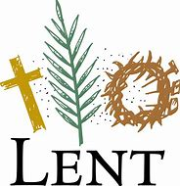

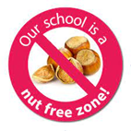

Chinese New Year Poster Competition
Congratulations to Eilidh and Sophie who received commendation certificates in this years’ Chinese New Year poster competition.

Enhanced Curriculum
With a visit to the Royal Concert Hall with the RSNO, a STEM activity day, our football roadshow and a visit from OPAL (Outdoor Play and Learning), we have had a month packed with opportunities to enhance the learning experiences of our pupils.
Farewell to Mrs McLaughlin
As most of you know, we said goodbye a valued member of our support staff at the end of last month. We wish Mrs McLaughlin every success in her new post at St Cuthbert’s Primary and thank her for all her hard work over her years here at St Cadoc’s.
Mini Vinnie Foodbank
Our junior members of the Society of St Vincent de Paul are setting up a foodbank in our school for anyone in the community who may need this service. If anyone has any donations of non-perishable food items, these can be handed in to the group. Look out for a letter from the Mini Vinnies explaining more about their campaign.

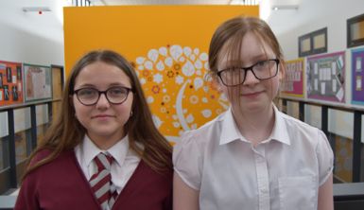

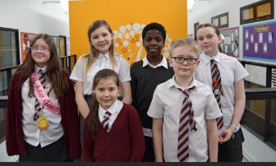
World Book Day
Our World Book Day celebrations were a big hit with our pupils. Thank you for all your efforts in organising the children’s costumes. The children have all been given their book tokens which can be swapped for a £1 book at participating retailers.

Nil by Mouth
Primary 7 pupils have started their Nil by Mouth project with Cairns Primary this month. Nil by Mouth is a non-religious organisation concerned with the destructive social impact that sectarianism has upon our society and aims to challenge intolerance and prejudice. We have been working with Nil by Mouth for many years and the children thoroughly enjoy working with their peers at Cairns Primary through this important work.

Climate Change and Sustainability Conference
Representatives from P5-7 will be attending a special Climate Change and Sustainability Conference on 25th March. This will be led by young people from the Youth Forum and will address the theme of EARTH, covering key topics such as Energy (renewables), Apparel (fast fashion), 3RS (reduce, reuse, recycle), Trees & Planting, and Habitat (biodiversity).

P7 Transition
The Trinity transition programme is now well under way and the P7s have enjoyed two visits from Trinity teachers as well as our recent visit to Trinity for the Badminton Festival. Their first half day transition visit took place on 10th March. The children were complimented on their good behaviour. The two full day visits will take place on the 11th and 12th June. Enhanced transition for specific pupils will take place at the end of April and further details will follow regarding this. Details about parental workshops have been shared via Parentsportal.

Sacrament of Reconciliation
Congratulations to our pupils who made the Sacrament of Reconciliation this month. We were so proud of how hard they worked to prepare for their special day and how beautifully they read, sang and prayed during the service. Thank you to Mrs Strachan and Mrs Kelly for preparing the children and to Fr Cirilo for presiding over the service.

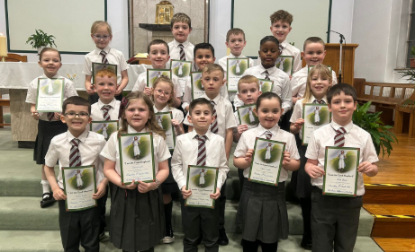

Where there is God there is light

