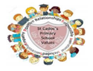
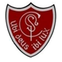
Welcome
Where there is God there is light
February 2026
St Cadoc’s Primary
Newsletter

Follow us on Instagram:
@stcadocsprimarycambuslang


As we move into February, we are beginning to see the first small signs of longer days returning. This time of year offers an opportunity for our school community to refocus, look forward and set high expectations for the term ahead, particularly in supporting our children’s learning and development.

With this in mind, we are delighted to invite our P1 parents to our upcoming literacy workshop on 4th Feb. We greatly value the partnership between home and school and recognise the important role families play in supporting children’s progress. During the session, we will share our approach to literacy and offer practical ideas and strategies to help support your child’s reading and writing at home.

Reading remains a vital part of every child’s development, and regular practice makes a real difference. It is vital for pupils in the lower classes to enjoy some reading time every evening, while pupils in the upper school are encouraged to read books of their choice as often as possible, helping to build both confidence and a love of reading.

Alongside this focus on learning, our recent assemblies have provided an opportunity for pupils to reflect on our school values. It has been lovely to see children across all year groups not only discussing these values but actively demonstrating them in their daily actions. Many pupils have earned house points for reflecting our values and it is great to see the pride they take in contributing to the positive ethos of our school.


Kathleen Faloon
Headteacher

Dates for the diary:
4th Feb – P1 literacy workshop
4th Feb – Football roadshow (St Cadoc’s Team)
5th Feb – Dental check P1&7
6TH Feb- First Friday Mass
Sun 8th Feb – School Community Mass
16th & 17th Feb – Holiday
18th Feb – INSET day (school closed to pupils)
23rd Feb – STEMazing day for P4-7
27th Feb – Big Hit Badminton Festival at Trinity P7

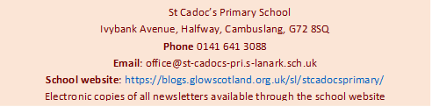

Easy Fundraising
Support our school effortlessly by signing up for Easy Fundraising and raising funds every time you shop online!
https://www.easyfundraising.org.uk/causes/stcadocsprim
Extra-curricular activity
Monday lunchtime: Sidekicks P1
Tuesday lunchtime: Multisports P2
Wednesday 3pm-4pm: Multisports P3 (last session 11th Feb)
Wednesday 4pm-5pm: Community Club P5-7
Parent Council
A reminder that the Parent Council have a new Facebook page. You can find the group by searching for “St Cadoc’s Parent Group” on Facebook.
The Parent Council will use this platform to share the minutes of meetings and gather your views.
Interdisciplinary Learning
The whole school theme within our IDL lessons at the moment is Our History. The projects are wide and varied across the school including The Dinosaurs, Ancient Egypt, Scottish Wars of Independence and World War II. Please talk to your child about what they have been learning in class.
P.E. Kit
The children have now begun the gymnastics block in P.E. It is very important that they bring the correct kit on these days. For health and safety reasons, they must have appropriate footwear. Outdoor shoes or boots are not suitable and children will not be able to take part in the lesson if they do not have the correct footwear. The children’s safety is always our highest priority.
Football Roadshow
Our P6/7 football team will begin competing in the local football roadshow against neighbouring schools. It is always a pride-filled moment to see our pupils represent the school with sportsmanship, drive and teamwork. We wish them the very best of luck. Unfortunately, this event is not open to parents but rest assured, we will keep you informed of how they get on!

Communication
We have received feedback from some parents regarding the difficulty of keeping track of school events and updates. We understand that with multiple digital platforms, it can occasionally feel overwhelming and we want to ensure every family feels fully "in the loop."
To help streamline this, please note our three main pillars of communication:
- Parentsportal: This remains our primary source for sharing all official information. If you have not yet signed up, we would ask you to do so as soon as possible to ensure you don’t miss vital updates.
- The Annual Calendar & Monthly Newsletter: Our full-year calendar is issued every August to help with long-term planning. We then use this monthly newsletter to highlight the key dates and events for the weeks immediately ahead.
- Instagram (@stcadocsprimarycambuslang): For those who prefer a quick digital digest, we issue a ‘What’s on This Week’ reminder every Sunday evening via our Instagram feed.
We hope that providing information through these different lenses—long-term, monthly, and weekly—ensures you feel well-informed and fully supported in keeping up to date with school life.

STEMazing event
Later this month, we are thrilled to host visiting STEM specialists for a dedicated day of innovation and discovery. This hands-on experience will involve all pupils from P4–P7, challenging them to think critically and solve complex problems using science, technology, engineering and mathematics in real-world contexts. We can't wait to see the creative solutions our young engineers come up with.

Uniform
We appreciate the efforts families make to support school uniform. To help maintain consistency and equality for all pupils, we kindly ask for your continued support in ensuring children attend school in full uniform each day.
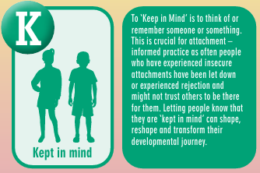
Attachment
Attachment refers to the deep and enduring emotional bond established between a child and their primary caregivers, providing a foundation for emotional security and healthy relationships throughout life. St Cadoc’s prides itself on adopting attachment-informed practice. Each month, we aim to include a section from the A-Z of South Lanarkshire’s Attachment Strategy in order to share and explain this approach. This month we are sharing ‘K’

Where there is God there is light
Where there is God there is light

