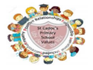
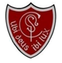
Welcome
Where there is God there is light
January 2026
St Cadoc’s Primary
Newsletter

Follow us on Instagram:
@stcadocsprimarycambuslang




Dear Parents/Carers,

Welcome to our first newsletter of the New Year! I hope you all had a lovely Christmas and a restful break. I want to thank you all again for your engagement and contributions during our school celebrations and can I wish you all a very happy and healthy 2026!

As we enter the new year, we begin to look ahead and enrolment for next year begins this week. If you know anyone who has a child due to start school after the summer, please mention this to them. Enrolment is completed online via the South Lanarkshire Council website.

Also looking ahead, we will be beginning Sacramental Preparations with children who are making their first Reconciliation and Holy Communion this term. As a reminder, the dates for these Sacraments are as follows:

Reconciliation (P3): Thursday 5th March at 6.30pm
First Communion (P4): Saturday 25th April 11.30am

Finally, as always at this time of year, can I ask that if you have changed your mobile phone number or any of your contact details over the holiday to please inform our school office to have your details updated.


Kathleen Faloon
Headteacher

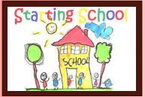
Primary 1 enrolment
Enrolment is now open for any child due to start school in August 2026.

Please log on to:
www.southlanarkshire.gov.uk
and follow the link.

Please pass this information
on to anyone in the area with
school age children.


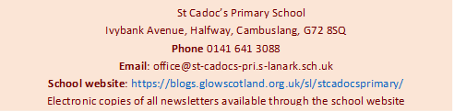
Easy Fundraising
Support our school effortlessly by signing up for Easy Fundraising and raising funds every time you shop online!
https://www.easyfundraising.org.uk/causes/stcadocsprim
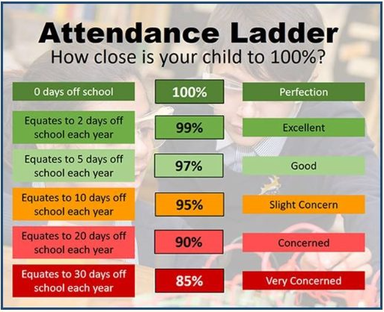
Confirmation
Congratulations to those pupils who received the Sacrament of Confirmation in December.
It was a beautiful celebration and our pupils made us extremely proud through their reverent participation, lovely singing and confident Mass responses. May God bless each of you as you continue on your faith journey.
Christmas Thanks
Thank you all once again for your support and participation over the Christmas period. It was wonderful to see our school packed with so many people at our events. This helped to make it a very special time for the children and I am sure create memories that will last a lifetime. Our Christmas fundraising activities raised almost £2000 which will go towards end of year activities and leaver’s gifts.

Parent Council
Our next joint pupil/parent council will take place on Tuesday 20th January at 2pm.
All welcome.
Please also remember that our Parent Council have a new Facebook page. You can find the group by searching for “St Cadoc’s Parent Group” on Facebook.

Attendance
Attendance has remained an issue since the pandemic and we are working hard as a school to try to improve this as it has a significant impact on children’s learning. To help with this we are issuing termly updates on your child’s attendance. Please check your child’s bag this week for their update.

P7 transition
As part of the Primary 7 transition programme, pupils will receive two further visits from Trinity staff in January. On 16 January, Mrs Galloway will deliver a second science lesson. On 29 January, members of Trinity staff will visit to speak with the children and meet with our staff to discuss individual needs, ensuring a thorough sharing of information to support a smooth transition.
St Vincent De Paul
A huge thank you to our friends at St Vincent de Paul who funded our Room 1 trip to see Santa at Gouldings. In addition, they also provided vouchers for families over the Christmas period. St Vincent de Paul do incredible work supporting families in need. The cost of living crisis has increased the need for such valuable help.
If anyone in our school community is struggling, either through financial difficulties or social isolation, please do not struggle alone. You can either contact St Vincent de Paul Society directly or pop into the school for a private chat and we will direct you to support. For more information go to https://svp.org.uk

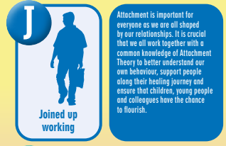
Attachment
Attachment refers to the deep and enduring emotional bond established between a child and their primary caregivers, providing a foundation for emotional security and healthy relationships throughout life. St Cadoc’s prides itself on adopting attachment-informed practice. Each month, we aim to include a section from the A-Z of South Lanarkshire’s Attachment Strategy in order to share and explain this approach. This month we are sharing ‘J’

Where there is God there is light
Where there is God there is light

