**

Where there is God there is light

September 2024

**St Cadoc’s Primary**

**Newsletter**

Dear Parents/Carers,

We are delighted to announce the appointment of this year’s House Captains and Vice Captains. We are confident they will excel in their new leadership roles. The standard of pupil speeches was exceptionally high this year and we couldn't be more proud of everyone who participated. Additionally, we have elected chairs for each of our Pupil Voice committees and we look forward to working closely with them in their respective areas. We are committed to ensuring that all students across the school have a voice and the opportunity to share their thoughts and ideas on various topics.

Leadership doesn’t stop with the pupils. We want to make sure you have a say in leading our school too! You can do this in many ways, for example joining our Parent Council (first meeting rescheduled to Wed 25th Sep at 6.30pm) or by adding your suggestions for how we spend our Participatory Budget (see overleaf).

Thank you to our Primary 1 parents in clearing the playground as quickly as possible at the end of the school day. Please note, the playground is only open to adults for pick up at the end of the school day and this is strictly for P1 parents only to help with the collection of our youngest learners. I am grateful to you all for your cooperation with this.

Finally, can I take this opportunity to wish Mrs Causer our very best wishes as she begins her maternity leave. We all look forward to hearing of the safe arrival of her little one. Mrs McFadzean will take over as class teacher in Room 4 in Mrs Causer’s absence.

Kathleen Faloon

Headteacher

Headteacher

‘What’s on This Week’ is now being posted on Twitter every Sunday evening so please check out our Twitter feed **@stcadocsPCambus** for a helpful reminder of what’s happening in school.

Can we please remind everyone to label their child’s belongings. We have had a number of items handed in without names on them which makes it extremely hard to identify the owners!

**P.E. Kit**

A wee reminder that school gym kit of dark shorts and white t-shirt should be brought to school on a **Monday** of each week and remain in school until **Friday** when it will be brought home to be cleaned. Thanks.





St Cadoc’s Primary School

Ivybank Avenue, Halfway, Cambuslang, G72 8SQ

**Phone** 0141 641 3088

**Email**: office@st-cadocs-pri.s-lanark.sch.uk

**School website**: <https://blogs.glowscotland.org.uk/sl/stcadocsprimary/>

Electronic copies of all newsletters available through the school website

**Pupil Leadership:**

We are pleased to announce the House Captains and Vice-Captains for our Houses. They are:

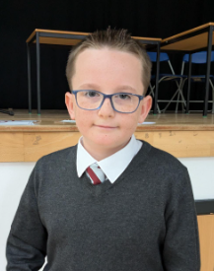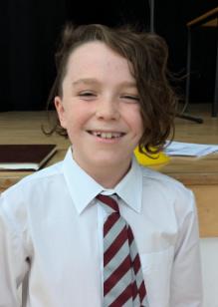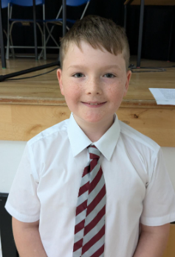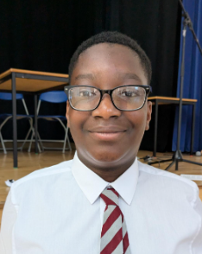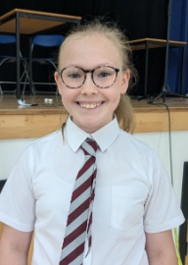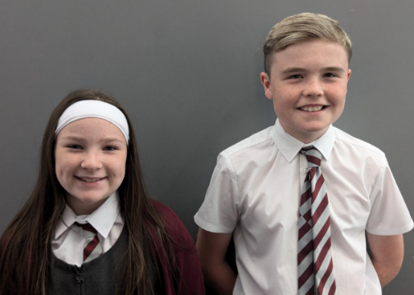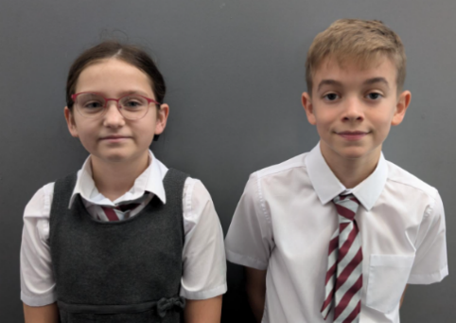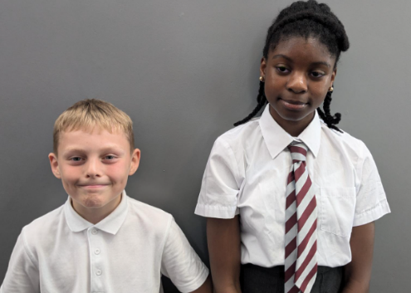

Reading Committee: Eco Committee: Sports Committee: Digital Committee:

Nathan Nicky Cameron Mark

Curriculum Committee: JRSO: JRSO:

Maya Nathaniel Hassan

**Pupil Leadership**

Well done to all pupils who confidently presented at the House Captain elections assembly. Following the whole school vote, our new House Captains and Vice Captains have been announced. Congratulations on receiving these important roles. We wish you every success in becoming important role models and ambassadors for our school.

Lily House Captain: Lyle Ivy House Captain: Noah

Lily Vice Captain: Esme Ivy Vice Captain: Elaine

Wood House Captain: Olivia Rose House Captain: Erin

Wood Vice Captain: Zac Rose Vice Captain: Lewis

Lily

Captain:

Vice-Captain

Lily

Captain:

Vice-Captain

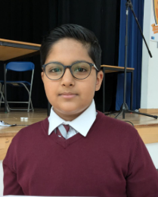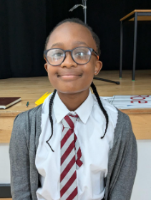

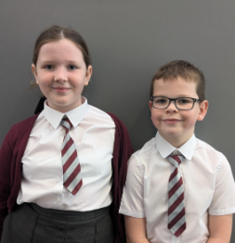

**Papal Nuncio Mass**

Mrs Faloon and Mrs Kelly had the

honour of attending the beautiful

Mass to welcome His Excellency

Archbishop Miguel Maury Buendía,

the Apostolic Nuncio to Great

Britain at Motherwell Cathedral on

Friday 30th August. We are very

proud of Adam and Miah,

who acted as fantastic

pupil representatives for the school.

**Meet the Teacher**

Thank you to all of you who turned out for our Meet the Teacher event on Tuesday. We hope this gave you all a small insight into what goes on, the resources we use and a chance to have a brief chat with your child’s teacher. It was great a great turn out and we really appreciate so many of you coming along.

**OPAL – Outdoor Play and Learning**

We hope many of you managed to have a look at our OPAL

display board during our Meet the Teacher event. The aim

of the display is to highlight the possibility that your child

may be coming home with a few more marks on their

uniforms as we encourage greater use of our outdoor

spaces. We fully believe however that this is a worthwhile

trade off for all the skills (and fun) that the increased

outdoor activity brings. We really appreciate your support

as we develop our playground. Please talk to your child

about the changes that are taking place- the children are

in agreement that it is great fun at playtime and lunchtime!

**Art Club with East Kilbride Arts Centre**

A big thank you to Fiona our art tutor who has been leading an afterschool art club for our P4s and P5s. The children have been having great fun developing their creativity.

**Sacramental Dates**

We now have confirmation of Sacramental dates for

this year

**Confirmation:** 10th Dec at 7pm

**Reconciliation**: Tuesday 18th March 6.30pm

**First Communion**: Saturday 26th April 9.30am

**Sacramental meetings** will take place at St Cadoc’s

Church on Tuesday 1st October:

Reconciliation meeting- 6pm

Holy Communion meeting 6.35pm

Confirmation meeting 7.05pm

**Enrolment Mass** for all Sacraments is on Sun 27th October

at 10am Mass.

**Participatory Budget**

Participatory Budgeting is a way for pupils, parents and staff to have a direct say in how some of the school budget is spent. We are gathering ideas for how a percentage of the Pupil Equity Fund can be spent. The money will be spent in a way that helps ensure all pupils have the same experience of school. Last session’s participatory budget funded our whole school trip to Culzean Castle. We would like your thoughts on how to spend this year’s budget to support the learning, health and wellbeing of all our pupils and especially those directly affected by poverty.

Some ideas are:

Nurture Resources

Playground resources to support our playground changes

Sports coaching

Parent groups

As parents, it is important that we get your views and suggestions. Could you please give any comments/suggestions for how you think we could spend the Participatory Budget this year. All ideas are welcome!

We will collate all suggestions and discuss them within the Participatory Budgeting group. A final three or four ideas will then be put forward for a final vote.

**Please complete and return the attached suggestions sheet to the school by Friday 20th September**

|  |
| --- |
| **Suggestions:** |
|  |
| **Additional Comments:** |
|  |
| **Name:** |
| **Pupil Name:** |
| **Pupil Class:** |

Where there is God there is light