**

Where there is God there is light

August 2024

**St Cadoc’s Primary**

**Newsletter**

Dear Parents and Carers,

Welcome to the first newsletter of the new school year. I hope you all had a wonderful summer break. We are delighted to welcome all the children back to school; we have missed them over the summer! They all look so smart in their school uniforms so thank you for your efforts in getting the children ready for their return.

This session we welcome Miss O’Neill and Mrs Iles who join our teaching staff. I am also pleased to announce the arrival of two further additions to the St Cadoc’s team as Miss Jordan and Miss Delaney have both recently had their babies. Welcome to the world Amy and John!

Our new Primary 1 children have settled in really well and have been having lots of fun in Room 1. Well done boys and girls! A huge welcome to all our new families. We look forward to strengthening our parent partnerships throughout the coming school year.

Kathleen Faloon

Headteacher

** Welcome back!**

Dates for your diary:

3rd Sept – Meet the Teacher event 3.15-4pm

13th Sept- First Friday Mass 10am St Cadoc’s Church

25th Sept – Mass 10am Feast of St Cadoc

26th Sept – Room 6 assembly 2pm

27th Sept/30th Sept - Holiday

St Cadoc’s Primary School

Ivybank Avenue, Halfway, Cambuslang, G72 8SQ

**Phone** 0141 641 3088

**Email**: office@st-cadocs-pri.s-lanark.sch.uk

**School website**: <https://blogs.glowscotland.org.uk/sl/stcadocsprimary/>

Electronic copies of all newsletters available through the school website

Can all Primary 1 parents please check the labels on your child’s clothing when they come home. We have had some blazers swapped in the cloakrooms and would like to return them to the correct owners.

Please make sure all items of clothing have your child’s name on them.

**School Staff:**

Our fantastic team have returned well rested and ready to go. They have done an amazing job of getting the classrooms prepared and taking care of all the many other jobs that go in to getting the school ready for the year ahead. A massive thank you to the staff for all their hard work in the preparations.

**Our class teachers this year are as follows:**

Primary 1 Room 1 : Mrs Coleman (Mon, Tue, Wed) Mrs Iles (Thu, Fri)

Primary 2 Room 3: Miss O’Neill (Mon, Tue, Thu, Fri) Mrs Iles (Tue, Wed)

Primary 3.4 Room 7: Mrs Strachan

Primary 4.5 Room 4: Mrs Causer

Primary 5.6 Room 5: Mrs Kelly

Primary 7 Room 6: Mrs Cocozza

Mrs Elliott, Principal Teacher, will be providing support and challenge for groups and individual pupils throughout the year.

Mrs Clark, Specialist Support Teacher, visits the school on Friday mornings.

Mr Yan, Mandarin Teacher, visits the school on Wednesdays.

Mr McAleenan, Brass Teacher, provides music tuition on Mondays.

**Our support staff this year are as follows:**

Team Leader: Mrs Lydon

Room 1: Miss Dowds

Room 3: Ms Ure

Room 7: Mrs McLaughlin

Room 4: Mrs Hakeem

Room 5: Mrs McHugh

Room 6: Mrs Hurles

Our school janitors are Elaine (Mon and Fri) and Jim (Tue, Wed, Thur)

**Snacks**

A reminder that our school is strictly a **nut free zone.** Children should not bring any snacks such as Nutella, Kinder Bueno or any other products containing nuts. All children should have a small healthy snack with them for morning break.

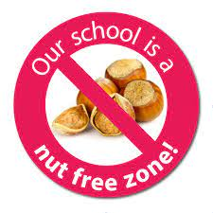

**How can you help?**

We are always looking for parents to work in closer partnership with the school.

Are you a football coach who would be willing and able to train our pupils after school? Are you an avid gardener who would take a small after school club in our school grounds?

Please get in touch as we would love to hear from you.

*Please note that anyone working with children or protected adults must be PVG checked with Disclosure Scotland.*

**School Improvement**

Every year we review and evaluate our progress and set our priorities for further improving our school. This session we will continue to focus on increasing attainment in writing, improving attainment in maths, and improving outcomes for pupils impacted by socio-economic disadvantage. We are also going to work on reimagining our curriculum to make learning as relevant and engaging as possible. The poster can be accessed on the school website.

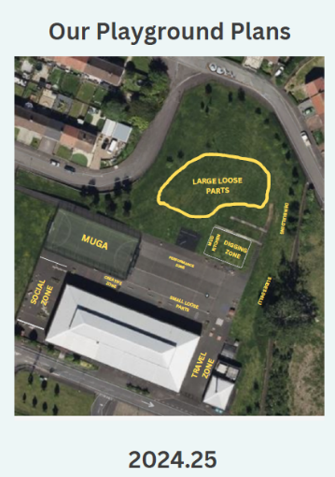

We are in the process of launching an exciting new project in conjunction with OPAL to make our play times even better. OPAL is an award-winning programme aimed at promoting more active childhoods. In discussion with the children, we have been planning how to best use our outdoor spaces. More information will follow however can we ensure that all children routinely bring a suitable jacket with them to school as we will be encouraging outdoor play as much as possible.

**The OPAL Programme**

**Have Your Say!**

We are always eager to work in partnership with all parents/carers to ensure that every child receives the best education possible and feels valued and respected. We welcome your thoughts and ideas. If, at any time you have any comments you wish to make, please complete the tear off slip below and return to school.

____________________________________________________________________________________

I am happy with……

It would be good if…..

Can we have….

Name and contact number (if you wish to be contacted)…

*Please return this slip to the school office*

**Parent Council**

Some members of our Parent Council have now left the school as their children have moved on to Secondary School. This means we need new members! We will be hosting the first Parent Council meeting of the school year on **10th September at 6.30pm**. We would love as many of you to come along as possible. It really is a great chance for you to have a say in the running of our fab school. Please be assured our meetings are informal and there is even a cuppa and a biscuit included!

Where there is God there is light