**

Where there is God there is light

November 2023

**St Cadoc’s Primary**

**Newsletter**

Dear Parents/Carers,

October rushed past us in a blur of bustling activities at school. From the excitement of Kids’ Kitchen and Halloween parties to the creativity of our new art project, this month’s newsletter is full of delightful highlights.

Looking ahead, November brings the much-anticipated Book Week Scotland. During this time, we aim to highlight the importance of reading for pleasure. In today's digital age, where electronic devices dominate, nurturing a love for reading is more vital than ever. Reading with your child not only fosters a strong bond but also offers a multitude of lifelong benefits. Let’s continue to encourage our children to immerse themselves in the world of stories.

Reading aloud with your child for just 10 minutes a day is one of the best ways to provide your child with learning tools for life.

Kathleen Faloon

Headteacher

**Dates for your diary:**

7TH November – Parent Council meeting 6.30pm

9th 16th 23rd November – Families Connect

9th November – P7 Sports Event at Trinity

13th November – INSET Day- school closed to pupils.

13-17th November - Book Week Scotland

20th November – Adventures in Storyland visiting Room 1 and 3

24th November – Dental checks for P1 and P7

29th November – Christmas Fair 6pm-8pm

5th December – Flu Vaccinations

12th December – Christmas lunch

13th & 14th December – Nativity

22nd December – School closes 2.30pm

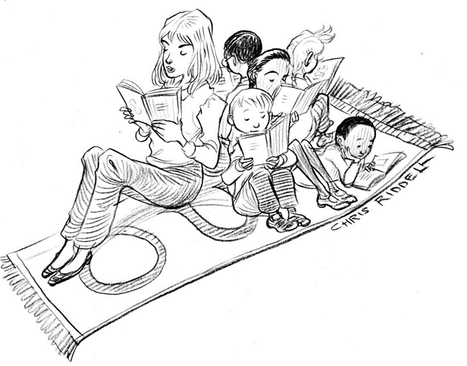

St Cadoc’s Primary School

Ivybank Avenue, Halfway, Cambuslang, G72 8SQ

**Phone** 0141 641 3088

**Email**: office@st-cadocs-pri.s-lanark.sch.uk

**School website**: <https://blogs.glowscotland.org.uk/sl/stcadocsprimary/>

Electronic copies of all newsletters available through the school website

**Extra-curricular activities**

Mon lunchtimes- Sidekicks P1 (led by P7)

Mon 3-4 – Bikeability P5

Tue- FUNdamentals music P5

Tue (14th Nov 5th Dec) Reading club P2&3

**Halloween Fun**

We had lots of spooktacular fun across the school on Halloween. The children looked fantastic in their costumes!

**Kids’ Kitchen**

Rooms 5 and 6 had a great time developing their culinary skills under the guidance of Chef Robert from Kids’ Kitchen. Thank you to all our parents who managed along for the final session. We hope the children have been helping out with meal prep’ at home…and doing the dishes afterwards!

-=====[kj

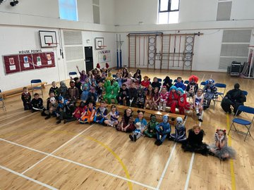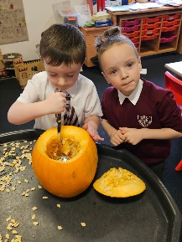

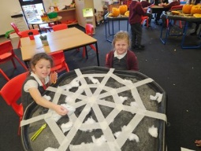

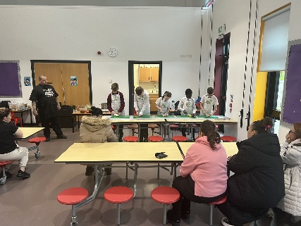

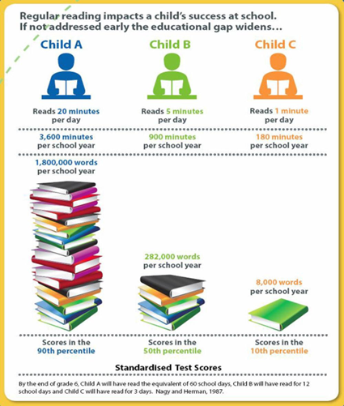

**Art Project**

We are delighted to welcome art tutors, Fiona Clark and Moira Maclean from the East Kilbride Arts Centre. Both tutors will be working in St Cadoc’s every Friday afternoon until Christmas on a special art project which we hope to unveil in the new year.

-=====[kj

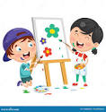

**Parentsportal**

We now have almost 30% of our families signed up to Parentportal which will eventually become our main method of communication. This is still far off the 100% that we need.

Please remember, you can book an appointment for any Friday throughout November for help if you are having difficulties getting set up.

**Money Matters**

Can I ask that if you check your Parent Pay account if you haven’t logged in recently. There are a few accounts with amounts outstanding and this can build up quickly if left unchecked. Please let the school know if there is any difficulty in settling accounts.

The initial cash deposit of £50 for the Primary 7 Dalguise residential trip is now due. Subsequent installments can be made through Parent Pay.

**Christmas Fair Preparations**

We are now accepting donations for the Christmas Fair. If you have items you would like to donate, please drop these in the school office. If anyone would like to rent a table at the fair please contact the school office. Thank you, as always, for your support.



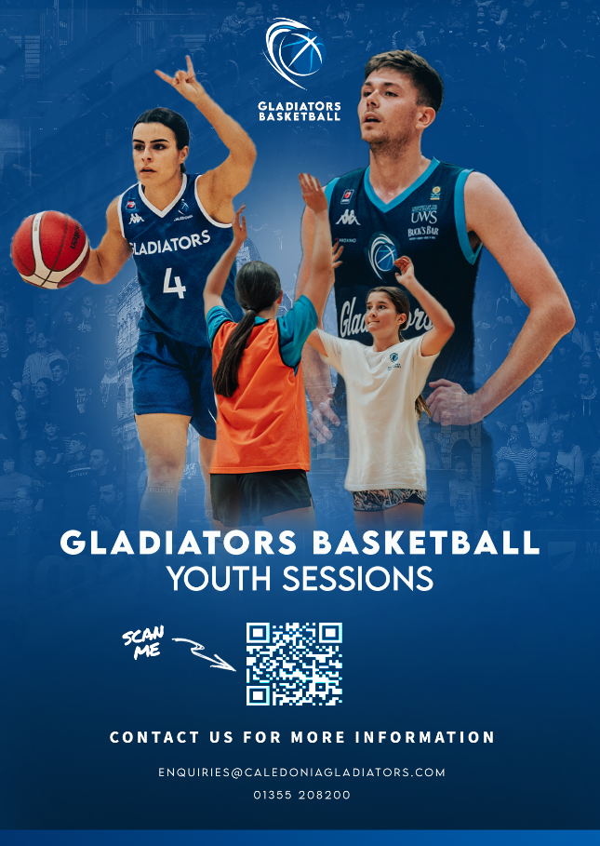**Health and Wellbeing Information**

**Sleep Scotland**

Quality sleep is essential for children's growth, development, and overall health and poor sleep has a huge impact in school. We understand the challenges of ensuring our children get the rest they need, especially in today's fast-paced world.

Sleep Scotland is a renowned organisation dedicated to promoting healthy sleep habits and providing support for families facing sleep-related challenges. They offer valuable advice, practical tips, and evidence-based strategies to improve sleep patterns and create a bedtime routine that works for yourfamily. I would encourage any families experiencing difficulties with their child’s sleep to contact Sleep Scotland’s support service:

**sleepsupport@sleepaction.com**

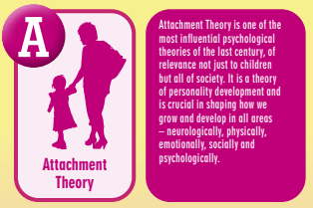

Where there is God there is light

**Attachment**

Attachment refers to the deep and enduring emotional bond established between a child and their primary caregivers, providing a foundation for emotional security and healthy relationships throughout life. St Cadoc’s prides itself on adopting attachment-informed practice. Each month, we will include a section from the A-Z of South Lanarkshire’s Attachment Strategy in order to share and explain this approach:

**Flu vaccinations**

Flu vaccinations will take place in the school on the 5th of December. If anyone has not returned a consent form but wishes to have their child vaccinated, please contact Sandra on 07814935927 to book.

**Upcoming Online Free Parent Mental Health Workshops Delivered by SAMH**

 06/11/2023        Listening To & Supporting My Child                       1.00pm

08/11/2023        Mental Health Awareness                                        10.00am

09/11/2023        Understanding & Managing Stress & Anxiety       7.00pm

14/11/2023        Listening To & Supporting My Child                       1.00pm

15/11/2023        Mental Health Awareness                                        1.00pm

16/11/2023        Managing My Wellbeing                                           11.00am

16/11/2023        Understanding & Managing Stress & Anxiety       12.30pm

Spaces are limited. Use the email address below to secure your space.

<https://www.eventbrite.co.uk/o/samh-lets-connect-camglen-67397018633>

Where there is God there is light