**

Where there is God there is light

January 2024

**St Cadoc’s Primary**

**Newsletter**

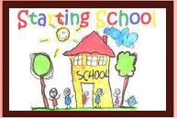

**Primary 1 enrolment**

Enrolment is now open for any child due to start school in August 2024.

Please log on to:

[www.southlanarkshire.gov.uk](http://www.southlanarkshire.gov.uk)

and follow the link.

Please pass this information

on to anyone in the area with

school age children.



Dear Parents/Carers,

Welcome to our first newsletter of 2024! I hope you all had a lovely Christmas and a restful break. The children have settled back into the school routines although there were a few tired wee faces this week!

Looking ahead, we will be beginning Sacramental Preparations with children who are making their first Reconciliation and Holy Communion this term. As a reminder, the dates for the Sacraments are as follows:

**Enrolment Mass for both Sacraments**: Sunday 14th January 11.30am

**Reconciliation:** Thursday 7th March at 6.30pm

**First Holy Communion**: Saturday 27th April at 11.30am

Feedback from last term indicated that an annual calendar of key dates would be helpful for parents. From now on this will be issued at the start of each school year. For now, I have included all key dates for the remainder of the school year overleaf. I hope you find this useful.

Finally, can I ask that if you have changed your mobile phone number or any of your contact details over the holiday please inform our school office to have your details updated.

Kathleen Faloon

Headteacher

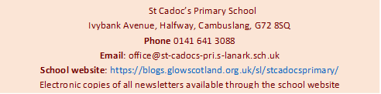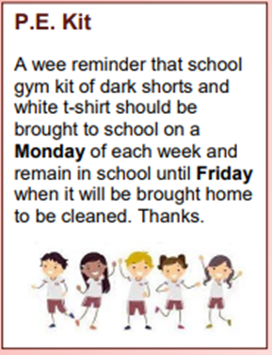



**Christmas Thanks**

Thank you all once again for your support and participation over the Christmas period. It was wonderful to see our school packed with so many people at our events. This helped to make it a very special time for the children and I am sure create memories that will last a lifetime.

Our Christmas fundraising activities raised over £2000 which will go towards providing school trips and leaver’s gifts.

**Welcome**

We extend a warm welcome to Mr Weiming Yan who joins us from China as our Mandarin tutor. We are delighted to have Mr Yan join the team for the next couple of years.

**Cheerleading Club**

Active Schools are hosting a new cheerleading club for P6 and P7 girls. This starts next Thursday (18th January) from 3pm-4pm and will run for five weeks.

**St Vincent De Paul**

A huge thank you to our friends at St Vincent de Paul who provided vouchers for families over the Christmas period. St Vincent de Paul do incredible work supporting families in need. The cost of living crisis has increased the need for such valuable help.

If anyone in our school community is struggling, either through financial difficulties or social isolation, please do not struggle alone. You can either contact St Vincent de Paul Society directly or pop into the school for a private chat and we will direct you to support. For more information go to <https://svp.org.uk>





**Upcoming Online Free Parent Mental Health Workshops Delivered by SAMH**

16/01/2024     Listening To & Supporting My child                                10.00am

17/01/2024     Understanding & Managing Stress & Anxiety               6.00pm

18/01/2024     Mental Health Awareness                                                 1.00pm

Spaces are limited and can be booked using the address below:

<https://www.eventbrite.com/o/samh-lets-connect-team-clydesdale-69441409893>

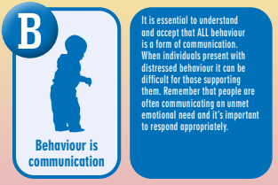

**Attachment**

Attachment refers to the deep and enduring emotional bond established between a child and their primary caregivers, providing a foundation for emotional security and healthy relationships throughout life. St Cadoc’s prides itself on adopting attachment-informed practice. Each month, we include a section from the A-Z of South Lanarkshire’s Attachment Strategy in order to share and explain this approach. This month we are sharing ‘B’

Where there is God there is light

Where there is God there is light