**

Where there is God there is light

September 2023

**St Cadoc’s Primary**

**Newsletter**

Dear Parents/Carers,

It’s hard to believe that the summer holidays were only a few weeks ago as we return to the hustle and bustle of school life.

This week we were delighted to announce the first of our pupil leadership roles. Our new House Captains and Vice Captains will take on important roles in the school. Well done to all pupils who prepared and presented their speeches at assembly. What a confident bunch!

Please talk to your children about other leadership roles they might be interested in as next week we will be nominating members for the Pupil Council, Eco Committee and Reading Committee from each class.

Our Primary 7s have also been leading ‘Buddy Play’ with our new Primary 1 pupils. This will take place each Tuesday and Thursday. The P1s have also enjoyed a ‘Buddy Lunch’ with their Big Buddies and will continue to do so on the last Wednesday of each month.

Leadership doesn’t stop with the pupils. We want to make sure you have a say in leading our school too! You can do this in many ways, for example joining our Parent Council or by adding your suggestions for how we spend our Participatory Budget (see overleaf).

Kathleen Faloon

Headteacher

Headteacher



**Dates for your diary:**

5th  September – Go Fresh Themed lunch

5th  September- Transition Mass at Trinity High School 4pm

6th September: Meet the teacher drop in event

12th September: Parent Council Meeting – **ALL WELCOME** 6.30pm

**P.E. Kit**

A wee reminder that school gym kit of dark shorts and white t-shirt should be brought to school on a **Monday** of each week and remain in school until **Friday** when it will be brought home to be cleaned. Thanks.

St Cadoc’s Primary School

Ivybank Avenue, Halfway, Cambuslang, G72 8SQ

**Phone** 0141 641 3088

**Email**: office@st-cadocs-pri.s-lanark.sch.uk

**School website**: <https://blogs.glowscotland.org.uk/sl/stcadocsprimary/>

Electronic copies of all newsletters available through the school website



**Pupil Leadership:**

We are pleased to announce the House Captains and Vice-Captains for our Houses. They are:

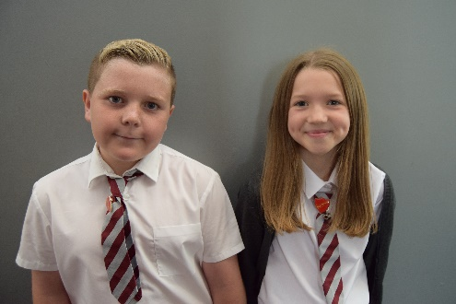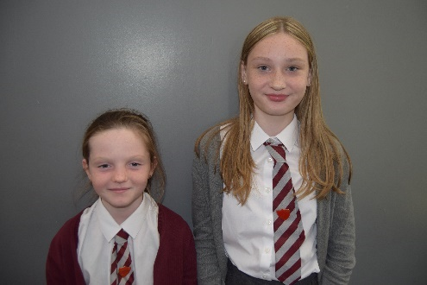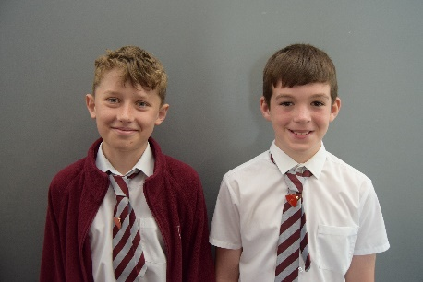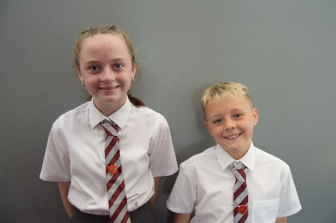

**Meet the teacher**

We are hosting our Meet the Teacher session on Wednesday 6th September. Pop in after school with your child between 3.15pm -4pm to visit your child’s classroom, have a look at resources and meet the teacher. There will also be input from Margo Mooney from the Supporting Families Project (for Primary 1 parents) and Mrs Faloon will be sharing information about proposed locations, dates and durations of this year’s residential trip (for Primary 7 parents). Please come along if your able- we would love to see you there!

**Parents Portal**

Thank you to everyone who has signed up to Parents Portal. It is important that **everyone** signs up for this as it will eventually become the main method of communication from the school. This is being introduced in every school in South Lanarkshire to make communication easier. If you have not yet signed up to Parents Portal please do so as soon as possible. You can download the app or sign up via: https://parentsportal.scot/pportal/

**Pupil Leadership**

Well done to all pupils who confidently presented at the House Captain elections assembly. Following the whole school vote, our new House Captains and Vice Captains have been announced. Congratulations on receiving these important roles. We wish you every success in becoming important role models and ambassadors for our school.

Lily House Captain: Teagan Ivy House Captain: Robert

Lily Vice Captain: Cole Ivy Vice Captain: Shay

Wood House Captain: Alecia Rose House Captain: Ryan

Wood Vice Captain: Danni Rose Vice Captain: Ava

Lily

Captain:

Vice-Captain

Lily

Captain:

Vice-Captain

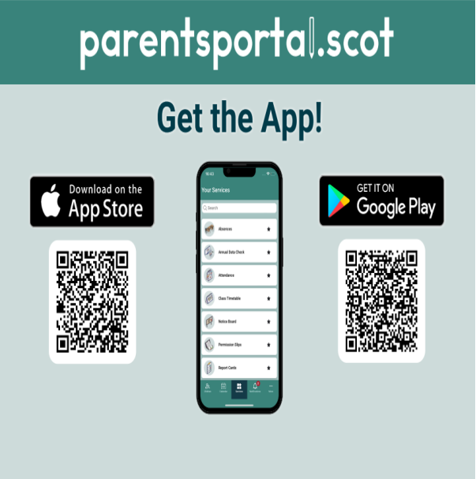



**Participatory Budget**

Participatory Budgeting is a way for pupils, parents and staff to have a direct say in how some of the school budget is spent. We are gathering ideas for how a percentage of the Pupil Equity Fund can be spent. The money will be spent in a way that helps ensure all pupils have the same experience of school. We would like your thoughts on how to spend this to support the learning, health and wellbeing of pupils directly affected by poverty.

Some previous ideas have been:

**A washing machine for washing/drying borrowed P.E kits**

**Fruit tasting sessions/Fruity Friday**

**Spare P.E kits**

Nurture Resources

Playground equipment

Sports coaching/experiences

Trips

Parent groups

*Items in bold were purchased last session*

As parents, it is important that we get your views and suggestions. Could you please give any comments/suggestions for how you think we could spend the Participatory Budget this year. All ideas are welcome!

We will collate all suggestions and discuss them within the Participatory Budgeting group. A final three or four ideas will then be put forward for a final vote.

**Please complete and return the attached suggestions sheet to the school by**

|  |
| --- |
| **Suggestions:** |
|  |
| **Additional Comments:** |
|  |
| **Name:** |
| **Pupil Name:** |
| **Pupil Class:** |

**Meet the teacher**

We are hosting Meet the Teacher session on Wednesday 6th September. Pop in after school with your child between 3.15pm -4pm to visit your child’s classroom, have a look at resources and meet the teacher. There will also be input from Margo Mooney from the Supporting Families Project (Primary 1) and Mrs Faloon will be sharing information about proposed locations, dates and durations of this year’s residential trip (Primary 7). Please come along if your able- we would love to see you there! 

Where there is God there is light