**

Where there is God there is light

August 2023

**St Cadoc’s Primary**

**Newsletter**

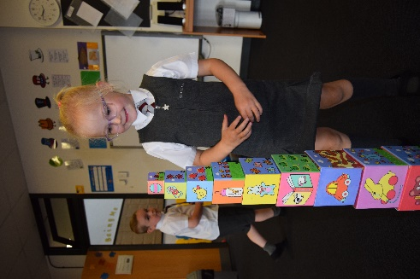

Dear Parents and Carers,

Welcome to the first newsletter of the new school year. I hope you had a lovely summer. We are delighted to welcome all the children back into St Cadoc’s; we have missed them all over the summer! Everyone looks so smart in their school uniforms so thank you all for your efforts in getting the children ready for their return to school.

We are so impressed by how well our new Primary 1 children have settled in; they are already following school routines with ease. Well done boys and girls!

A huge welcome to all our new families. Our strong positive partnership with parents/carers is so valuable and we look forward to strengthening this throughout the coming school year.

Kathleen Faloon

Headteacher

** Welcome**

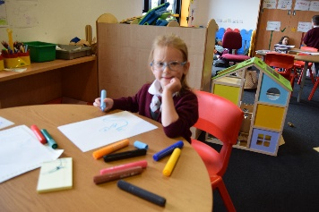

St Cadoc’s Primary School

Ivybank Avenue, Halfway, Cambuslang, G72 8SQ

**Phone** 0141 641 3088

**Email**: office@st-cadocs-pri.s-lanark.sch.uk

**School website**: <https://blogs.glowscotland.org.uk/sl/stcadocsprimary/>

Electronic copies of all newsletters available through the school website

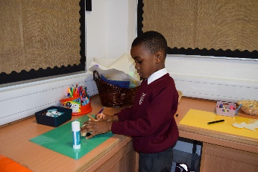

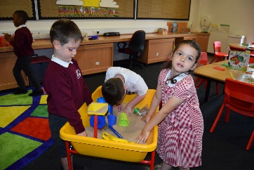

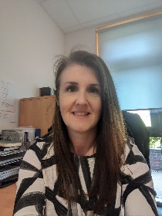

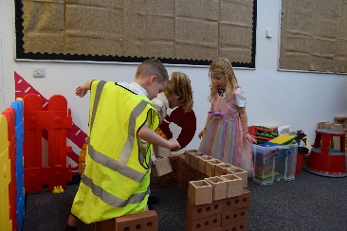

**School Staff:**

Our fantastic team have returned well rested and ready to go. They have done an amazing job of getting the classrooms prepared and taking care of all the many other jobs that go in to getting the school ready for the year ahead. A massive thank you to the staff for all their hard work in the preparations.

**Our class teachers this year are as follows:**

Primary 1 Room 1 (*P1 benefit from two teachers in class most days):* Mrs Coleman (Mon, Tue, Wed) Mrs McFadzean (Wed, Thu, Fri) & Mrs Strachan (Mon, Fri)

Primary 2.3 Room 3: Miss Jordan

Primary 3.4 Room 7: Miss Coppola

Primary 4.5 Room 4: Miss Welsh (Mon-Thu) Mrs Kelly (Thu, Fri)

Primary 5.6 Room 5: Mrs Cocozza

Primary 6.7 Room 6: Mrs Causer

Mrs Strachan will also be delivering music, science and Spanish lessons across the school.

Mrs Kelly and Mrs Elliott will be providing support and challenge for groups and individual pupils throughout the year.

Mrs Cameron, Specialist Support Teacher visits the school each Thursday.

**Our support staff this year are as follows:**

Team Leader: Mrs Lydon

Room 1: Miss Dowds

Room 3: Ms Ure

Room 7: Mrs Hurles

Room 4: Mrs McLaughlin

Room 5: Mrs Hakeem

Room 6: Mrs McHugh

Our school janitors are Elaine (Mon and Fri) and Jim (Tue, Wed, Thur)

**Snacks**

A reminder that our school is a nut free zone. Children should not bring any snacks such as Nutella, Kinder Bueno or any other products containing nuts. All children should have a small healthy snack with them for morning break.



**Mobile Phones**

The use of mobile phones or smart watches is not permitted in school. If you feel your child needs to bring a mobile phone to school with them we will require written confirmation of this. Your child should deposit their mobile device to the school office and it should be collected again from the office at the end of the school day.



**School Improvement**

Every year we review and evaluate our progress and set our priorities for further improving our school. This session we will be focusing on increasing attainment in writing, improving attainment in maths, strengthening professional judgment and improving outcomes for pupils impacted by socio-economic disadvantage.

Further details are available within the poster which can be seen full size on the school noticeboard and on the school website.

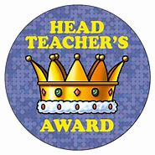

**Have Your Say!**

We are always eager to work in partnership with all parents/carers to ensure that every child receives the best education possible and feels valued and respected. We welcome your thoughts and ideas. If, at any time you have any comments you wish to make, please complete the tear off slip below and return to school.

____________________________________________________________________________________

I am happy with……

It would be good if…..

Can we have….

Name and contact number (if you wish to be contacted)…

*Please return this slip to the school office*

**Parent Council**

As many of you know, the majority of members of our Parent Council have now left the school as their children have moved on to Secondary School. This means we desperately need new members! We will be hosting the first Parent Council meeting of the school year on **12 September at 6.30pm**. We would love as many of you to come along as possible. It really is a great chance for you to have a say in the running of our fab school. Please be assured our meetings are informal and there is even a cuppa and a biscuit included!

**Assemblies and Awards**

This year assemblies will take place every week with one Headteacher award given for each class. The awards will help to promote and develop the skills required to become ***Confident Individuals, Responsible Citizens, Successful Learners and Effective Contributors.***

Award winners will be invited to take part in ‘Hot Chocolate with the Heedie’ and feature on our Stars of the Week Wall. Vegan and no added sugar hot chocolate will be available however any parent does not wish their child to take part in Hot Chocolate with the Heedie’ please let us know.

Once a month we will also hold a special ‘Wider Achievement Assembly’. This will celebrate all achievements, big or small, beyond school.

Where there is God there is light