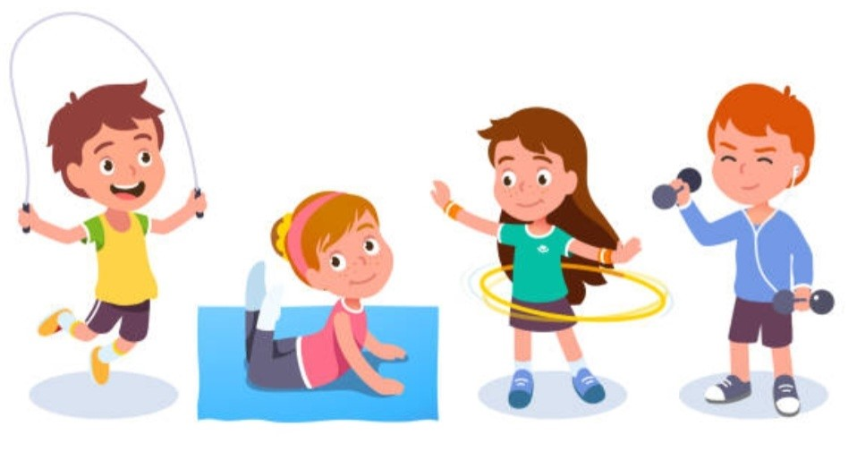

**PE Kit**

Gym time at St Cadoc’s primary school is an important part of the school week, it not only supports the children’s physical and mental wellbeing it also improves children’s learning and development. We want to ensure all children have the opportunity to take part in gym time. We are looking for donations of pre-loved PE kits including black/navy shorts, and white polo shirts. If you can help could you please hand these into the school office.

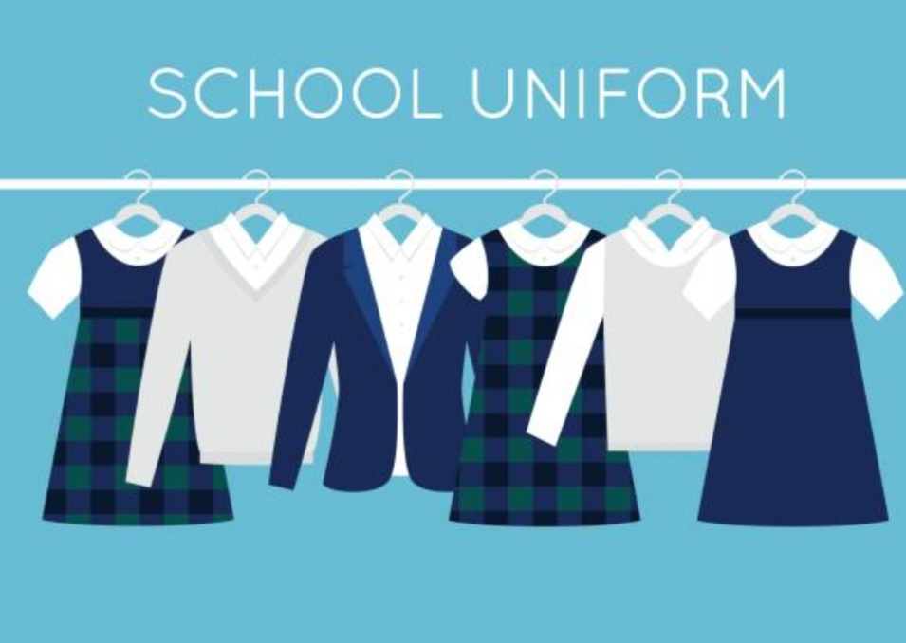

**School Uniform**

Around this time of year our children seem to grow really fast! If you are having a clear out of school uniforms including shirts, trousers, skirts, jumpers, cardigans could please hand these into the school office. We can then pass these on to families who could make good use of the uniform items.

Thank you for your continued support

From

**Parent Council**