DUTY OF CANDOUR
St. Bride’s Nursery Class – Annual Report
All health and social care services in Scotland have a duty of candour. This is a legal requirement which means that when things go wrong and mistakes happen, the people affected understand what has happened, receive an apology, and that organisations learn how to improve for the future. An important part of this duty is that we provide an annual report about the duty of candour in our services. This short report describes how St. Bride’s Nursery Class has operated the duty of candour since the beginning of session 2024-2025.

- About St. Bride’s Nursery Class: St. Bride’s Nursery is a children’s Early Years service in Bothwell for up to 56 children aged 3-5 at any one time. We currently provide1140 hours over 5 days. We aim to ensure that we care for children in a way which supports them to grow and develop.

- How many incidents happened to which the duty of candour applies? In the last school session, there were no incidents to which the duty of candour applied. These are where types of incident have happened which are unintended or unexpected, and do not relate directly to the natural course of someone’s illness or underlying condition.

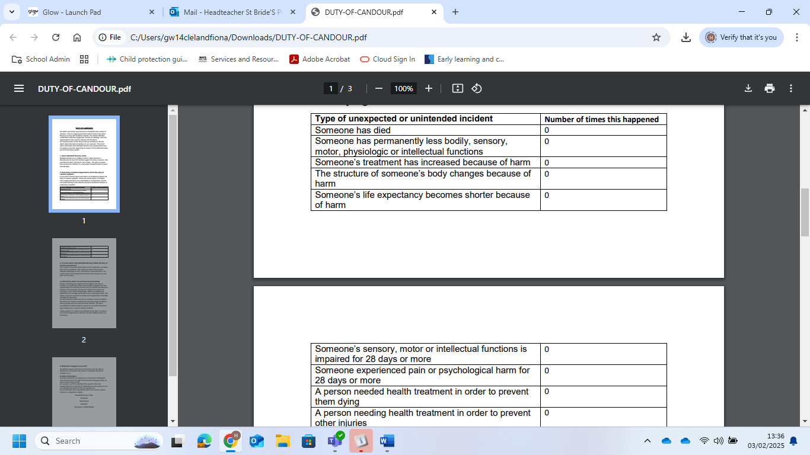

- To what extent does St. Bride’s Nursery follow the duty of candour procedure? If we realise the events listed above have happened, we follow the correct procedure. This means we inform the parents affected, apologise to them, and offer to meet with them. We would review what happened and what went wrong to try and learn for the future.

- Information about our policies and procedures: Where something has happened that triggers the duty of candour, our staff report this to the nursery manager who has responsibility for ensuring that the duty of candour procedure is followed. The manager records the incident and reports as necessary to the Care Inspectorate. When an incident has happened, the manager and staff set up a learning review. This allows everyone involved to review what happened and identify changes for the future. All new staff learn about the duty of candour at their induction. We know that serious mistakes can be distressing for staff as well as people who use care and their families. We have occupational welfare support in place for our staff if they have been affected by a duty of candour incident. Where parents or children are affected by the duty of candour, we have arrangements in place to provide welfare support as necessary.

5. What has changed as a result? All staff are aware of the Duty of Candour and are able to identify the procedures they have to undertake should an incident occur.

- Other information: The Duty of Candour is helping us to remember that people who use care have the right to know when things go badly, as well as when they go well. As required, we have submitted this report to the Care Inspectorate but in the spirit of openness we have placed in on our website and shared it with our parents too. If you would like more information about our nursery, please contact us using these details:

St. Bride’s Nursery Class
Ailsa Drive
Bothwell
G71 8LP

Tel: 01698 853709

