- Prayer led by Ms Campbell
- Confirmed all school stages have been met through current attendees at parent council
- No comment on minutes
- MCG discusses the new anti bullying policy.
- The policy was last launched in 2018. New government guidance has come out so the policy has been updated to reflect it
- New definition of bullying has come out with more impact on the child being brought out
- Difference between conflict vs bullying was brought out
- Online bullying was also raised - may be more relevant for secondary school
- More guidance to be provided to schools regarding bullying that took outside the school and how school could approach it
- More guidance and information to be provided to parents on online bullying
- Lot of work done on racial/gender bullying - gender bullying has risen
- Cases of bullying are recorded on a system and how the bullying has been dealt with is recorded eg resolved, unresolved, unfounded
- There is also an escalation route for parents who don’t agree with the bullying outcome
- SLC speaking to headteachers about the new policy.
- Educational psychologists have been engaged and have spoken to pupils around the current policy.
- New policy to be shared in November 2025 for feedback then full launch in the new year
- SLC keen to understand how best to communicate these changes to the parents bodies across the council area
- FC updated anti bullying policy in March 2025 for the school and when actual guidance received then will update the policy.
- FC confirms the recording of bullying is absolute and the outcome of the investigation is recorded on the system
- LM asks how prevalent bullying is at primary school. FC says not as much as the word bullying doesn’t tend to be used as much. Only 3/4 instances in recent history.
- There only needs to be one instance of bullying to then be recorded in the system
- KM asks if teachers need to resolve issues - FC confirmed this is a big part of it; however some parents will say they don’t want their child to be involved in the resolution.
- This can lead to a breakdown between parents and the school as the parents’ needs may not be met
- Key focus is relationship building and items can be escalated outside the school eg parents resolution
- FC wonders if a parental information evening should be considered for online education system. ACTION
- PM speaks about the importance of education to children about the apps
- JP talks about St John’s and their commitment to no phones before they leave the school. Peer pressure massive issue for phone buying
- Standards and quality - improvements seen
- Writing programme launched - it’s been great so far. Area of biggest gap right now
- Prescriptive programme from SLC to help writing and drive improvements
- Where deficits are found, sprints are done over four weeks and this will be focused to see if improvements are made
- RE consultation made and FC has responded on behalf of the school
- A school in the learning community has had people wanting to opt their children out of the Catholic education cycle eg not going to Mass.
- FC states that no one has opted out of RE (parent right) at St Brides
- LM will take the lead on the PEF with more structure and to address equity issues
- Mrs Cocozza is still unwell and Mrs Hilton is unwell this week and Miss Ridge has had a bereavement
- Additional support assistant is due to start this term; however recruitment checks are still on going
- Mr Lambie is going off sick; however this is delayed
- MCG is investigating Connect; however you need to pay for it. There will need to be a review of benefits to see if it would be beneficial.
- JP states she has ParentKind for the PTA (the free version)
- Nothing done on the MUGA because of the messes left on the MUGA
- Incident happened over the summer with an injury sustained, they were treated by members of the public
- Views of the parent body may need to be sought if it should be public access
HT Report
Standards and Qualities and Improvement Planning (SQIP)
Our SQIP document summarises the performance data for 2023/2024 as well identifying the improvement agenda for the upcoming year.
The data measures the percentage of children in P1, P4 and P7 that are on track and have achieved their expected levels in numeracy and literacy. This data shows that overall literacy and numeracy improved and remains above the national and SLC figures.
The 3 main improvement items are outlined on the “Improvement on a Page” as below.
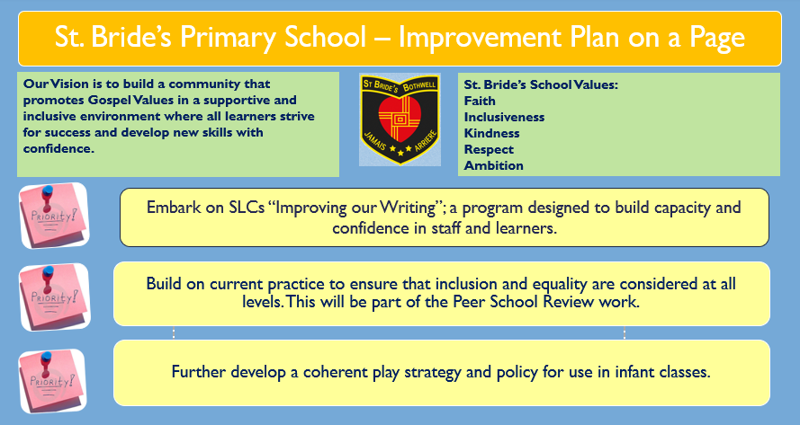
This document and the Improvement on a page have been added to the school website.
RE/RO Consultation
Last year the Scottish Government launched a consultation regarding proposed changes to primary legislation relating to RE and RO. The proposed changes were to align legislation with the UNCRC and introduce the opportunity for pupils to have their views heard when their parents seek to withdraw them from either RE or RO.
On Friday 20th June, the Equalities, Human Rights and Civil Justice Committee launched an online call for views on the Children (Withdrawal from Religious Education and Amendment of UNCRC Compatibility Duty) (Scotland) Bill. This is the next stage in the process for passing the Bill.
The Scottish Catholic Education Service (SCES) contacted schools again asking for responses to be submitted relating to the rights of children to have their voices/opinions heard when it comes to withdrawing from Religious Education and Religious Observance. I have done this on behalf of St. Bride’s and will keep you abreast of any further developments.
PEF/Participatory Budget
Our Pupil Equity Funding is £34,485.54 which includes a small amount of carry over from last year. As with previous years roughly 5% of this is allocated to Participatory Budgeting. In previous years this has gone on playground resources (toys/stages), reading for enjoyment & library resources and science resources. This year Miss McEnaney will be the PB lead and will arrange consultations with parent, staff and pupil groups to try and ensure that this is allocated well.
Staffing
We returned in August without Mrs Cocozza in P2/3 as expected. We were fortunate to secure Miss Murphy who has worked really hard helping the children to settle in and provided a great start to the year for them. We hope to see Mrs Cocozza back as soon as possible and will keep parents up to date when we have a return date confirmed.
We have been allocated another support assistant and are awaiting recruitment checks to be completed before she starts with us and hope that this will be done quickly.
Miss Reynolds our NQT is working hard in P5/6 and Mrs Campbell is mentoring and supporting her as she gets to know the children and families.
Connect
We have been informed by SLC of a resource for Parent Councils and PTAs called Connect which is to support partnerships in education (https://connect.scot/)
Parent groups can register with this and gain access to a variety of resources and supports.
I have attached a link for the video https://www.youtube.com/watch?v=BOuz4a23I6A
It may be worth looking into as we continue to try and raise parental engagement.

