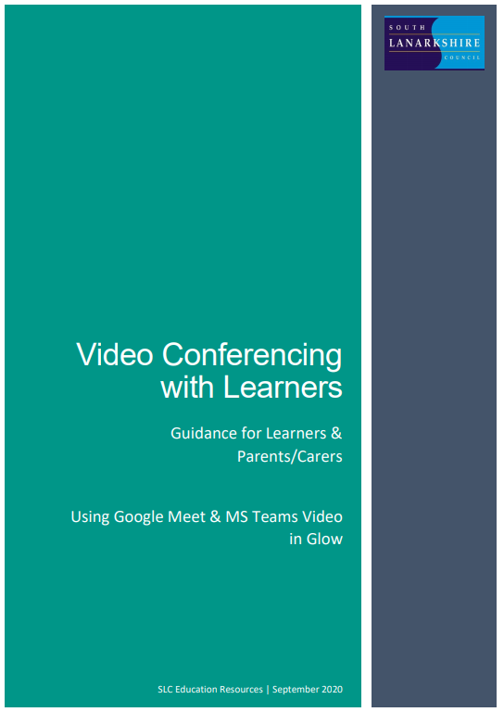
Code of Conduct
Google Meets

As part of the schools online teaching provision we will be using the Google Meet video conferencing app, accessible through Google Classroom. This will provide your child with the opportunity to communicate with their class teacher, each day, during lockdown.
If you do not consent to your child participating in these video conferencing sessions, please email:
headteacher@st-brides-bothwell-pri.s-lanark.sch.uk

Pupils
- Find a suitable place to sit – this should be somewhere:

  - that is not your bedroom, unless this is completely unavoidable.
  - with your back towards a wall to reduce how much of your surroundings are in the camera frame and try not to have personal items on display such as family photographs.
  - quiet with no distractions e.g. turn off the TV, radio etc or use headphones
  - with good light but do not sit with your back to a window as it makes it difficult for others to see you.
  - with a table or hard surface to place your device on to maintain a stable image/connection.
- Prepare as you would for a real lesson in school – which means:

  - dress appropriately, as you would if others outside your home would see you.
  - be on time for the session starting and be ready to take part – your teacher will share the dates/times of online sessions; you should discuss this schedule with your parent/carer.
  - have a pen/pencil and paper/jotter beside you and anything else you need for that sessions learning.
  - let other people in your house know that you are joining an online lesson so they do not accidently interrupt you once the session gets underway.
- Behave as would be expected in face-to-face lessons.
- Follow up on any activities given to you by your teacher – these will be posted on your Google Classroom. If there is anything you are unsure of you can ask a question by posting on the stream or by adding a private/class comment to the work.

Parents/Carers
- Information and a schedule of meetings will be made available to learners in advance of any online sessions; learners are asked to ensure these are shared with parents/carers to help you plan for online lessons/meetings.
- Help your child by finding a quiet and well-lit place, preferably not a bedroom, to take part in online lessons; the background area should be clear and away from an area where other members of the household may be visible on camera.
- Remind your child of the need to behave appropriately and to follow teacher instructions and the class code of conduct; for younger children it would be desirable if you stayed close by to monitor their activity.
- It is important that parents/carers do not attempt to participate in online meetings with learners, this is to protect your own privacy and that of others. If you need to speak to your child’s teacher, please use the usual means of communication to do this.
If you child is experiencing difficulty during a meeting they should use the chat facility to communicate this to their teacher, parent/carers must not interrupt meetings by speaking or appearing on camera.

- It would be helpful if you could follow up with your child after online meetings (depending on their age and stage) to ensure they are clear about next steps provided by their teacher.

