St Bride’s Primary School & Nursery Class Bothwell
Remote Learning Policy
January 2021


In St. Bride’s we are all V.I.Ps
Valued, Included and Praised for all we do!

Background:
Before Christmas 2020 the First Minister announced that most school pupils would learn remotely, rather than in school, until Monday 18 January 2021. On 4 January 2021 the First Minister confirmed that the Scottish Government had decided to extend this date and keep school buildings closed to the majority of pupils until 1 February 2021.
While the COVID-19 pandemic has changed many things, our curriculum framework continues to apply. The core principles of Scotland’s curriculum and the four fundamental capacities at its centre remain critical in putting learners at the heart of education.
Education Scotland COVID 19 Education Recovery Group

Education Scotland Definition of Remote Learning :
Remote learning is learning that is directed by practitioners and undertaken by children and young people who are not physically with the practitioner while instruction is taking place.
Remote learning involves a combination of ‘live’ interactions between teacher and learners, and also learning which takes place away from the direct presence of the class teacher. It may involve a range of learning experiences which take place in a variety of learning spaces, including outdoors and includes active and physical learning.
Education Scotland COVID 19 Education Recovery Group

What is Remote Learning as defined by South Lanarkshire Council….
“ Remote Learning can be defined as the planned and systematic delivery of learning and teaching that takes place away from school and makes use of available technology and resources”
South Lanarkshire remote Learning : Advice and Guidance for Establishments 2021
Our Aim :
Here in St Bride’s our aim is to provide our school community with a Remote Learning Policy, the use of which will safeguard our children and staff. This document sits within Education Scotland COVID 19 Education Recovery Group Document and South Lanarkshire Council’s Video Conferencing with Learner Guide to Staff AND Video Conferencing with Learner Guide for Learners, Parents/Carers.

Remote Learning in St Bride’s:
Of the two video conferencing platforms available within South Lanarkshire Council, we will be using Google Meet ( Nursery & School) and as our learners are familiar with the use of Google Classroom in P1-7 this will be the main platform for the school to post and access work All staff have read and agreed with SLC Video Conferencing Guide and Form A34b Notification of Use has been completed and emailed to appropriate person within the authority.
All parents across the Nursery & School have been issued with a version of SLC Video Conferencing Guide for Learners, Parents & Carers via the school app. (Appendix 3)
Our Remote Learning offer:
Children should register daily on Google Classroom.
We will deliver a mix of interactive, recorded and live sessions with our learners. Not all learning will take place in the presence of a teacher as we recognise the importance of independent learning, children should not be in front of a screen all day and therefore we have adopted a flexible approach to supporting families and pupils.
Our remote learning will include opportunities as it would in class, to consolidate and extend learning to take account of and meet the needs of learners and their families.
Class teachers will be available from 9:00- 2.30pm each day following the school day which includes a morning break and afternoon lunch break.
We have issued an online Timetable for the School ( Appendix 1) and a separate Nursery Timetable ( Appendix 2) which has been shared with Parents
The staff submit a weekly plan to SLT and an updated Record of Work on a Friday detailing an overview of what has been covered. Detailed teaching and activities are uploaded to Google Classroom daily (on or before 8.00am). This takes account of responsive planning, feedback from pupils and ensures continued pace and progress of learning. Early morning upload has been requested and agreed with parents to allow families to be able to download materials if required and plan effectively for the day ahead.
We have created Remote Learning Advice email addresses for the SLT and Nursery Teachers to support, advise and answer any questions or queries around our offer as quickly and as effectively as possible.
To ensure quality learning experiences SLT have the usual quality assurance measures in place including joining Google Meets, monitoring weekly plans and regular contact with families, Staff dialogue and learner conversations.

Agreed understanding of “Live” Interactions and Direct Teaching online:
The weekly timetable will include up to 3 live interactive sessions per day which will focus on Health & Wellbeing, Literacy and Numeracy with Plenary and feedback.
First Google Meet of the day is to welcome and share the plan of work this is where our learners will be able to see each other and their teacher. This will be a Daily HWB, Pastoral Care check-in
The school timetable will include a mixture of weekly pre-recorded lessons in RE, Science, HWB, Expressive Arts and PSE/ Lifeskills delivered by the SLT and Support Assistants. The end of the week includes a weekly Assembly on a Friday ( FaceTime Friday) which will be a live session with the Head Teacher
All live interactions will be recorded and a second member of staff will be on the meeting as a back up for any technical issues. All staff when not in school will use the background function. SLT and Nursery Teachers will monitor Google Meets across the School and Nursery to ensure positive engagement
Pupil engagement will be monitored weekly by staff and SLT
The first Google Meet of the Session will allow the class teacher to set up the rules to be used by all participants.
Lessons:
Lessons will be delivered as a mix of live interactive lessons, pre-recorded and independent activities to complete. The weekly timetable includes a minimum of one lesson per day which will be a live interactive session taking place in real time.
The class teacher will direct the lesson sharing the Learning Intention and Success Criteria at the beginning of the lesson.
A mix of delivery will be used such as power point, videos, readings etc. The teacher will be available on the chat function to direct and support learning. Children can ask questions, check for understanding etc in real time and the teacher will respond.
The learners will be given a task/assignment to complete.
Children are required to be online at a given time to take part in the interactive lesson or specific group task, staff will direct. All other lessons for that day can be completed at a time that suits the learner and family circumstances.
All recordings used are available on the Google Classroom so that if a child cannot access the lesson at the given time they will still be able to watch and complete the tasks.

Lesson Feedback:
Assignments/tasks are given with a 48 hour window to complete for feedback. Feedback will be given on activities, when appropriate, concentrating on strengths and next steps
If assignments/tasks are not completed and submitted within that time, feedback from class teacher will not be given.
Our shared timetable affords staff time from 2.00-3.00pm every day for correction and use of the chat function for feedback with pupils.

Communication with Parents
Communication with parents will be via the School App, Twitter, designated RL email and telephone through Main Office
Essential and updated information will always be sent via the School App
Twitter will be used to celebrate success, share advice/ resources and photographs/ videos of pupil learning A variety of School Home Learning Leaflets and Advice notes have been created and shared online for parents to help with advice and troubleshooting
SLT will make weekly contact with vulnerable learners and Class Teachers/ Nursery Staff will make scheduled check ins with families as and when appropriate/ necessary Parents should be aware that SLT can be contacted by email or telephone to answer concerns or queries

Quality Assurance
SLT are members of every Google Classroom and will continue to monitor weekly concepts to be covered, this will be reviewed by SLT and feedback given to through staff dialogue and tracking of Google Classroom
The weekly engagement of pupils will be recorded and reported by Teaching Staff. SLT will contact those pupils not engaging to offer further support and/ or advice

Safeguarding & Child Protection:
All staff are fully aware that the normal safeguarding and child protection procedures apply and know to contact the Head Teacher with any concerns.
All live meets will be recorded and will be stored on the one drive.

Appendices
Example of School Timetable ( Appendix 1)
Day | 9.00-9.30 | 9.30-10.15 | 10.15-10.45 | 10.45 – 12.00 | 12.00-1.00 | 1.00-2.00 | 2.00-3.00
Monday | Fitness/  Starter Task + GM 1 | Online Learning  ( Num)) | Break | GM 2  Online Learning  ( Lit) | Lunch | GM 3  Online Learning  Topic | RE  Pre-recorded
Tuesday | As above | As above |  | 11.45 – 12.00  Check-in with Fr Coyle |  | As above | SCIENCE  Pre-recorded
Wednesday | As above | As above |  | 11.45 – 12.00  “ Stop for a Story” ( P1-3)  ERIC time( P4-7) |  | As above | HWB  Pre-recorded
Thursday | As above | As above |  | As Monday |  | As above | EXPRESSIVE ARTS  Pre-recorded
Friday | Facetime  Friday -  Assembly | As above |  | As Monday |  | As above | PSE/ Lifeskills  Pre-recorded

Nursery Programme ( Appendix 2)
Weekly | Home Learning Grids prepared ( differentiated)+ posted for 3-4yr and pre-schoolers on App/ Twitter
Twice a Week | Pre-school “Lessons” – Pre-recorded by Nursery Teacher ( Tuesday & Thursday pm)
Once a Week | Nursery Teacher Google Meet “ live interaction” with 3 groups am / pm
Daily | Calendar Time and Welcome – recorded and posted on Twitter  Google Meet “ live interaction” with Keyworker and designated group  Pre-recorded Activity posted on Twitter

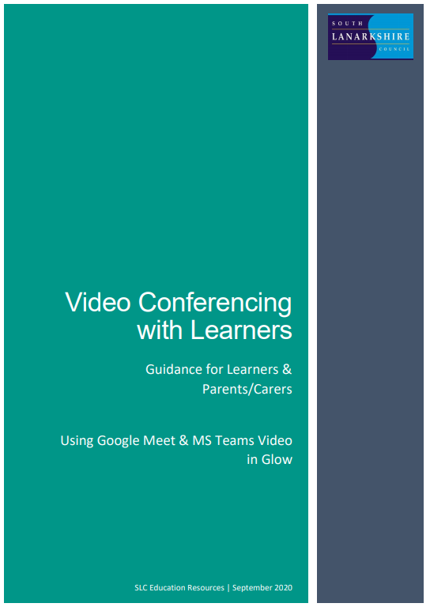
Appendix 3
Contents
Important Note for Parents/Carers 9
Learners – setting up Google Meet at Home 8
Before the online meeting starts 8
Connecting to the online meeting 9
During the online meeting 11
After the online meeting 11
Connecting to Google Meet on a tablet or mobile device 13
Parents/carers – helping your child with Google meetings 14
Before the online meeting starts 14
Connecting to the online meeting 14
During the online meeting 15
After the online meeting 16

Important Note for Parents/Carers

Video conferencing can be an effective way to keep in touch, provide support, reinforce and deliver new learning but this is a new way of interacting for most learners, teachers and parents/carers.
Please familiarise yourself and your child with the following advice and guidance to ensure that everyone feels safe and secure whilst using video conferencing for learning; and note that online meetings may be recorded to ensure everyone is protected when using video calls. Learners will be informed of this (if recording is taking place) at the beginning of online session and recordings that include images or audio of learners will not be shared with other learners or on other online platforms such as Google Classroom or Microsoft Teams.
There are 2 video conferencing platforms, available for use by SLC staff, from within the national digital platform Glow. Until recently this has only been enabled for staff-to-staff communication. Following the implementation of recent technical changes to Google Meet and Microsoft Teams, Education Scotland has now opened access to these tools to allow staff-to-learner communication. It should be noted that these are the only platforms currently sanctioned for use within SLC as they meet the technical requirements necessary to ensure the safeguarding of all participants.

Learners – setting up Google Meet at Home

Your teacher will be using an online videoconferencing platform called Google Meet, to deliver some of your lessons or to connect with you when unable to meet with you face-to-face.
Follow the instructions and advice below to ensure you make the most of these online sessions.

Before the online meeting starts
- Find a suitable place to sit – this should be somewhere:
  - that is not your bedroom, unless this is completely unavoidable
  - with your back towards a wall to reduce how much of your surroundings are in the camera frame and try not to have personal items on display such as family photographs
(at the time of writing this guidance, blurred backgrounds were not an option in Meet)
  - quiet with no distractions eg turn off the TV, radio etc or use headphones (see below)
  - with good light but do not sit with your back to a window as it makes it difficult for others to see you
  - with a table or hard surface to place your device on to maintain a stable image/connection
- Prepare as you would for a real lesson in school – which means:
  - dress appropriately, as you would if others outside your home would see you
  - be on time for the session starting and be ready to take part – your teacher will share the dates/times of online sessions; you should discuss this schedule with your parent/carer
  - have a pen/pencil and paper/jotter beside you to take notes or have a digital alternative such as a Word or Google doc open in advance of the session starting
also
  - let other people in your house know that you are joining an online lesson so they do not accidently interrupt you once the session gets underway

Connecting to the online meeting
Most of your online sessions will take place through your Google Classroom(s) in Glow and your teacher will have shared the schedule showing dates/times in advance.
The link to your online meeting space is on the banner in your Google Classroom(s).
You will not be able to join the meeting until your teacher has started it.
- Log into your Glow account and go to Google Classroom
(if you are using a tablet or mobile device, see page 7 for help connecting with the Meet app)
- Click on the meeting link on the Classroom banner (remember you won’t be able to join the meeting until your teacher has started it – see point 8 below)
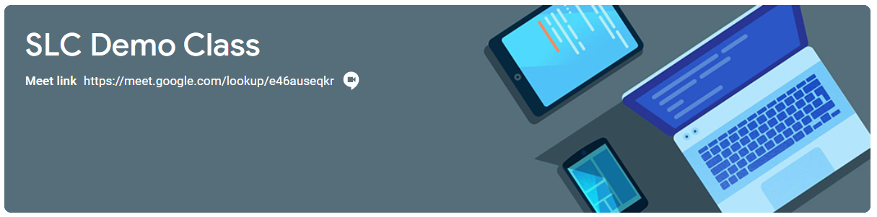
- You may see a message about using your camera and microphone – click Allow (even if you know you don’t want either to be on during the meeting – this can be done later)
You will now see a preview window showing your webcam view – click on the microphone icon to MUTE your mic – the icon will turn red (do the same to turn off camera, if you wish)

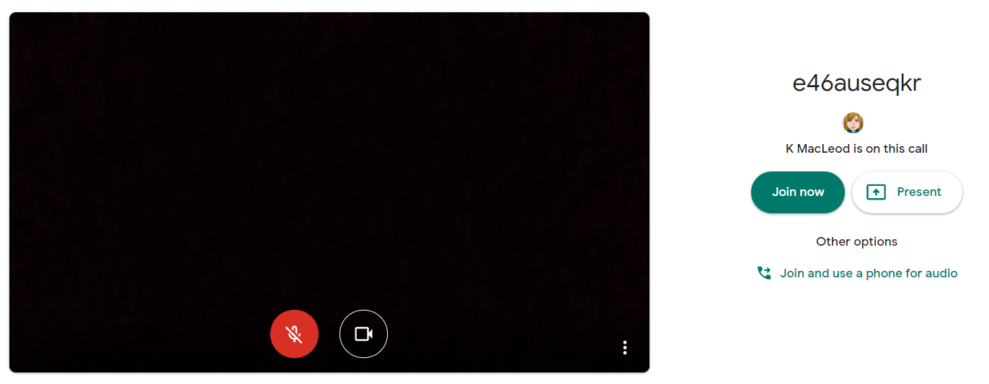
Ms Smith is on this call
- Click Join now to enter the Google Meet – do not click Present
- Once connected, listen carefully to your teacher and instructions being given
If you are experiencing any technical problems eg unable to hear or see your teacher – use the chat facility to report this and wait for the teacher (or support person) to take action. Do not interrupt by turning on your mic (unless this is permitted by your teacher/class code)
- Before starting the lesson, your teacher will remind everyone that it will be recorded - you will see the red REC button on the top left of your screen when the recording begins
- If your internet connection fails and you ‘drop out’ of the meeting, you should be able to reconnect by following the steps above, as long your teacher is still in the meeting
- If you see this message when you click on the Meet link in Classroom…
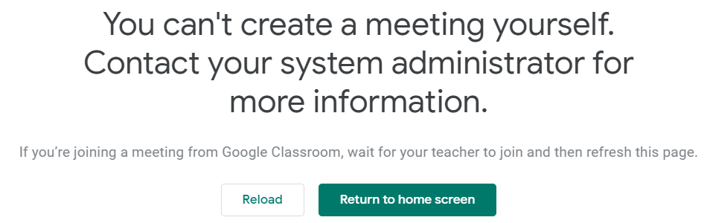
it means your teacher has not started the meeting yet – go back to Classroom and try again nearer the time of the meeting

During the online meeting
- Behave as would be expected in face-to-face lessons.
Your teacher is able to remove you from the meeting if you do not conduct yourself appropriately and this is likely to result in follow-up action by Mrs Colgan who may also discuss this with your parents/carers
- Use the chat facility to communicate with your teacher and/or participate in discussions – this can be found on the top right of your screen
The chat area is also where your teacher may post links and resources and where you may need to register your attendance and/or access an exit ticket/pass
- Only unmute your microphone if your teacher gives you permission – remember to mute it again once finished speaking
You will find the mic/camera controls by clicking anywhere on your screen, a white banner appears at the bottom, click on the red microphone icon to unmute, click on the white microphone icon to mute
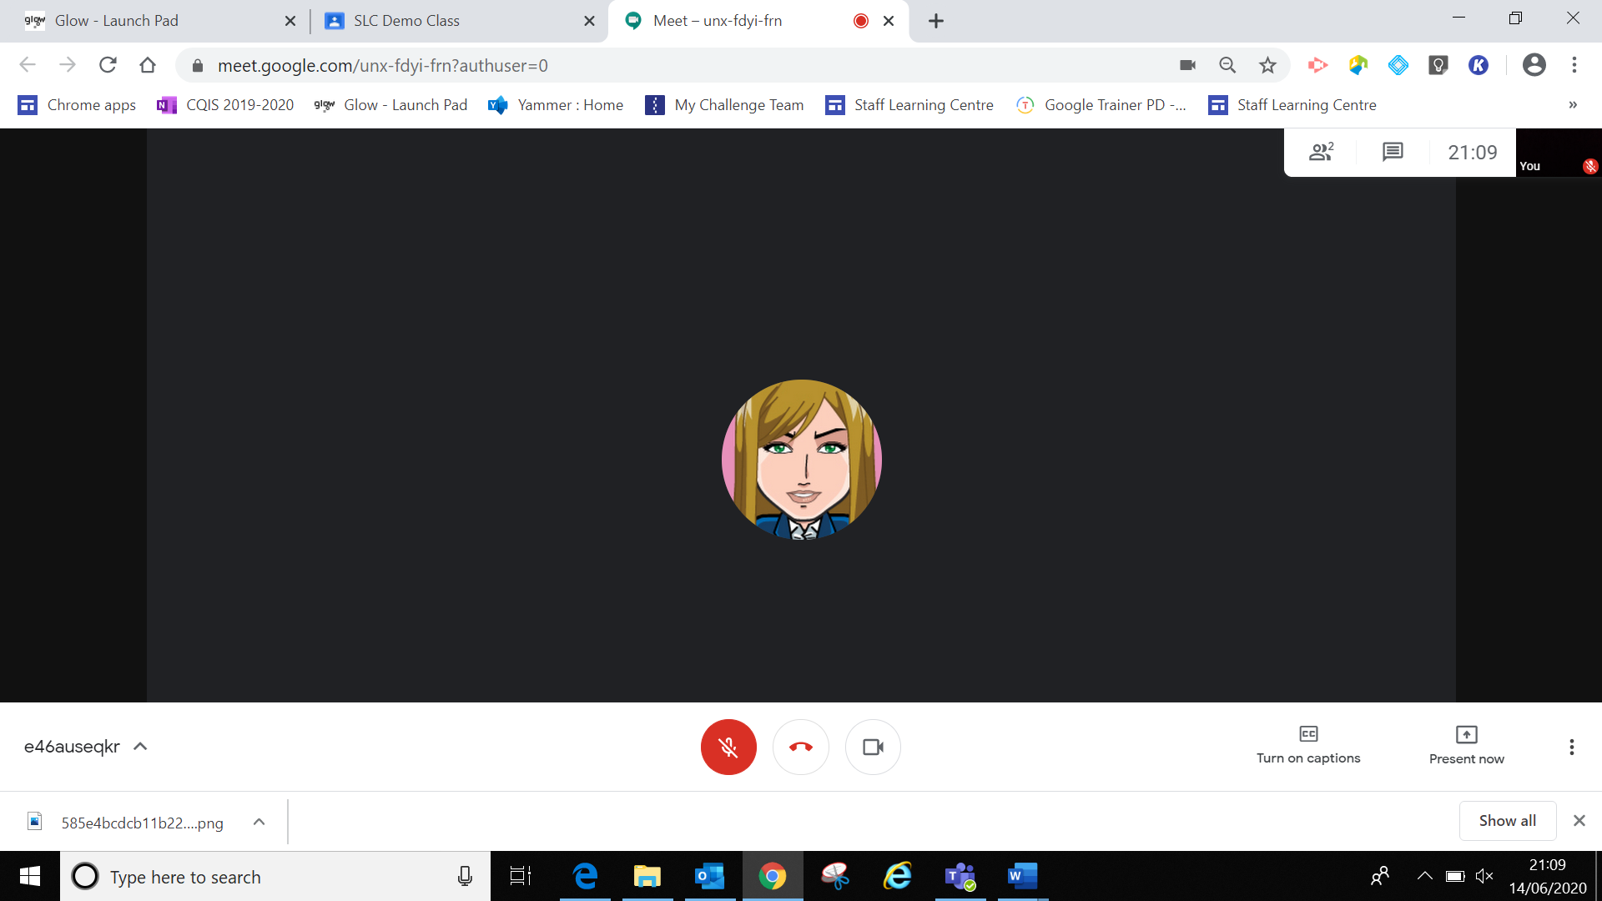
- Only share your screen (Present now) if your teacher gives you permission – remember to stop sharing once you have finished
- You may find it easier to follow what’s being said during lessons by turning on captions, which show text of the conversation; no one else can see you are using closed captions and only you can put them on or off

- At the end of the meeting, disconnect by clicking on the red ‘hang up’ icon (found between the microphone and camera icons)

After the online meeting
- Follow up on any actions given to you by your teacher – these may be posted on your
Google Classroom
- If there was anything during the meeting that caused you concern, it is important that you contact your teacher and/or discuss with your parent/carer who can contact your school.

Connecting to Google Meet on a tablet or mobile device

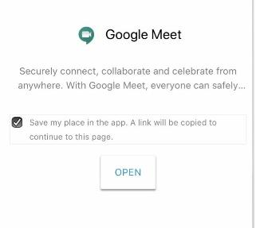

- Click on the meeting link on the Classroom banner or, if you don’t see the link,
look for the video icon and click on it
- Your device will prompt you to download the
Google Meet App – click OPEN
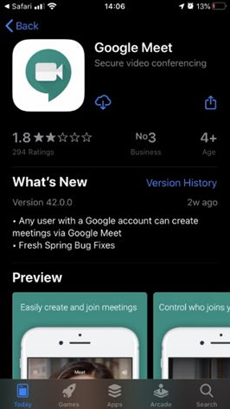
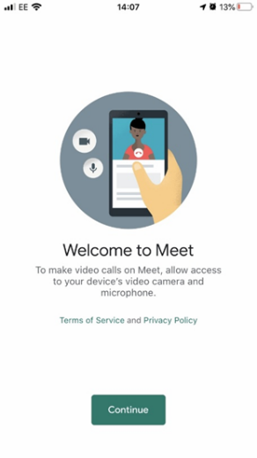
- You need to download the app from your app store and once you click to download you’ll see a Welcome to Meet message – click Continue and allow access to your camera and microphone when prompted
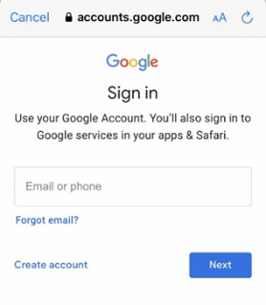
- Click to Sign In and Choose an Account – you need to use your Glow account and it should have the @sl.glow.scot ending not @glow.sch.uk
If you don’t see your Glow account, then click to Add another account and enter your Glow account details – REMEMBER username@sl.glow.scot not glow.sch.uk
- You are now in Google Meet – but if your teacher hasn’t started the meeting you won’t be able to join yet. Controls for camera, microphone and hang up are on the screen and more controls can be accessed once the meeting starts, including closed captions, as well as tabs for chat and attendees. Turning your phone landscape can improve the Meet experience as presenters and presentations are displayed in a larger format.

Parents/carers – helping your child with Google meetings

Before the online meeting starts
- Information and a schedule of meetings will be made available to learners in advance of any online sessions; learners are asked to ensure these are shared with parents/carers to help you plan for online lessons/meetings
- Help your child by finding a quiet and well-lit place, preferably not a bedroom, to take part in online lessons; the background area should be clear and away from an area where other members of the household may be visible on camera
- Remind your child of the need to behave appropriately and to follow teacher instructions and the class code of conduct; for younger children it would be desirable if you stayed close by to monitor their activity
Inappropriate behaviour may result in a child being removed from a lesson and a follow-up discussion with senior school staff
- All online meetings will be recorded to ensure everyone feels safe and secure while using videoconferencing – your child will be reminded of this before recordings begin; only teachers are permitted to record meetings

Connecting to the online meeting
- Your child has been provided with instructions for joining a Google Meet videoconference but may require some help getting the sound and/or camera to work – you can help your child explore the different settings for this prior to an online session starting

- Go to https://meet.google.com – learners are not able to start or create meetings but from his window they can click on the settings cog on the top right of the screen
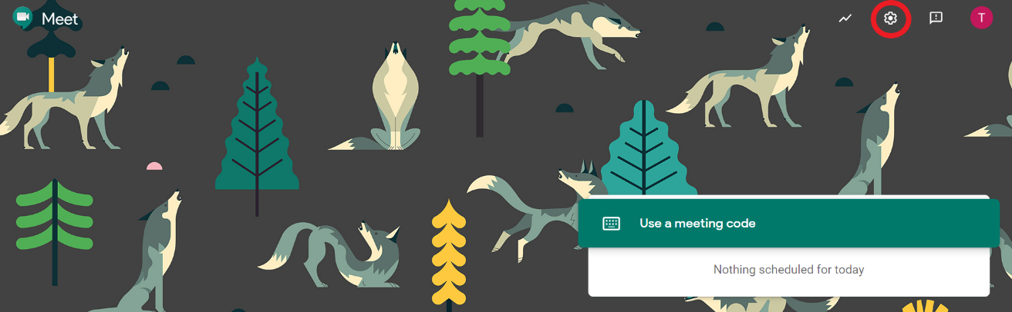

Audio settings – from this window your child can select to use their headphones instead of the default speakers; Video settings – your child can select a different webcam if required
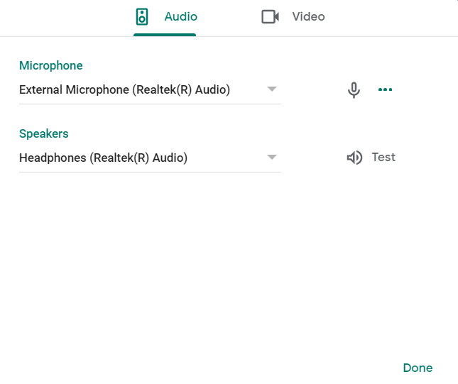
Your child may also require help downloading the Meet app onto a tablet or mobile device – instructions for this can be found in the Learner instructions.

During the online meeting
- It is important that parents/carers do not attempt to participate in online meetings with learners, this is to protect your own privacy and that of others. If you need to speak to your child’s teacher, please use the usual means of communication to do this.
If you child is experiencing difficulty during a meeting they should use the chat facility to communicate this to their teacher, parent/carers must not interrupt meetings by speaking or appearing on camera.

After the online meeting
- It would be helpful if you could follow up with your child after online meetings (depending on their age and stage) to ensure they are clear about next steps provided by their teacher.
- If you have any concerns about the use of Google Meet or the content of online lessons, please contact the school using the normal channels of communication.

