St Bride’s Primary School Bothwell

The paragraphs below describe the different scenarios we may face during the school year and how we propose to ensure continuity of learning for your child
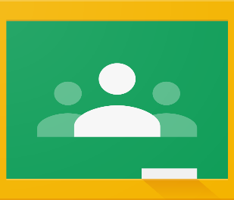 |  |  | 
Weekly Homework | Self - Isolation  Individual Child | Self- Isolation  Whole Class | School Closure
ALL classes will post  Fortnightly Homework Grids on Google Classroom  Pupils can access this by logging into their Glow Account  Password in Homework Diary  Homework may be online learning – Reading/ Number task OR pupils may be asked to upload a photograph or document with a completed task  We ask that the Class Teacher should not be contacted by parents through this Channel  Suggested Timings  P1 + 2 – 15 minutes per evening  P3 & P4 – 20 minutes per evening  P5-7 – 30 minutes per evening | If your child is self-isolating and able to complete work, we want to support them as much as we can.  We are unable to replicate the teaching in class, however they should continue to access Google Classroom and in addition their teacher will upload individual work for them to complete.  They are also able to continue with online learning such as  Easi Maths and Oxford Owls  Support Calls from school will also take place | This situation is the same as an individual self-isolating  The Class Teacher, or another member of staff, will increase the volume of work being posted on Google Classroom for pupils to complete.  Class Teachers will be available on GC from 9-3pm each weekday during the whole class isolation, however there is not an expectation that pupils will be on GC from 9-3pm. The work uploaded for pupils is not optional to complete, however, pupils can be on for the length of time it takes for them to complete the daily tasks.  We are aware that families may have more than one child who need to use the same device to access online learning. | In the event of a whole school closure, Class Teachers will manage learning for their classes through Google Classroom in much the same way as a whole class self-isolating

