Parent Update - Digital Learning and Homework in St Bride’s Primary School Bothwell “LEARNING IN THE TECHNOLOGIES PROVIDES OPPORTUNITIES TO CONTINAULLY DEVELOP, USE AND EXTEND SKILLS THAT ARE ESSENTIAL COMPONEMNTS FOR LIFE, WORK & LEARNING, NOW AND IN THE FUTURE”
Education Scotland Technologies Principles and Practices Paper
As a result of COVID 19 we have been catapulted into a world of Digital Learning for all. This session our aim is to further develop skills and knowledge of online platforms to support weekly Homework tasks and also provide a contingency should we have a class/es in isolation for prolonged periods of time and/or another lockdown.
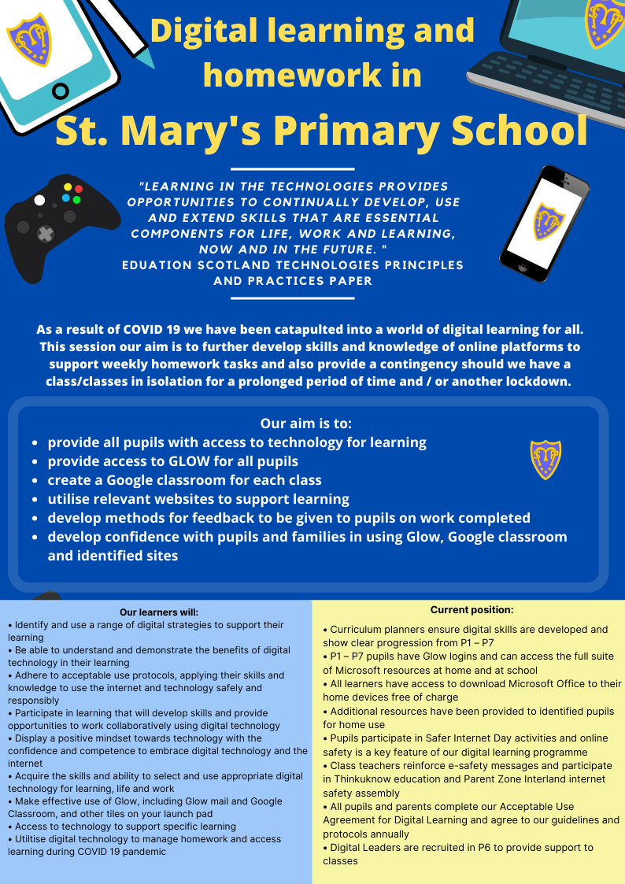
In St Bride’s we are committed to continue to develop our digital skills to support the development of digital learning across the school. This is a key priority in Session 2020/21 as we manage the COVID -19 Pandemic and strive to continue to deliver quality learning & teaching

