Making Better Readers
We are learning to read in order to write and to write in order to read.

How do we prepare pupils for texts like these? By building confidence and skills with complex texts from S1.
Scientists are developing an alternative industrial process to produce ammonia, which is more efficient than the Haber process.
This involves the electrolysis of molten lithium hydroxide to produce lithium, water and oxygen. Lithium is then reacted with nitrogen gas, which is obtained from air, to produce lithium nitride. Ammonia and lithium hydroxide are produced when lithium nitride reacts with water.

Bruce murdered Comyn in church but Bishop Wishart did not punish him for this act of sacrilege. Instead Wishart helped Bruce to become king, giving him robes for his coronation and a banner which had belonged to the last king of Scots. Wishart took timber Edward had given him to repair the cathedral roof and used it to make weapons to attack castles held by the English. Edward later imprisoned him for eight years.

An investigation was carried out into the respiration of yeast. A dough was made containing live yeast and left in optimum conditions. As the yeast respired, the carbon dioxide produced caused the dough to rise. The volume of the dough was measured every 10 minutes for 60 minutes.

Mary, Queen of Scots and Darnley were married in July 1565. The marriage caused divisions among the Scottish lords who rebelled against Mary resulting in the Chaseabout Raid. Although Mary successfully restored order in Scotland she lost the support of important nobles involved in the rebellion such as Moray and Argyll. The marriage then deteriorated quickly when Darnley demanded the Crown Matrimonial and Mary refused. This caused tension between Mary and Darnley and led to more Scottish nobles disliking Darnley as Mary’s choice of husband.

Before using a text, consider:
- How difficult is the text to understand?
- What words are most important to understand the text/topic?
- What words are unlikely to be part of a child’s prior knowledge?
- What words are interrelated and help children know additional words?
- What words are encountered in many subject disciplines?
- Get pupils to activate prior learning, to predict and to ask questions BEFORE reading

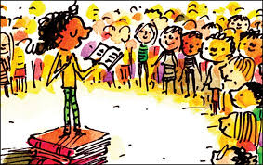
Read aloud
Singularly the most important thing you can do to make reading easier and enhance understanding.
Encourage pupils to read aloud to each other.

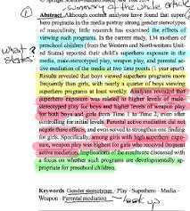
Mark the text
- Get pupils to interact with the text.
- Use highlighters to highlight all the words they don't know OR all the
words they do know OR to look for words on a special theme…
- Use 3-3-1 or 5-5-1 on longer texts to get pupils to look for the 3 or 5 most
important sentences and justify their choices.

Generate great discussion
- Promote and scaffold high quality academic discussion in the classroom.
- Make texts the basis of discussion and questioning.
- Ask 3 key questions: What do you like/dislike about this text?; Did anything puzzle you about it? Did it remind you of anything?
- Discuss the purpose of the text - to persuade, inform, entertain, educate, reflect…
- Introduce, teach and discuss command words.
- Prioritise teaching of Tier 2 and 3 vocabulary

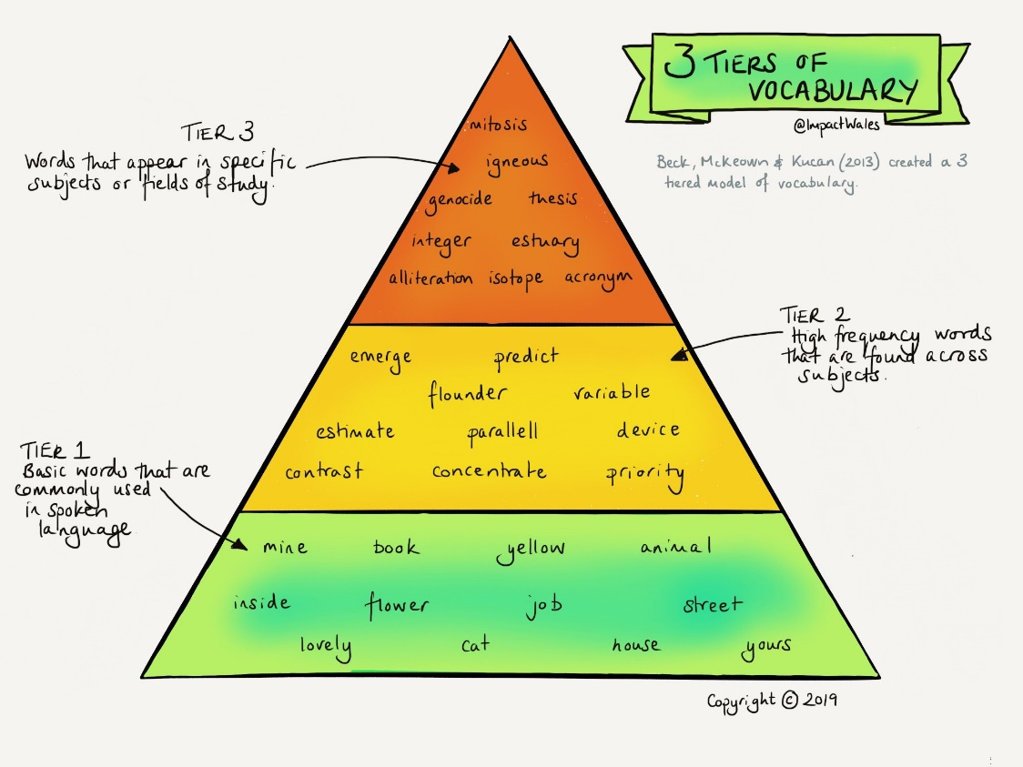

- Together, work out meanings to unknown words - sound the word out; look around the word for clues; look within the word for roots, prefixes, suffixes; explore more examples of the word in use; explore related images/ideas evoked by the word; get pupils to give examples too and clear up any misconceptions; explore ways to remember the word/concept…
- Use reciprocal reading roles - predictor; questioner; clarifier; summariser; illustrator

Play with the text
There are lots of Directed Activities for Responding to Texts (DARTs) that get
pupils engaging more fully with texts. You can miss out words for pupils to fill or reorder the text and get pupils to put the text in the right order or give a text and a diagram and get pupils to show understanding by labelling the diagram or...

Copy/Imitate the text
Promote and scaffold high quality academic writing in the classroom.
Pupils can show understanding of a text and its structure,
features, language by writing their own version or by using the
same structure to write about a different topic.
Encourage pupils to use the words they have learned in their new version.

