Lunch/Dinner Box examples

Rigside and Rural Communities nursery
Meal Guide

It can be tricky trying to think up ideas for lunches/nursery dinners! This is a little guide that offers advice from the NHS regarding preparing and storing meals, as well as some handy tips and ideas to keep your wee ones full until home time.
Please note that these ideas are if your child is on solid foods. If you need any advice or ideas on weaning, please come and speak to us.
NHS:
Your baby's diet should consist of a variety of the following:
- fruit and vegetables, including ones with bitter flavours, such as broccoli, cauliflower, spinach and cabbage
- potatoes, bread, rice, pasta and other starchy foods
- beans, pulses, fish, eggs, meat and other non-dairy sources of protein
- pasteurised full-fat dairy products, such as plain yoghurt and cheese (choose lower salt options)
As your baby becomes a more confident eater, remember to offer them more mashed, lumpy and finger foods. Remove any stones or pips before serving. Quarter (length ways) small fruit and vegetables like cherry tomatoes, grapes and blackberries and cut large fruits into slices rather than chunks.q
Providing finger foods as part of each meal helps encourage infants to feed themselves, develop hand and eye co-ordination, and learn to bite off, chew and swallow pieces of soft food.

Finger foods are great for children – obviously we do not expect them in a fancy box like this – just stick them all in a cool box and we can give them out.
The broccoli has been cooked and chilled.
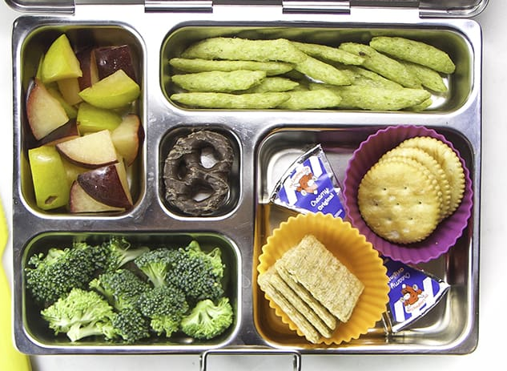
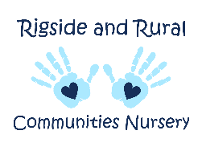

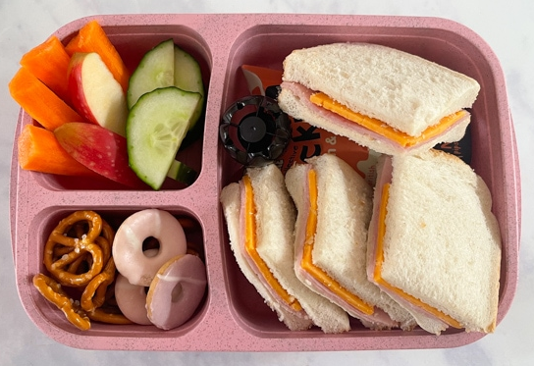
A little treat is fine if there is a balance of foods for lunch. We cannot feed raw carrot sticks to under 5’s but lots of other fruits and veggies are great!

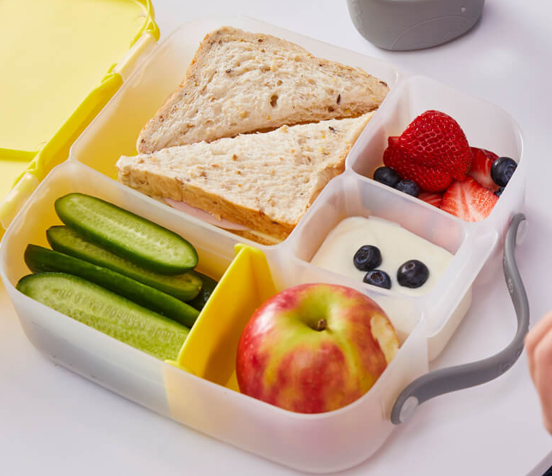
You can’t beat a good sarny! The children in here love a cheese sandwich!
If your children is new to eating them, you can cut them into fingers, to make it easier for them to pick it up!

Packed lunch examples (hot):

Packed lunch examples (cold):

Soup
You can bring in lots of different soups in a flask – please see the guidance below for using a flask. We love a wee homemade Lentil soup or a Heinz tin – especially tomato.
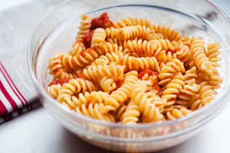
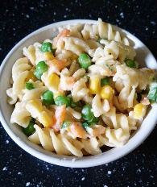
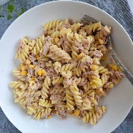
Pasta

tomato pasta with cheese, cheesy pasta with carrots and broccoli, tuna pasta with sweetcorn, pesto pasta with peas

Hot Meals
Liquid/Saucy meals stay hot for longer. Some ideas could be as simple as last nights leftovers! Stew, casseroles, and saucy pasta dishes, are ideal! You can always bring in a ready meal if the manufacturer’s instructions state it can be warmed in hot water.
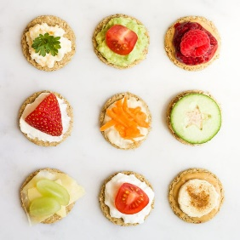
Breads/Starch
Ham or cheese sandwich, tuna roll,
soft cheese bagel, oatcake and cherry
tomatoes, Rice cakes and banana, pancakes

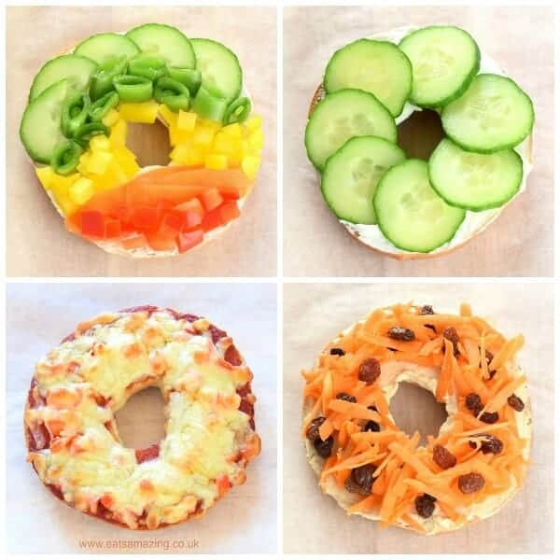

PLEASE REMEMBER
- Any homemade hot food must be heated to a temperature of 75' before going in the flask. (piping hot)
- We can only give this food to your child, if it is at 63'c or above at lunch time - we will probe it before giving to your child
- Check your flask is capable of this as some of them only keep food hot for a short period of time
- We advise you to fill your flask with boiling water first for 2 minutes before using.
- Children's unopened pouches can be given by following the manufacturer’s instructions. Normally this is warmed with boiling water and can be given at any temperature. We cannot use a hob or microwave.
- Cold pastas can be provided but must be under 5'c - an ice pack will ensure this.

Other Ideas to add in…
Breadsticks, crackers, pitta fingers, with dips (salsa, houmous, soft cheese), muffins, boiled egg, yoghurts, chopped up fruits, cheese cubes, cocktail sausages, fridge raiders, lunchables etc

PLEASE REMEMBER…
Cold foods that live in the fridge (Dairy, meats etc) MUST be placed in a cool bag with an ICE PACK inside. The food must be kept at a cold temperature until lunch time (11.30-1.30)

