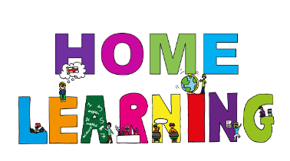
South Lanarkshire Council
RIGSIDE PRIMARY SCHOOL

READINESS TO LEARN FROM HOME

PARENT/CARER INFORMATION LEAFLET – HELPFUL HINTS

Within Rigside Primary School, your child’s class teacher will set weekly learning tasks via Google Classroom.
Your child has been shown how to access this within their class. They have been shown where to find their weekly tasks, how to communicate with their teacher and how to upload their work. If your child has any difficultly accessing this at home, please see the important information details below.
Instructions on how to access your child’s Google Classroom have been sent out previously, however, if you require another copy of these please let the school know.
Where possible your child is asked to be online by/at 10am each day to check in for the day.
On each school week, a number of tasks will be issued for your child to complete. These will include a Literacy task, Numeracy task and a learning task from at least one other curricular area.
If Learning from Home continues for a prolonged period of time, some extended tasks may be shared, and your child will be given a number of days to complete them. If this is the case, specific instructions will be shared by your child’s class teacher.
Your child’s class teacher will be available to answer questions during the school day via Google Classroom. Responses may not be instant, but they will endeavour to respond as quickly as possible. They will be available “live” within the class’ Google Classroom at the following times:
- Morning between 10am and 11am.
- Afternoon between 2pm and 3pm.
If you have any additional questions or queries, please do not hesitate to contact the School Office
on emergencyclosurerps@glow.sch.uk where we will be happy to help.
Google Classroom Access: https://glow.rmunify.com/
Class Code: w3q6mw6
Miss Shearer email: gw17shearerkirsty@glow.sch.uk

