Kit and Resource Ideas
S.T.E.M focus | Resource | Image | Possible links to buy
STEM | STEM Challenge Cards | 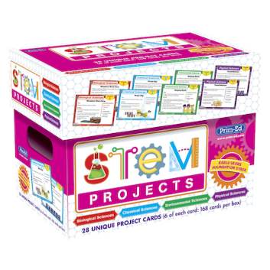 | https://www.tts-group.co.uk/stem-projects---pack/1018678.html  https://www.hope-education.co.uk/search?phrase=STEM+projects  https://www.prim-ed.co.uk/series/stem-project-boxes/
 | Science: A STEM Approach Books | 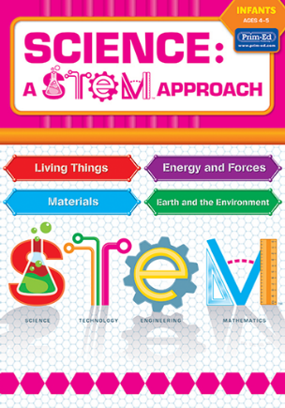 | P1 – https://www.prim-ed.co.uk/shop/science-a-stem-approach-primary-1-scotland-northern-ireland-/  P2 – https://www.prim-ed.co.uk/shop/science-a-stem-approach-primary-2-scotland-northern-ireland-/  P3 – https://www.prim-ed.co.uk/shop/science-a-stem-approach-primary-3-scotland-northern-ireland-/  P4 – https://www.prim-ed.co.uk/shop/science-a-stem-approach-primary-4-scotland-northern-ireland-/  P5 – https://www.prim-ed.co.uk/shop/science-a-stem-approach-primary-5-scotland-northern-ireland-/  P6 – https://www.prim-ed.co.uk/shop/science-a-stem-approach-primary-6-scotland-northern-ireland-/  P7 – https://www.prim-ed.co.uk/shop/science-a-stem-approach-primary-7-scotland-ireland/
Science | Measuring cylinders | 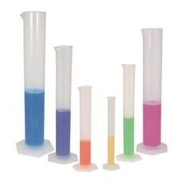 | https://www.tts-group.co.uk/search/?q=measuring+cylindes&searchType=simple-search  https://www.hope-education.co.uk/search?phrase=measuring+cylinders  https://www.amazon.co.uk/s?k=measuring+cylinders&crid=Z52M1OISB508&sprefix=measuring+cylinders%2Caps%2C86&ref=nb_sb_noss_1
 | Pipettes | 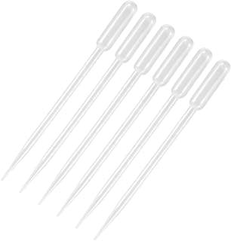 | https://www.tts-group.co.uk/search/?q=pipettes&searchType=simple-search  https://www.hope-education.co.uk/search?phrase=pippettes  https://www.amazon.co.uk/s?k=pippettes&crid=21JFBEVMZ3FFS&sprefix=pipettes%2Caps%2C73&ref=nb_sb_noss
 | Beakers | 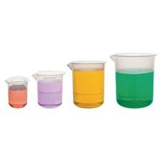 | https://www.tts-group.co.uk/search/?q=beakers&searchType=simple-search  https://www.hope-education.co.uk/search?phrase=beakers  https://www.amazon.co.uk/s?k=beaker&crid=NJDIRHRNSLZI&sprefix=beaker%2Caps%2C77&ref=nb_sb_noss
 | Goggles | 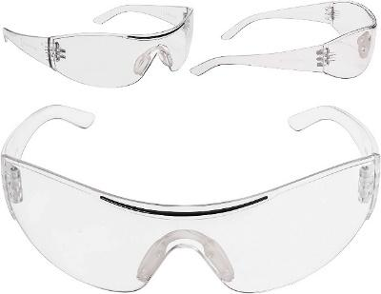 | https://www.tts-group.co.uk/search/?q=safety+googgles&searchType=simple-search  https://www.hope-education.co.uk/search?phrase=goggles  https://www.amazon.co.uk/s?k=kids+safety+goggles&crid=1EUAQ3ULJJ2DK&sprefix=kids+safety+goggles%2Caps%2C73&ref=nb_sb_noss
 | Magnifying Glass | 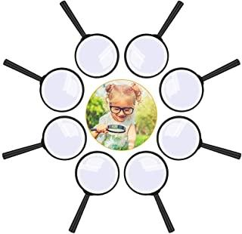 | https://www.tts-group.co.uk/search/?q=magnifying+glasses&searchType=simple-search  https://www.hope-education.co.uk/search?phrase=magnifying+glasses  https://www.amazon.co.uk/s?k=magnifying+glasses&crid=370ZR2WDV3B4X&sprefix=magnifying+glasses%2Caps%2C82&ref=nb_sb_noss
 | Measuring Jug | 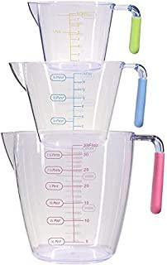 | https://www.tts-group.co.uk/search/?q=measuring+jug&searchType=simple-search  https://www.hope-education.co.uk/search?phrase=measuring+jug  https://www.amazon.co.uk/s?k=measuring+jug&crid=1NE2ZISQNS9P6&sprefix=measuring+jug%2Caps%2C87&ref=nb_sb_noss
 | Thermometers | 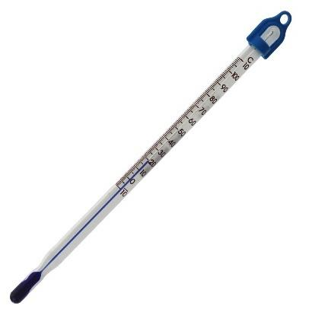 | https://www.tts-group.co.uk/search/?q=thermometer&searchType=simple-search  https://www.hope-education.co.uk/search?phrase=thermometer
 | Digital Thermometers | 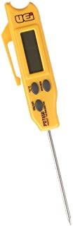 | https://www.hope-education.co.uk/search?phrase=digital+thermometer
 | Digital Microscopes | 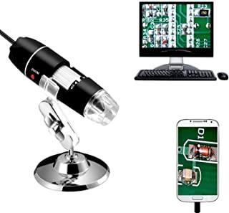 | https://www.tts-group.co.uk/search/?q=digital+microscope&searchType=simple-search  https://www.hope-education.co.uk/search?phrase=digital+microscope  https://www.amazon.co.uk/s?k=digital+microscope&crid=3HRY95F637BXE&sprefix=digital+microscope%2Caps%2C92&ref=nb_sb_noss
 | Tuff Tray | 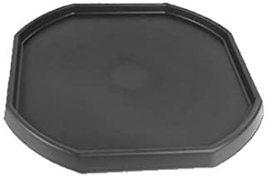 | https://www.tts-group.co.uk/early-years/small-world/tuff-trays-stands-accessories/  https://www.hope-education.co.uk/search?phrase=tuff+tray  https://www.amazon.co.uk/s?k=tuff+tray&crid=1UMHUZ90TYPIE&sprefix=tuff+tray%2Caps%2C74&ref=nb_sb_noss
 | Mud Kitchen | 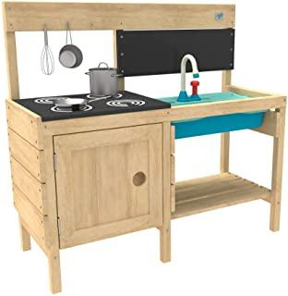 | https://www.tts-group.co.uk/early-years/messy-play/mud-kitchens/  https://www.hope-education.co.uk/search?phrase=mud+kitchen  https://www.amazon.co.uk/s?k=mud+kitchen&crid=S1OWUCJ9V269&sprefix=mud+kitchen%2Caps%2C78&ref=nb_sb_noss
 | Electricity kits for building circuits | 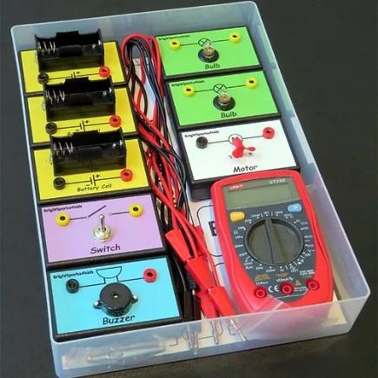 | https://www.brightsparksedu.com/electricity-kits  https://www.tts-group.co.uk/search/?q=electricity&searchType=simple-search  https://www.hope-education.co.uk/search?phrase=electricity  https://www.amazon.co.uk/s?k=electricity+kits&crid=2IJBWE7IE1H9E&sprefix=electricity+kits%2Caps%2C74&ref=nb_sb_noss
 | Magnets | 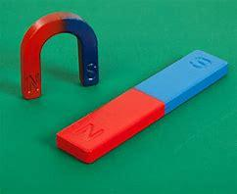 | https://www.tts-group.co.uk/magnetism-experiments-class-kit/SC00735.html  https://www.hope-education.co.uk/search?phrase=magnets
 | Magnet Wands | 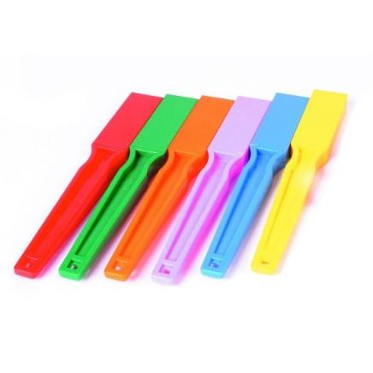 | https://www.tts-group.co.uk/search/?q=magnet+wands&searchType=simple-search  https://www.hope-education.co.uk/search?phrase=magnet+wands  https://www.amazon.co.uk/s?k=magnet+wands&crid=28DTXEP89FQ3G&sprefix=magnet+wands%2Caps%2C68&ref=nb_sb_noss
 | Magnet Construction | 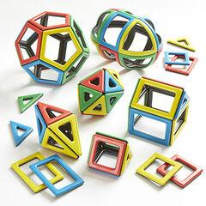 | https://www.tts-group.co.uk/search/?q=magnet+construction&searchType=simple-search  https://www.hope-education.co.uk/search?phrase=magnet+construction  https://www.amazon.co.uk/s?k=magnet+construction&crid=2A5065KZ1YBQ4&sprefix=magnet+construction%2Caps%2C71&ref=nb_sb_noss
 | Spring Balance Newton Meters | 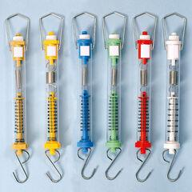 | https://www.tts-group.co.uk/search/?q=newton+meter&searchType=simple-search  https://www.hope-education.co.uk/search?phrase=newton+meter  https://www.amazon.co.uk/s?k=newton+meter&crid=1MYGWDAWAFS6H&sprefix=newton+meter%2Caps%2C66&ref=nb_sb_noss
 | Binoculars | 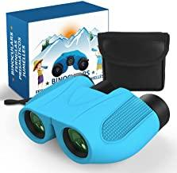 | https://www.tts-group.co.uk/search/?q=binoculars&searchType=simple-search  https://www.hope-education.co.uk/search?phrase=binoculars  https://www.amazon.co.uk/s?k=kids+binoculars&crid=29A4IK6IV6JY5&sprefix=kids+binoculars%2Caps%2C72&ref=nb_sb_noss
 | Recordable Buttons | 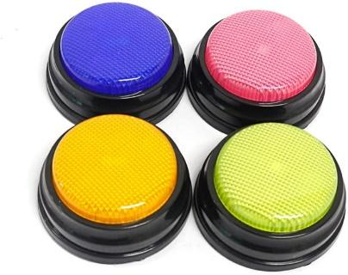 | https://www.tts-group.co.uk/search/?q=recordable+buttons&searchType=simple-search  https://www.hope-education.co.uk/search?phrase=recordable+button  https://www.amazon.co.uk/s?k=recordable+button&crid=1AS8J6ZDG4P8J&sprefix=recorda%2Caps%2C71&ref=nb_sb_ss_ts-doa-p_1_7
 | Clipboards | 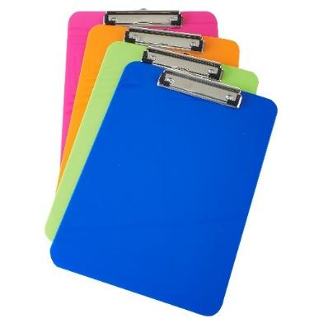 | https://www.tts-group.co.uk/search/?q=clipboards&searchType=simple-search  https://www.hope-education.co.uk/search?phrase=clipboards  https://www.amazon.co.uk/s?k=clipboard&crid=3J74RGNMPRQME&sprefix=cli%2Caps%2C85&ref=nb_sb_ss_ts-doa-p_1_3
 | Rain Gauge | 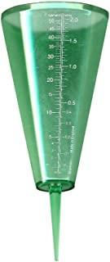 | https://www.tts-group.co.uk/search/?q=rain+gauge&searchType=simple-search  https://www.hope-education.co.uk/search?phrase=rain+gauge  https://www.amazon.co.uk/s?k=rain+gauge+for+kids&crid=14IDD0YPC4SVR&sprefix=rain+gauge+%2Caps%2C69&ref=nb_sb_ss_ts-doa-p_5_11
 | Guttering | 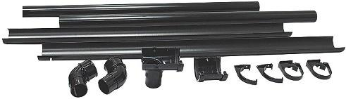 | https://www.tts-group.co.uk/search/?q=guttering&searchType=simple-search  https://www.hope-education.co.uk/search?phrase=guttering  https://www.amazon.co.uk/s?k=guttering&crid=2XOYZJSHBF5B8&sprefix=guttering%2Caps%2C197&ref=nb_sb_noss_1
 | Spoons – plastic and metal | 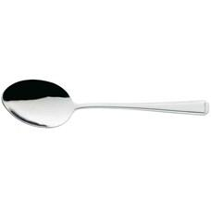 | https://www.tts-group.co.uk/search/?q=spoons&searchType=simple-search  https://www.hope-education.co.uk/search?phrase=spoons  https://www.amazon.co.uk/s?k=spoons&crid=37IFDINAZPTH2&sprefix=spoons%2Caps%2C75&ref=nb_sb_noss
 | Measuring Spoons | 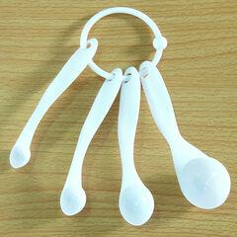 | https://www.tts-group.co.uk/search/?q=measuring+spoons&searchType=simple-search  https://www.hope-education.co.uk/search?phrase=measuring+spoons  https://www.amazon.co.uk/s?k=measuring+spoons&crid=28826L4DQVJV8&sprefix=measuring+spoons%2Caps%2C81&ref=nb_sb_noss_1
 | Petri Dishes | 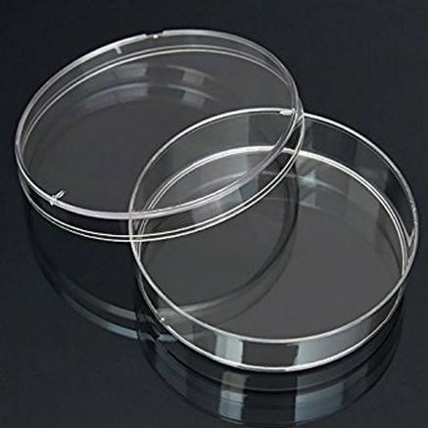 | https://www.tts-group.co.uk/search/?q=petri+dish&searchType=simple-search  https://www.hope-education.co.uk/search?phrase=petri+dish  https://www.amazon.co.uk/s?k=petri+dish&crid=3PNOGPAPTT8VH&sprefix=petri+dish%2Caps%2C117&ref=nb_sb_noss
 | Spatula | 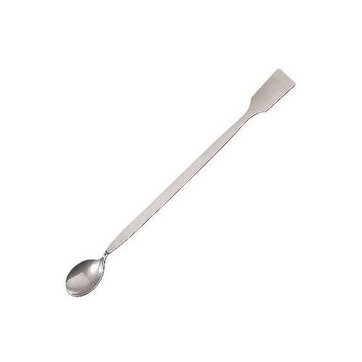 | https://www.hope-education.co.uk/search?phrase=spatula  https://www.amazon.co.uk/s?k=science+spatula&crid=4K8WSQ77KYXV&sprefix=science+spatula%2Caps%2C60&ref=nb_sb_noss
 | Filter Funnels | 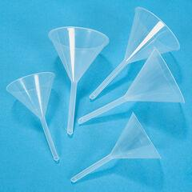 | https://www.tts-group.co.uk/search/?q=funnel&searchType=simple-search  https://www.hope-education.co.uk/search?phrase=filter+funnel  https://www.amazon.co.uk/s?k=filter+funnel&crid=182TQW2401CSX&sprefix=filter+funnel%2Caps%2C71&ref=nb_sb_noss
 | Conical Flasks | 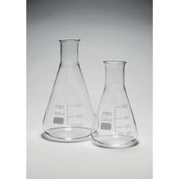 | https://www.hope-education.co.uk/search?phrase=conical+flask  https://www.amazon.co.uk/s?k=conical+flask&crid=1BKHTE0SZNF63&sprefix=conical+flask%2Caps%2C122&ref=nb_sb_noss
Technologies – Digital | Beebot | 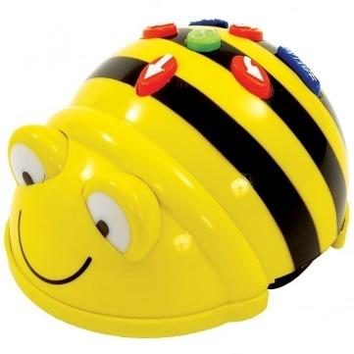 | https://www.tts-group.co.uk/search/?q=beebot&searchType=simple-search
 | Dot and Dash | 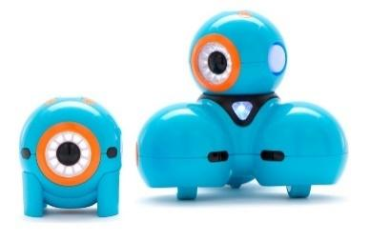 | https://www.tts-group.co.uk/search/?q=dash+and+dot&searchType=simple-search  https://www.rapidonline.com/Catalogue/Search?tier=Wonder%20Workshop%20Robots  https://www.rapidonline.com/Catalogue/Search?tier=Wonder%20Workshop%20Bundles
 | Sphero | 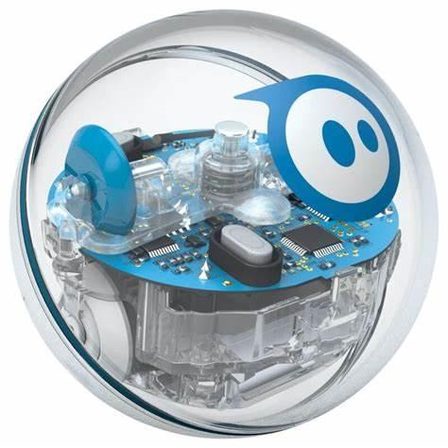 | https://www.hope-education.co.uk/search?phrase=sphero  https://www.amazon.co.uk/s?k=sphero&crid=2N9AAEAMVZNXU&sprefix=sphero%2Caps%2C74&ref=nb_sb_noss
 | Pro-bot | 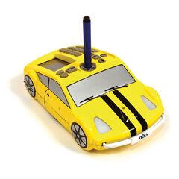 | https://www.tts-group.co.uk/primary/computing-ict/our-floor-robot-family-bee-bot-others/?prefn1=ID&prefv1=Pro-Bot
 | Botley | 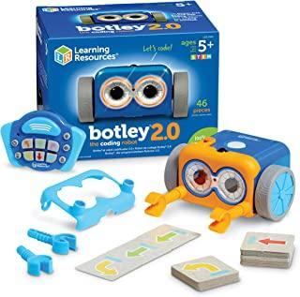 | https://www.amazon.co.uk/s?k=botley&crid=3H7WNT2C5IJR0&sprefix=botley%2Caps%2C77&ref=nb_sb_noss
Technologies/  Engineering | Make-do kits | 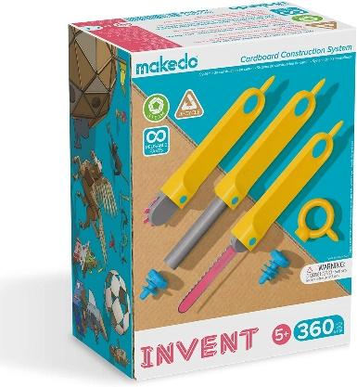 | https://www.hope-education.co.uk/search?phrase=makedo  https://www.amazon.co.uk/s?k=makedo&crid=2A0L6GWBXFO5F&sprefix=makedo%2Caps%2C126&ref=nb_sb_noss
 | Tools | 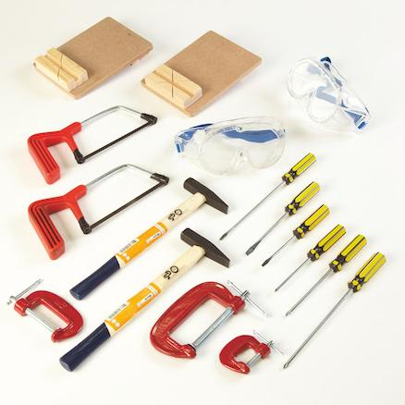 | https://muddyfaces.co.uk  https://www.tts-group.co.uk/search/?q=woodwork+tools&searchType=simple-search  https://www.hope-education.co.uk/search?phrase=woodwork+tools
 | Wood for woodwork | 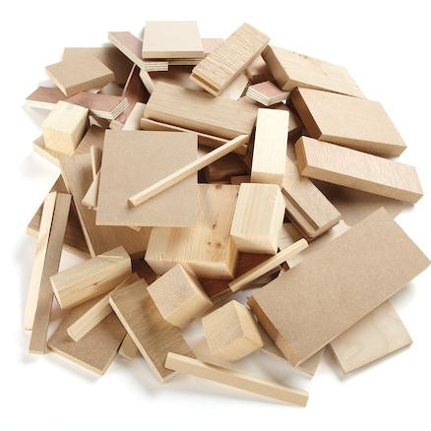 | https://www.cosydirect.com/catalogsearch/result/?q=softwood+offcuts  https://www.tts-group.co.uk/wooden-offcuts-4kg/OFFCUT.html?gclid=CjwKCAiA9aKQBhBREiwAyGP5ldZLkJeXbZ-7JvL0IPwHKI17QrqFfn4y_FnYH1Gu8wqAiXAPnp1qbxoCCvAQAvD_BwE
 | Kapla | 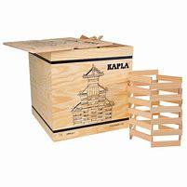 | https://www.kaplaplanks.co.uk/special-school-offer_i37.html  https://www.kaplaplanks.co.uk/natural_c17.html  https://www.kaplaplanks.co.uk/color_c13.html
 | Magformers | 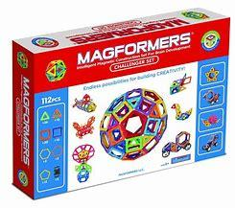 | https://www.tts-group.co.uk/search/?q=magformers&searchType=simple-search  https://www.hope-education.co.uk/search?phrase=magformers  https://www.amazon.co.uk/s?k=magformers&crid=13OKXY8HEJQ9Y&sprefix=magformers%2Caps%2C134&ref=nb_sb_noss_1
 | K’Nex | 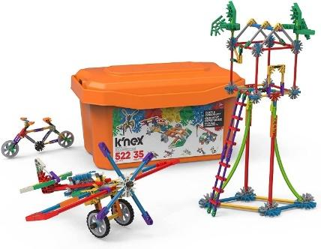 | https://www.tts-group.co.uk/search/?q=knex&searchType=simple-search  https://www.hope-education.co.uk/search?phrase=knex  https://www.amazon.co.uk/s?k=knex&crid=TS0TXJTZJ7I6&sprefix=knex%2Caps%2C89&ref=nb_sb_noss
 | Wooden Dowels | 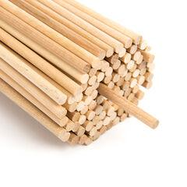 | https://www.tts-group.co.uk/search/?q=dowels&searchType=simple-search  https://www.hope-education.co.uk/search?phrase=dowels  https://www.amazon.co.uk/s?k=wooden+dowels&crid=35OLML9GQJL3I&sprefix=wooden+dowels%2Caps%2C84&ref=nb_sb_noss
Maths | Timer | 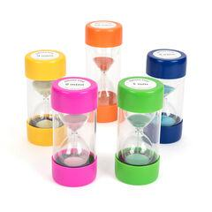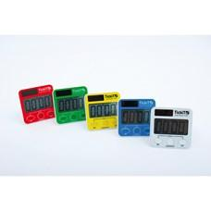 | https://www.tts-group.co.uk/search/?q=timer&searchType=simple-search  https://www.hope-education.co.uk/search?phrase=timer  https://www.amazon.co.uk/s?k=timer&crid=33XL8ZG6CLDRJ&sprefix=timer%2Caps%2C84&ref=nb_sb_noss
 | Compass | 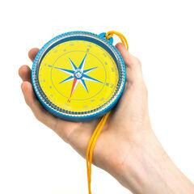 | https://www.tts-group.co.uk/search/?q=compass&searchType=simple-search  https://www.hope-education.co.uk/search?phrase=compass  https://www.amazon.co.uk/s?k=compass&crid=1SP9T1DJJLDV4&sprefix=compas%2Caps%2C75&ref=nb_sb_noss
 | Ruler | 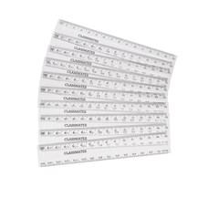 | https://www.tts-group.co.uk/search/?q=ruler&searchType=simple-search  https://www.hope-education.co.uk/search?phrase=ruler  https://www.amazon.co.uk/s?k=ruler&crid=32Q05ZX69A8XU&sprefix=ruler%2Caps%2C102&ref=nb_sb_noss
 | Measuring Tape | 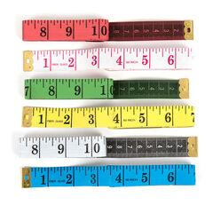 | https://www.tts-group.co.uk/search/?q=measuring+tape&searchType=simple-search  https://www.hope-education.co.uk/search?phrase=measuring+tape  https://www.amazon.co.uk/s?k=measuring+tape&crid=2JYX3RLH18JX7&sprefix=measuring+tape%2Caps%2C85&ref=nb_sb_noss
 | Weighing Scales | 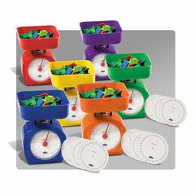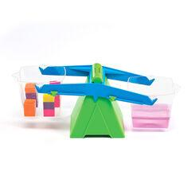 | https://www.tts-group.co.uk/search/?q=weighing+scales&searchType=simple-search  https://www.hope-education.co.uk/search?phrase=weighing+scales  https://www.amazon.co.uk/s?k=classroom+weighing+scales&crid=2HRCRSRW0RAQQ&sprefix=classroom+weighing+scales%2Caps%2C53&ref=nb_sb_noss

