Sgoil nan Loch
HWB Progression Framework
Cookery Skills
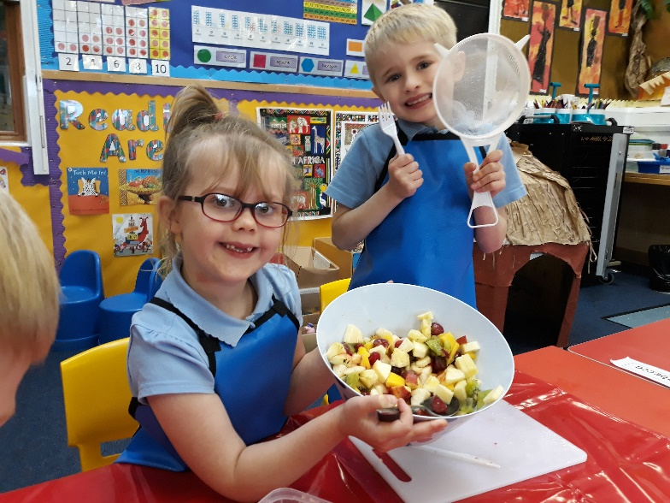
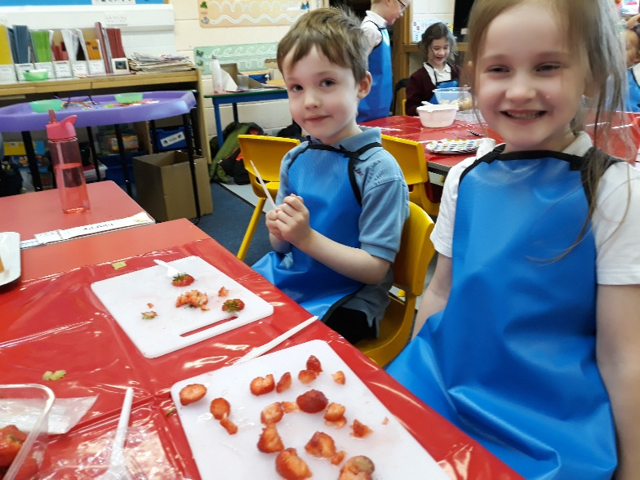

Primary Organisers | Skills | Assessment | Benchmarks
EARLY LEVEL  I enjoy eating a diversity of foods in a range of social situations.  HWB 0-29a  Together we enjoy handling, tasting, talking, and learning about different foods, discovering ways in which eating, and drinking may help us to grow and keep healthy.  HWB 0-30a  I explore and discover where foods come from as I choose, prepare, and taste different foods.  HWB 0-35a  I know that people need different kinds of food to keep them healthy.  HWB 0-32a  I enjoy exploring and working with foods in different contexts.  TCH 0-04a  I am becoming aware of how cleanliness, hygiene and safety can affect health and wellbeing and I apply this knowledge in my everyday routines such as taking care of my teeth.  HWB 0-33a | Follow instructions given one at a time by an adult.  Carryout instructions with Support.  Baking skills  Sieving e.g., flour  Cutting out rolled pastry with cookie cutters.  Brushing (Glazing)  Mixing/ stirring e.g., ingredients  Weighing and measuring  Count ingredients  Using measuring spoons and cups  Food preparation skills  Pick e.g., hull grapes.  Peeling (not using a knife or peeler) e.g., banana, satsuma  Tearing/ shredding e.g., lettuce  Pouring  Spoon ingredients between containers.  Sprinkling – e.g., toppings  Arranging ingredients e.g., on pizza  Knife skills (cutlery knives only)  Spreading e.g., butter/ icing  Bridge knife technique – Soft foods e.g., Strawberry/tomato  Slicing – soft items e.g., ham/banana  Food Hygiene/ Safety  Gets ready to prepare food, for example, wash hands, tie hair back, wear an apron, roll up sleeves.  Follows basic food hygiene through, for example, washing fruit, don’t put fingers in food, don’t pick up and use food that has fallen on the floor.  Follows safety rules and stays away from oven, pans, kettles.  Articulate some safety rules and behaviours to be followed when cooking. | - Name and describe the ‘Get ready to cook’ steps; https://www.foodafactoflife.org.uk/3-5-years/cooking/hygiene/  - Explain that it is important to get ready to cook so the food we prepare is safe to eat.  - Demonstrate and practise correct hand washing techniques.  - Recall the basic hygiene ‘rules’ in a food preparation area.  - Demonstrate hygienic behaviour in a food preparation area.  - Practise and demonstrate food preparation.  - Taste a variety of different fruits.  - Demonstrate following rules and procedures.  - Demonstrate sharing equipment  From Benchmarks  Within a food/textile context; -  - Explores and identifies at least two ideas to solve a problem. –  - Selects an appropriate solution.  • Uses given resources | - Eats socially with others.  • Recognises that we eat different foods at different times of the day and on different occasions.  • Prepares and tastes a range of familiar and unfamiliar foods  • Recognises and respects that others’ food choices may be different from their own.  - Recognises that eating more of some types of foods and less of others is good for health.  - Identifies, prepares and tastes a range of foods, for example, fruit, vegetables.  - Identifies how much fluid should be consumed in a day.  - Uses the words lots, some and a little to prepare and describe the amount of food that should be eaten from each food group to stay healthy  - Prepares and tastes a range of familiar and unfamiliar foods.  - Identifies, prepares, and tastes a range  of foods, for example, fruit, vegetables.  - . Gets ready to prepare food, for example, wash hands, tie hair back, wear an apron.  - Demonstrates an understanding of basic food hygiene and safety through, for example, washing fruit and vegetables, storing perishables in the fridge.  - Works safely when using simple kitchen equipment.  - Demonstrates simple food preparation techniques, for example, peeling, slicing, mixing, spreading.  - • Describes which foods come from plants and which come from animals when working with and tasting foods.
Primary Organisers | Skills | Assessment | Benchmarks
First Level  I enjoy eating a diversity of foods in a range of social situations.  HWB 1-29a  Together we enjoy handling, tasting, talking, and learning about different foods, discovering ways in which eating, and drinking may help us to grow and keep healthy.  HWB 1-30a  I experience a sense of enjoyment and achievement when preparing simple healthy foods and drinks.  HWB 1-30b  I am becoming aware of how cleanliness, hygiene and safety can affect health and wellbeing and I apply this knowledge in my everyday routines such as taking care of my teeth.  HWB 1-33a  When preparing and cooking a variety of foods, I am becoming aware of the journeys which foods make from source to consumer, their seasonality, their local availability, and their sustainability.  HWB 1-35a  I can use a range of simple food preparation techniques when working with food.  TCH 1-04a | Follow a simple recipe with guidance from an adult.  Carry out instructions with a little support (more independently at P3)  Baking skills  Sieving e.g., flour  Cracking/ beating an egg  Rubbing fat into flour  Creaming fat and sugar  Folding flour into creamed mixture  Spoon ingredients with increasing accuracy and minimal spillage  Dividing mixture into tins (guided)  Mixing – with increasing thoroughness/ Beating  Mixing to form a bread dough  Kneading  Shaping e.g., Bread rolls, meat balls  Using pastry cutters  Glazing e.g., brush with milk, egg  Weighing and measuring  Using measuring spoons and cups  Using a jug  Using balance scales  Food preparation skills  Tearing e.g., herbs, veg  Whisk food using a fork  Arranging ingredients  Garnishing and decorating, sprinkling.  Mashing  Using a lemon squeezer  Pouring  Grating soft foods e.g., cheese  Knife skills (P2/3 cutlery knives only)  Bridge knife technique -soft foods e.g., strawberry and tomato  Bridge knife technique – Harder food e.g., Apple (P3)  Use fork to secure food  Snipping herbs in a jug using scissors  Peeling soft veg e.g., courgette  Food Hygiene/ safety  Gets ready to prepare food, for example, wash hands, tie hair back, wear an apron, roll up sleeves, remove jewellery.  Use separate chopping boards for meat and vegetables.  Wash equipment in warm water and washing up liquid and dry it thoroughly  Clean down surfaces  Put ingredients or food away appropriately, e.g., wrap, seal, refrigerate.  Always take care when using knives or near ovens/ hobs, know when to ask for an adult to help.  Lifting lids off pans and kettles, moving hot tins, dishes, and water to be restricted to adults only.  Follows safety rules and stays away from oven, pans, kettles.  Articulate some safety rules and behaviours to be followed when cooking. | - Name and describe the ‘Get ready to cook’ steps; https://www.foodafactoflife.org.uk/3-5-years/cooking/hygiene/  - Explain that it is important to get ready to cook so the food we prepare is safe to eat.  - Demonstrate and practise correct hand washing techniques.  - Recall the basic hygiene ‘rules’ in a food preparation area.  - Demonstrate hygienic behaviour in a food preparation area.  - Practise and demonstrate food preparation.  - Weigh and measure with increasing accuracy. (Adult support P2/3)  - Explain how food should be stored  https://www.foodafactoflife.org.uk/5-7-years/cooking/hygiene-and-safety/  - Handles equipment safely.  From Benchmarks  Within a food / textile context:  • Investigates a simple problem / challenge.  • Explores and identifies a range of ideas to solve the problem / challenge.  • Selects and uses resources to reach the solution / solve the problem.  • Assesses solution against given criteria | - Prepares, tastes, and tries an increasing range of familiar and unfamiliar foods.  - Explains likes and dislikes in relation to food.  - Chooses appropriate foods to prepare for a given situation.  - Describes appropriate table manners within different social situations.  - Chooses appropriate foods to prepare  for a given situation.  - Recognises and names the main food groups, for example, The Eatwell Guide.  - • Sorts a selection of foods into the food groups.  - Chooses foods from different food groups  to create a balanced meal.  - Assists in preparing healthy dishes for  a variety of occasions, for example,  an intergenerational visit.  - Identifies at least one reason as to why it is important to drink enough water.  - Works safely and hygienically before, during and after preparing foods, for example, adhering to appropriate allergy advice, getting ready to cook, storing ingredients appropriately, washing, and drying equipment and surfaces.  - Identifies where different types of food  are stored.  - Handles equipment safely, for example, when using hot or sharp kitchen tools.  - • Describes the basic journey of food, for example, milk can come from a cow, bread comes from wheat / rye / oats  - Identifies how to prevent food related waste, for example, composting peelings, reusing leftovers, reducing use of packaging.  - Maps sources of food and drink in the local area  - Follows a recipe using fresh, local, seasonal produce, for example, making soup, hot or cold snack.  - Demonstrates a range of practical skills when preparing foods, for example, washing, using a peeler, juicing, grating, cutting, simple knife skills (claw grip/bridge hold).
Primary Organisers | Skills | Assessment | Benchmarks
Second Level  I enjoy eating a diversity of foods in a range of social situations.  HWB 2-29a  By applying my knowledge and understanding of current healthy eating advice I can contribute to a healthy eating plan.  HWB 2-30a  I understand that people at different life stages have differing nutritional needs and that some people may eat or avoid certain foods. HWB 2-32a  Having learned about cleanliness, hygiene, and safety, I can apply these principles to my everyday routines, understanding their importance to health and wellbeing.  HWB 2-33a  When preparing and cooking a variety of foods, I am becoming aware of the journeys which foods make from source to consumer, their seasonality, their local availability, and their sustainability.  HWB 2-35a  By investigating food labelling systems, I can begin to understand how to use them to make healthy food choices. HWB 2-36a  I am developing dexterity, creativity and confidence when preparing and cooking food.  TCH 2-04a  can extend and explore problem solving strategies to meet increasingly difficult design challenges with a food or textile focus. TCH 2-04c | Follow a simple recipe independently.  Carryout modifications to recipes.  Baking skills  Sieving e.g., flour, cocoa.  Cracking an egg, beating an egg,  Separating an egg (guided)  Rubbing fat into flour, mixing to form a bread dough, kneading, shaping e.g., Bread rolls  Using pastry cutters  Glazing e.g., brush with milk, egg, oil  Creaming fat and sugar and folding in flour carefully.  Scraping out a bowl with spatula, dividing mixture.  Weighing and measuring  Using measuring spoons and cups  Understanding abbreviations in recipes – tsp, tbsp,  Using a measuring jug – checking scales (guided for some)  Using balance scales  Using digital scales  Food preparation skills  Tearing e.g., herbs, veg  Whisking  Arranging ingredients  Garnishing and decorating, Sprinkling – e.g., herbs.  Mashing  Using a lemon squeezer  Pouring/ Spoon liquid foods e.g., Muffin mix  Grating soft foods e.g., cheese  Crush Garlic  Using the hob (P6/7 closely supervised)  Knife skills  Bridge knife technique – Harder food e.g., Apple  Claw knife technique – Hard food e.g., carrots  Fine chopping of herbs  Always use a chopping board.  Peeling soft veg e.g., courgette  Peeling e.g., carrot  Coring an apple  Grating hard foods e.g., carrot, apple  Finer grating e.g., Parmesan cheese, nutmeg  Food Hygiene/ Safety  Gets ready to prepare food, for example, wash hands, tie hair back, wear an apron, roll up sleeves, remove jewellery.  Cover any cuts with a plaster.  Use separate chopping boards for meat and vegetables.  Wash equipment in warm water and washing up liquid and dry it thoroughly  Clean down surfaces  Put ingredients or food away appropriately, e.g., wrap, seal, refrigerate.  Always take care when using knives or near ovens/ hobs, know when to ask for an adult to help.  Remember that trays in the oven, pans on cooker can get very hot. Use oven gloves / ask an adult to get things in/out of oven. Never use a damp cloth to lift hot trays or pans.  Know to keep pan handles turned in to avoid accidently knocking the pan. | - Name and describe the ‘Get ready to cook’ steps.  - Explain that it is important to get ready to cook so the food we prepare is safe to eat.  - Demonstrate and practise correct hand washing techniques.  - Recall the basic hygiene ‘rules’ in a food preparation area.  - Demonstrate hygienic behaviour in a food preparation area.  - Demonstrates an increasing range of practical skills and cooking techniques, for example, weighing and measuring, kneading, chopping, baking, grilling.  - Explain how food should be stored  - Handles equipment safely.  - Understand that certain foods e.g., nuts / milk cannot be eaten by some due to allergic reactions.  - Identifies ways to reduce the risk of food poisoning, for example, reheating food until piping hot, safe food storage, use of different coloured chopping boards.  - Explains the difference between Use by and Best Before dates  From Benchmarks  Within a food / textile context.  • Investigates a challenge / problem.  • Identifies and demonstrates ways to solve the challenge / problem.  • Plans and reaches the solution.  • Assesses solution against own criteria.  • Identifies at least one possible improvement. | - Uses sensory descriptors to describe foods, for example, taste, texture, appearance, smell.  - Identifies, prepares and selects foods for a range of situations, for example, social, cultural, religious events.  - Devises guidelines for good table manners.  - Explains the proportions each food group should contribute to a healthy eating plan.  - • Identifies and classifies composite dishes according to the food groups, for example, lasagne, chicken stir fry.  - • Outlines at least three current healthy eating messages, for example, lowering salt and sugar intake.  - • Creates a healthy eating plan which reflects current dietary advice, prepares food which contributes to it and compares plan to own diet.  - Identifies simple changes or improvements to own diet.  - Explains the importance of keeping hydrated.  - Recognises that all food and drink provide different levels of nutrients.  - Lists the five nutrient groups.  - Recognises that energy is provided by carbohydrates, fats and proteins and that vitamins and minerals are required to keep the body healthy.  - Explains at least three nutritional requirements at different stages of life, for example energy, protein, calcium.  - Suggests why people might avoid certain foods, for example, religion, culture, allergies, medical reasons.  - Makes food items safely and hygienically, adhering to allergies, cleaning, cross contamination, cooking, chilling.  - Identifies ways to reduce the risk of food poisoning, for example, reheating food until piping hot, safe food storage, different coloured chopping boards.  - Demonstrates an increasing range of practical skills and cooking techniques, for example, weighing and measuring, kneading, chopping, baking, grilling.  - Explains the difference between Use by and Best Before dates.  - Creates a risk assessment for a practical food session.  - Describes the journey of food from source to plate for example, from the sea, farms or factories to markets, supermarkets or direct to consumer.  - • Creates a dish using fresh, local, seasonal ingredients and calculates food miles of key ingredients.  - Explains the benefits of waste management, for example, the 3 ‘Rs’ - reduce, reuse, recycle.  - Compares the cost of identified ingredients to establish the most economical source.  - Identifies factors that may influence food choice, for example, religious, cultural, geographical, ethical factors.  - • Uses different food labelling systems to select foods for a specified dietary requirement, for example, low in fat.  - Identifies three methods of persuasion used by media/advertisers to influence consumers, for example, logos.

