Strategic Improvement Priorities Plan over 3-year cycle Timescale: 2026-2029
Strategic Priority | Year 1 | Year 2 | Year 3
1. | Update our knowledge of the Curriculum Improvement Cycle and begin to refresh our curriculum as appropriate (including Religious Education). | Refresh our curriculum as appropriate (including Religious Education) in line with new guidance. | Continue to embed our curriculum in line with developing guidance.
2. | Embed an inclusive classroom/playroom/setting through improving our knowledge of the principles of NAIT, the Circle Framework and Attachment Informed Practice. | Continue to develop our Attachment Informed Practice in line with the next pledge whilst continuing to embed the principles of NAIT and the Circle Framework. | Continue to embed our Attachment Informed Practice in line with the completion of the pledges.
3. | SLC Offer: Improving Our Learner Agency | Embedding Our Learner Agency | Creation of a fully progressive inquiry and interdisciplinary learning approach in line with the new curriculum.

Performance Data - Achievement of Curriculum for Excellence Levels (official data 2024/25)

Performance Data (Literacy and Numeracy Stage147) - Excellence Over Time Charts 2016/17-2023/24
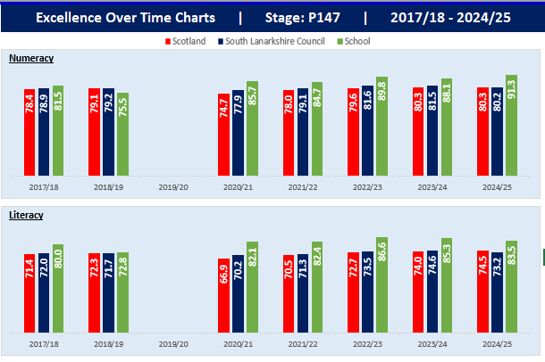

Performance Data (Literacy and Numeracy Stage 147) - Equity (Local) Over Time Charts
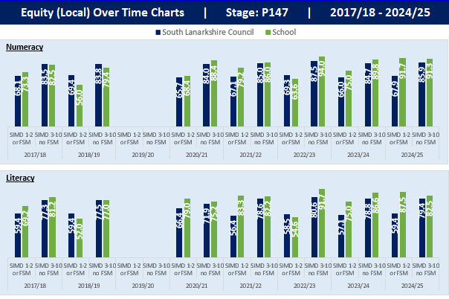

Performance Data (Literacy and Numeracy Stage147) – Equity (Local) Gap Over Time Charts
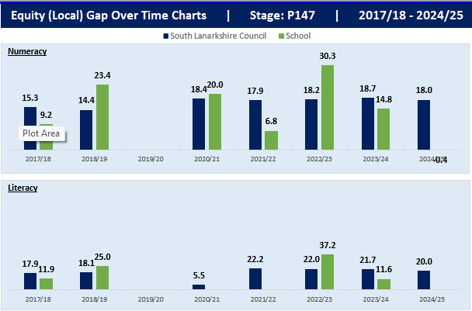
Context of school
School/Nursery:
Our Lady of Lourdes Primary is a denominational school in East Kilbride. Our end of year roll is 412 children: 13 classes (a mixture of both straight and composite) totalling 352 pupils in the school and 60 children within our nursery. Annually, our roll is borderline on the number of classes which often results in quite a late configuration: either we have 12 classes which have little or no spaces or, more often than not, we need to configure 13 classes and this continues to be the case in the forthcoming year 2026-27. Our school catchment area includes families from a variety of socio-economic backgrounds including 18% (64 chn) entitled to FSM within our school including those living in Decile 1 and 2 (Quintile 1) [ie 16% (57 chn) are entitled to FSM, 0% living within Decile 1 and 2% (7 chn) living within Decile 2].

Our Senior Leadership Team includes the Head Teacher, 2 Depute Head Teachers and one Principal Teacher. Both the Deputes have a 0.2 teaching commitment and the Principal Teacher is fully class committed. Due to one of our DHTs reducing her hours to 0.6 (3 days Mon-Wed) after returning from Maternity Leave, we continue to have a 0.4 Acting DHT for the coming year.

Our Vision and Values:
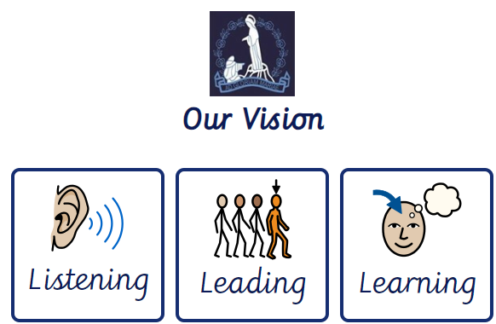
School (Extended) Vision: Nursery (Extended) Vision:

School Values: Nursery Values:




Our Lady of Lourdes
RELATIONAL POLICY
CALM  | CONNECT 
REFLECT  | REPAIR 

