Cost of the School Day Position Statement
Neilsland Primary School, South Lanarkshire Council
“We all know the ferocious and long-lasting effect that poverty can have on children and young people’s lives and the impact it has on their health, social, emotional and cognitive development and educational outcomes.” Cost of the School Day Toolkit, P5
At Neilsland Primary School we fully understand the need to reduce the Cost of the School Day for all our pupils and families, and particularly for our pupils who are already experiencing poverty. Providing all children with equal access to opportunities at Neilsland Primary School is our key aim and we endeavour to do this by:
- removing barriers to participation and learning for children and young people from low income households.
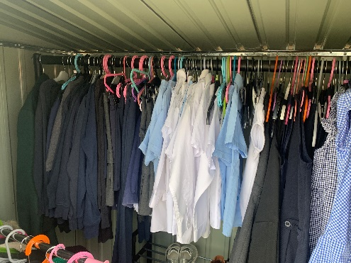
- minimising income stigma.
- reducing pressures which school costs place on family incomes.
- supporting families to access entitlements and maximising their incomes.
- using Pupil Equity Funding and/or Participatory Budgeting to remove financial barriers which stand in the way of children and young people learning.
- embedding Cost of the School Day in school improvement planning.
Neilsland’s Cost of the School Day Position statement is examined through the following headings:
- Travelling to school
- Getting Dressed for school
- Friendships at School
- Learning at School
- School Trips
- Fun Events
- Eating at School
- Attitudes Towards Poverty
- School Clubs
- Home Learning
- Matters that arise
Travelling to School
The majority of our children walk to school. Almost all of our children are able to attend after school clubs and for those who are not within walking distance of the school, we ensure that we have lunch time activities as well as after school activities. Children in Primary 1 to Primary 6 have been issued with application form for free travel in Scotland and the school will process the returned completed forms.

Getting Dressed for School
- Our current uniform is:
- Navy blue/black sweatshirt,
- sweater or cardigan,
- White polo shirt or shirt and tie,
- Navy blue/grey/black skirt,
- Pinafore or trousers,
- Jacket or blazer,
- Soft shoes for indoor wear throughout day.
Families can purchase uniforms from Scotcrest, 41 Quarry Street, Hamilton or from Logoxpres.co.uk. We do not insist on badged sweatshirts/poloshirts, therefore, parents are able to choose their preferred and most affordable uniform supplier, including local supermarkets.
We also have a wide range of preloved uniforms and footwear available on our ‘Rake and Take’ rail and parents/carers or members of our local community can take what they need. The school openly encourages the use of the ‘Rake and Take’ rail via newsletters parents/carers. The school understands that events happen in family life that result in children being unable to wear school uniform. Additionally, if a family is unable to provide a uniform, the school will support the family by providing a uniform for their child/ren.
Our ‘Rake and Take’ rail is housed in our shed which is located just outside the front office. The use of the shed ensures that uniforms are available all year round.
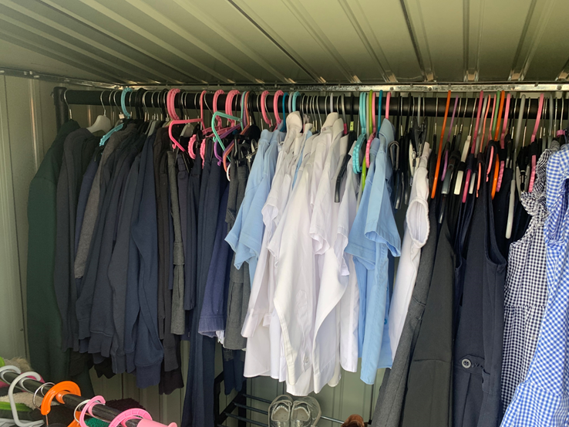

Shed with Rake and Take, Footwear and Foodbank.

Friendships
We ensure that any pupil experiencing poverty-related bullying has a way of reporting this in confidence. Every Friday, the school runs ‘Friendship Friday,’ where all children come together at lunch time to play together. This is the highlight of the children’s week and all children enjoy.
We teach young people about poverty related issues as part of our Health and Wellbeing programme and during assemblies. We continually discuss the Cost of the School Day with the Parent Council and try to identify creative ways of engaging families in school events that have minimum or no cost.

Learning at School
At Neilsland Primary School, the children do not need to pay for any core learning activity. Pens and pencils are provided, and young people do not need to bring their own equipment. Each class has a stationery station and resources like pencils, sharpeners, rubbers and coloured pencils are stored for children to use. Stationery Stations were an initiative voted by our whole school community through our Participatory Budgeting. Pupils, parents/carers and staff voted for a list of initiatives aimed at reducing the poverty related gap. In additional to stationery resources, snacks and wattle bottles are provided for the children if they don’t have this equipment or something to eat.
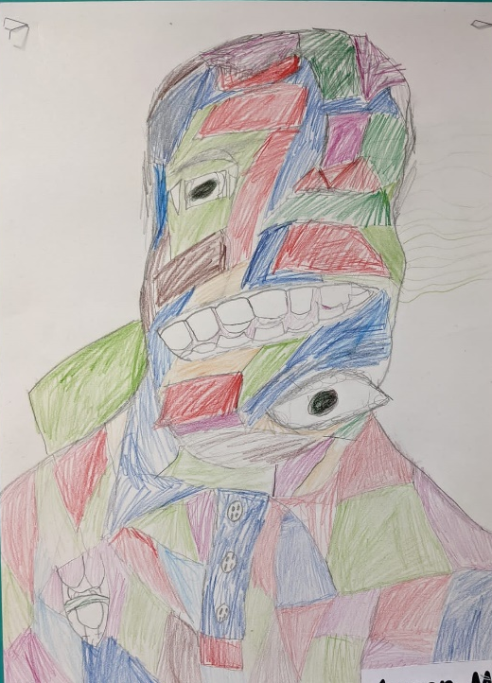
Artwork created by children, using resources from the Stationery Station
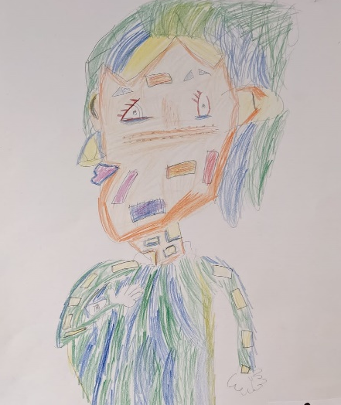

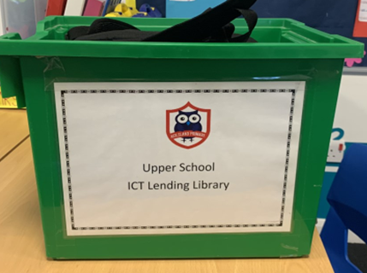
The school offers all pupils the opportunity to take home ICT equipment on a weekly basis to complete homework tasks. Ipads are available for P1-3 and Chromebooks are used to support learning for P4-7. Each class has a specific day for using the equipment and there is a flexible day if something unforeseen occurs.

Upper school lending library

Homework support is also provided on a daily basis in school and is on offer to all children. Each class has their specific day for homework support at lunch time and a School Support Assistant is allocated to each homework support day.

School Trips
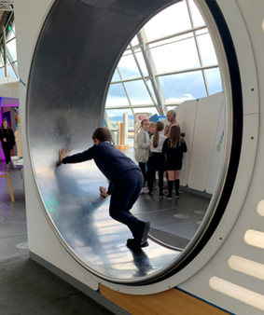
Trips are planned each year by class teachers to consolidate interdisciplinary work within the class. The average cost of trips for pupils is £5.00. We reduce the cost by subsidising each trip by the cost of the buses. In addition, we participate in a wide range of sporting activities promoted by South Lanarkshire Leisure and Culture and our Active Schools Coordinator. We also attend competitions and events in our Learning Community and SLC. We have an informal policy for families with more than one child. Families with three children only pay for two children and families with more than three children, pay a percentage of each trip for each child. We try to reduce the cost by fundraising. We do not charge our P7 pupils for any transition visits to secondary school. We work closely with our families to ensure that poverty is not a barrier to pupils’ participation in residential excursions. We make every effort to ensure that all excursions are accessible for all children and take into account the needs of individual family circumstances.

Fun Events
Neilsland Primary School continues to recognise that events planned for enjoyment can actually put added pressure on to families. Our fun events are planned at the start of the session to ensure that they are evenly spaced out over the year. When young people cannot afford to take part in any activity, we ensure they can still experience it. We currently fund raise by holding Christmas/Summer fayres and sponsored events within school. We understand that not all families are able to contribute so we ensure that there are always a variety of zero costed activities at fayres and that all children take part in the sponsored activities.

Eating at school
Within our current roll (2021/22) we had 41.2% of pupils who were in receipt of Free School Meals. The introduction of ParentPay has helped to reduce any stigma that may be associated with receiving a free lunch. We estimate that the majority of our P6-7 pupils who are eligible for Free School Meals take up their entitlement, however, there are some P1-5 pupils whose parents have not claimed this entitlement due to meals for these children being free for everyone. We continue to support parents/carers who use Parentpay to pay their child/ren’s lunch when the amount becomes too high. We do this through supportive phone calls and asking that they pay an amount each time to reduce the total.

Attitudes Towards Poverty
At Neilsland Primary our aim is to reduce the stigma of poverty for both our pupils and families. The school has an open-door policy with parents/carers and they are encouraged to contact the school if they are experiencing poverty. The school engages annually in Poverty Week in October, where classes examine what poverty is and how it effects children and families. The classes share their learning from Action Poverty Week during the Friday assembly. The children’s work is shared with the school community via Twitter and the school website.

School Clubs
At Neilsland Primary School we have a range of clubs including; netball, library, fun fitness, Taekwondo, Judo, chess, cooking, yoga, football, BSL and dance. We fund our clubs from the school’s PEF allocation and Participatory Budget. Currently, all of our extra-curricular clubs have no cost. We currently do not insist on any specialist kit for any of our extra-curricular activities. No child would be refused the opportunity to participate, due to lack of payment or equipment.

Home Learning
We try to reduce the cost of learning at home as much as possible by lending equipment, providing craft materials etc when required and by offering daily homework support to all children to allow tasks to be completed using resources available within school. For children who do not have access at home to ICT equipment to help them complete homework, we make other arrangements for them to use ICT in school or to tale ICT equipment home. Should any pupils with a specific learning difficulty or other additional support need require specialist resources this will be provided. Homework is not linked to our Behaviour Policy. We encourage all children to complete homework tasks and strategies are in place to facilitate this, however, we fully appreciate that individual circumstances need to be taken into account.

Matters that arise
Neilsland Primary School takes a proactive approach to supporting our families and children who experience a negative change in financial circumstances. The school actively has promoted the Community Outreach Wellbeing team at South Lanarkshire Council, whose role is to support families experiencing poverty or a change in financial circumstances due to a range of reasons. If families do not wish to contact the team directly, the school can complete a referral form on the family's behalf.
The school has created a mini foodbank for families who are finding it challenging to feed their family. The school has been accepted to the ‘Neighbourly Organisation’ who link with supermarkets whereby the supermarkets donate their slightly damaged goods to organisations. In addition, the Equity Lead has contacted a local supermarket to be accepted onto their system of donating food and toiletries to schools. The school has been given a timeline of Oct 22 to possibly be accepted by LIDL supermarket.

We are very clear that the Cost of the School Day is an area that requires constant vigilance and will not be ‘fixed’ by any one action. Our improvement planning continues to focus enhancing our approaches to ensure barriers to participation and engagement in the wider life of the school are reduced for all pupils and we will:
- continue to ensure pupils do not pay for any core learning activities or resources.
- raise awareness of free school meal entitlement through the Parent Council Q&A sessions.
- build on our positive relationships with our families to ensure that all those who should receive a free school meal take up their entitlement and if they are needing support through the community wellbeing team.
- continue to subsidise school trips, sporting activities, residential excursions and other out of school events.
- reduce the cost of school trips by looking for more opportunities within the local area.
- gather the views of our pupils and families on the Cost of the School Day and involve them in decision making.
- investigate funding opportunities to support the cost of extra-curricular clubs.
- highlight the benefits of ParentPay as a way of saving money on a regular basis
- work in partnership with our Parent Council to identify ways in which families who are struggling may be supported.

Policy Updated: June 2022
Review Date: June 2023

