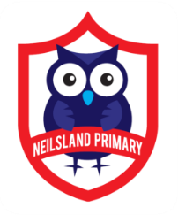
Video conferencing can be an effective way to keep in touch, provide support, reinforce and deliver new learning. At Neilsland we will be using the Google Meet platform for this purpose which your child can access through their Google Classroom. Starting on Monday 18th January staff will be hosting Google Meet sessions every Monday, Wednesday and Friday from 9.30-10.00am where the children can get together with staff and classmates to ‘keep in touch’ with each other.
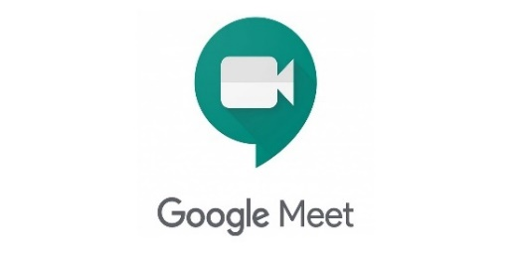
Please familiarise yourself and your child with the following advice and guidance to ensure that everyone feels safe and secure whilst using video conferencing for learning; and note that online meetings may be recorded to ensure everyone is protected when using video calls. Learners will be informed if recording is taking place at the beginning of online session. Recordings that include images or audio of learners will not be shared with other learners on Google Classroom. Only teachers are allowed to make recordings.
Learners/Parents and Carers
The teacher will be using an online video conferencing platform called Google Meet to deliver some of your lessons or to connect with you when unable to meet with you face-to-face.
Follow the instructions and advice below to ensure you make the most of these online sessions.
Before the online meeting starts learners should
- Find a suitable place to sit – this should be somewhere:
- that is not your bedroom, unless this is completely unavoidable
- with your back towards a wall to reduce how much of your surroundings are in the camera frame and try not to have personal items on display such as family photographs, no other family members should be visible
- quiet with no distractions eg turn off the TV, radio etc. or use headphones
- with good light but do not sit with your back to a window as it makes it difficult for others to see you
- with a table or hard surface to place your device on to maintain a stable image/connection
- Learners should prepare as they would for a real lesson in school – which means:
  - dress appropriately, as you would if others outside your home would see you
  - be on time for the session starting and be ready to take part – your teacher will share the dates/times of online sessions; you should discuss this schedule with your parent/carer
  - have a pen/pencil and paper/jotter beside you to take notes
  - let other people in your house know that you are joining an online lesson so they do not accidently interrupt you once the session gets underway
Parents/Carers should remind their child of the need to behave appropriately and to follow teacher instructions and the class code of conduct as would be expected in school. Inappropriate behaviour may result in your child being removed from a lesson/ session and a follow-up discussion with senior school staff.
Connecting to the online meeting
Your online sessions will take place through your Google Classroom in Glow and your teacher will have shared the schedule showing dates/times in advance.
The link to your online meeting space is on the banner in your Google Classroom.
You will not be able to join the meeting until your teacher has started it.
Log into your Glow account and go to your Google Classroom
(if you are using a tablet or mobile device, see below for help connecting with the Meet app)
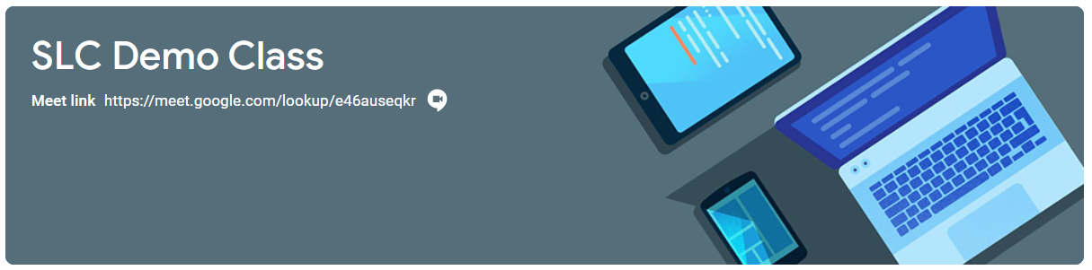
- Click on the meeting link on the Classroom banner below (remember you won’t be able to join the meeting until your teacher has started it).

You may see a message about using your camera and microphone – click Allow (even if you know you don’t want either to be on during the meeting – this can be done later)
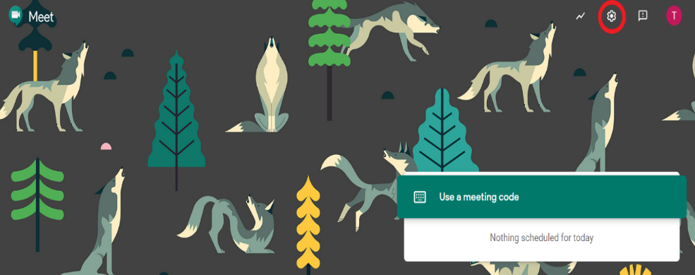
Before the scheduled Meet session you can familiarise yourself with getting the sound/camera to work go to https://meet.google.com – learners are not able to start or create meetings but from his window they can click on the settings cog on the top right of the screen.

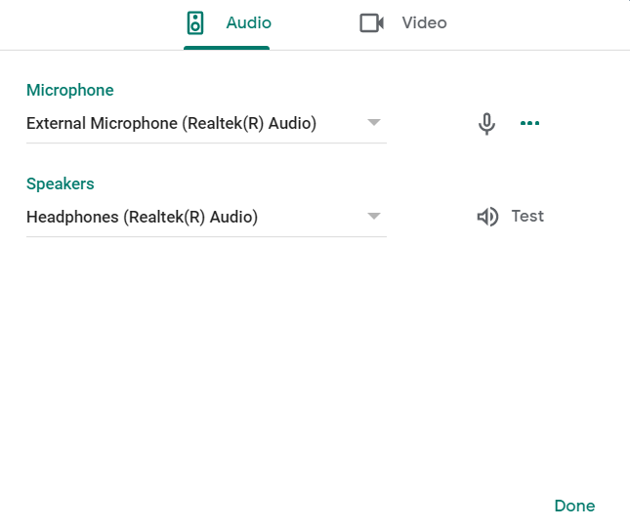
Audio settings – from this window your child can select to use their headphones instead of the default speakers; Video settings – your child can select a different webcam if required

You will now see a preview window showing your webcam view – click on the microphone icon to MUTE your mic – the icon will turn red (do the same to turn off camera, if you wish)
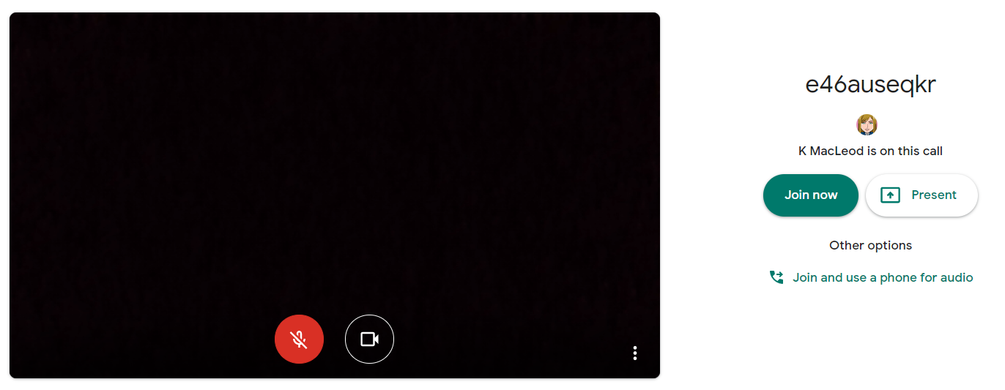
- Click Join now to enter the Google Meet – do not click Present.
- Once connected, listen carefully to your teacher and instructions being given.
If you are experiencing any technical problems eg unable to hear or see your teacher – use the chat facility to report this and wait for the teacher (or support person) to take action. Do not interrupt by turning on your mic (unless this is permitted by your teacher/class code).
- Before starting the lesson, your teacher will remind everyone (if relevant) that it will be recorded - you will see the red REC button on the top left of your screen when the recording begins.
- If your internet connection fails and you ‘drop out’ of the meeting, you should be able to reconnect by following the steps above, as long your teacher is still in the meeting.
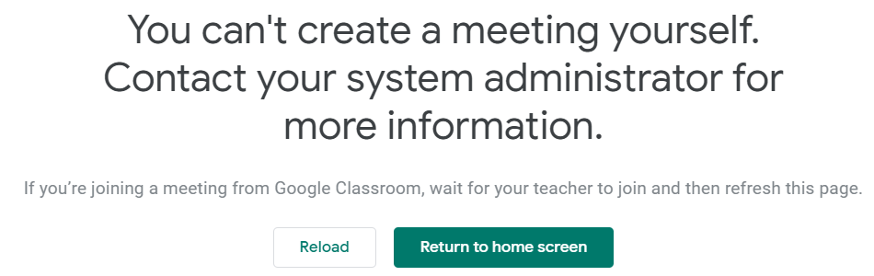
- If you see this message when you click on the Meet link in Classroom…

…it means your teacher has not started the meeting yet – go back to Classroom and try again nearer the time of the meeting.
During the online meeting
- Behave as would be expected in face-to-face lessons. Parents/carers should remind their child of the need to behave appropriately and to follow teacher instructions. For younger children it would be desirable if a parent/carer stayed close by to monitor activity.
Your teacher is able to remove you from the meeting if you do not conduct yourself appropriately and this is likely to result in follow-up action by a senior member of staff who may also discuss this with your parents/carers.
- It is very important that only pupils appear on camera and that parents/carers do not attempt to participate in online meetings with learners, this is to protect your own privacy and that of others. If you need to speak to your child’s teacher, please use the usual means of communication, phone or e-mail, to do this.
- Use the chat facility to communicate with your teacher and/or participate in discussions – this can be found on the top right of your screen.
- Only unmute your microphone if your teacher gives you permission – remember to mute it again once finished speaking.
You will find the mic/camera controls by clicking anywhere on your screen, a white banner appears at the bottom, click on the red microphone icon to unmute, click on the white microphone icon to mute.

- You may find it easier to follow what’s being said during lessons by turning on captions, which show text of the conversation; no one else can see you are using closed captions and only you can put them on or off.

- At the end of the meeting, disconnect by clicking on the red ‘hang up’ icon (found between the microphone and camera icons)

After the online meeting
- Follow up on any actions given to you by your teacher – these may be posted on your Google Classroom. It would be helpful if you could follow up with your child after online meetings (depending on their age and stage) to ensure they are clear about next steps provided by their teacher.
- If there was anything during the meeting that causes concern, it is important that you contact your teacher and/or discuss with your parent/carer who can contact your school.

