Murray Primary Nursery Class Home Learning Monday 1st February 2021 – Friday 5th February 2021

Welcome to Fabulous February! It was lovely to see those of you who managed to call up at nursery and collect the new learning packs last week. If you could not make it, and would like to collect one, please get in touch and we can make arrangements for you to collect it.
Here are some more suggestions of activities to do with your family this week. We would love to see what you have been up to so please use your child’s Learning Journal or e-mail us at gw20nurserymps.glow.sch.uk or tweet us @Murraynursery (closed page) or @MurrayPrimaryEK (public school page) to share what you have been doing.

Story time  Choose your favourite book and share it with a favourite person. Talk about the front cover. Do you know who the author is? What happens in your story?  SLLC are doing live Bookbug sessions on Facebook on Tuesday’s and Thursday’s if you would like to join them.  LIT 0-01b/LIT 0-11b | Let’s play hide and seek!  Choose your favourite toy and take turns to hide it in your house. Try using words like 'under' and 'behind' to describe where your toy is hiding. Give as many clues as you can to help someone find it without giving it away.  LIT 0-10a | Sensory Writing  Put a thin layer of salt, flour or glitter in a shallow baking tray. Use a variety of items for example pencils, sticks, spoons, forks, thin paint brushes or even just your fingers, to make marks or write letters, numbers or shapes in it.  LIT 0-21b | Ransom note  Gather some old magazines, newspapers or clean cardboard food packaging and look for the first letters of your name. Cut out all the ones you find and create a collage with them.  LIT 0-13a/LIT 021a | Listening walk  When you are out for a walk stop, close your eyes and listen. What noises do you hear? Where are they coming from? Can you hear any animals? What different types of vehicles did you hear? Some places we walk in are very quiet and other places are very noisy. Which type of walk do you prefer?  LIT 0-04a
Calendar  Do you have a calendar on your wall? Look at it with your adult - practice the days of the week song. Count how many days in a week. What month is your birthday?  If you don’t have a calendar at home, you could do our on-line one. Click here  www.starfall.com  MNU 0-10a | Caterpillar  Can you draw/paint/create a caterpillar with 5 circles for a body and 10 legs. Don’t forget to count them all. Is there anything else you need to add to the caterpillar?  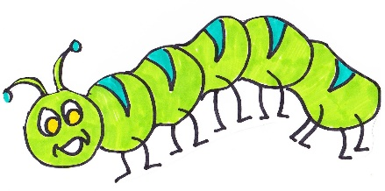  MNU 0-02a | Sorting our toys!  Ok let's help to tidy our toys. Why not try sorting our toys by colour today? If you have lots of coloured toys can you sort them by collecting groups of the same colour. If you can do this easily why not try to sort some of your toys by size. Do you have a biggest toy or a smallest toy?  Send us your photographs!  MTH 0-16a | Triangle  We’re going on a triangle hunt, we’re going to find so many!  Can you find triangle shaped objects around your house? How many can you find?  Can you sort them from biggest to smallest?  MTH 0-16a | Calculator Counting  A calculator has numbers on it and helps you do hard sums. Use a calculator or ask an adult if you can look at their phone, to recognise or find different numbers. Can you press the buttons to make some numbers? What is the biggest number you know?  MNU0-02a
Make your own pizza  You can choose any base you like, French bread, tortilla wrap, pitta bread.  Spread base with tomato puree or passata and top with grated cheese.  Choose your favourite toppings for example ham, tomato, mushroom, cooked chicken.  Cook in a hot oven for approximately 10 minutes. ENJOY!  HWB 0-35a | Sink or Float  This could be a bath time task. Look round your house and find 10 items. How many will sink and how many will float?  SCN 0-15a | Lazer maze  Make your own “Lazer Maze” by zig zagging wool or string across a room.  Who will be the champion and get across the room without touching the “Laser”?  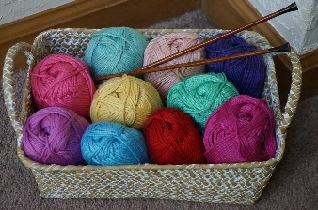  HWB 0-21a | Junk Modelling  Have a look in your recycling bin. Could you use any of the materials that you were going to recycle to build something.  You could build a castle robot or house or something completely different. Show us what you make.  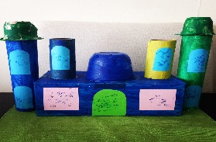  SCN 0-15 | Invent a game  Make up your own game to get fit at home. How will you move in the game? Will you walk, run, jump, hop or crawl? Will there be any throwing or catching? Remember to check with an adult that it is ok to throw something before you do it? Share your game with others by explaining the rules and asking someone to play it with you.  HWB 0-25a

These activities are provided as ideas and suggestions of things to do with your child and are not prescriptive and as parents you know your child/children best. Please use them in the way that best meets their needs. In nursery we provide a variety of open-ended resources which the children explore in their own way with their friends. It may be that they are happier to be left with some things to develop their own ideas instead of being directed to complete a set task – that’s fine by us – whatever makes this time better for you.

“Play is often talked about as if it were a relief from serious learning.
But for children play is serious learning. “
Fred Rogers

We hope to see you all again in person very soon.

Take care of yourself and each other.

From The Nursery Team

