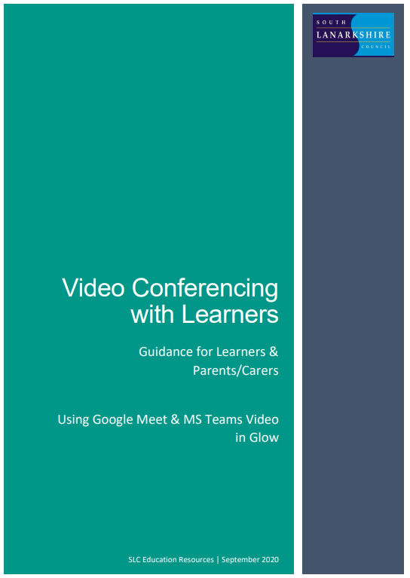
Contents
Important Note for Parents/Carers 2
Learners – setting up Google Meet at Home 3
Before the online meeting starts 3
Connecting to the online meeting 4
During the online meeting 6
After the online meeting 6
Connecting to Google Meet on a tablet or mobile device 7
Parents/carers – helping your child with Google meetings 8
Before the online meeting starts 8
Connecting to the online meeting 8
During the online meeting 9
After the online meeting 9
Learners – setting up Microsoft Teams Meetings at Home 10
Before the online meeting starts 10
Connecting to the online meeting 11
During the online meeting 13
After the online meeting 13
Connecting to MS Teams meetings on a mobile device 14
14
Parents/carers – helping your child with Teams meetings 16
Before the online meeting starts 16
Connecting to the online meeting 16
During the online meeting 17
After the online meeting 17

Important Note for Parents/Carers

Video conferencing can be an effective way to keep in touch, provide support, reinforce and deliver new learning but this is a new way of interacting for most learners, teachers and parents/carers.
Please familiarise yourself and your child with the following advice and guidance to ensure that everyone feels safe and secure whilst using video conferencing for learning; and note that online meetings may be recorded to ensure everyone is protected when using video calls. Learners will be informed of this (if recording is taking place) at the beginning of online session and recordings that include images or audio of learners will not be shared with other learners or on other online platforms such as Google Classroom or Microsoft Teams.
There are 2 video conferencing platforms, available for use by SLC staff, from within the national digital platform Glow. Until recently this has only been enabled for staff-to-staff communication. Following the implementation of recent technical changes to Google Meet and Microsoft Teams, Education Scotland has now opened access to these tools to allow staff-to-learner communication. It should be noted that these are the only platforms currently sanctioned for use within SLC as they meet the technical requirements necessary to ensure the safeguarding of all participants.

Learners – setting up Google Meet at Home

Your teacher will be using an online videoconferencing platform called Google Meet, to deliver some of your lessons or to connect with you when unable to meet with you face-to-face.
Follow the instructions and advice below to ensure you make the most of these online sessions.

Before the online meeting starts
- Find a suitable place to sit – this should be somewhere:
  - that is not your bedroom, unless this is completely unavoidable
  - with your back towards a wall to reduce how much of your surroundings are in the camera frame and try not to have personal items on display such as family photographs
(at the time of writing this guidance, blurred backgrounds were not an option in Meet)
  - quiet with no distractions eg turn off the TV, radio etc or use headphones (see below)
  - with good light but do not sit with your back to a window as it makes it difficult for others to see you
  - with a table or hard surface to place your device on to maintain a stable image/connection
- Prepare as you would for a real lesson in school – which means:
  - dress appropriately, as you would if others outside your home would see you
  - be on time for the session starting and be ready to take part – your teacher will share the dates/times of online sessions; you should discuss this schedule with your parent/carer
  - have a pen/pencil and paper/jotter beside you to take notes or have a digital alternative such as a Word or Google doc open in advance of the session starting
also
  - let other people in your house know that you are joining an online lesson so they do not accidently interrupt you once the session gets underway

Connecting to the online meeting
Most of your online sessions will take place through your Google Classroom(s) in Glow and your teacher will have shared the schedule showing dates/times in advance.
The link to your online meeting space is on the banner in your Google Classroom(s).
You will not be able to join the meeting until your teacher has started it.
- Log into your Glow account and go to Google Classroom
(if you are using a tablet or mobile device, see page 7 for help connecting with the Meet app)
- Click on the meeting link on the Classroom banner (remember you won’t be able to join the meeting until your teacher has started it – see point 8 below)
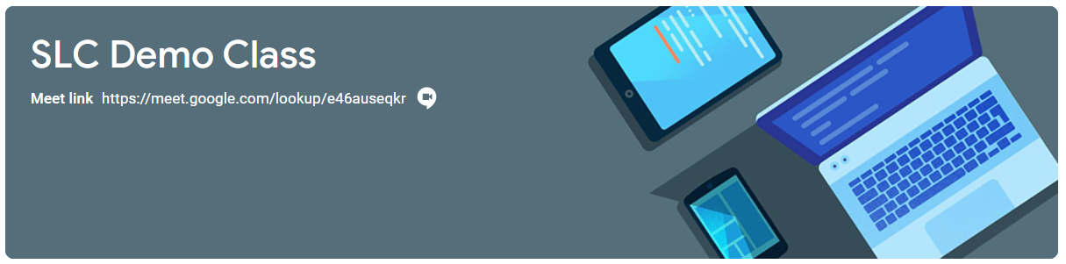
- You may see a message about using your camera and microphone – click Allow (even if you know you don’t want either to be on during the meeting – this can be done later)
You will now see a preview window showing your webcam view – click on the microphone icon to MUTE your mic – the icon will turn red (do the same to turn off camera, if you wish)
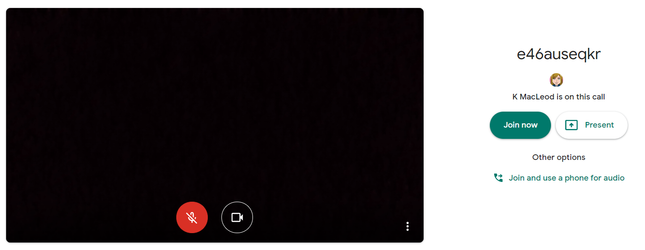
Ms Smith is on this call
- Click Join now to enter the Google Meet – do not click Present
- Once connected, listen carefully to your teacher and instructions being given
If you are experiencing any technical problems eg unable to hear or see your teacher – use the chat facility to report this and wait for the teacher (or support person) to take action. Do not interrupt by turning on your mic (unless this is permitted by your teacher/class code)
- Before starting the lesson, your teacher will remind everyone that it will be recorded - you will see the red REC button on the top left of your screen when the recording begins
- If your internet connection fails and you ‘drop out’ of the meeting, you should be able to reconnect by following the steps above, as long your teacher is still in the meeting
- If you see this message when you click on the Meet link in Classroom…
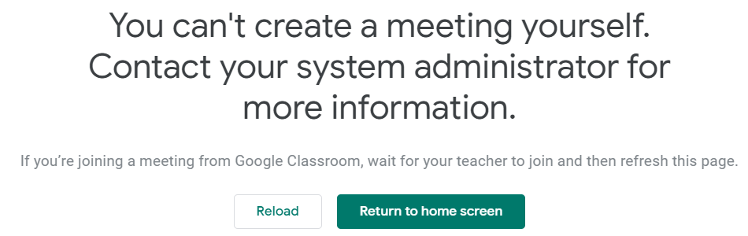
it means your teacher has not started the meeting yet – go back to Classroom and try again nearer the time of the meeting

During the online meeting
- Behave as would be expected in face-to-face lessons.
Your teacher is able to remove you from the meeting if you do not conduct yourself appropriately and this is likely to result in follow-up action by a senior member of staff who may also discuss this with your parents/carers
- Use the chat facility to communicate with your teacher and/or participate in discussions – this can be found on the top right of your screen
The chat area is also where your teacher may post links and resources and where you may need to register your attendance and/or access an exit ticket/pass
- Only unmute your microphone if your teacher gives you permission – remember to mute it again once finished speaking
You will find the mic/camera controls by clicking anywhere on your screen, a white banner appears at the bottom, click on the red microphone icon to unmute, click on the white microphone icon to mute
- Only share your screen (Present now) if your teacher gives you permission – remember to stop sharing once you have finished
- You may find it easier to follow what’s being said during lessons by turning on captions, which show text of the conversation; no one else can see you are using closed captions and only you can put them on or off

- At the end of the meeting, disconnect by clicking on the red ‘hang up’ icon (found between the microphone and camera icons)

After the online meeting
- Follow up on any actions given to you by your teacher – these may be posted on your
Google Classroom
- If there was anything during the meeting that caused you concern, it is important that you contact your teacher and/or discuss with your parent/carer who can contact your school.

Connecting to Google Meet on a tablet or mobile device

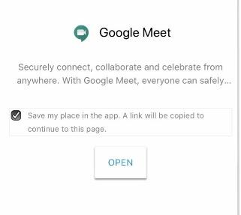
- Click on the meeting link on the Classroom banner or, if you don’t see the link,
look for the video icon and click on it
- Your device will prompt you to download the
Google Meet App – click OPEN
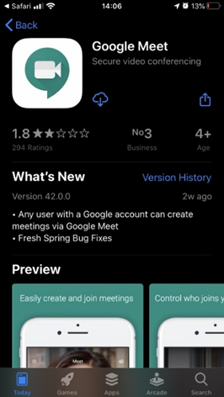
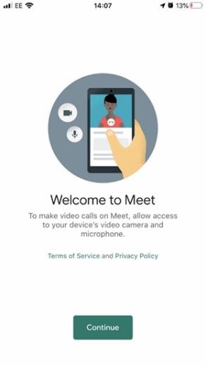
- You need to download the app from your app store and once you click to download you’ll see a Welcome to Meet message – click Continue and allow access to your camera and microphone when prompted
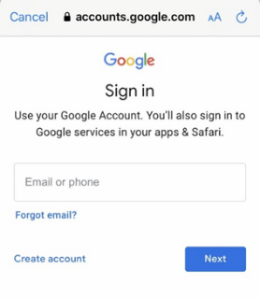
- Click to Sign In and Choose an Account – you need to use your Glow account and it should have the @sl.glow.scot ending not @glow.sch.uk
If you don’t see your Glow account, then click to Add another account and enter your Glow account details – REMEMBER username@sl.glow.scot not glow.sch.uk
- You are now in Google Meet – but if your teacher hasn’t started the meeting you won’t be able to join yet. Controls for camera, microphone and hang up are on the screen and more controls can be accessed once the meeting starts, including closed captions, as well as tabs for chat and attendees. Turning your phone landscape can improve the Meet experience as presenters and presentations are displayed in a larger format.

Parents/carers – helping your child with Google meetings

Before the online meeting starts
- Information and a schedule of meetings will be made available to learners in advance of any online sessions; learners are asked to ensure these are shared with parents/carers to help you plan for online lessons/meetings
- Help your child by finding a quiet and well-lit place, preferably not a bedroom, to take part in online lessons; the background area should be clear and away from an area where other members of the household may be visible on camera
- Remind your child of the need to behave appropriately and to follow teacher instructions and the class code of conduct; for younger children it would be desirable if you stayed close by to monitor their activity
Inappropriate behaviour may result in a child being removed from a lesson and a follow-up discussion with senior school staff
- All online meetings will be recorded to ensure everyone feels safe and secure while using videoconferencing – your child will be reminded of this before recordings begin; only teachers are permitted to record meetings

Connecting to the online meeting
- Your child has been provided with instructions for joining a Google Meet videoconference but may require some help getting the sound and/or camera to work – you can help your child explore the different settings for this prior to an online session starting
- Go to https://meet.google.com – learners are not able to start or create meetings but from his window they can click on the settings cog on the top right of the screen
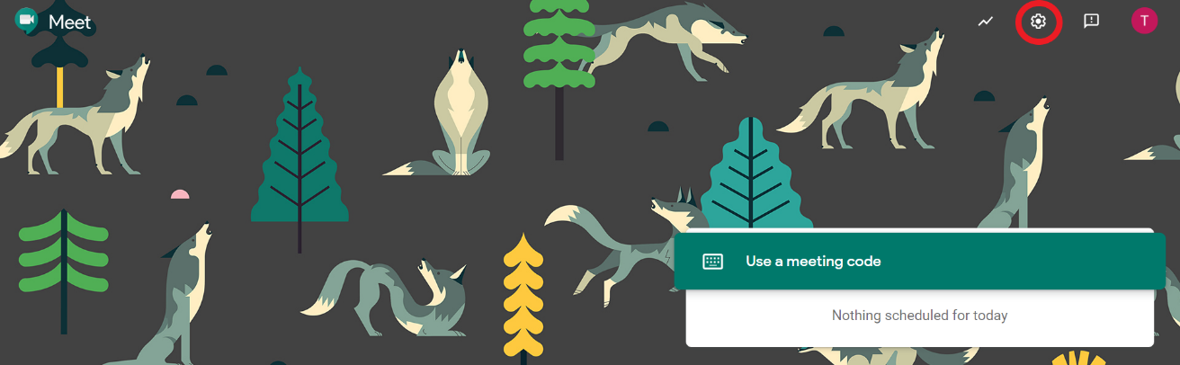

Audio settings – from this window your child can select to use their headphones instead of the default speakers; Video settings – your child can select a different webcam if required
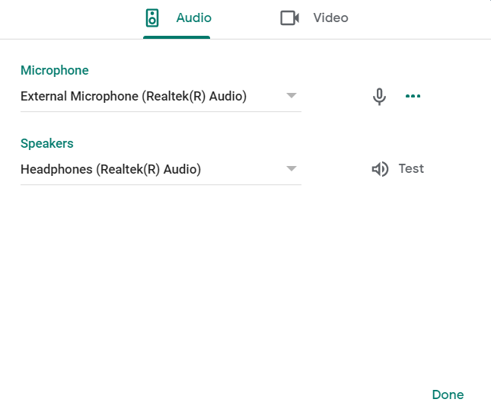
Your child may also require help downloading the Meet app onto a tablet or mobile device – instructions for this can be found in the Learner instructions.

During the online meeting
- It is important that parents/carers do not attempt to participate in online meetings with learners, this is to protect your own privacy and that of others. If you need to speak to your child’s teacher, please use the usual means of communication to do this.
If you child is experiencing difficulty during a meeting they should use the chat facility to communicate this to their teacher, parent/carers must not interrupt meetings by speaking or appearing on camera.

After the online meeting
- It would be helpful if you could follow up with your child after online meetings (depending on their age and stage) to ensure they are clear about next steps provided by their teacher.
- If you have any concerns about the use of Google Meet or the content of online lessons, please contact the school using the normal channels of communication.

Learners – setting up Microsoft Teams Meetings at Home

Your teacher will be using an online videoconferencing platform called Microsoft Teams video, to deliver some of your lessons or to connect with you when unable to meet with you face-to-face.
Follow the instructions and advice below to ensure you make the most of these online sessions.

Before the online meeting starts
- Find a suitable place to sit – this should be somewhere:
  - that is not your bedroom, unless this is completely unavoidable
  - with your back towards a wall to reduce how much of your surroundings are in the camera frame and try not to have personal items on display such as family photographs
(at the time of writing this guidance, blurred backgrounds are not an option for leaners unless they have downloaded and are using the desktop app for Microsoft Teams)
  - quiet with no distractions eg turn off the TV, radio etc or use headphones (see below)
  - with good light but do not sit with your back to a window as it makes it difficult for others to see you
  - with a table or hard surface to place your device on to maintain a stable image/connection
- Prepare as you would for a real lesson in school – which means:
  - dress appropriately, as you would if others outside your home would see you
  - be on time for the session starting and be ready to take part – your teacher will share the dates/times of online sessions; you should discuss this schedule with your parent/carer
  - have a pen/pencil and paper/jotter beside you to take notes or have a digital alternative such as an Online Word document or Google doc open in advance of the session starting
also
  - let other people in your house know that you are joining an online lesson so they do not accidently interrupt you once the session gets underway

Connecting to the online meeting
Most of your online sessions will take place through your class Microsoft Team in Glow and your teacher will have shared a schedule showing dates/times in advance.
The link to your online meeting space is likely to appear on the General channel of the Team. You will not be able to join any only meetings until your teacher has started it.
- Log into your Glow account and go to Microsoft Teams
(if you are using a tablet or mobile device, see page 14 for help connecting the Teams app)
- If you double click on the meeting link on the blue banner…
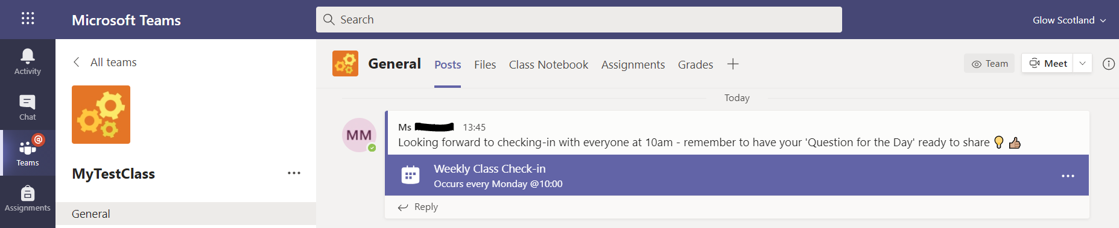
- You will see a window like the one below – click the blue Join button (top right)
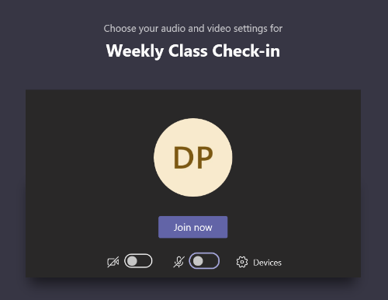
- Turn off your microphone and choose to show your camera, or not
You can change the camera, microphone and/or speakers you are connected to by clicking on the Devices cog
When ready, click the blue Join now button
If you see the following message, it means your teacher hasn’t started the meeting yet, click Dismiss and try again nearer to the scheduled start time – you can’t join before your teacher!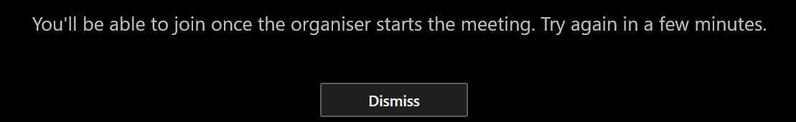
- It may be easier to wait until you see the following notification appear on the Team channel – this indicates that the meeting has started – click the Join button to enter the meeting
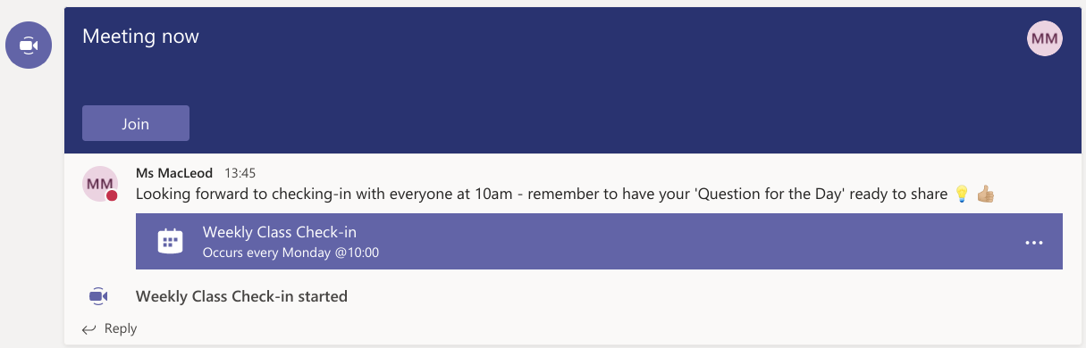
You may be prompted to provide access to your video camera and microphone – click Allow for both – you can still choose to switch these settings off before joining the meeting
(see point 4 above)
- Once connected, familiarise yourself with the meeting settings on the floating toolbar
(hover the mouse over the screen to show the toolbar)
Turn video on/off
Mute/unmute mic
Screen share*
More actions
Who’s in the meeting
Participate in chat
Raise your hand
Leave meeting
- Listen carefully to your teacher and instructions being given
If you are experiencing any technical problems eg unable to hear or see your teacher – use the Chat facility to report this or Raise Hand and wait for the teacher (or support person) to take action. Do not interrupt by turning on your mic (unless this is permitted by your teacher/class code)
- Before starting the lesson, your teacher may tell everyone that it will be recorded
- If your internet connection fails and you ‘drop out’ of the meeting, you should be able to reconnect by following the steps above, as long your teacher is still in the meeting

During the online meeting
- Behave as would be expected in face-to-face lessons.
Your teacher is able to remove you from the meeting if you do not conduct yourself appropriately and this is likely to result in follow-up action by a senior member of staff
who may also discuss this with your parents/carers
- Communication - use the hands up and/or chat facility to communicate with your teacher and/or participate in discussions; the chat area is also where your teacher may post links and resources and the area you may need to access to complete an exit ticket/pass
Only unmute your microphone if your teacher gives you permission – remember to mute it again once finished speaking – your teacher may prevent students from unmuting, you will see the following symbol beside your mic if this is the case
- Screen sharing – when you join the meeting you may see the following message
This means you can’t share your screen unless your teacher changes you from an attendee
to a presenter – the teacher can switch between these permissions at any time
- At the end of the meeting, disconnect by clicking on the red ‘hang up’ icon

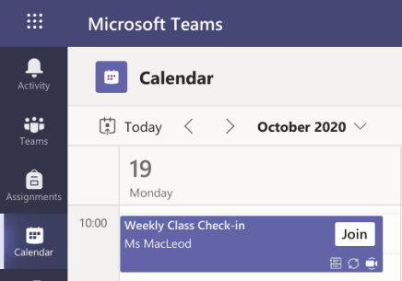
Teams Calendar
You will also see meetings set up by your teacher on your Calendar in Teams – this is an alternative way to join a meeting
Click Join and follow the instructions above

After the online meeting
- Follow up on any actions given to you by your teacher – these may be posted in the Chat and/or on your class Team (remember to check all appropriate Channels)
- If there was anything during the meeting that caused you concern, it is important that you contact your teacher and/or discuss with your parent/carer who can contact your school.

Connecting to MS Teams meetings on a mobile device
- Download the free Microsoft Teams app onto your device (available on both Android and iOS)
- Click on the app once downloaded – sign in with our Glow account
(the following screenshots may differ slightly depending on the mobile device being used)
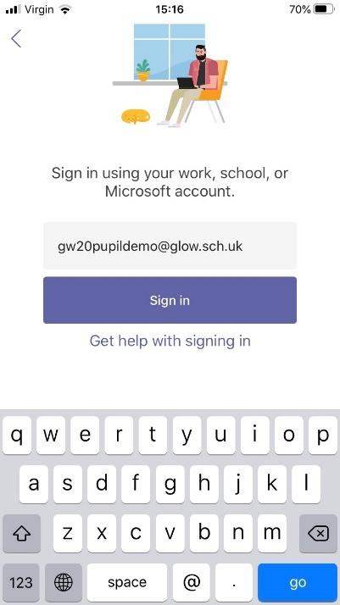 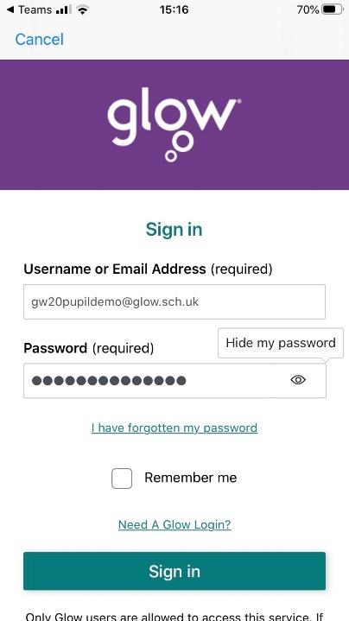
You may be prompted to allow access to your camera and microphone – allow this
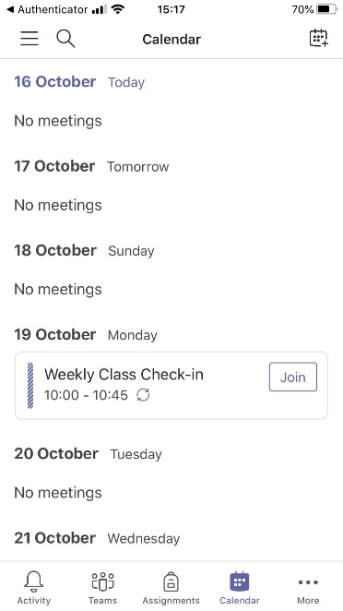
- You should now see you Teams window and all Teams you are a member of… if not, click on the blue Teams icon
You can also click on the Calendar icon to check for any upcoming video meetings

- When inside your class Team, a video icon will be displayed next to the channel the meeting is taking place within – click the blue Join button
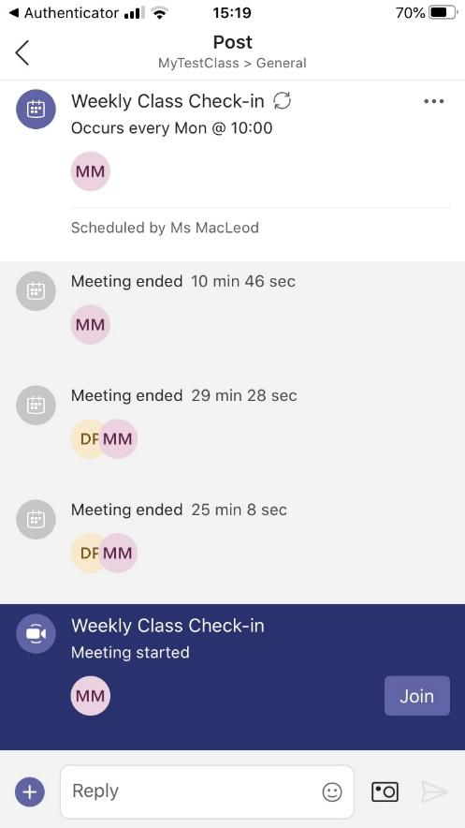
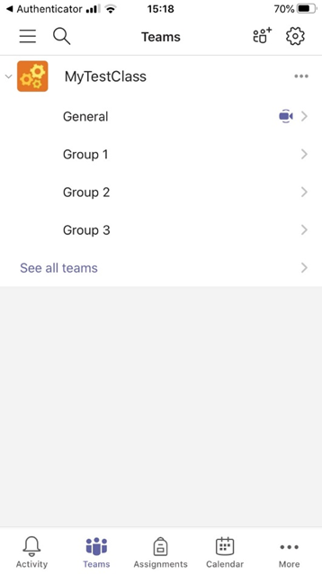
- Choose to have your camera/mic on or off and click Join now – you will now be in the meeting and see either your teacher of their screen if screen sharing when you join; from the more actions button (…) you can choose to turn on live captions, raise hand etc
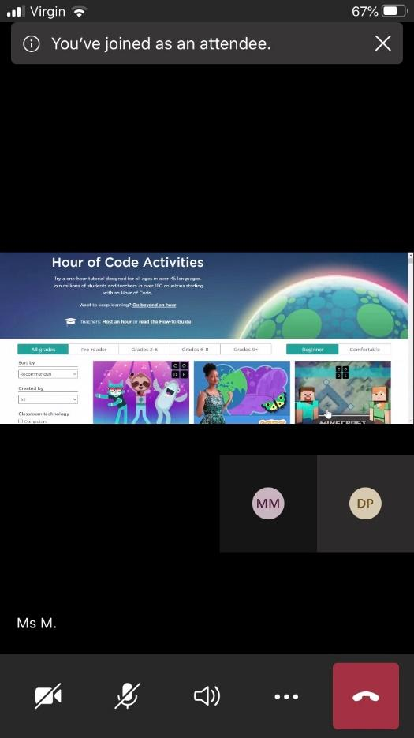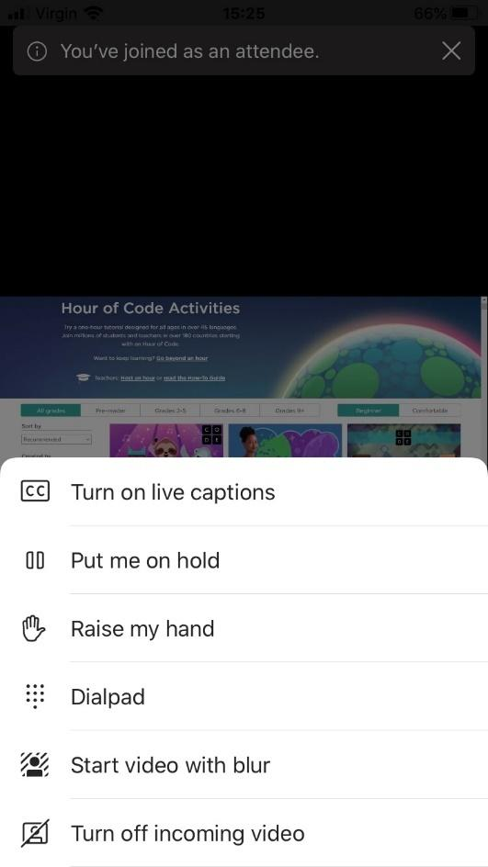

Parents/carers – helping your child with Teams meetings

Before the online meeting starts
- Information and a schedule of meetings will be made available to learners in advance of any online sessions; learners are asked to ensure these are shared with parents/carers to help you plan for online lessons/meetings
- Help your child by finding a quiet and well-lit place, preferably not a bedroom, to take part in online lessons; the background area should be clear and away from an area where other members of the household may be visible on camera
- Remind your child of the need to behave appropriately and to follow teacher instructions and the class code of conduct; for younger children it would be desirable if you stayed close by to monitor their activity
Inappropriate behaviour may result in a child being removed from a lesson and a follow-up discussion with senior school staff
- Online meetings may be recorded to ensure everyone feels safe and secure while using videoconferencing – your child will be reminded of this before recordings begin; only teachers are permitted to record meetings

Connecting to the online meeting
- Your child has been provided with instructions for joining a Microsoft Teams video conference but may require some help getting the sound and/or camera to work – you can help your child explore the different settings for this prior to an online session starting
Learners are not able to start or create meetings but settings can be explored and setup in advance. Ask your child to:
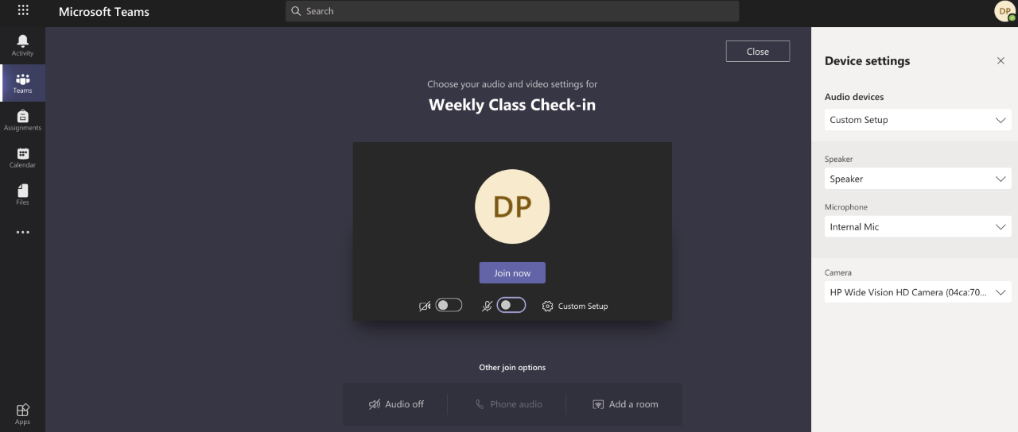
  - go to the class Team page and the post where the scheduled meeting is displayed
  - double click to open the meeting and click to Join (please note this will not allow the child into the meeting room but will provide the
setup screen opposite)
  - click Custom Setup – the following window will open:
From the Devices settings your child can select:
Audio settings – to use their headphones (recommended), the headphones will need to be plugged in to allow them to be selected
Speaker settings – to use different (external) speakers to the ones built into their device
Microphone settings – to use a different microphone to the one built into their device eg one attached by usb
Camera – to use a different webcam to the one built into their device eg one attached by usb
Your child may also require help downloading the Teams app onto a tablet or mobile device – instructions for this can be found in the Learner instructions.

During the online meeting
- It is important that parents/carers do not attempt to participate in online meetings with learners, this is to protect your own privacy and that of others. If you need to speak to your child’s teacher, please use the usual means of communication to do this.
If you child is experiencing difficulty during a meeting, they should use the chat facility to communicate this to their teacher, parent/carers must not interrupt meetings by speaking or appearing on camera.

After the online meeting
- It would be helpful if you could follow up with your child after online meetings (depending on their age and stage) to ensure they are clear about next steps provided by their teacher.
- If you have any concerns about the use of Teams video or the content of online lessons, please contact the school using the normal channels of communication.

