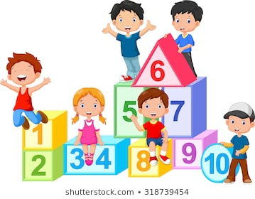**Number Sequences**

Here are some number sequence worksheets for you. Look very carefully at the numbers and try to work out what is happening to them. Are the numbers getting bigger or smaller? This tells us whether we are adding or subtracting. How much are the numbers changing by? This will tell us the pattern. Remember to ask an adult to help you if you are unsure. Please let me know if you enjoy doing these and I can provide you with some more.

Also, please let me know if there is something in particular that you would like me to try and find for you.

Have fun and stay safe!!

Ms Lennon

