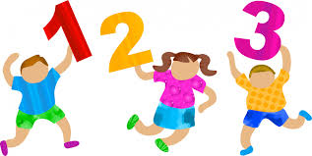
Number Box Counting Activities

Remember to regularly practise your counting as this will help you feel more confident with lots of your numeracy tasks.
Use number to 20 cards to try the following: -
- Cut out number cards 0 – 20 (see below)
- Arrange number cards in a rainbow shape
- Count forward from 0 – 20 pointing to each card as you say each number.
- Count backwards from 20 – 0
- Close your eyes can you go forward and backwards to 20 without looking at cards and without making any mistakes?
- Can you write these numbers, making sure that your numbers are all formed clearly and are the correct way round.
- If you can do this easily and confidently, then try counting forward and backwards to 50. Write these numbers again making sure that your numbers are all formed clearly and are the correct way round.
- If you would like a challenge, then try to reach 100.
- Using your number cards to 20 to help you count in 3s starting at 0
- Count in 3s but this time start at 1
- Count in 3s starting at 5
- Count in 3s starting at 2
- This time you choose a number to start from
- If you can do this easily and without mistakes try counting backwards in 3s. Start at 20 to begin with then choose different numbers to start from. Try starting from 17, or 12 or 19 or 16
- If you are looking for a challenge use numbers up to 50.
- If you are finding numbers to 50 easy and you are feeling confident, try numbers to 100.

You can use this activity for counting in 2s, 3s, 4s, 5s and 10s. Remember to say and write each number clearly. I have attached a hundred square to help you if you need it.
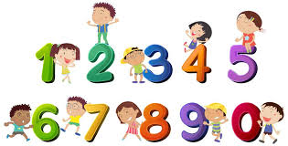
Have fun and stay safe!!
Ms Lennon

0 | 1 | 2
3 | 4 | 5
6 | 7 | 8
9 | 10 | 11
12 | 13 | 14
15 | 16 | 17
18 | 19 | 20

